 |  |  |  |  |  |  |  |  | Sadeepa Book Shop
 |  |  |  |  |  |  |  |  |  | No 50,Panadura Road,Horana
 |  |  |  |  |  |  |  | Tel - 034 - 3741751 email - sadeepa@gmail.com
 |  | Item Popularity Report For
 |  |  |  |  | From |  |  |  | 2014-08-01 |  |  |  | to | 2014-08-31
 |  |  |  | Item Code |  |  |  | Description |  |  |  | Sales Price |  |  |  | Quantity Sold
 |  |  | I0002 |  |  |  |  | book |  |  | 345.00 |  |  |  |  | 14
 |  |  | I0004 |  |  |  |  | book |  |  | 345.00 |  |  |  |  | 11
 |  |  | I0003 |  |  |  |  | book |  |  | 456.00 |  |  |  |  | 6
 |  |  | I0001 |  |  |  |  | hh |  |  | 234.00 |  |  |  |  | 4
 | 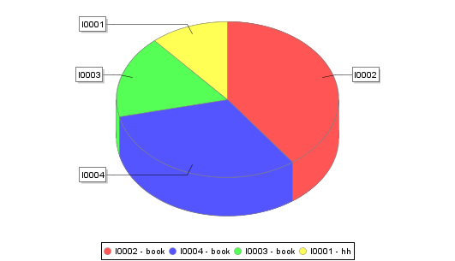
 |  |  |  |  |  |  |  |  |  |  |  |  |  |  |  |  | 24/08/2014
 |  |  |  |  |  |  |  |  |  |  |  |  |  |  |  |  | - - - - - - - - - - - - - - - -
 |  |  |  |  |  |  |  |  |  |  |  |  |  |  |  |  | Date

