Authored by: Trần Quang Hiếu - s3979597  Supervisor: Ms. Agnieszka Kiejziewicz | Last updated: 22/08/2025

CAPSTONE PROJECT: SIMIAN PRINT
GAME DESIGN DOCUMENT

CORE CONCEPT
SETTING:
“Simian Print” is set in a claustrophobic, vertical, post-apocalyptic and neo-urban city inspired by Kowloon Walled City.
You play as a Mother Monkey nurturing an AI Robot Child companion, whom she believes is her lost child. To survive, you must observe NPC (e.g., humans, other creatures) routines and interact with the environment to steal batteries for the child robot and find food for yourself.
As their bond evolves, the game gradually reveals its themes: longing for meaningful connection, adaptation in a shifting world, the persistence of motherhood, and learning to embrace the present over the past.

CONCEPT:
Primary Pillar:
- Companion systems and mechanics.
- Create interesting interactions between monkey and robot child.
- Gameplay dynamics deepen their relationship narratively.
Supporting Pillar:
- Vertical-focused, momentum-based stealth.
- Environmental & visual storytelling → motivation through NPC routines, cues, and companion behavior.
Uniqueness:
- Rare: fast-paced stealth platformer.
- Dynamic between main character (monkey) and companion (robot child).
- Perspective from an animal → unique lens on human society.
- NPCs/world react next day based on how stealthy you were.

MAIN CHARACTERS MODEL: (Progress 35%)
MOTHER MONKEY (Progress: 5%)
Characteristics:
- Nimble and fast.
- Swings around the level while carrying Child on her back.

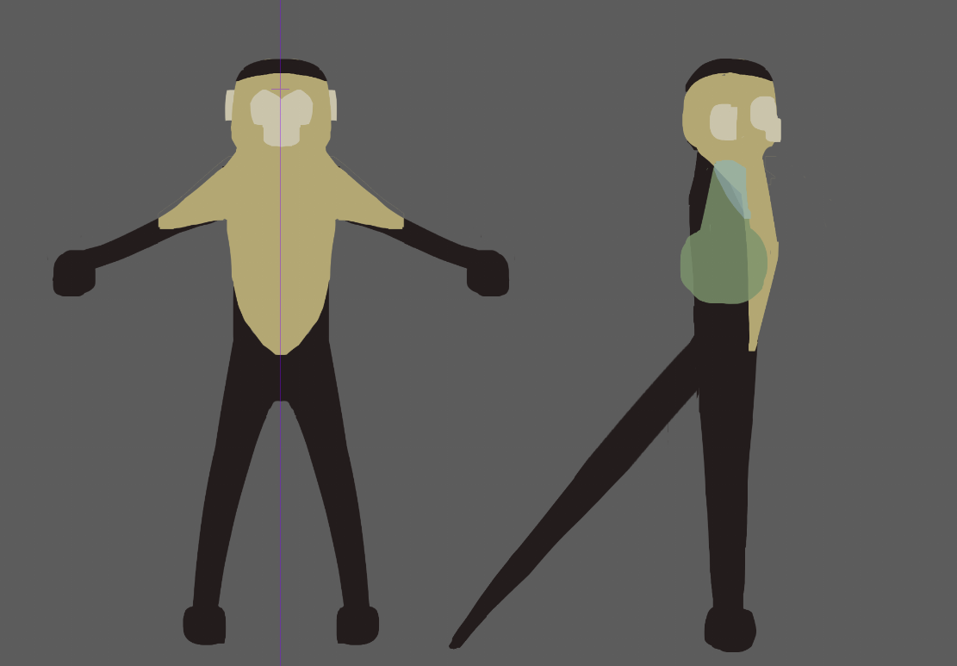
Concept art

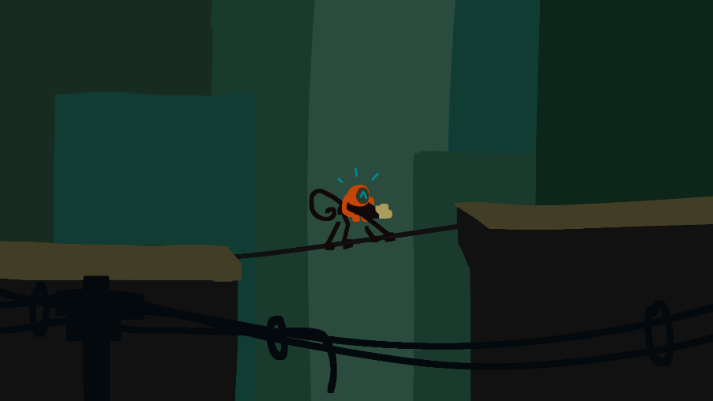
Concept art
CHILD (Progress: 70%)
Characteristics:
- Hangs on his mother’s back most of the time.
- Makes cute noises in reaction to the world.
- Asks to play sometimes.
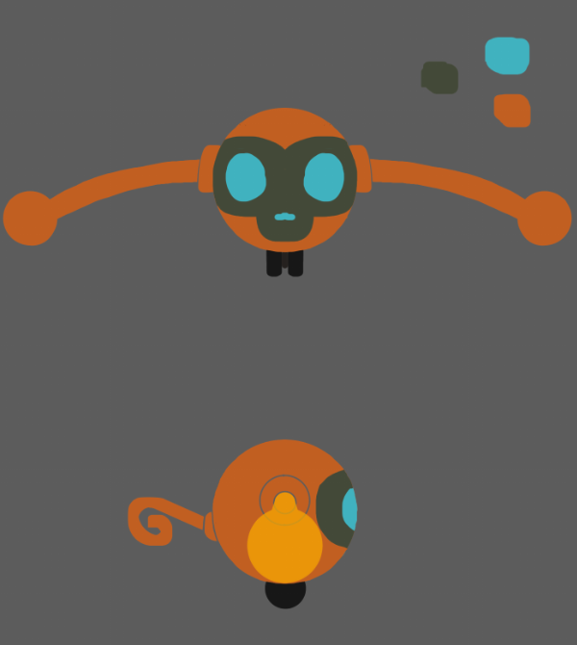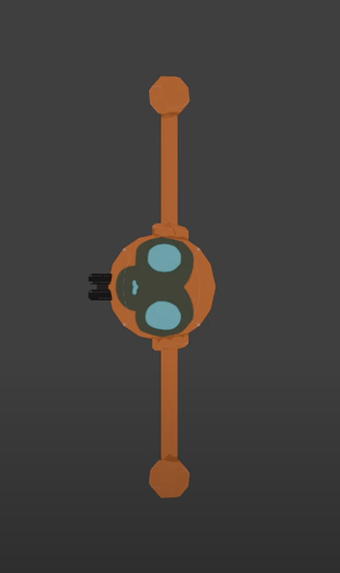
Concept art 3D Model

Airborne animation while being thrown

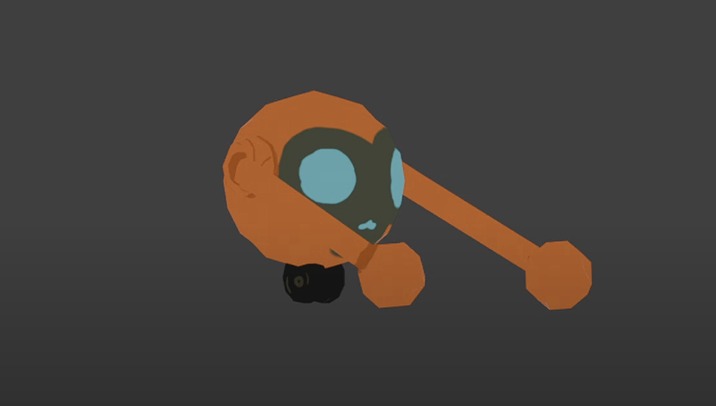
When hugged on Mother’s back

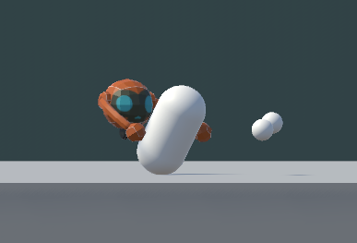
Current in-game appearance

GUARD (Progress: 0%)
Characteristics:
- Special NPC that gets spawned when you are spotted during stealth.
- Carries a stun gun and will hunt you down.

GAME PROGRESSION
TUTORIAL (PAST: REAL CHILD)
- Goal: Teach player the core loop and controls in a safe, story-driven space.
- Setting: Animal shelter with lush greenery and cages (in contrast to later decayed city).
- Mechanics introduced:
  - Move left/right, jump, climb.
  - Swing from pivots.
  - Establish gameplay loop: Investigate where food is, gather food, return home to sleep for the day, repeat.
  - Tone: Playful, hopeful.

TRANSITION (TIME SKIP)
- Event: Sudden hard cut during tutorial. It has a parallel visual where real child is replaced by robot child in same framing.
- Setting: New environment (claustrophobic vertical city, post-apocalyptic).
- Reveals:
• The “child” is now a robot.
• Player realizes survival now requires batteries + food.
• Tutorial knowledge carries into main loop.
- Tone: Sudden melancholy. Strong emotional drop.

MAIN GAME (PRESENT: ROBOT CHILD)
- Daily Loop:
• Observe NPC routines: their work, their home, how they do special tasks like operating pulleys for elevator.
• Stealth traversal: use fast movement, swinging, climbing.
• Investigate where food might be.
• Collect food for monkeys, batteries for child.
• Return home with food to end the day and progress.
- Environmental consequences:
• If you play stealthy, NPCs stay predictable.
• But if you get spotted, the stun guard will chase you. Then, next day, the environment will change (people lock their doors and you must find a new route to travel, get food).
- Story Delivery:
• Environmental storytelling shows decayed world, corp control, adaptation struggles.
- Theme Emerges:
• Monkey clings to past (lost child).
• Acceptance through play: you keep surviving despite not having what you lost.

PLAYER MECHANICS (Progress: 20%)
Core Movement (Monkey) (Progress: 90%)
- Run: A / Left Arrow, D / Right Arrow
- Jump: Space (tap)
- Climb: W / Up Arrow (on ladders/handles)
- Drop: S / Down Arrow

Swing System (Progress: 100%)
- Grab Pivot: Space (hold near pivot)
- Swing: A / D to drive clockwise or counter-clockwise
- Boost Upward: W (adds vertical lift when combined with swing)
- Fling / Release: Release Space (detach, launch with momentum)

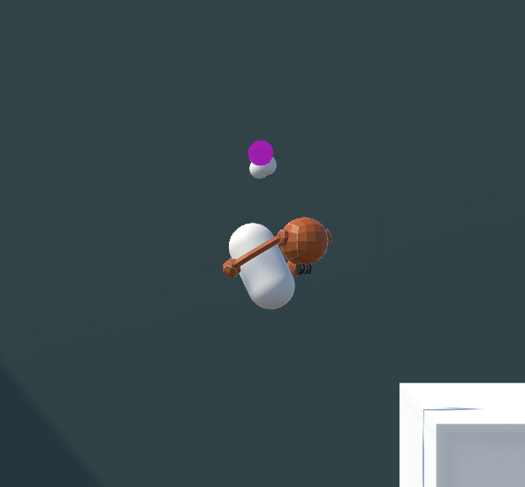
Hanging onto a pivot

Companion (Robot Child) (Progress: 0%)
- Throw Child: E (aim + throw at interactable)
- Recall Child: Q (instant recall)
- Based on what you throw Child at:
• Child Activates: trigger machines or props
• Child Draws Attention: lures people

Stealth Interaction (Progress: 0%)
- NPCs have Vision Cones
• Cross Fast = stay unseen (their cones can’t track fast speed).
• Linger = detection triggered.
- When Detected
• Special Guard spawns with stun gun.
• Guard Chases until player escapes (swing/fling to lose him).
• Escape successful = no game over, but consequences next day.

Day/Night Loop (Progress: 50%)
- Morning: NPCs leave homes, begin routines
- Evening: NPCs return home
- Return Home: enter shelter, rest
- Next Day: environment reacts:
• Doors locked
• Rerouted paths
• Bridges added/removed
• NPC suspicion increases

WINNING CONDITION
Survive for 3 days.

