**Abstract**

The goal of our project is to create a platform that will ensure a high-quality admission process to universities in Kazakhstan. It includes a university, a university faculty, a student, his points scored per ENT(math, history, logic math subject ½, ), there is also a list of those who received a grant and those who only have a discount on tuition. In terms of Erd and Database, we connected all this using primary keys and foreign keys. In general, there were exactly ten tables that are logically connected with the same primary and foreign keys. Moreover, each student has his own achievements or activity. We also created a table in which there is a ready-made list of those who entered which university. If we go through, backend and frontend we have used PHP, HTML , CSS , JAVASCRIPT languages. We persuaded all files into one folder to make easier to follow coding part. In addition, we would like to add we have chosen three based colors of our Platform OQU: white, black, dark blue.

To sum up, this project contains:

* Main page with news and information about creators
* Portfolio page for future graduates
* Application page to choose and apply
* University page with location, history of it
* Admin page to check and dispose of data

And we believe it has a good future; this is only part of the digitalization of Kazakhstan.

**Introduction**

Kazakhstan is a country located in the middle of Eurasia. A country that is in the top 9 by territory. Which has a rich past. But I think he has a lot to develop.

Of course, Kazakhstan took high positions in the list of developing countries. For example, 2012 can be referred to when Kazakhstan improved its position in the world ranking of countries that have implemented the e-government system, taking second place among developing countries. But later, Kazakhstan did not have significant developments. Of course, the government is trying to climb into the top 30 developed countries by 2050. For this, the government creates new strategies (For example: "Rouhani Zhangyru", "Strategy 2050"). But in my opinion and from personal experience I will say that we have some problems with this.

And so what am I getting at. It can be mentioned that not all places in Kazakhstan have Internet connections yet. Or as in my case it is, but it is bad. These problems stood out especially during this time. The period of COVID-19 pandemics. Because of the pandemics, all schools have moved online. And they conduct lessons on online sites such as: Bilimland, Online Mektep, IMektep, Twig - Bilim, Itest. Of course, at the moment I have already graduated from school, but I have a younger brother who studies online and often has problems. There were also problems for those who graduated from high school. Ask what? From personal experience, I will say that online platforms in Kazakhstan have problems with filing documents. In particular, I used the state site EGOV. There were a lot of crashes and confusion. Because of this, we decided to create an online platform OQU that should handle this. The OQU must conclude all university data starting from location, year of study, well-established information about each institution, and basic information about local, international students. Name, surname, age, year of birth, phone number and other successful additional data about students outside of school in the form of olympiads, competitions, as well as sports and social sections.

I think this platform has a future as a startup. And I think this will be a good example for other similar projects. However it is good alternative.

**METHODOLOGY**

Initially, when we already divided into groups, we chose the OQU theme that Askar suggested. Later, we have already begun to slowly discuss what we will have, what and where will be the main idea. Initially we came up with the university and student application and we thought a lot. It was decided that they would be "central". We have created few first pages: Main, university etc. But Aibek did not like the design, after wards he changed everything in one night ( 4 week ). Later, we started working with his idea of mind. Duman decided to work on backend because he liked mostly. Askar helped with design and focused on ERD with help of Duman. So, our work went well.

One of the problem has been we cracked our web in 8 week. We had obstacles between Database and Backend. But, we have solved it by working couple days together. Initially, our work was pretty good by timeline, and we finished everything at moment.

**Features of Project**

* Sign in
* Sign up
* Forgot password
* Sort of universities
* Details of each University
* Apply for University
* 4 Universities 4 Specialty
* 5 Subject and scores
* Achievement
* Personal page with edit data
* Admin page with conduction of information applicants

**ERD**

Our entity relationship diagram

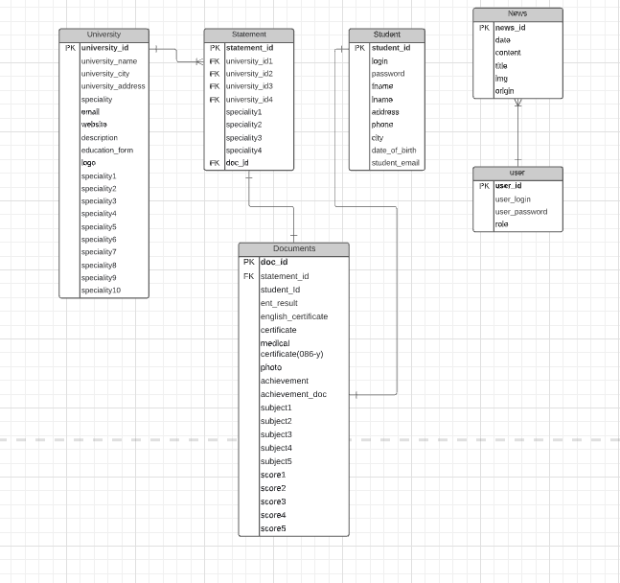

As you can see, we used Crow's foot notation.

**Case Study/Results**

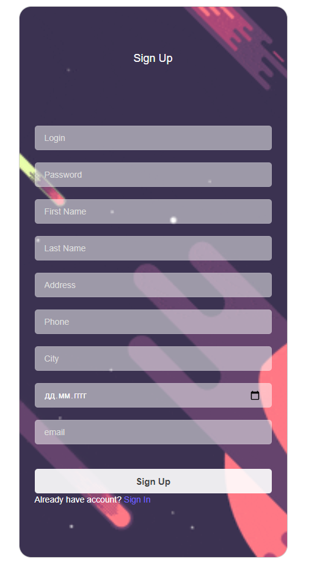

Here you can see that we have made page to Sign up to our platform, as inputting all indeed information. The all information is saved in database system, because it makes to search and edit quickly.

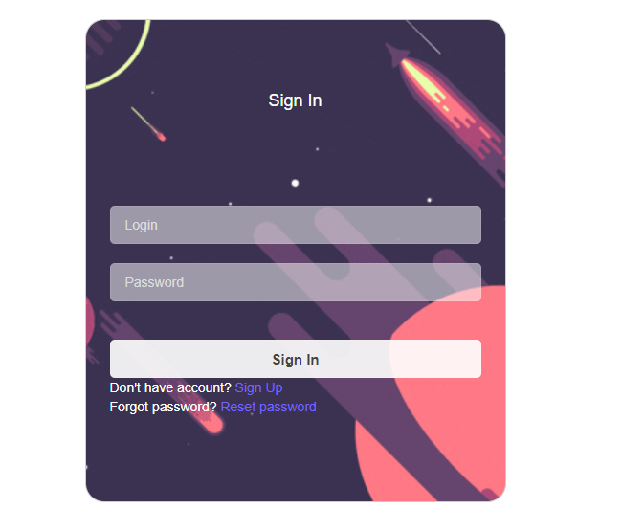

Now you can see here that Sign in page with details of Login and Password that you typed it before. In addition, it has Sign up link if you are new to our platform or, reset password if you have forgotten password to log in.

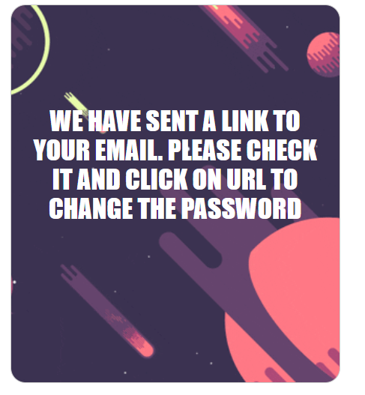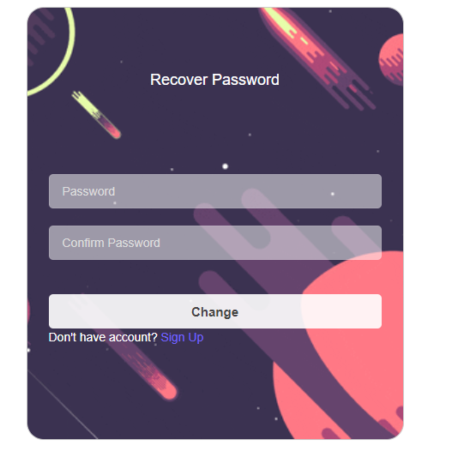



We have made forgot password feature, in the case of not remembering your password, you could easily rejoin again to Web. So, that’s why each user must use proper email account.

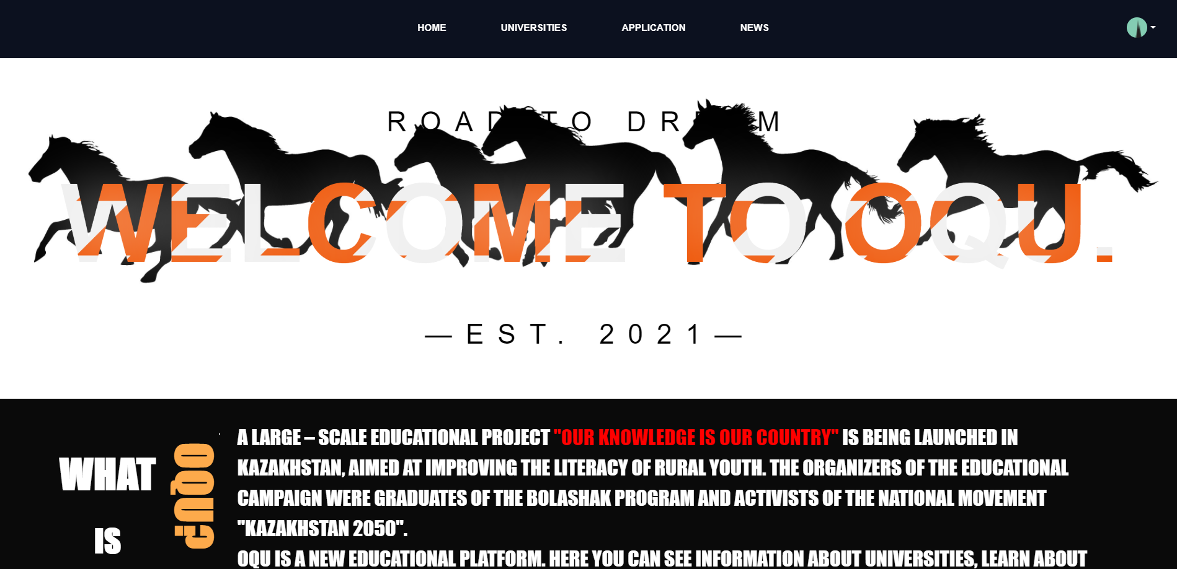

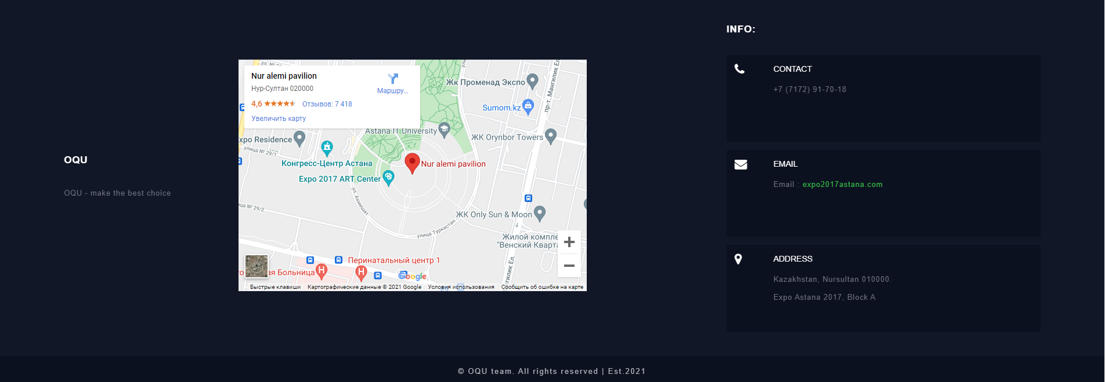

Here we indicated our main pages header and footer. Header provides link to each off other sites as: Home, University, Application, News. Also, our logo as convicting “Welcome to OQU – est 2021”. Footer presents location of out virtual office, and hot clue contacts.

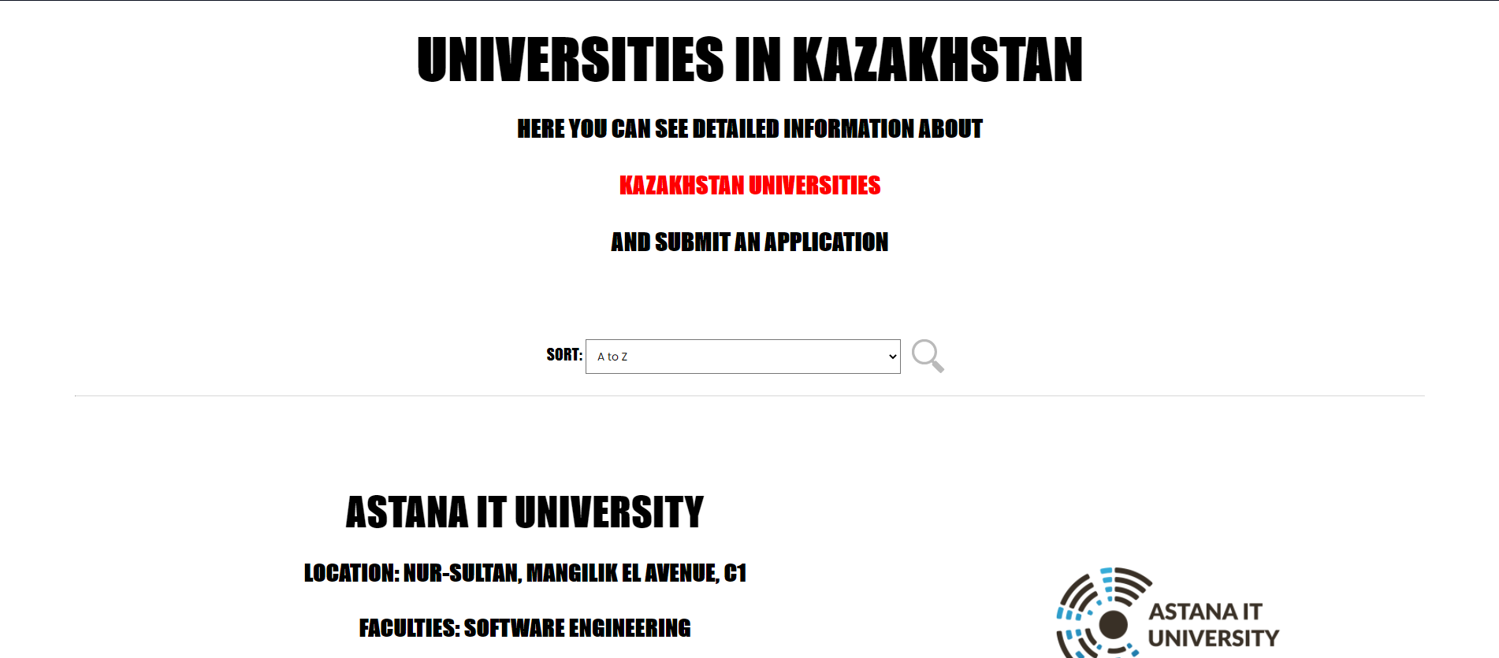

And so we come close to one of the most important moment of using sorting algorithm of universities by alphabetic order. (ex: from A to Z, from Z to A, Sorting by data) Later it shows the result that you have asked

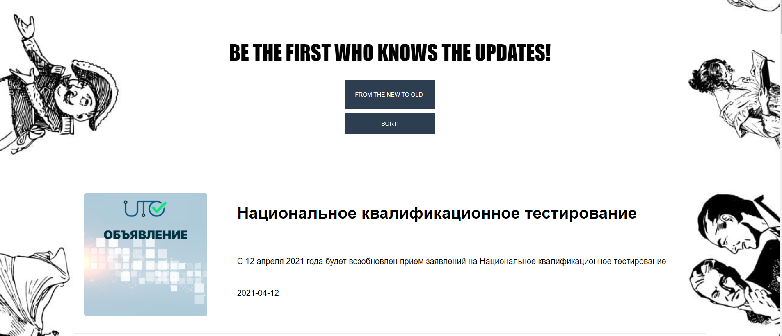

And here as you can see News page, also here you could use sorting to sort out all information. News page provides information latest news about Universities, Schools etc.

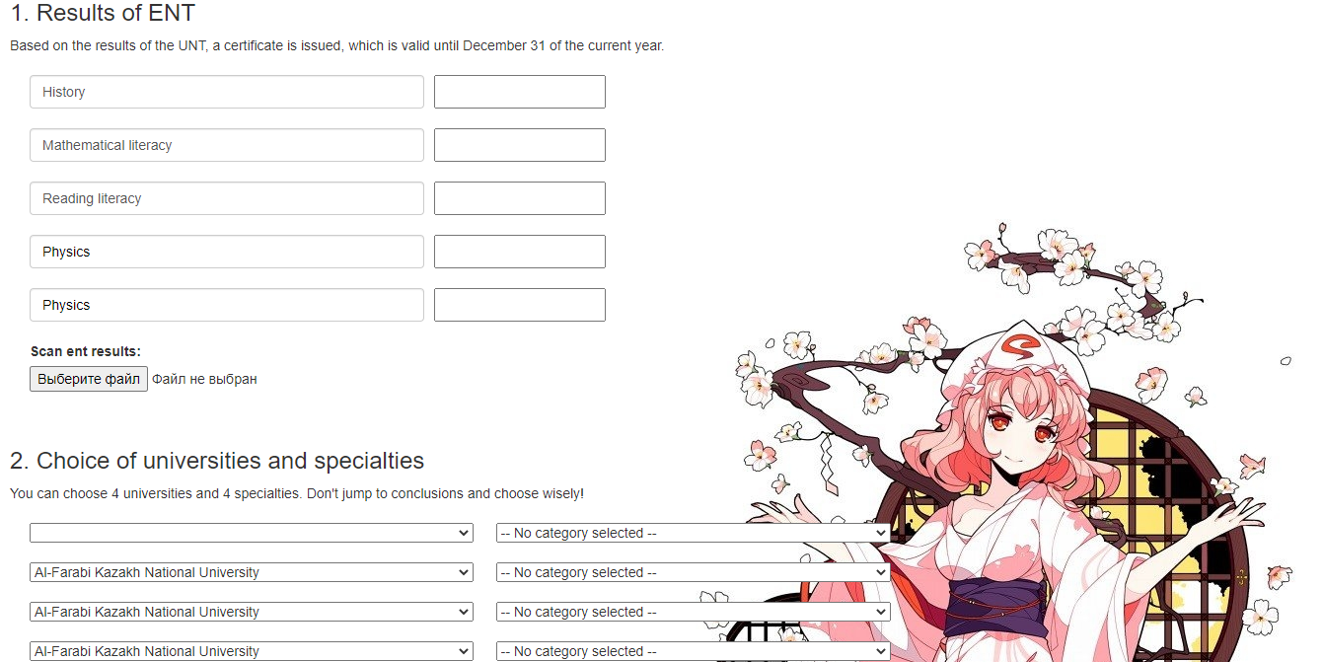 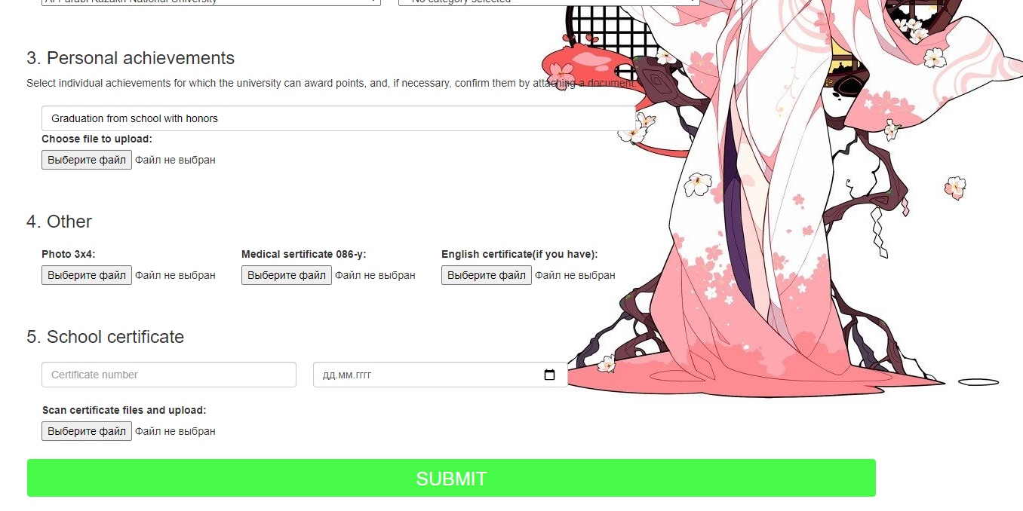

Addition, you could take look at processes of application. You could insert:

1. Results of ENT
2. Choice of University
3. Personal Achievements
4. Other documents as: 3*4 photo, IELTS certificate, 0-86 form
5. School certificate

Mostly here you can see page with university list and their facilities. Ex: Astana IT University: SE, CS, DJ, BD, MT, IA, ITM, CyberS, TS

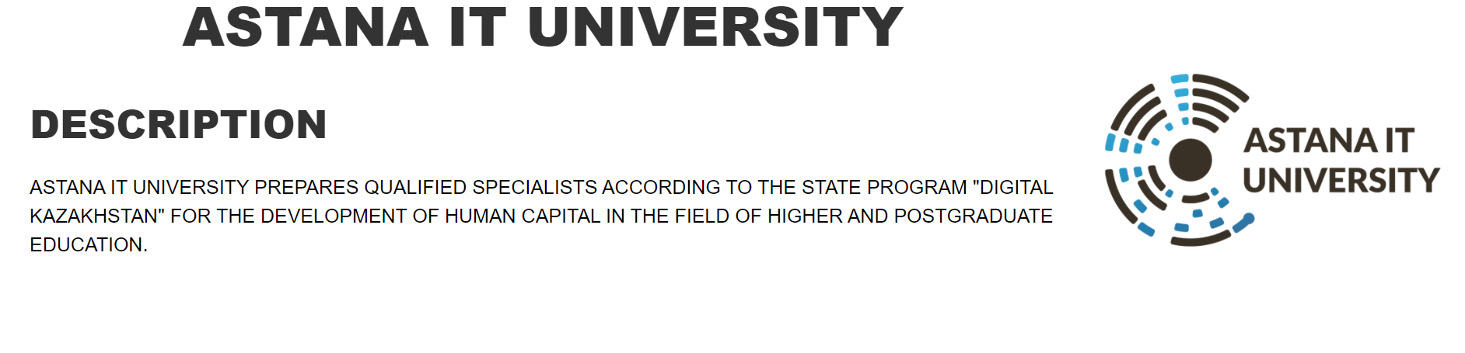

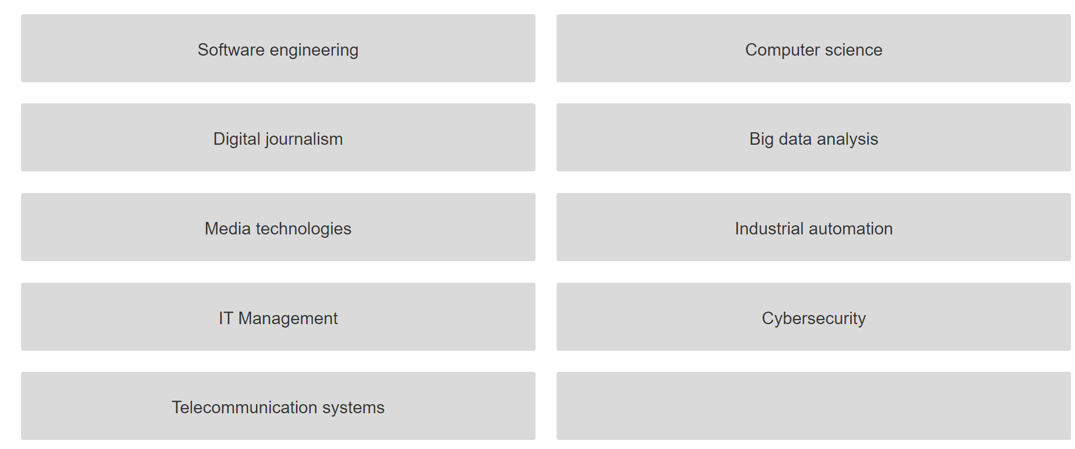

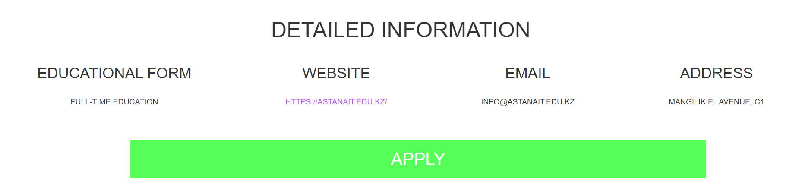

One of advantages is that portfolio page. Here you could change information about yourself in the case of mistaken data. Also, we have added to recon duct your documents. Something to add is that, it has been showing “In progress” whenever you fill each gap, and click submit. Later it is going to show “Accepted”

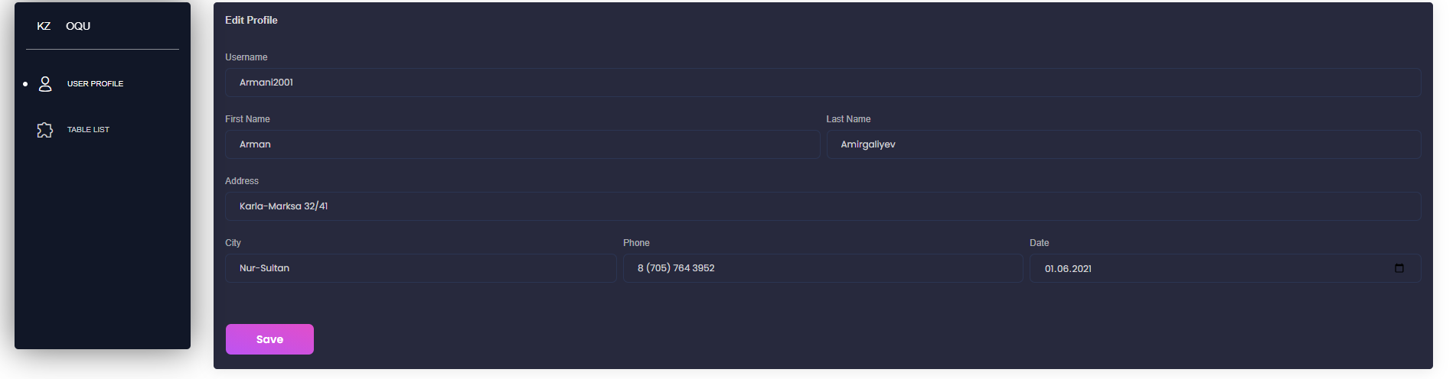

This page based for admin. They have access to take look at information of each student and their documents. After admission committee decides to accept this students via scholarship from Kazakhstan Education State.

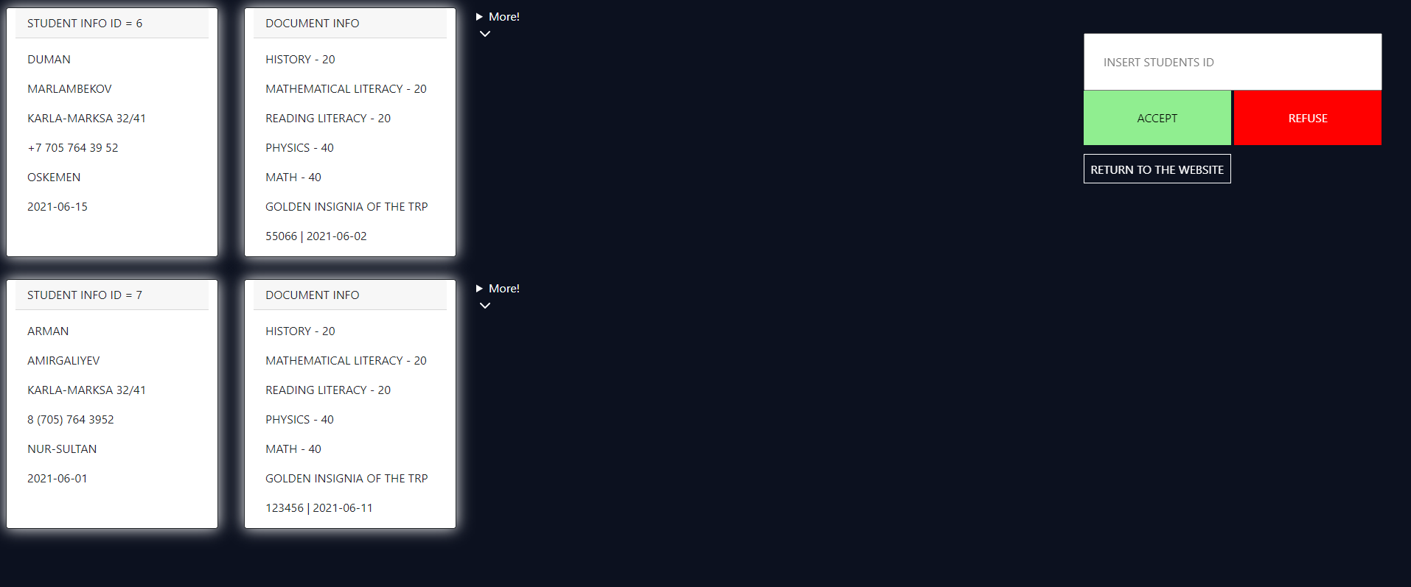

**Feedback from us:**

Aibek: “Actions speak louder than words, and your constant enthusiastic presence breathes life into this organization every day”.

Duman: “It was great working on the project, but of course there were a few sleepless nights and nerves. But I think the project is very good in terms of it has no competition. But I think that we need to work more on it and bring it to the ideal that it would work without flaws.”

Askar: “Ye, I hope we did our best. I remember some nights going through discord as interrupting between each other. These have been good days. ”

**Conclusion**

In conclusion, we want to say that we have achieved what we wanted within 10 weeks. Of course, we may have some mistakes, but we will try to fix them. We think that we will improve this project. As we said before, it has great potential.

We truly confident that in 10 week our team build up and showed best skills. One of the main advantage of is that we OQU connected great relationship between our team.

OQU online platform is able to provide comfort for future graduates and digitalization. In near future we would like to create App for platform, Telegram bot etc. We must make this idea reachable for each of application.   
We hope that Kazakhstan will move forward in the idea of IT as teams as we make some good startups.