DeepQuery: Content based Video Retrieval

Ratin Kumar
Department of Computer Engineering
National Institute of Technology, Kurukshetra
ratin_11822004@nitkkr.ac.in

Abstract
Digital media, comprised largely of images and videos, has been on the rise in the past decade. Due to its ease of access and efficiency in spreading information, Pixels now have become the currency used by most information transaction on the Internet.
We present DeepQuery a object detection based deep learning model which leverages the scenes from video clips to generate fixed sized vectors for videos. **These fixed sized vectors are used to retrieve videos from clips**. It offers a solution to efficient solution which balances the precision/accuracy with processing computation.
On UFC101 generates competitive performance in terms of run-time and accuracy. To validate our approach in a “wild” environment, we also test our algorithm on two datasets, MovieClips and subset of YouTube-8M dataset. We also show that benefits of using our `algorithm` in a constraint (videos). Code is available at: https://github.com//dumbmachine/deepquery (Will be made public before the release of the paper)

Keywords: Content-based video retrieval, Video Database, object detection, approximate nearest neighbour search.

Introduction
Video search is a very challenging problem which not only requires alot of processing but storage as well. Internet has seen the sites like Google Images and Tineye which provide the facility to reverse image search, such facilities for reverse searching videos using small clips or even images are yet to see the sunshine. Large amount of information is stored in video files as multiple image frames. Thousands of hours of video data are uploaded to the internet every minute !(I think that the previous line can be phrased better).
The problem of video retrieval using media can be divided into two smaller tasks; conversion of video into fixed sized vectors and searching for simlarity between the query clips and the clips in the database.
Recently, deep CNN has been successfully applied on many vision tasks, such as image classification (Krizhevsky, Sutskever, and Hinton 2012) and image segmentation (Sharma, Tuzel, and Jacobs 2015), which shows the powerful ability of deep CNN for describing complex non-linear mappings and learning rich mid-level representations. The CNN features learned from data are discriminative, but still high dimensional for the retrieval task. . In retrieval tasks, the hashing-based methods which project high dimensional features to a low dimensional space are often used (Liu et al. 2012; Li et al. 2015b), but feature extraction and hash function learning in these methods are independent, in other words, the extracted features may not be compatible with the hash coding process. Some models use an end-to-end system for mixing the feature generation and its appropriate hash generation (Dong, Jia, Wu and Pei 2016).
Many algorithms exist for exact video retrieval (Large-Scale Video Hashing via Structure Learning) (Robust Video Hashing via Multilinear Subspace Projections) which take a route very similar to that are used by image retrieval, wherein the a hash is generated for each video in the database. Then hamming distance is used as the measure of similarity between the hashes.
However, most current works in scalable visual search focus on image-based retrieval [6]–[14] or text-image/image-text retrieval [15]–[19]. To our best knowledge, no frameworks exist which provide a video-video retrieval.
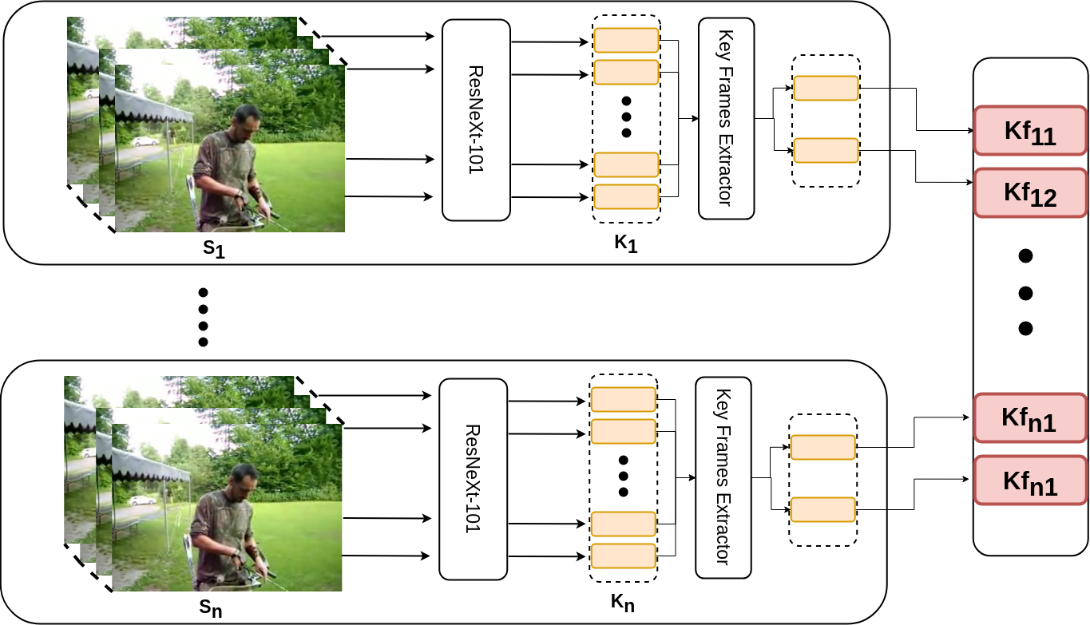
Fig. 1. Illustration of the proposed framework for converting video into a fixed sized vector. The input video clip in divided into segments, each of size equal to its frames per second equivalent. Each segment is fed into an object detector. Frame features obtained object detector are fed into the clustering algorithm which returns the features from the most distinct frames.

We present a novel scalable solution for Content Based Video Retrieval, which uses the object location information of the video frames to extract key frames from the videos and generate fixed sized vector representation of video clips to allow to fast and efficient searching.
An object detection model is used to obtain inference of each frame. The inference information is used to cluster the individual frames obtaining key frame representations of each scene of video. We define a "scene" as set of frames in video wherein the total change in information, prominently the objects, their location and background , is minimal. This helps use to remove redundant frames while making sure unique frame informations are not lost.
Our proposed solution is highly scalable, the inference of video frames can easily be run on multiple gpus and the algorithm used for clustering of video frames is also highly parallelized. This system makes use of the resources available to it efficiently. Bucket-like searching using approximate nearest neighbour search allows the framework to search fast.

Related Works
In this section, we briefly review realted topics: 1) feature comparison based searching 2) video hashing.+

categorize the papers and give example and reference for each one of them`

Proposed Approach

In this section, we formulate the proposed DeepQuery framework (Fig. 1). Notations and problem
definition that will be used in the rest of the paper will be
introduced first. Then we will present two major components of our novel framework, Key Frame Extraction and Bucket-like approximate nearest neighbor search.

Notation and Problem Definition
Given a video V = {s₁, s₂, … s_{n}} ∈ R having Fr number of frames and its fps as Fp, where s_{i} refers to the i^{th} segment of the video, and n is the number of segment with n = Fr / Fp.
Each frames in segment s_{i} in V, s_{k} = {f_{1k}, f_{2k}, … f_{mk}} with 1<m<Fp, are denoted by f_{jk}, where j is the index of the frame in the segment and k is the index of the segment in the video V. Each frame f_{jk} comprises of objects that can be identified by the object detector used : f_{jk} = {o_{1k}, o_{2k}, … o_{mk}} !(objects information needs a check here). N denotes the number of videos in the dataset.

Object Detection
Will talk about the choice of object detection here. The importance of using a very accurate Object detection algorithm. Ending with a note that using a highly specialized object detector to only detect a few classes will reduce the scope of the framework but will make the accuracy of this framework go through the roof.

This section describes the importance of choosing the correct Object detector for the pipeline.

The object detector plays a very important role in the pipeline and thus the correct choice of object detector is important?. Accuracy and inference time are two major factors when considering object detectors. If the detector is unable to detect the objects in the image, this leads to loss in information for the vector representation. But highly accurate object detector suffers from very high inference times leading to increase in the time required to build data for indexing and also increases the search time.

Thus SSD: Single Shot MultiBix Detector [here](https://arxiv.org/pdf/1512.02325.pdf) was chosen as the detector. Most object detectors have approaches similar to: hypothize the bounding boxes, resample pixels or features for each box, and apply a high-quality classifier. `reference for R-CNN.` or approach similar to: dividing the image into regions and predicts bounding boxes and probabilities for each region. `refrence to yolo`.While accurate, these approaches have been too computational intensive for embedded systems and, even with high-end hardware, too slow for real-time applications. The impact of inference time has a drastic impact on the usability of this system.

Thus SSD: Single Shot MultiBox Detector was chosen as the detector of choice. `reference SSD`. The fundamental improvement in speed comes from eliminating bounding box proposals and the subsequent pixels or features resampling stage. Usage of small convolutional filter to predict object categories and offsets in bounding boxes proposals, using separate predictors for different aspect ratio detectors, and applying these filters to multiple feature maps from the later stages of a network in order to perform detection at multiple scales.

Using an object detector with focus on inference time reduces the total number of indexable frames since the ability for a frame to be indexable depends on whether the object from the frame where detected or not.

`fGive example of images where side shots of the object are not tagged human or something`

To overcome such cases, we augmented the training dataset with additional data of common object, from daily life, from different angles. This helped increase the indexable `from this number to this number.`
`difference between coco and specially trained model, accuracy and total indexable frames`
`Give speed differences, seraching and indexing dataset difference for each of the objects detectors (Fast-RCNN, SSD, YoloV3)`

Key Frame Extraction
Once object location information is obtained from the object detector, the next step is to extract the key frames to get rid of the redundant frames allowing for faster searching and better space optimization. Lets consider the object location information from the first segment of the video s₁. Segment has frames: S₁ = {f₁, f₁ … f_{Fp}} with each frame f_{i} having its detected objects: f_{i} = {O₁, O₁ … O_{x}} where 0≤x≤∞

Will mention the algorithm here.

1
In this section, we first present the basic idea and pipeline of this algorithm. Then the different elements of this cbvr system, object detector, k means-based frame object clustering and finally a fast searching method, are explained with further details.

1. Pipeline:

The pipeline begins with a video. A object detector is used to get the information of objects from each frame in the video. The required information for each object are:

The video is divided into segments or shorter clips, wherein each clip would give a certain threshold number of frames. The frames would be the key frames from that segment of the video. The key frame(s) from each segment would then be combined to obtain the shorter video representation of the original clip. It was observed for most videos the best segmentation strategy is to divide the video is buckets of bucket size as the fps of the video.

`Give maths here.`

The object information from frames is used to determine the appropriate cluster for each frame in the image. The algorithm used for clustering is defined in details `mention section number here`. Videos `of one kind, ask ihab` have utmost 4 scene changes, here by scene changes we refer to change in the overall representation of frame where objects and their background are of utmost importance. Thus 4 cluster are chosen for clustering the frames of each segment. All the segment return 4 frames each. This shorter representation of the video is then indexed into a database. The objects and their respective location from each frame along with its background histogram are used in indexing.

Video frames may have different number of object in them, this results in each frame's vector representation having a different dimension, with a successive difference of 6. This serves as a very important part of the search algorithm as it isolates the vector with appropriate dimensions in-turn reducing the total search computations. For further information about the searching refer to section `section number `.

A. Object Detection / Feature Extraction

B. Frame Clustering

We use a K-Means algorithm for clustering the video frames into unique clusters. The features used for clustering are the

`table of that thing`

confidence score, bounding boxes and category of each object in the video frame. The frames in one segment of video are clustered on the basis of the respective objects. Among the frames f~i~ in segment s~i~ , the highest number of objects are noted. Let this number be denoted by O~max~ and the video frame by f~max~ . Frames in S~i~ can have utmost O~max~ in any order. All the features of objects O~j~ , where j E {0..len(O~max~)}, is the j^th^ object in frame F~i~ , are then clustered using K-Means algorithm into `4` clusters. The number of clusters can be changed to increase the accuracy by trying to store as many distinct frames from the segment as possible, though increasing the number of frames per segment has drastic effects on the retrieval times

ALOGRITHM

Experiments
To evaluate the effectiveness of our proposed system for scalable content based video retrieval, we conducted experiments on 3 video datasets. Namely the UCF101, HDF51 and a custom `Rick and Morty dataset`. The details of the experiments and the results are descrived in the following sections.

A. Datasets and Experiments Settings

B. Pretraining:

: The normal ImageNet Pretraining and the second specific pretraining

Evaluations and Settings
We follow the evaluation protocols used in [21] and adopt the following two criteria: (1) Hamming ranking: All the video clips are ranked according to their Hamming distance to the query video. (2) Hash lookup: A hash lookup table is constructed and all the samples fall within a Hamming ball with radius r (r = 2 in our setting) to the query sample are returned. Since each query video is represented as a set of binary codes corresponding to the frames in the video, here we adopt the following query strategy to return the nearest neighbor (NN) video clips. For Hamming ranking based evaluation, it is fairly straightforward to return the nearest video clips by exhaustively computing and ranking the video Hamming distance between the query and the database samples, as defined in Eq. (3). For hash lookup based evaluation, we first retrieve the nearest neighbor frames within Hamming radius 2 for each individual hash code vector of the query video frames. Then all the videos whose composite frames are successfully hit by any query frame will be regarded as the candidate NN videos. An intuitive way to rank all these candidate NN videos is by counting the hit frequency of each video (normalized by the number of total frames in that video). Note that these two evaluations focus on different aspects of hashing techniques.

UCF101 Dataset
Bla Bla

MovieClips
Bla Bla about omvie clips

