Computer Organization  
Lab Assignment

# Assignment 3

Name: Beeta Samad  
Roll Number: 181210016

1.Write‌ ‌a‌ ‌program‌ ‌to‌ ‌print‌ ‌the‌ ‌sum‌ ‌of‌ ‌first‌ ‌n‌ ‌natural‌ ‌numbers. ‌

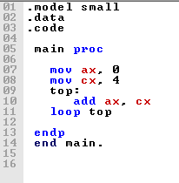

2.Write‌ ‌a‌ ‌program‌ ‌to‌ ‌print‌ ‌“‌ ‌Hello‌ ‌World”‌

