Computer Organization  
Lab Assignment

# Assignment 4

Name: Beeta Samad  
Roll Number: 181210016

1.‌ ‌Write‌ ‌a‌ ‌program‌ ‌to‌ ‌check‌ ‌whether‌ ‌input‌ ‌string‌ ‌is‌ ‌palindrome‌ ‌or‌ ‌not. ‌

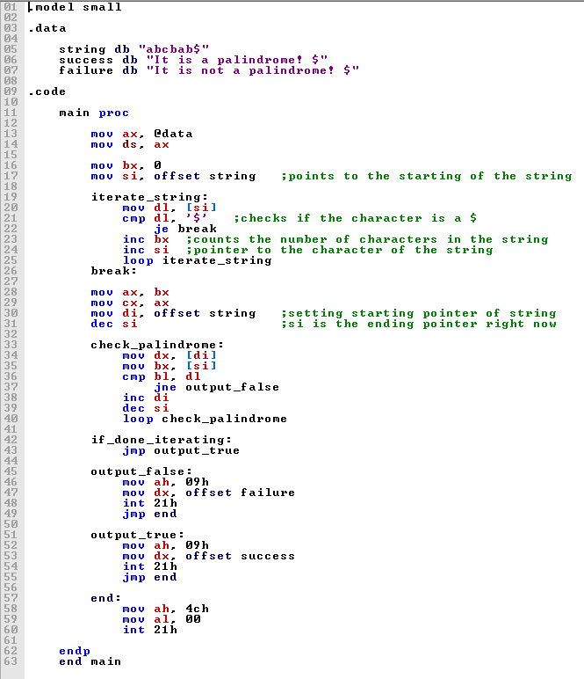

2.‌ ‌Write‌ ‌a‌ ‌program‌ ‌to‌ ‌check‌ ‌ “Number‌ ‌is‌ ‌palindrome‌ ‌or‌ ‌not”. ‌ ‌

