Computer Organization  
Lab Assignment

# Assignment 5

Name: Beeta Samad  
Roll Number: 181210016

1.Write‌ ‌a‌ ‌program‌ ‌to‌ ‌implement‌ ‌x‌ ‌=‌ ‌y+4. ‌

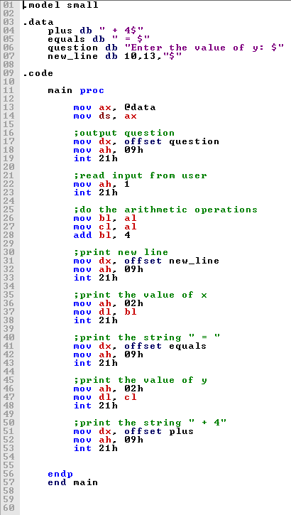

2.Write‌ ‌a‌ ‌program‌ ‌to‌ ‌check‌ ‌whether‌ ‌a‌ ‌number‌ ‌is‌ ‌prime‌ ‌or‌ ‌not. ‌

