Computer Organization  
Lab Assignment

# Assignment 6

Name: Beeta Samad  
Roll Number: 181210016

1.An‌ ‌Assembly‌ ‌language‌ ‌program‌ ‌that‌ ‌converts‌ ‌an‌ ‌ASCII‌ ‌string‌ ‌containing‌ ‌decimal‌ ‌digits‌ ‌into‌ ‌equivalent‌ ‌binary‌ ‌number. ‌

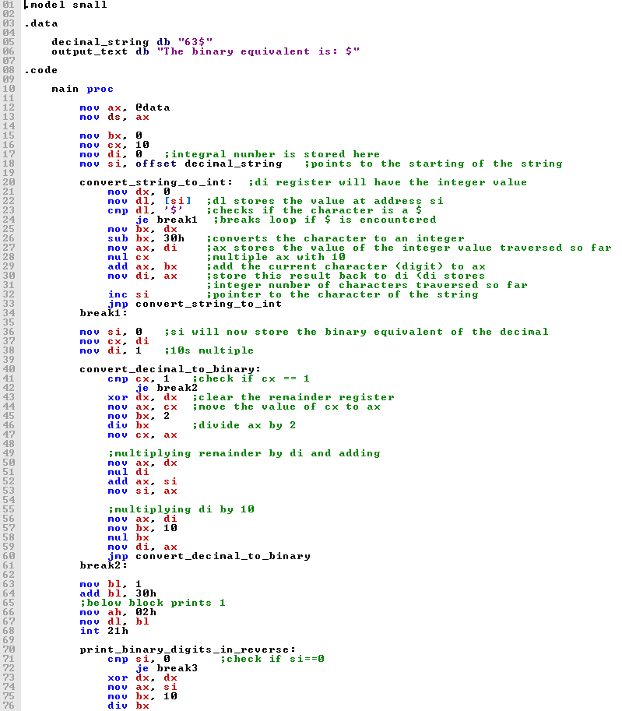

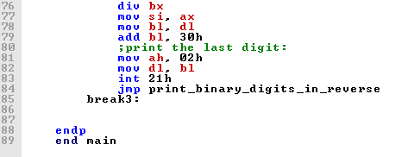

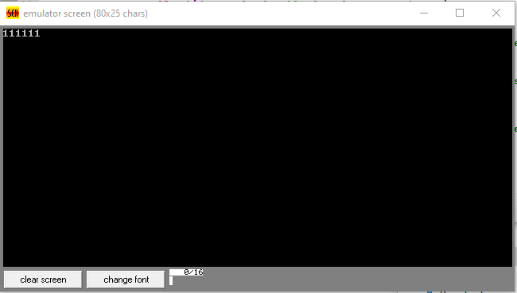

2.Write‌ ‌a‌ ‌program‌ ‌to‌ ‌add‌ ‌three‌ ‌numbers

