Computer Organization  
Lab Assignment

# Assignment 7

Name: Beeta Samad  
Roll Number: 181210016

1. Write‌ ‌a‌ ‌program‌ ‌to‌ ‌print‌ ‌Fibonacci‌ ‌series. ‌ ‌

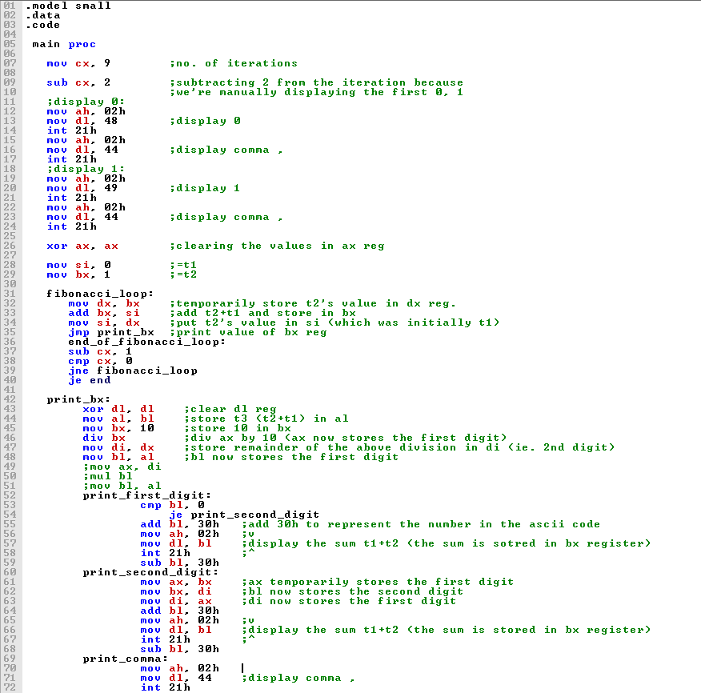

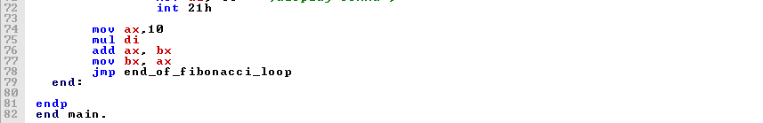

Output:

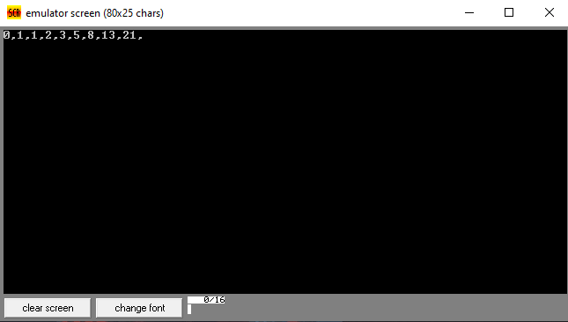

2.Write‌ ‌a‌ ‌program‌ ‌to‌ ‌print‌ ‌multiples‌ ‌of‌ ‌4‌ ‌and‌ ‌7