

EPL 2009-2019
  - Players’ value

KELVIN LEE KAY HENG | ST3189 MACHINE LEARNING | 02/03/2025

Contents
1. Unsupervised Learning 3
1.1 Problem Statement 3
1.2 Data Description 3
1.3 Models 4
1.3.1 Principal Component Analysis (PCA) 4
1.3.2 K-Means Clustering 5
1.3.3 Hierarchical Agglomerative Clustering (HAC) 6
1.4 Model Evaluation 7
1.5 Recommendation 7
2. Supervised Learning (Classification) 7
2.1 Problem Statement 7
2.2 Dataset Description 7
2.3 Evaluation Metrics 8
2.4 Models 8
2.4.1 Logistic Regression 8
2.4.2 Support Vector Classification (SVC) 9
2.4.3 Random Forest 9
2.5 Model Evaluation 9
2.6 Recommendations 10
3. Supervised Learning (Regression) 10
3.1 Problem Statement 10
3.2 Data Description 10
3.3 Evaluation Metrics 11
3.4 Models 11
3.4.1 Linear Regression (Base and Polynomial) 11
3.4.2 Regularization Regression (Lasso and Ridge) 11
3.4.3 Random Forest 12
3.5 Model Evaluation 12
3.6 Recommendation 12
4. References 12
5. Appendix 13
5.1 Appendix A 13
5.2 Appendix B 14
5.3 Appendix C 14
5.4 Appendix D 14
5.5 Appendix E 16
5.6 Appendix F 16

Unsupervised Learning

Problem Statement
In every English Premier League (EPL) season, teams will alternate between playing on their home and away ground. With teams adapting their tactics and playstyles in pursuit for the top English division title or avoiding relegation to second tier, it is challenging to classify these evolving playstyles. By analyzing this 10-year EPL dataset, our objective is to cluster home teams into at least 3 different playstyles based on their underlying statistics. Additionally, we aim to identify if teams playing at home will be offensive.

Data Description
This 10-year EPL data set consists of 3800 rows and 23 columns with numerical and categorical variables with the list of variables and their data types can be found in Appendix A. Since our target is to cluster home team playstyle, all features relating to away teams were removed. ‘Div’ is also removed as it does not provide any meaningful interpretation while ‘Date’ has been shortened to ‘Year’.
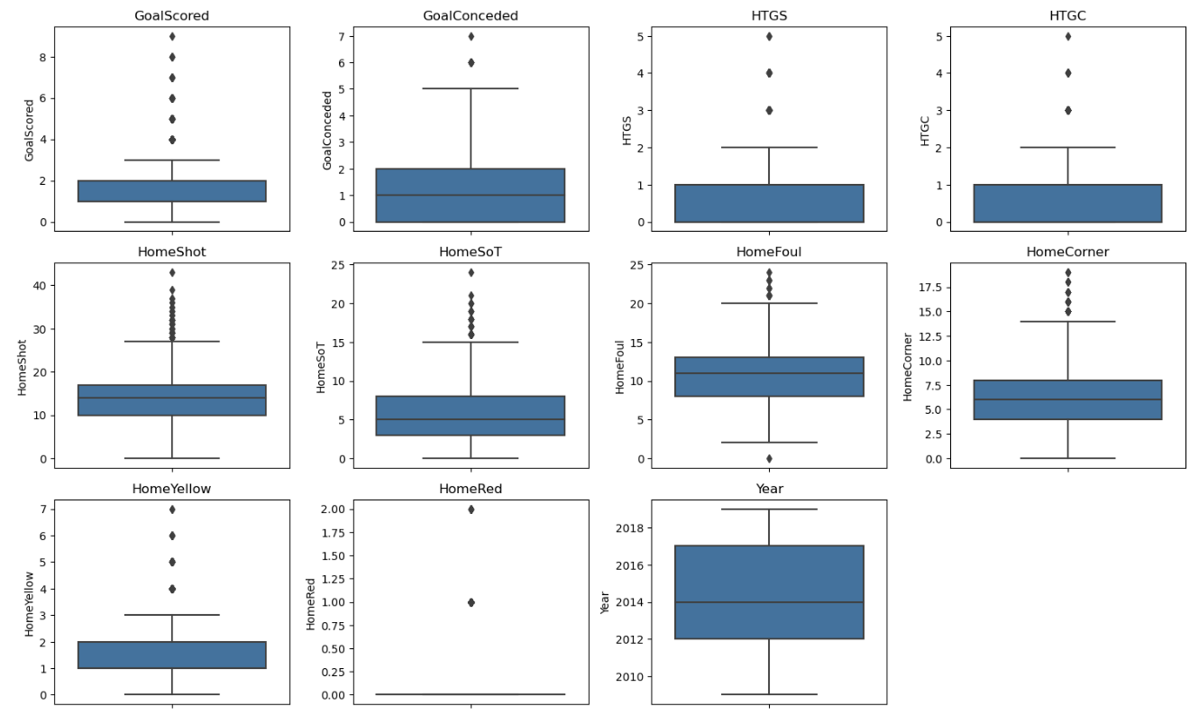
Figure 1.1 Box Plot of Features
Figure 1.1 shows the boxplot of the numerical features where some features have obvious outliers which will affect our model. These outliers will be removed to enhance our model performance. More explanation and the cleaned dataset can be found in Appendix A.
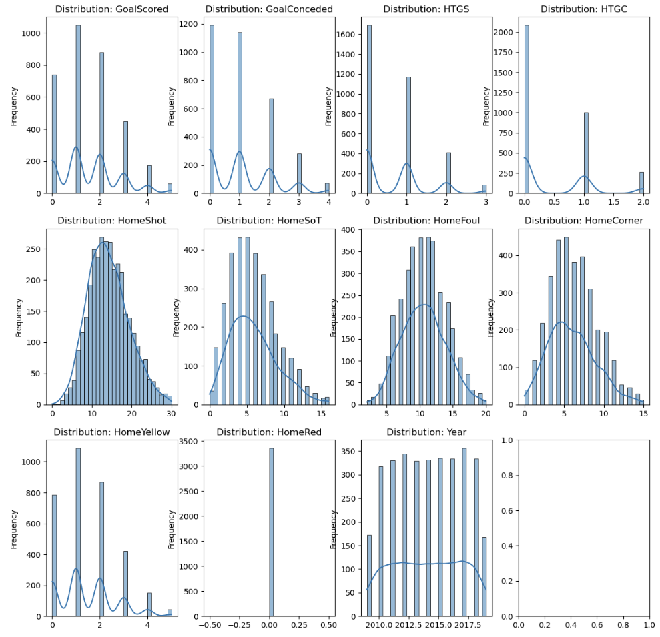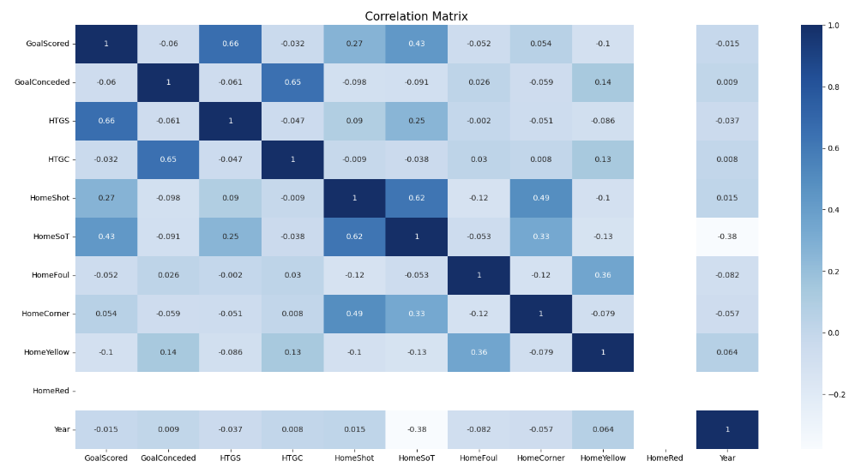
Figure 1.2 Distribution Plot Figure 1.3 Correlation Matrix
Figure 1.2 shows the distributional characteristics of each numerical feature and most of the features have right-skewed distribution.
Figure 1.3 shows the correlation matrix of all the home team features. ‘GoalScored’ (Number of goals scored) will be our target feature in determining the team playstyle. From the correlation matrix, ‘HTGS’ (Number of goals scored by half time), ‘HomeSoT’ (Number of shots on target), ‘HomeShot’ (Number of shots) has the highest positive correlation with ‘GoalScored’. Conversely, ‘HomeYellow’ (Number of yellow cards) and ‘GoalsConceded’ (Number of goals conceded) have the highest negative correlation.
Since ‘HomeRed’ (Number of red cards) has no correlation with other features, we will remove it from our dataset. Using both figures and our domain knowledge, the remaining features will be selected to perform our unsupervised learning models. Additionally, “GoalScored” will be compared to ‘HomeSoT’, ‘HomeShot’ and ‘GoalConceded’ based on their absolute correlation score, a comparison will be on Appendix B.

Models

Principal Component Analysis (PCA)
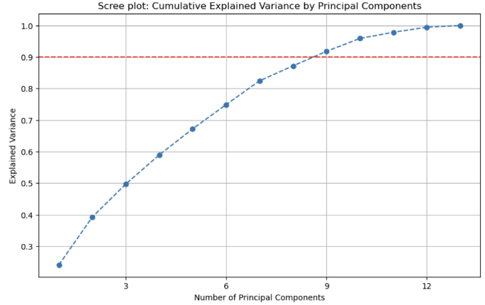
PCA is a linear dimensionality reduction technique where the data is transformed to capture the most variation in data.
From figure 1.4, we have chosen 9 Principal Component (PC) covering 95.88% of the total variance, effectively reducing the number of dimensions. The exact values of the variance can be found in Appendix C.
Figure 1.4 Scree Plot: Explained Variance

K-Means Clustering
K-Means clustering is a centroid based algorithm to calculate the distances to assign a point to its cluster with the goal of minimizing the Sum of Squared Distances (SSD) between each data point and the closest centroid. (Sharma, P, 2023)
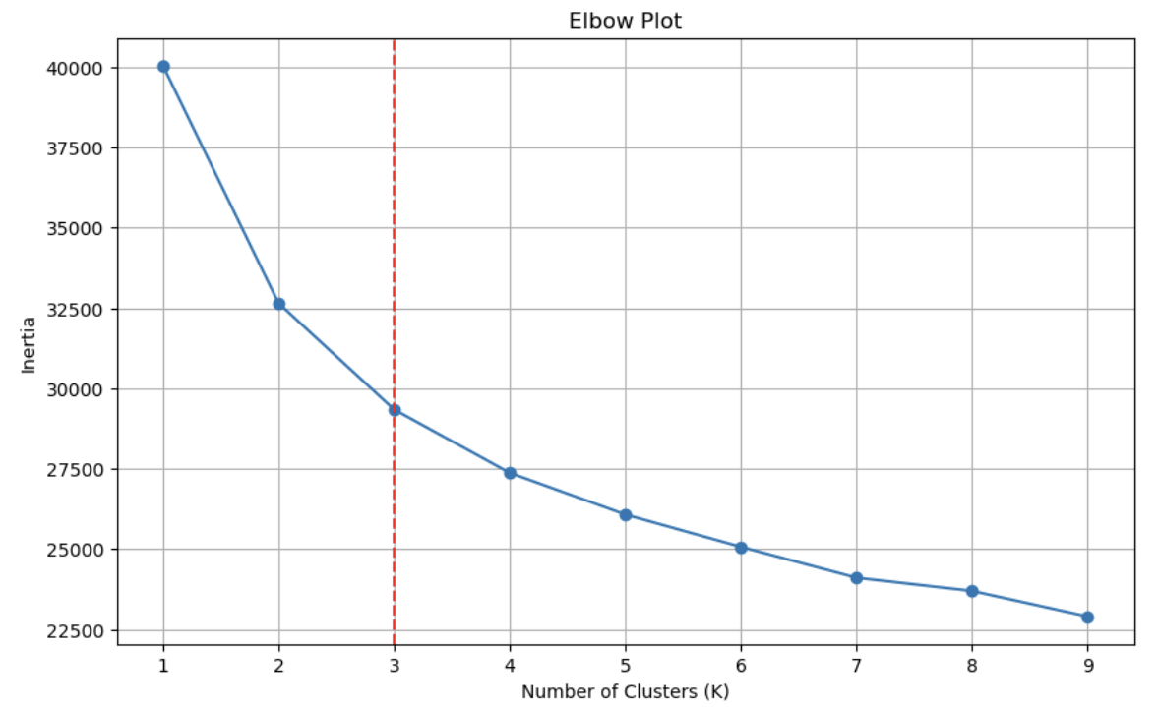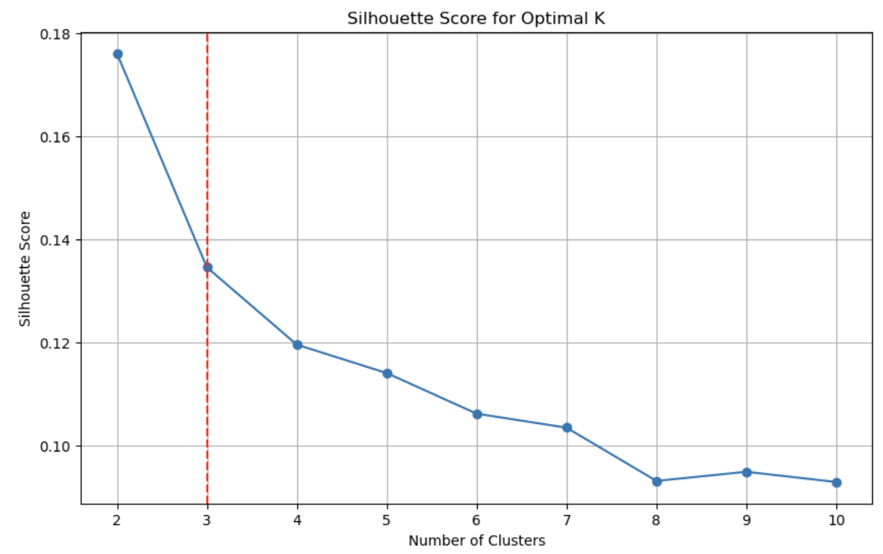
Figure 1.5 Elbow Plot Figure 1.6 K-Means Silhouette Score
Figure 1.5 shows the inertia (SSD) compared to the number of clusters. Using the elbow method, the optimal K value observed is 3 before the inertia declines gradually. Additionally, figure 1.6 supports our optimal cluster by having the highest silhouette score with at least 3 clusters.
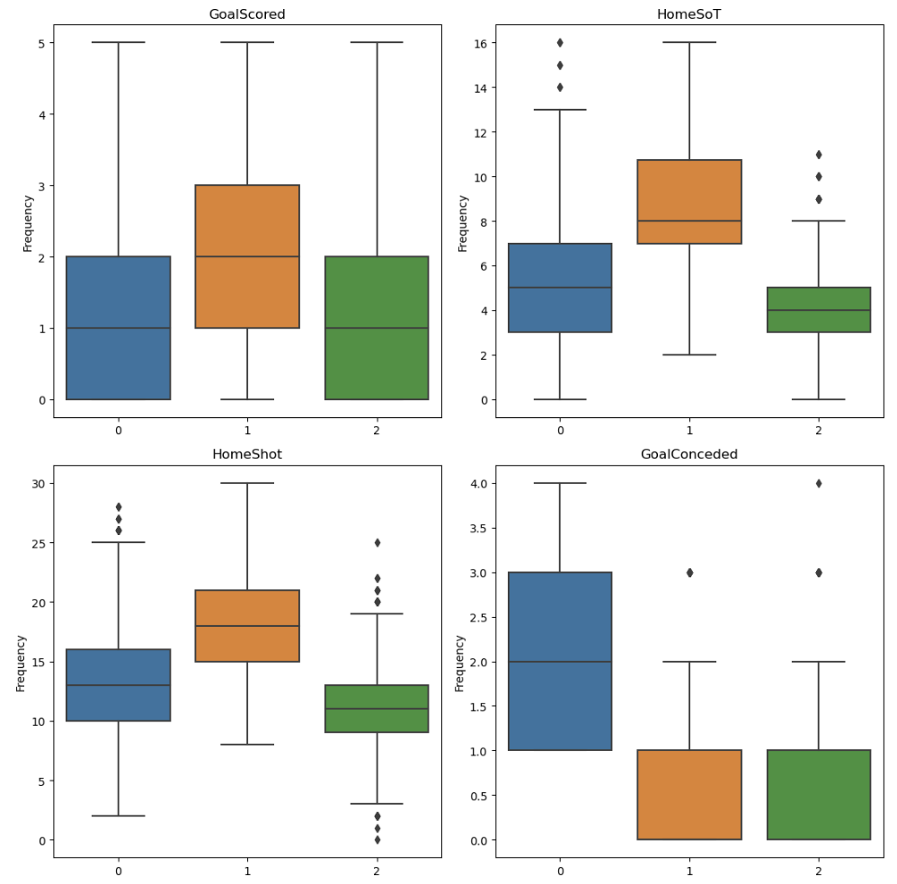 Figure 1.7 K-means Variables vs Clusters
Figure 1.7 indicates the cluster analysis of the correlation between ‘GoalScored’ and the above mentioned features (‘HomeSoT’, ‘HomeShot’, ‘GoalConceded’). We can perceive that cluster 1 is the highest for all features except ‘GoalConceded’ and cluster 2 is the lowest for all. Based on these findings, I would conclude that cluster 1 represents attacking teams, cluster 2 as defending team while cluster 0 as balanced team.

Hierarchical Agglomerative Clustering (HAC)
Hierarchical Clustering is a distance-based algorithm using a dendrogram to show how data points are grouped. By assigning data points into a cluster based on closest pair until a single cluster is left.
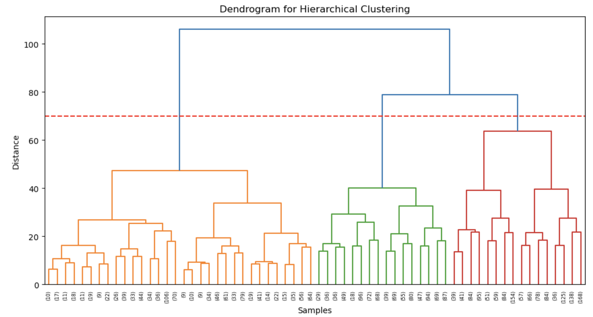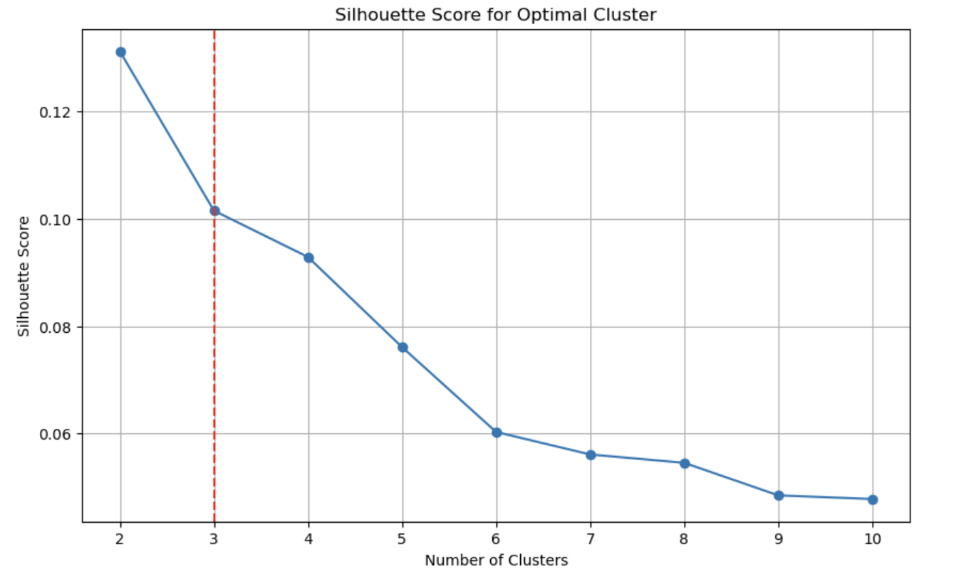
Fig 1.8 HAC Figure 1.9 HAC Silhouette Score
From figure 1.8, having the threshold set at 70, we will have the same number of clusters as K-means which is 3 clusters. Additionally, figure 1.9 supports our optimal cluster by having the highest silhouette score with at least 3 clusters as well.
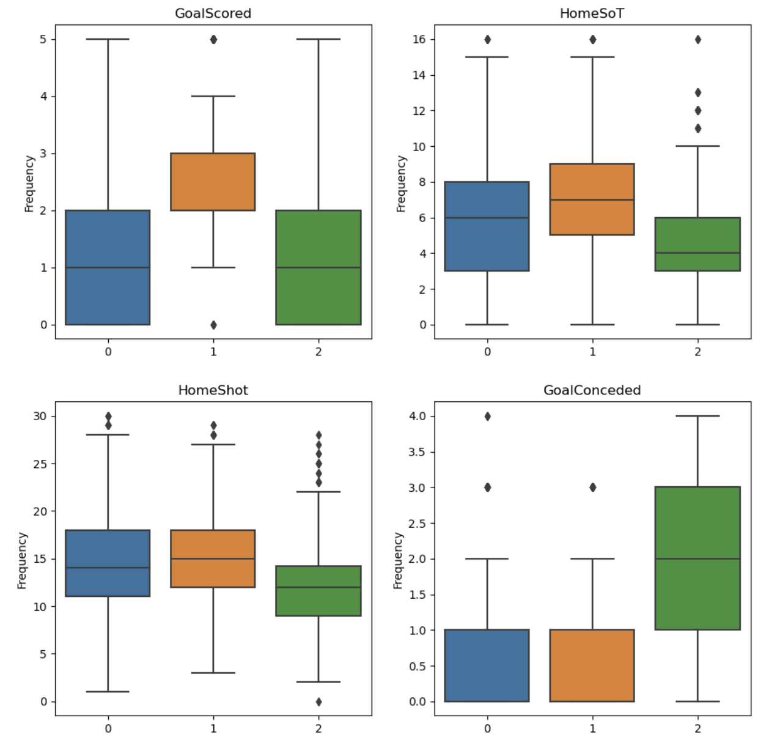
Figure 1.10 HAC Variables vs Clusters
Similarly to figure 1.6, cluster 1 represents attacking team with ‘GoalScored’, ‘HomeSoT’ and ‘HomeShot’ the highest and ‘GoalConceded’ the lowest. However, compared to K-means, cluster 2 has the highest ‘GoalConceded’. We will still classified cluster 2 as defensive team as the remaining features are still the lowest. Cluster 0 will be the balanced team.

Model Evaluation
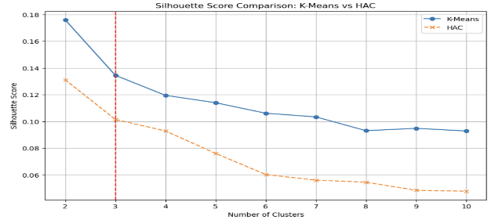
Silhouette scores are used to evaluate clustering results with the higher score (coefficient) being a better model. (Gultekin, H, 2023) Figure 1.11 compares both models’ silhouette score and concludes that K-means is a better model as its score is higher than HAC.
Figure 1.11 Silhouette Scores of both Models

Recommendation
We can conclude that all home teams in EPL fall into 3 different clusters such as attacking, defensive or balanced playstyle based on the models performed.
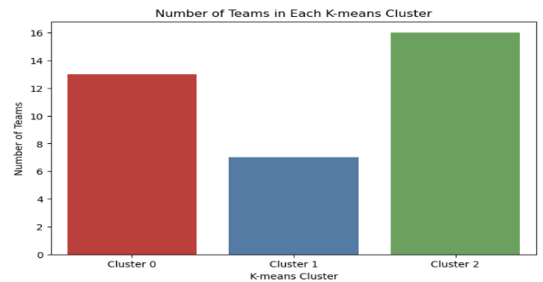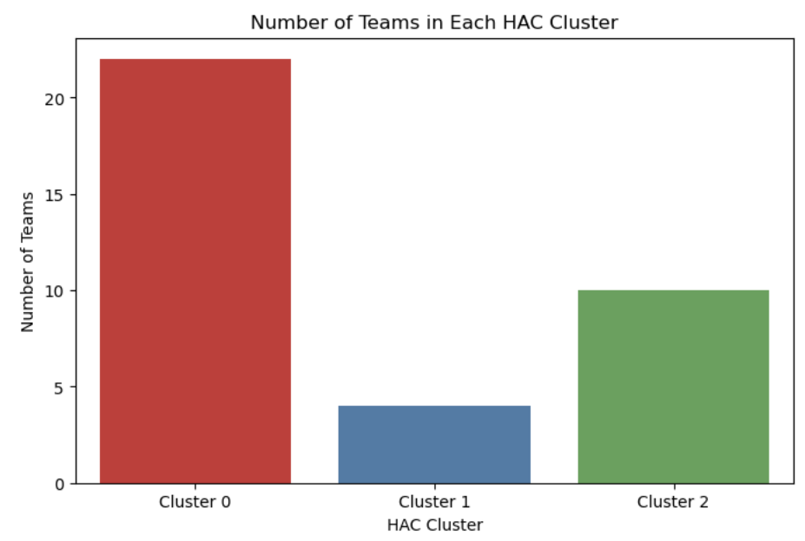
Figure 1.12 Number of Teams in each K cluster Figure 1.13 Number of Teams in each HAC cluster
Using the above figures, we can cluster home teams into three different clusters. Both models clustered attacking teams to be cluster 1 as it is the lowest among the three clusters, hence we can conclude that home team are unlikely to be playing offensively.

Supervised Learning (Classification)

Problem Statement
In football, results meant everything from the revenue a club might generate to managers or players getting sacked due to consecutive losses. Understanding the factors that influence the home team match outcomes can provide valuable insights. Using the same football dataset, we aim to predict if the home team tends to win, lose or draw a match.

Dataset Description
As we are using the same dataset as unsupervised learning, the features selected are the same and can be found in Appendix B.
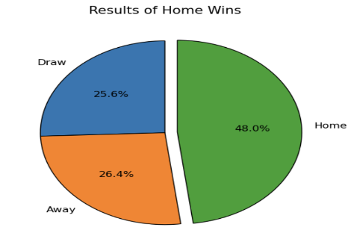
Figure 2.1 shows that the home team tends to win (48%) followed by lose (26.4%) and draw (25.6%). This shows that the data is somewhat balanced and will help in training predictive models effectively. We will be performing multiclass classification as we have 3 potential results.

Figure 2.1 Pie Chart

Evaluation Metrics
As our dataset is close to balanced, we will use Receiver Operating Characteristics (ROC) curve and F1 Score. ROC curve will help to evaluate the performance of each result by how much it can distingush itself from the other two results. F1-Score derives from the Precision and Recall Scores where it helps to rate how successful is each result. (Evidently AI Team, 2025) Hence, the best models decided on having the highest accuracy, ROC curve and F1-Score. (baeldung, W, 2025) The formulas can be found in Appendix D.

Models

Logistic Regression
Logistic Regression achieves binary classification tasks by predicting the probabilities of an outcome, in our case is multiclass classification tasks.
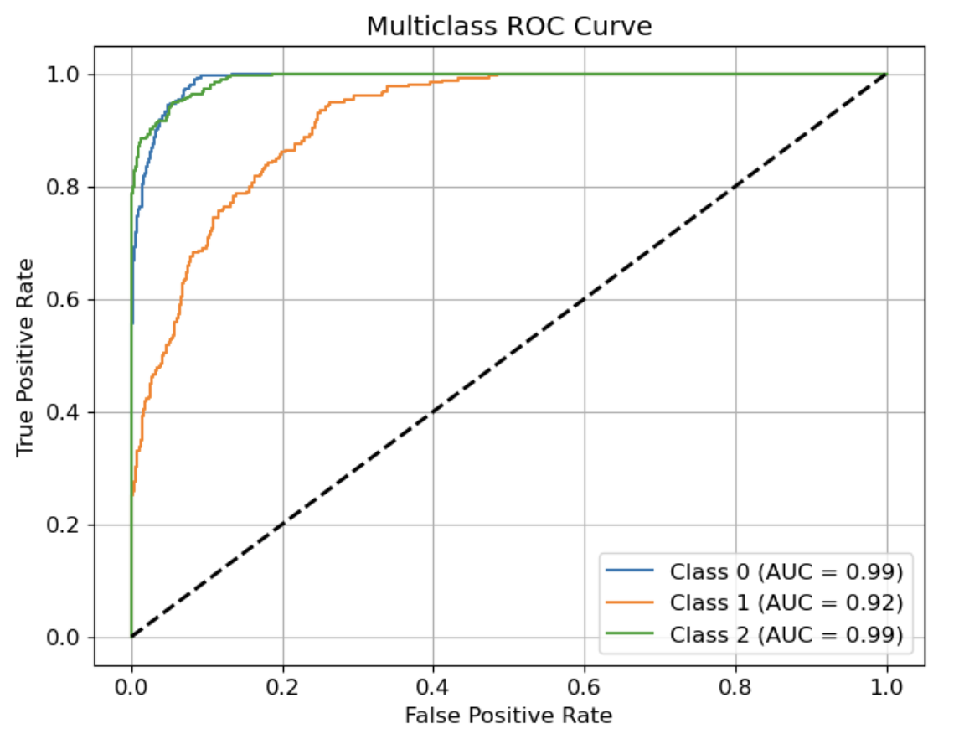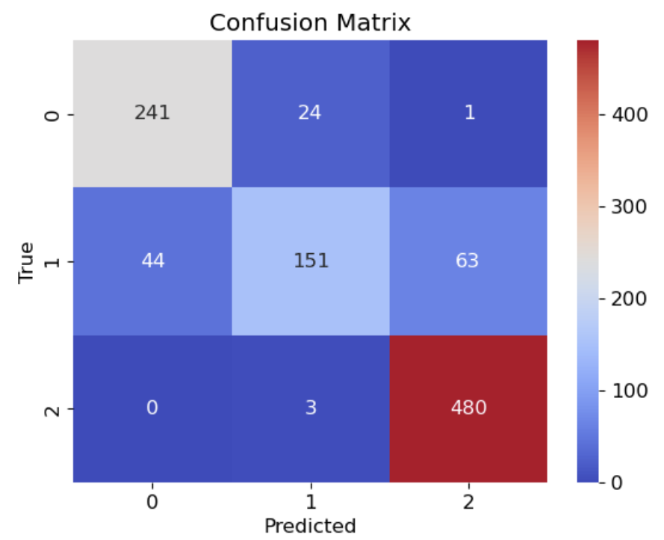
Figure 2.2 Logistic Regression ROC Figure 2.3 Logistic Regression Confusion Matrix
Figure 2.2 shows the Logistic Regression classifying teams based on their results (Class 0: Win, Class 1: Lose, Class 2: Draw) using a linear model. The Confusion Matrix in figure 2.3 indicates the predictive model is somewhat accurate but there are a concerning number of wrong predictions. Hence, we see if another model will maximize our result. Appendix D will show the full classification report.

Support Vector Classification (SVC)
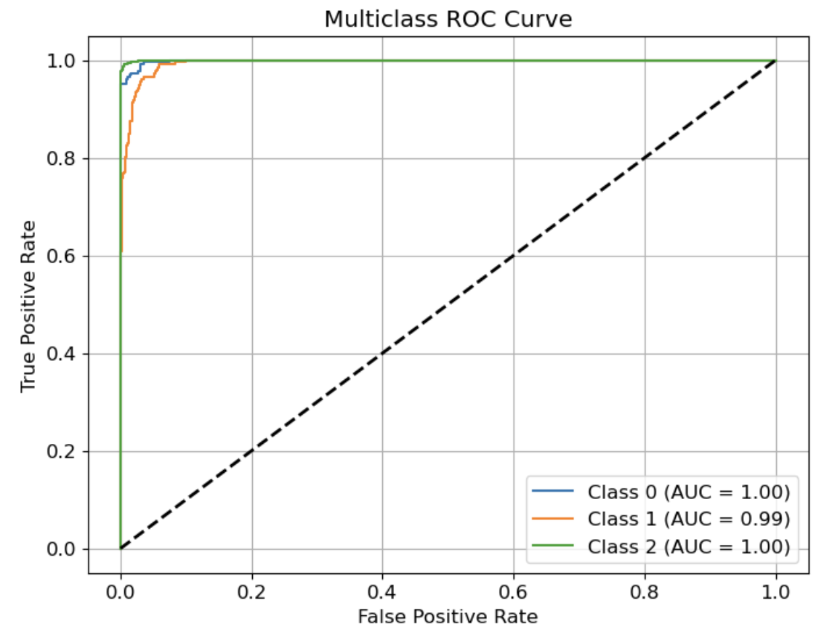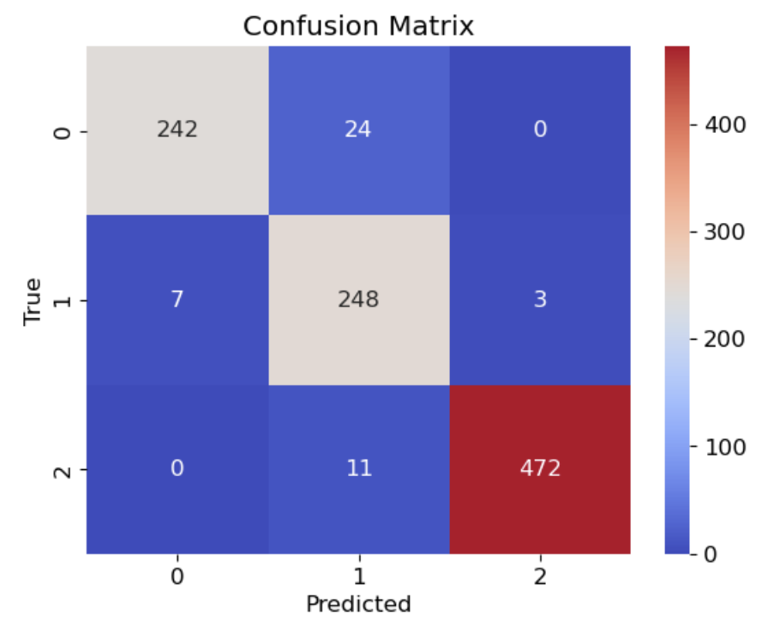
Figure 2.4 SVC ROC Figure 2.5 SVC Confusion Matrix
Figure 2.4 shows the classification results of SVC using ROC curve. Compared to Logistic Regression, the SVC uses a hyperplane to separate the classes based on statistical approaches which improves our dataset results. (Anshul, 2024) Additionally, the Confusion Matrix in figure 2.5 supports our claim as it has higher accuracy. We will move on to our last model and see if the result will improves. Appendix D will show the full classification report.

Random Forest
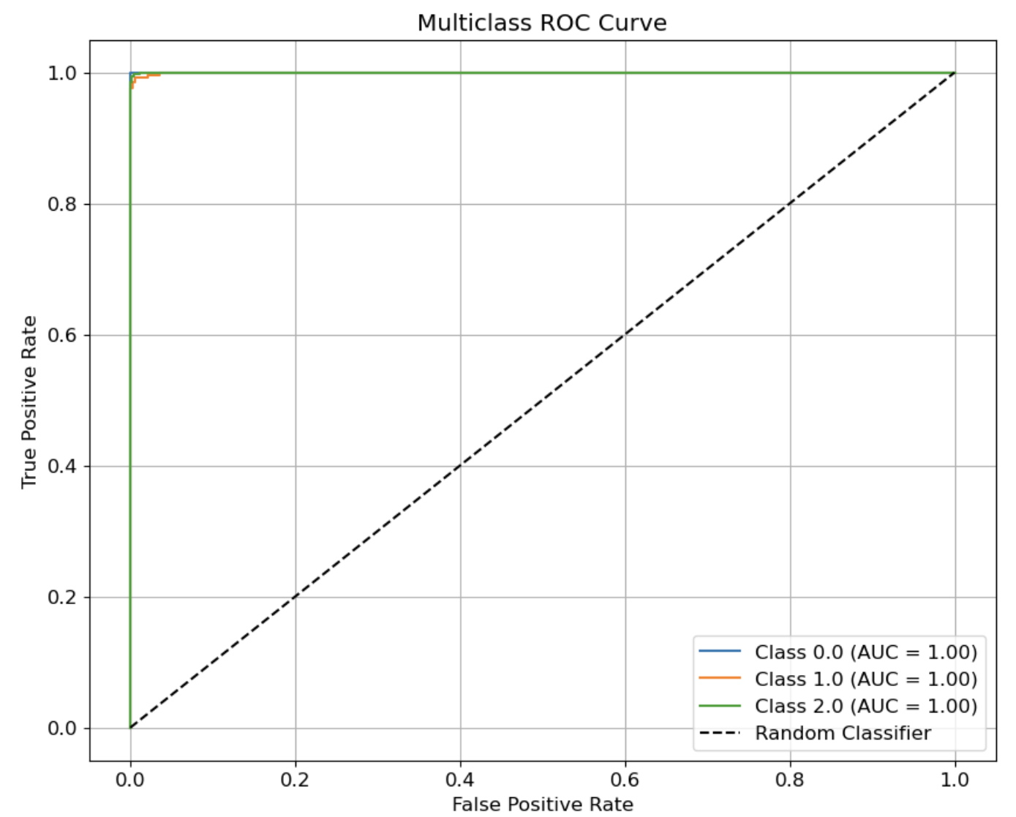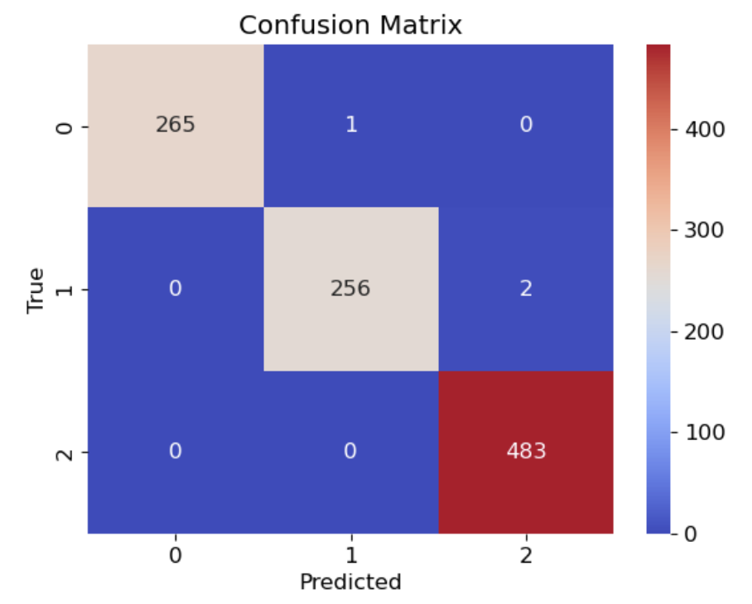
Figure 2.6 Random Forest ROC Figure 2.7 Random Forest Confusion Matrix
Random Forest is a combination of multiple decision trees to reach a single result. Random samples of data in a training set are selected with replacement and used on different models to reduce variance and overfitting. It is an ensemble approach of decision trees which reflects the mean results of the predictive models. Figure 2.6 shows exceptional results supported by figure 2.7 CM with almost perfect predictions. Appendix D will show the full classification report.

Model Evaluation
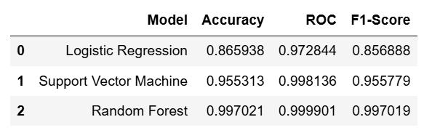
Using figure 2.8, we can conclude that Random Forest is the best predictive model to use as per our evaluation metrics, it has the highest accuracy, ROC and F1 Score.

Figure 2.8 Summary of Classification Models

Recommendations
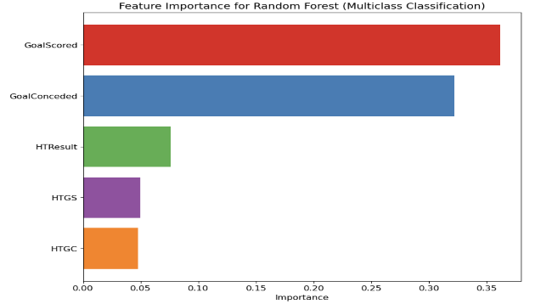
Figure 2.9 shows that ‘GoalScored’ and ‘GoalConceded’ are the most important features affecting the Result of the game. This aligns with our domain knowledge of more goals scored leads to more wins while not conceding any goals, teams would not lose. Hence, the team should focus on scoring more goals and conceding less goals.

Figure 2.9 Feature Importance

Supervised Learning (Regression)

Problem Statement
In the dynamic world of football, player transfer is common every season. It plays a crucial role in improving teams while managing financial constraints. By accurately estimating a player’s value, clubs are able to make informed decisions. By analyzing this dataset on players’ performance, the objective is to develop a predictive model that can estimate a player’s market value leading to clubs utilizing their budgets properly.

Data Description
This player dataset consists of 2612 rows and 18 columns with numerical and categorical variables with the list of variables and their data types can be found in Appendix E. Some features are removed using domain knowledge. The remaining features have outliers removed. Most Nan values are replace with mean except ‘foot’ which is replaced with right. ‘nationality’ only takes the first word (some players have two nationalities) and ‘position’ has ‘attacker, ‘midfielder’, ‘defender’ or ‘goalkeeper’ for simplicity. The cleaned dataset can be found in Appendix E as well
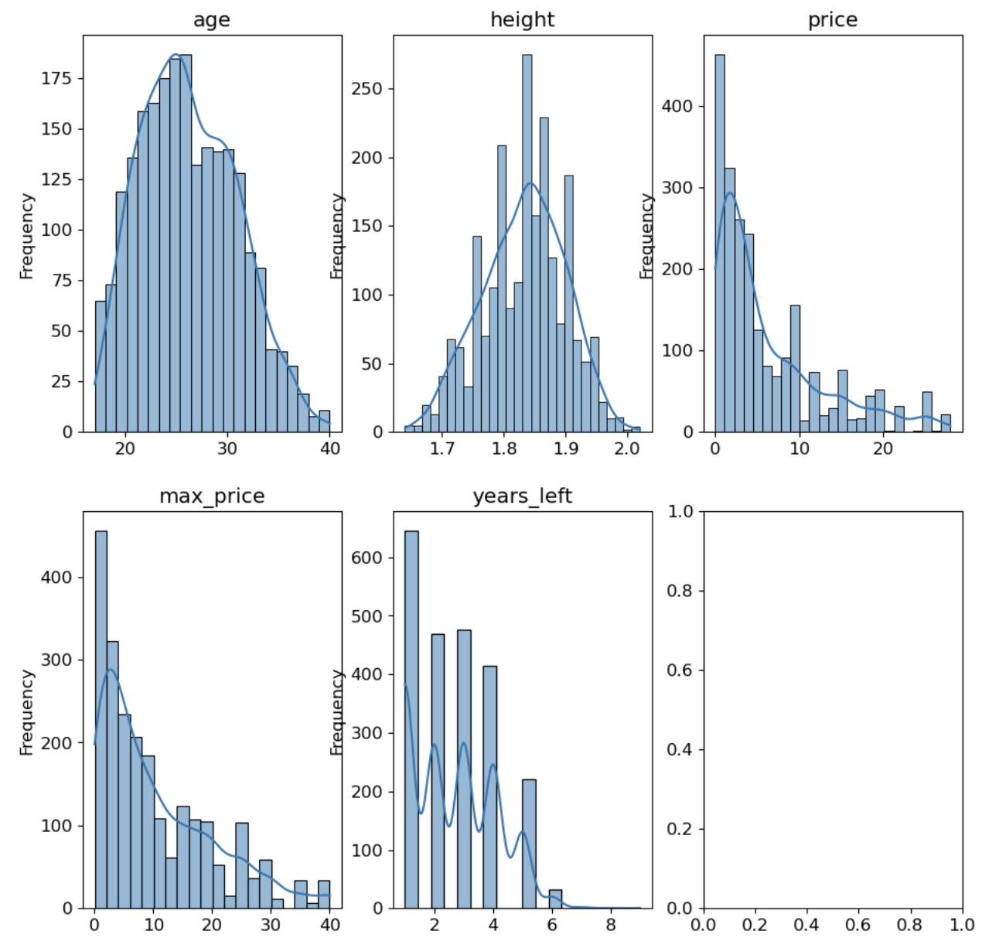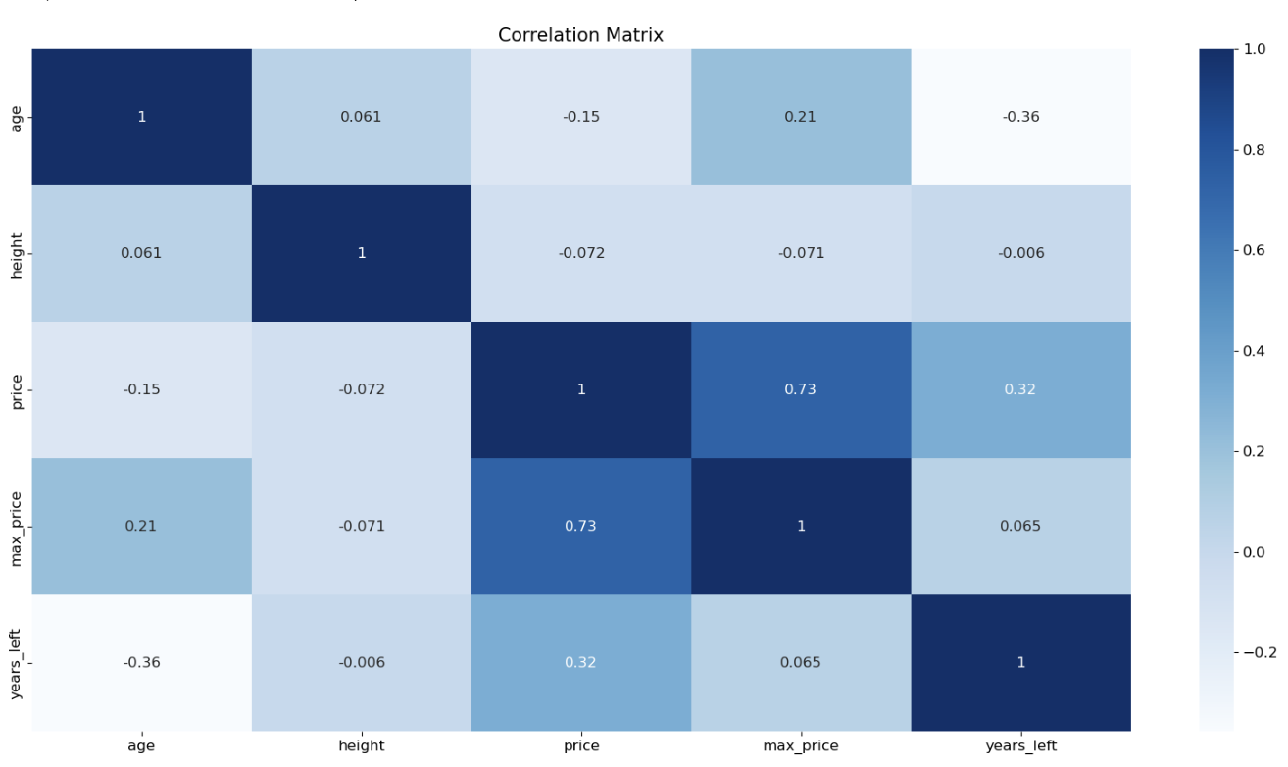
Figure 3.1 Distribution Plot Figure 3.2 Correlation Matrix
From figure 3.1, most numerical features tend to be right-skewed distribution. Figure 3.2 shows ‘Price’ which is our target feature to determine the player’s value has the highest positive correlation with ‘max_price’ (highest value the player had) and ‘years_left’ (years before contract expires) and negative correlation with ‘age’ and ‘height’.

Evaluation Metrics
To evaluate our models, we will use Mean Absolute Error (MAE), Root Mean Squared Error (RMSE) and R Squared (R2). MAE calculates the mistake of the model by comparing the absolute difference between actual and predicted values. RMSE is the root distance between actual and predicted values. R2 reflects the performance of the model. The formulas can be found in Appendix F.

Models

Linear Regression (Base and Polynomial)
Linear Regression (LR) is used to predict the mean value of the target variable ($y$) and the known value of the features ($x_{i}$) using a line of best fit. The formula can be found in Appendix F:
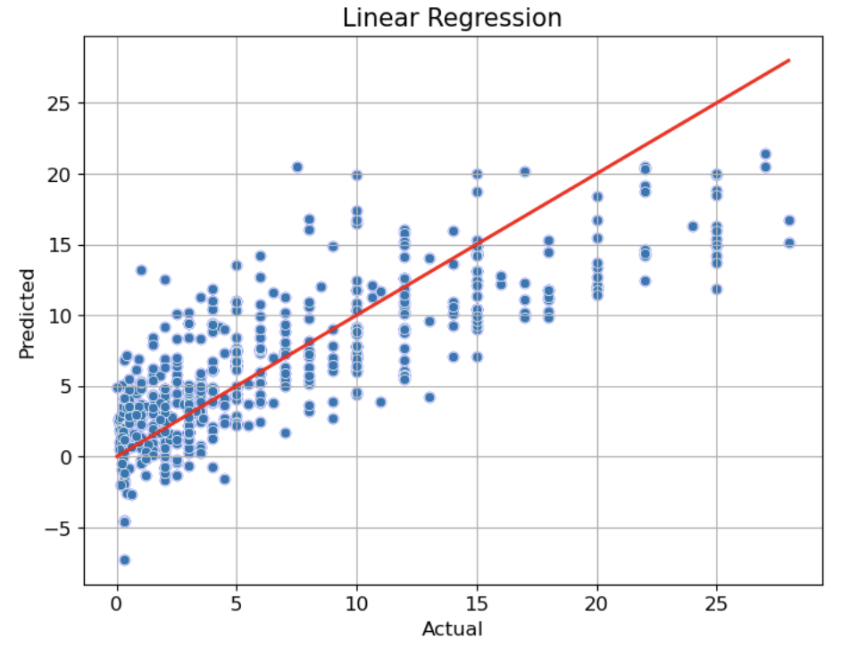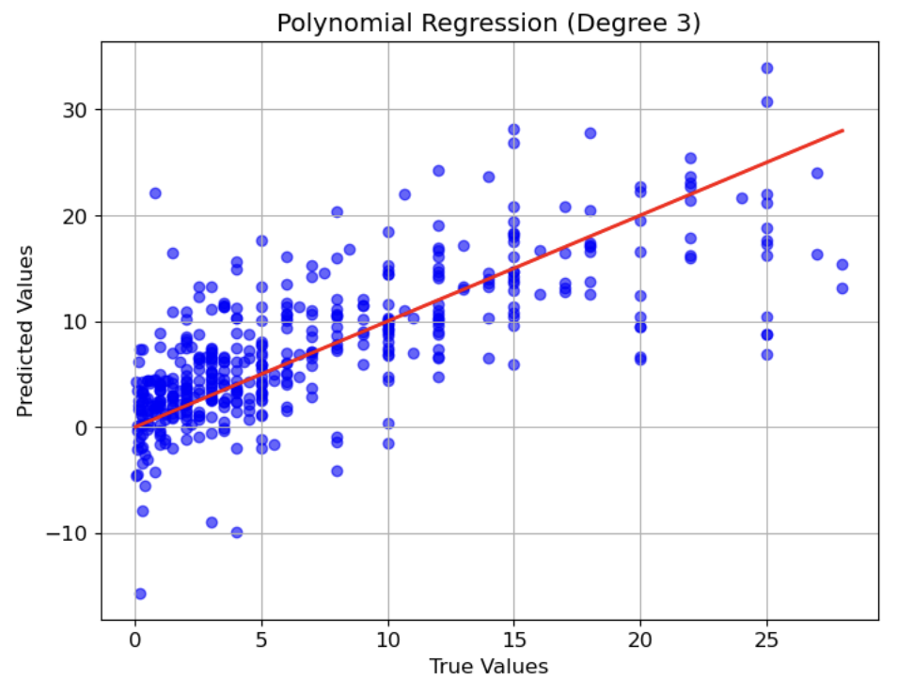
Figure 3.3 Linear Regression Figure 3.4 Polynomial Regression

Figure 3.3 shows how the actual and predicted values correspond to the line of best fit using LR. Ideally, if the data points are as close as possible to the red line. Figure 3.4 uses 3rd degree polynomial regression to predict the values. It is used to handle complex patterns by adding more polynomial terms. Comparing both models, Linear Regression is better as it has lower errors and higher R2.

Regularization Regression (Lasso and Ridge)
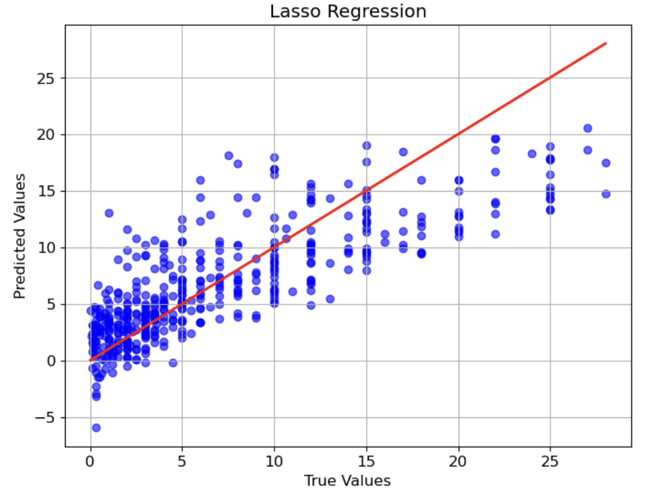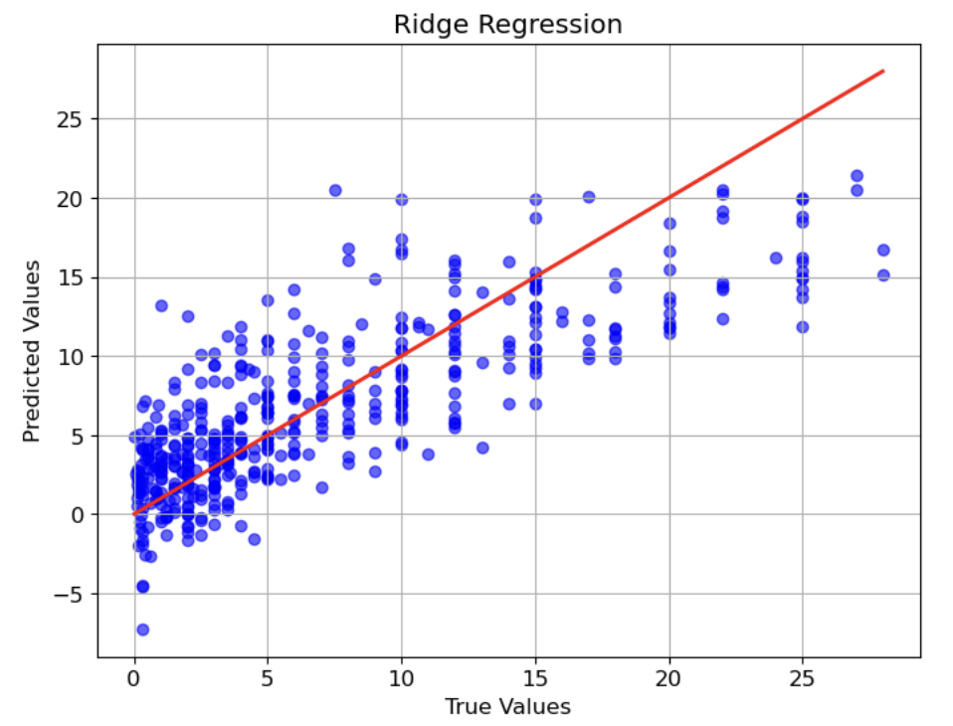
Figure 3.5 Lasso Regression Figure 3.6 Ridge Regression

Regularization Regression aims to avoid overfitting and improve model performance by adding penalty terms. Lasso Regression assumes that the coefficients of the linear model are sparse and few of them are non-zero while Ridge Regression uses the coefficient’s square to add a penalty component that regularizes the coefficient. Comparing both models, Lasso Regression outperforms Ridge Regression slightly.

Random Forest
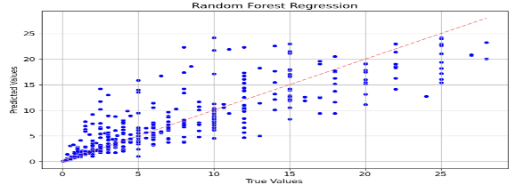
Random Forest uses an ensemble approach by training each decision tree separately to prevent overfitting and lowering the test data’s variance like the Random Forest in classification.

Figure 3.7 Random Forest

Model Evaluation
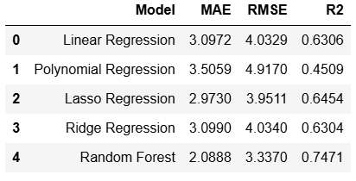
Using figure 3.8, we can conclude that Random Forest is the best predictive model as it has the lowest MAE and RMSE and highest R2 among all the models we have performed.

Figure 3.8 Summary of Regression Models

Recommendation
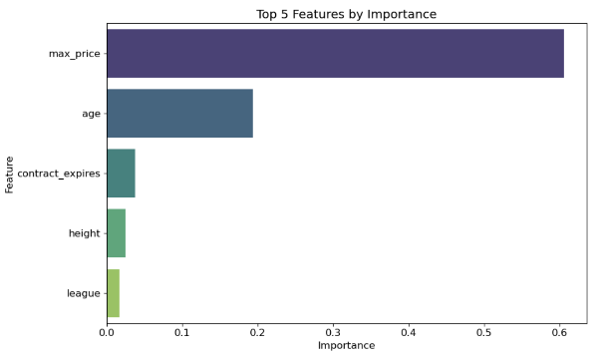
Figure 3.9 shows that ‘max_price’, ‘age’ and ‘contract_expires’ are the highest importance in predicting the player’s values. Since ‘max_price’ is similar to ‘price’, a player’s age and the number of years before his contract with the current expires changes a player’s value the most.

Figure 3.9 Feature Importance

References
Agrawal, R. (2025) Know the best evaluation metrics for your regression model !, Analytics Vidhya. Available at: https://www.analyticsvidhya.com/blog/2021/05/know-the-best-evaluation-metrics-for-your-regression-model/ (Accessed: 02 March 2025).
Anshul (2024) Guide on Support Vector Machine (SVM) algorithm, Analytics Vidhya. Available at: https://www.analyticsvidhya.com/blog/2021/10/support-vector-machinessvm-a-complete-guide-for-beginners/#h-logistic-regression-vs-support-vector-machine-svm (Accessed: 18 January 2025).
baeldung, W. by: (2025) F-1 score for multi-class classification, Baeldung on Computer Science. Available at: https://www.baeldung.com/cs/multi-class-f1-score (Accessed: 02 March 2025).
Evidently AI Team (no date) Accuracy, precision, and recall in multi-class classification, Evidently AI - Open-Source ML Monitoring and Observability. Available at: https://www.evidentlyai.com/classification-metrics/multi-class-metrics (Accessed: 02 March 2025).
Gultekin, H. (2023) What is silhouette score?, Medium. Available at: https://medium.com/@hazallgultekin/what-is-silhouette-score-f428fb39bf9a (Accessed: 03 March 2025).
Sharma, P. (2025) What is K-means clustering?, Analytics Vidhya. Available at: https://www.analyticsvidhya.com/blog/2019/08/comprehensive-guide-k-means-clustering/#What_Is_K-Means_Clustering? (Accessed: 18 January 2025).

Appendix

Appendix A
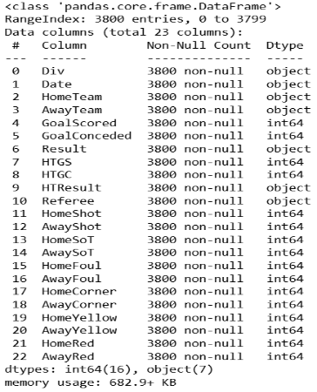
Figure 5.1 shows the raw football dataset with 3800 rows and 23 columns with no Nan values. ‘Div’, ‘AwayTeam’, ‘AwayShot’, ‘AwaySoT’, ‘AwayFoul’, ‘AwayCorner’, ‘AwayYellow’, ‘HomeRed’, ‘AwayRed’ will be removed as we are targetting home team only. ‘Div’ has no meaningful interpretation and ‘Date’ has been changed to ‘Year’ taking only the year value. ‘HomeRed’ will be removed after identifying it has no correlation with other features

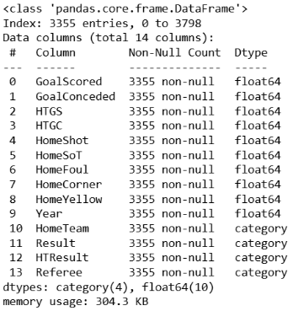
Figure 5.1 Data Inspection
Figure 5.2 shows the cleaned data set with 3355 rows and 14 columns. ‘HomeShot’ represents shots taken by the home team. ‘HomeSoT’ represents shots on target taken by the home team. ‘HomeFoul’ represents the number of times the home team foul. ‘HomeCorner’ is the number of corner taken by the home team.

Figure 5.2 Cleaned Data

Appendix B
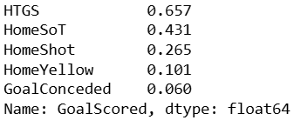
Figure 5.3 shows the absolute value of the top 5 features correlated with ‘GoalScored’. Based on the absolute value and the meaningfulness of the features, ‘HomeSoT’, ‘HomeShoT’ and ‘GoalConceded’.
Figure 5.3 Top 5 Correlation

Appendix C
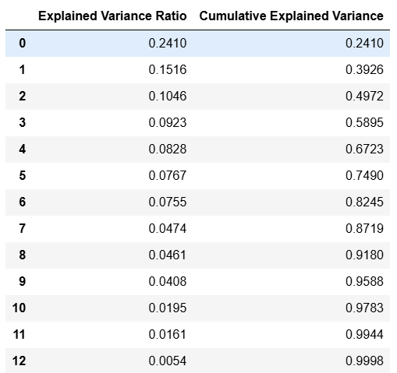
Figure 5.4 shows the cumulative variance. As we can see, 9 PCs will cover more than 95% of the cumulative explained variance at 95.88%

Figure 5.4 Explained Variance

Appendix D
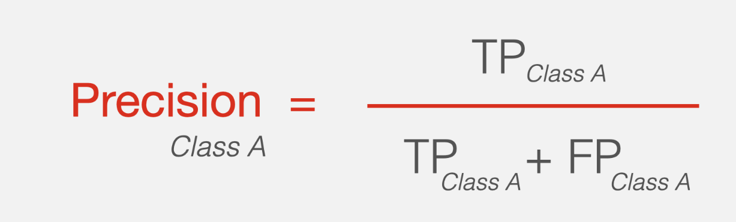
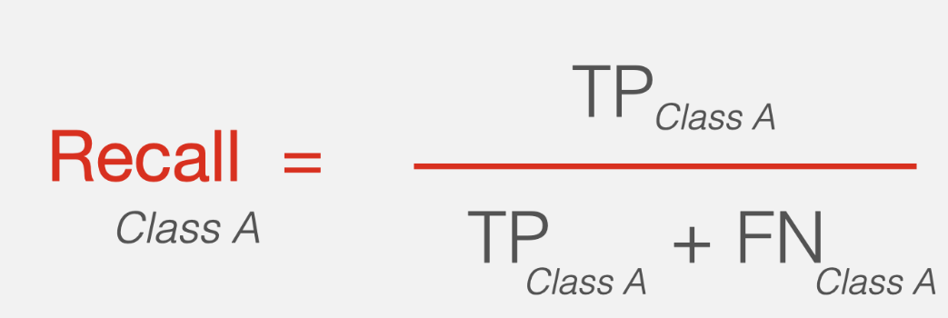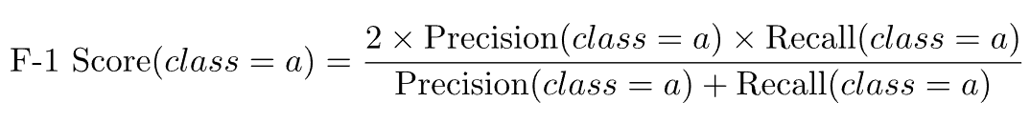
Figure 5.5 Formulas for Classification Models Evaluation Metrics
Figure 5.5 shows the formulas used to evaluate the classification model. The aim is to have high accuracy and F1-Score. (baeldung, W, 2025)
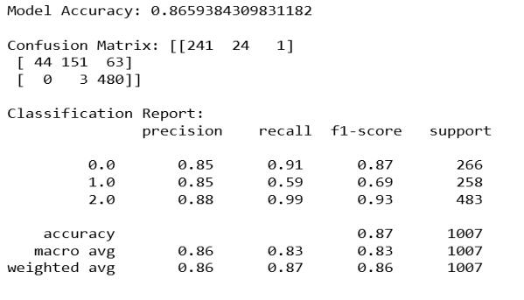
Figure 5.6 shows the accuracy and detailed classification report of Logistic Regression model.

Figure 5.6 Logistic Regression Classification Report
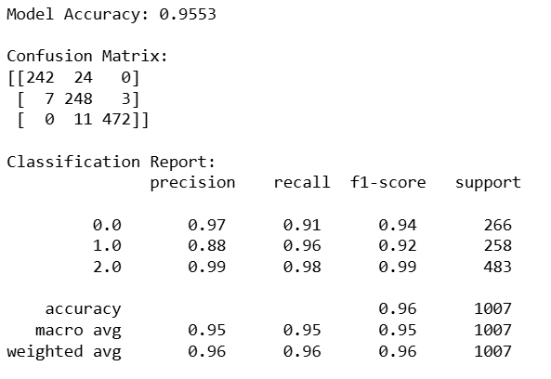
Figure 5.7 shows the accuracy and detailed classification report of SVC model.

Figure 5.7 SVC Classification Report
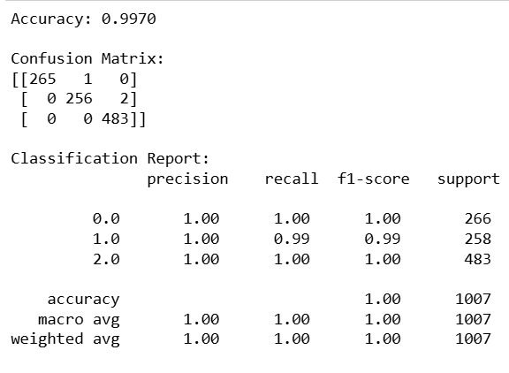
Figure 5.8 shows the accuracy and detailed classification report of Random Forest model.

Figure 5.8 Random Forest Classification Report

Appendix E
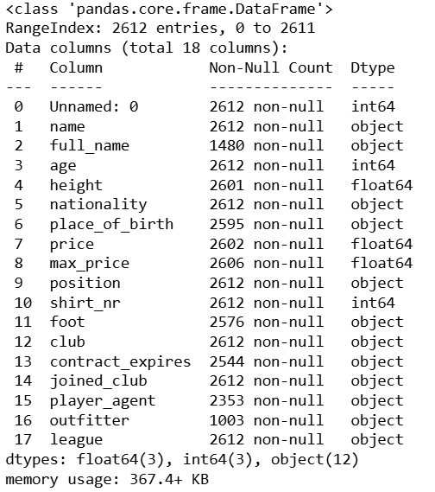
Figure 5.9 shows the raw player dataset with 2612 rows and 17 columns.

Figure 5.9 Data Inspection

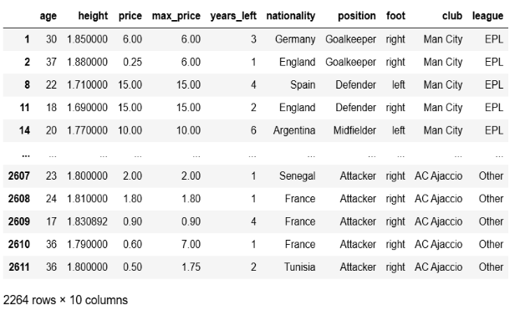
Figure 5.10 shows the cleaned player dataset. Outliers have been removed, ‘foot’ filled Nan values using mode (right). ‘nationaility’ only takes the first word. ‘Position’ changed to 4 main types as mentioned above. The remaining Nan values are filled with mean.

Figure 5.10 Cleaned data

Appendix F
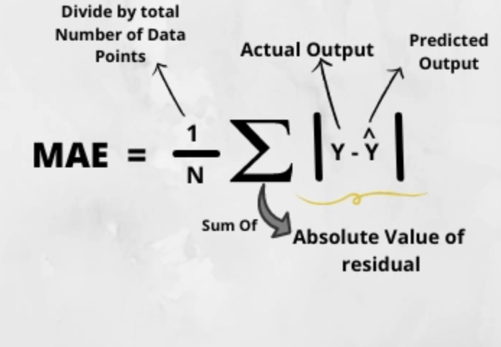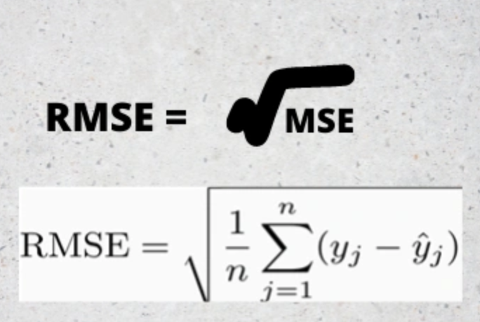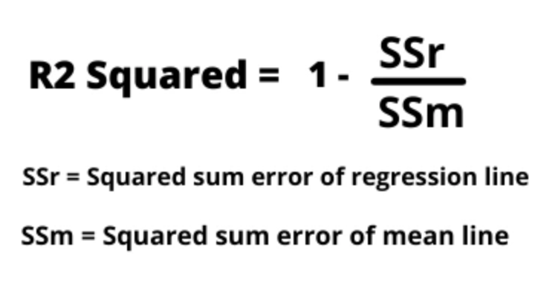
Figure 5.11 Formula for MAE, RMSE and R2
Figure 5.11 shows the formulas used to evaluate the regression models used. The aim is to have the lowest MAE and RMSE. For R square, the aim is to get the value closest to 1 as it ranges from 0 to 1. (Agrawal, R, 2025)
The formula for Linear Regression is:
$$y= b_{0}+b_{1}x_{1}+ b_{2}x_{2}+…+b_{i}x_{i}$$
$$y=Price, b_{i}= Estimated Coefficient of x,x_{i}= Features$$

