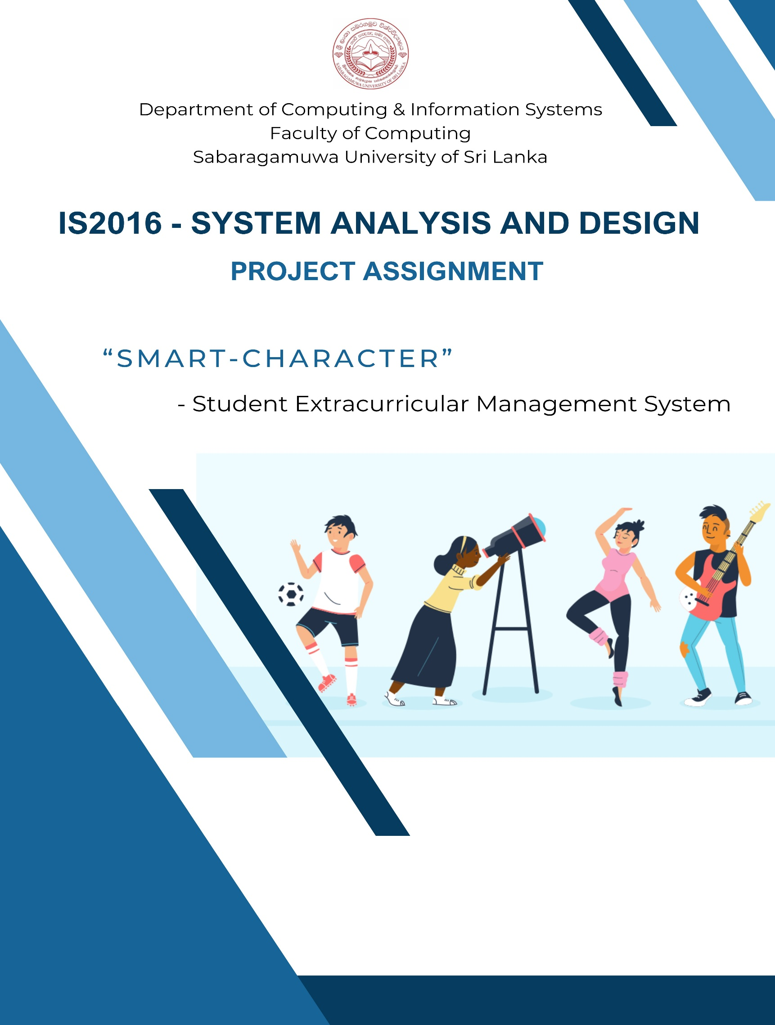

**SUBMITTED BY**

**E.M.D.P.B. EKANAYAKE – 21CIS0102**

**G.G.U.N. SAMARANAYAKE – 21CIS0127**

**T.M.S.P.B. THENNAKOON – 21CIS0128**

**Requirements Gathering Phase - (SRS - V1)**

**Date of Submission: 04-03-2024**

**Contents**

1. PROJECT SCOPE 1

1.1 Introduction 1

1.2 Purpose 1

1.3 Objectives of the system 1

1.4 Stakeholders 2

1.5 Time Line 2

1.6 Functional requirements 3

1.7 Non Functional Requirements 3

1.8 Tools and Technology Used 3

1.9 Project Features 3

1. Student Profile Management 3

2. Character Certificate Generation 3

3. User Authentication and Access Control 4

4. Search and Reporting 4

5. Data Import and Export 4

# PROJECT SCOPE

## 1.1 Introduction

Student Extracurricular Management System aims to manage the extracurricular activities of students in Sri Lankan schools.

This system will provide a digital platform for school administrators to efficiently record and manage personal details and extracurricular activities of students, and it will help to easily issue character certificates for school leavers.

## 1.2 Purpose

Issuing a character certificate for school leavers has become a hard handling and very slow process in Sri Lankan schools. Schools may need to verify the character of students by checking academic records and talking to relevant teachers and there may be strict standards for the content to ensure accuracy and reliability. So, this verification process may cause delays and may take a lot of extra time to issue the character certificate.

By making an automated system for issuing a character certificate for school leavers, the school management can overcome these challenges. It can reduce the time and effort required for issuing character certificates. It can also minimize human errors, ensuring that character certificates are reliable and error-free. It can also overcome the communication issues between different departments responsible for issuing character certificates.

So, the main purpose of developing the “Smart-Character” - Student Extracurricular Management System is to address the challenges faced by Sri Lankan schools in issuing character certificates for school leavers.

## 1.3 Objectives of the system

* Develop a user-friendly application for managing student extracurricular activities which helps in issuing character certificates.
* Automate the verification process by integrating teacher feedback.
* Improve efficiency, accuracy, and reliability of issuing a character certificate.
* Making a easy-to-handle to handle, feasible, cost reduction, fast, and convenient process for issuing a character certificate.

## 1.4 Stakeholders

School administrators, teachers, students and parents of Sri Lankan schools are the main intended audience for the “Smart-Character” - Student Extracurricular Management System.

School administrators are the ones who are responsible for managing student records within the school and issuing character certificates.

Teachers are the ones who provide input and feedback on students’ behavior and performance of extra-curricular activities, which informs issuing character certificates.

Students are the ones who receive the character certificates as a reflection of their behavior and achievements in extra-curricular activities.

Parents are the ones who may need access to their child’s character certificate for various purposes such as applying for scholarships.

“Smart-Character” - Student Extracurricular Management System will facilitate all the above-mentioned parties providing them with easy access to accurate and reliable character certificates while restructuring the administrative process of the school.

## 1.5 Time Line

|  |  |  |  |  |  |  |
| --- | --- | --- | --- | --- | --- | --- |
| **Task Name** | **Duration** | **Period** | | | | |
| **4/3** | **4/10** | **4/19** | **5/13** | **5/17** |
| Requirement Gathering | 6 days |  | | | | |
| System Design | 7 days |  | | | | |
| UI/UX Design | 9 days |  | | | | |
| Prototype Development | 24 days |  | | | | |
| Testing & Evaluation | 4 days |  | | | | |

## 1.6 Functional requirements

The project will record student data and extracurricular activity details with the feedback of the relevant teachers. There will be user-friendly user interfaces to record data and retrieve data in the system. The system will be easily accessed only by the administration of the school.

* School administration can create, update, and delete student registration.
* School administration can create, update, and delete student extracurricular activities.
* Activities should be categorized as sports, clubs arts etc.
* Each activity should have details such as Activity ID, Name, Description, Date, and Location.
* Each student should have details such as Admission Number, Full name, Address, Date of Birth, Parents’ Name, and Telephone Number.

## 1.7 Non Functional Requirements

* The system should have user-friendly user interfaces to record data and retrieve data in the system.
* The system should be available 24/7.
* Backups should be taken to prevent loss of data.

## 1.8 Tools and Technology Used

* PHP
* C#
* JAVA
* Figma

## 1.9 Project Features

The Student Information Management System will offer the following key features.

### 1. Student Profile Management

The system will allow users to create and maintain comprehensive profiles for each student, including personal details, contact information, academic records, and extracurricular activities.

### 2. Character Certificate Generation

Users can generate character certificates for students, incorporating their academic performance, behavior, and participation in extracurricular activities. These certificates will serve as official documentation of a student's conduct and achievements.

### 3. User Authentication and Access Control

The system will implement secure user authentication mechanisms to control access to sensitive student information. Different user roles, such as administrators, teachers, and parents, will have specific access rights based on their responsibilities and permissions.

### 4. Search and Reporting

Users can search for specific students by admission number or other identifiers and generate reports summarizing student information, including academic records, attendance, and extracurricular achievements.

### 5. Data Import and Export

The system will support importing existing student data from external sources, such as spreadsheets or legacy databases, to ensure a smooth transition to the new system. It will also allow users to export data for backup purposes or analysis.