# Plant Color Analysis Report

Original (Left) vs Processed (Right): Plant1_Day10_Morning_Side.jpg

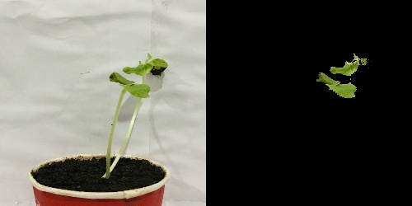

Original (Left) vs Processed (Right): Plant2_Day10_Morning_Side.jpg

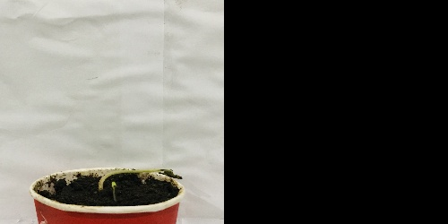

Original (Left) vs Processed (Right): Plant3_Day10_Morning_Side.jpg

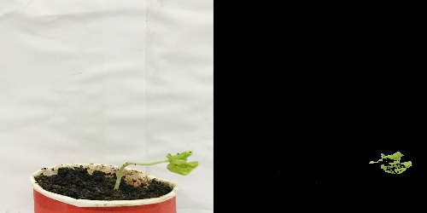

Color Distribution Graph:

