Gaussian Naive Bayes Classifier: Visualising Behaviour and Decision Boundaries
Student Id: 24098192
Module Name: 7PAM2021-0901-2025 - Machine Learning and Neural Networks

1. Introduction
Naive Bayes is a family of simple yet powerful probabilistic classifiers based on Bayes’ theorem. Despite its conceptual simplicity and the strong independence assumptions it makes, Naive Bayes remains widely used because of its efficiency, interpretability, and surprisingly strong performance on many real-world datasets. One of the most popular variants, Gaussian Naive Bayes (GNB), assumes that the continuous features of each class follow a normal (Gaussian) distribution. This makes GNB particularly suitable for visualisation and analysis using low-dimensional numerical datasets.
The aim of this project is to analyse and visualise the behaviour of the Gaussian Naive Bayes classifier using a manually uploaded dataset. We provide intuitive explanations, generate colour-coded decision boundaries, and explore how Naive Bayes responds to non-linear and spiral-shaped data. Unlike other classifiers such as k-Nearest Neighbours or Support Vector Machines, Naive Bayes does not attempt to model complex relationships directly. Instead, it relies on statistical properties—means, variances, and class priors—to compute probabilities and assign a class label.
To examine this visually, we plot both the dataset and the classifier’s decision boundary using distinct colour themes. These plots help reveal how GNB attempts to partition the feature space. As we will see, this is especially interesting for datasets with highly non-linear shapes, such as spirals, since Naive Bayes inherently creates elliptical or Gaussian-shaped boundaries.

2. Dataset Description
The dataset used in this demonstration is a manually uploaded two-feature spiral dataset. It contains two numerical feature columns (feature1 and feature2) and a binary label column (label). The spiral shape of the dataset is particularly useful for illustrating the limitations of Gaussian Naive Bayes because the two classes wind around each other in a nonlinear fashion—something that cannot be captured by Gaussian decision regions.
Before training the classifier, the dataset is scaled using StandardScaler. This ensures that both features contribute equally to the probability calculations. Without scaling, Gaussian Naive Bayes may over-emphasise features with larger numerical ranges.
The dataset scatter plot shows how the features are arranged:

📷 Image 1 — Dataset Scatter Plot (Neutral Colours)
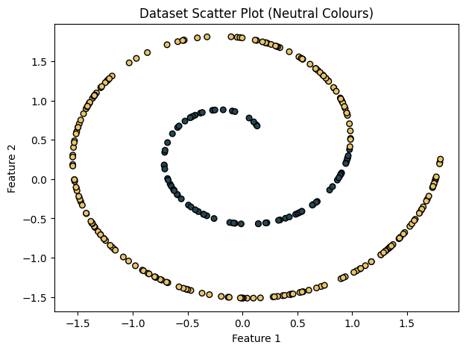

This scatter plot visualises the uploaded spiral dataset using a neutral palette: deep navy for one class and golden yellow for the other. The spiral shape is clearly visible—each class forms a smooth, curved arm wrapping around the centre. Unlike datasets such as moons, circles, or blobs, spiral datasets are extremely nonlinear, and the two classes interweave closely.
This makes classification difficult for models that rely on simple geometric or statistical assumptions, especially Gaussian Naive Bayes. The plot also highlights that the two spirals are well separated spatially but connected through a consistent curve. The tight organisation of points demonstrates that while the dataset is visually appealing, it is intentionally challenging for classification algorithms that assume linear separability or Gaussian distributions.

3. Methodology
The methodology applied in this project involves four main steps: data loading, preprocessing, model training, and visualisation.
3.1 Data Loading and Scaling
The dataset is loaded from a CSV file using pandas. Only two features are selected, ensuring compatibility with decision boundary visualisation. Feature scaling is performed using StandardScaler to normalise numerical ranges.
3.2 Model Training
We use Gaussian Naive Bayes (GNB) from sklearn.naive_bayes. This classifier models each feature of each class using a Gaussian distribution defined by a mean and variance computed from the training data.
The prediction rule becomes:
$$P(y∣X)∝P(y)\prod_{i=1}^{n}{exp⁡}\left( − \frac{\left(x_{i} − μ_{y,i})^{2}\right.}{2σ_{y,i}^{2}}\right)$$
Because GNB has no hyperparameters and trains almost instantly, it is ideal for exploratory analysis.
3.3 Decision Boundary Generation
To visualise the classifier’s behaviour, we generate a dense meshgrid covering the feature space. We then use the trained model to predict a class label for every grid point. Plotting these predictions produces a colour-coded decision surface.
3.4 Colour Mapping
We use a custom soft colour scheme:
- Light mint green vs light peach for decision regions
- Deep red vs deep green for class points
This makes boundaries easier to see without overwhelming the viewer.

4. Results and Visualisation
The Gaussian Naive Bayes classifier produces the following decision boundary:

📷 Image 2 — Gaussian Naive Bayes Decision Boundary
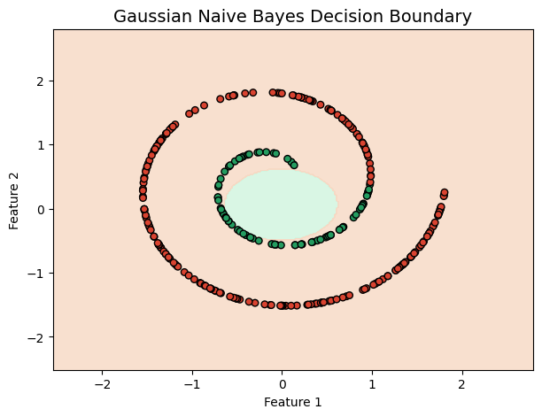
This plot shows the classifier’s decision surface overlaid with the spiral dataset. The background colour indicates which class the model predicts at each point: the mint green region corresponds to class 0, while the peach region corresponds to class 1. The data points themselves remain coloured using deep red and green to distinguish the true class labels.
Interpretation:
The decision boundary produced by Gaussian Naive Bayes is elliptical and smooth, reflecting the Gaussian distributions estimated for each class. GNB assumes each class is shaped like a multivariate “hill” in probability space. As a result, the classifier attempts to carve out a single elliptical region for one class in the centre, with the outer region belonging to the other class.
However, because the spiral dataset is highly nonlinear, this approach fails to capture the true data structure. The classifier ends up assigning much of the spiral incorrectly—only the central portion of one spiral is classified correctly, while the rest of the dataset falls in the peach-coloured misclassified region.
This reveals a key limitation of Naive Bayes:
🔹 It cannot model complex, winding, or intersecting class shapes.
🔹 It performs best when classes resemble Gaussian “blobs,” not spirals.
Despite this, the visualisation is extremely informative. Unlike models that may produce jagged or complex boundaries, GNB provides a clean, mathematically interpretable decision surface. This makes it excellent for educational purposes.

5. Discussion
The results highlight several important characteristics of Gaussian Naive Bayes:
5.1 Strengths
- Very fast training and prediction
- Easy to interpret due to its probabilistic foundations
- Performs well on linearly separable or Gaussian-shaped data
- Handles noise and small datasets gracefully
5.2 Limitations
- Poor performance on nonlinear structures like spirals
- Sensitive to incorrect normality assumptions
- Produces smooth, global decision boundaries that cannot adapt to fine-grained class shapes
- Independence assumption between features may be unrealistic
5.3 Visualisation Insights
The spiral dataset clearly exposes the model’s limitations. Naive Bayes can only draw one smooth boundary, but the true boundary between the spirals is a long, winding curve. Because of this mismatch, most points are misclassified.
Visualisation also helps understand model geometry:
- Euclidean models (e.g., k-NN) can adapt to local variations
- Naive Bayes builds global Gaussian structures
This comparison is highly valuable in machine-learning education.

6. Conclusion
This project demonstrates the behaviour of the Gaussian Naive Bayes classifier using a challenging two-feature spiral dataset. While Naive Bayes is a robust, fast, and interpretable model, its assumptions about Gaussian distributions and feature independence limit its ability to classify nonlinear datasets accurately.
The two plots included in this report—one showing the dataset distribution and one showing the classifier’s decision boundary—provide clear visual evidence of how Naive Bayes generalises information. It forms smooth, elliptical boundaries that fail to follow the spiral structure of the data. Yet, this visualisation is not a failure; rather, it is a powerful demonstration of why model selection matters.
Naive Bayes remains excellent for many real-world applications such as text classification, spam detection, and medical diagnosis, where feature independence is common and data is statistically well-behaved. However, for highly nonlinear patterns like spirals, more flexible models are required.
Overall, this project provides a clear, visual, and conceptual understanding of Gaussian Naive Bayes, highlighting both its strengths and limitations in a practical and intuitive way.
7.References
- GeeksforGeeks. (2025). How to plot the decision boundary for a Gaussian Naive Bayes classifier in R. Retrieved from https://www.geeksforgeeks.org/machine-learning/how-to-plot-the-decision-boundary-for-a-gaussian-naive-bayes-classifier-in-r/
- Cornell University. (2018). Lecture 5: Bayes Classifier and Naive Bayes. Retrieved from https://www.cs.cornell.edu/courses/cs4780/2018fa/lectures/lecturenote05.html
- Scikit-learn Developers. (2025). GaussianNB — scikit-learn 1.7.2 documentation. Retrieved from https://scikit-learn.org/stable/modules/generated/sklearn.naive_bayes.GaussianNB.html
- Yanjini. (2023). Linear-and-Nonlinear-Gaussian-Naive-Bayes-Classifier-with-Visualization-on-A-Plane. GitHub repository. Retrieved from https://github.com/YANJINI/Linear-and-Nonlinear-Gaussian-Naive-Bayes-Classifier-with-Visualization-on-A-Plane
- Stack Overflow. (2017). How to plot the decision boundary for a Gaussian Naive Bayes classifier?. Retrieved from https://stackoverflow.com/questions/45804430/how-to-plot-the-decision-boundary-for-a-gaussian-naive-bayes-classifier
GIT HUB
https://github.com/Dumpalaakhil/Machine-Learning-Tutorial

