

Course Name: DSD
Course Number and Section: 14:332:434:02

Experiment: [Experiment # 6 – Spooky registers]
Lab Instructor:

Date Performed: Today

Date Submitted: Tommorrow

Submitted by: Kai Gardner – kzg5 : 188002688

Course Name: DSD
Course Number and Section: 14:332:434:02

! Important: Please include this page in your report if the submission is a paper submission. For electronic submission (email or Sakai) please omit this page.

--------------------------For Lab Instructor Use ONLY--------------------------

GRADE: _______________

COMMENTS:

Electrical and Computer Engineering Department
School of Engineering
Rutgers University, Piscataway, NJ 08854
ECE Lab Report Structure

1. Purpose / Introduction / Overview – describe the problem and provide background information
2. Approach / Method – the approach took, how problems were solved
3. Results – present your data and analysis, experimental results, etc.
4. Conclusion / Summary – what was done and how it was done

This page is unintentionally left blank.

Top.sv
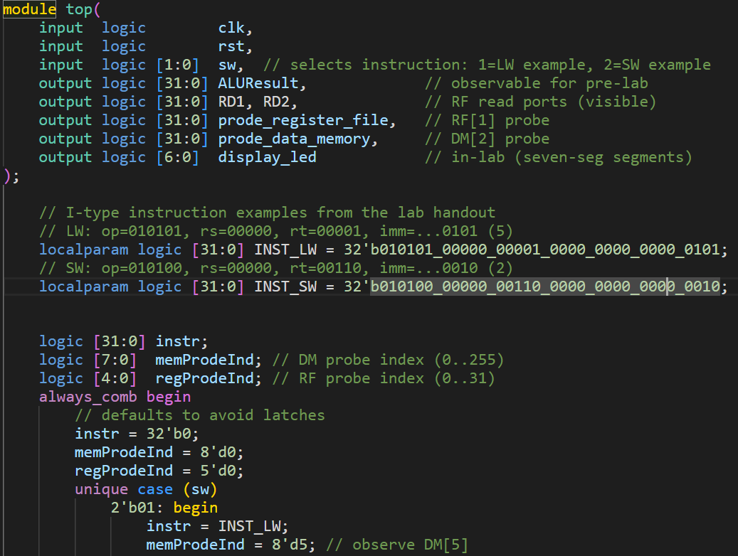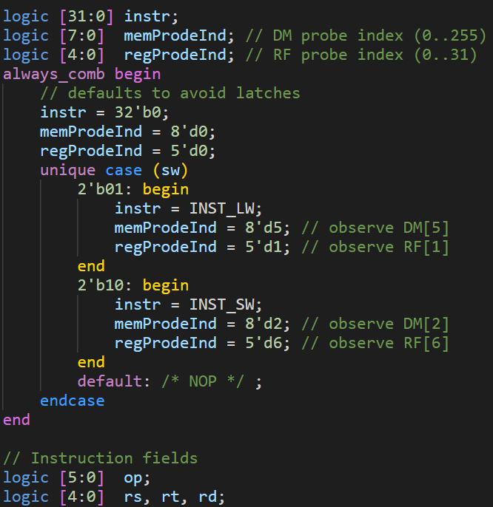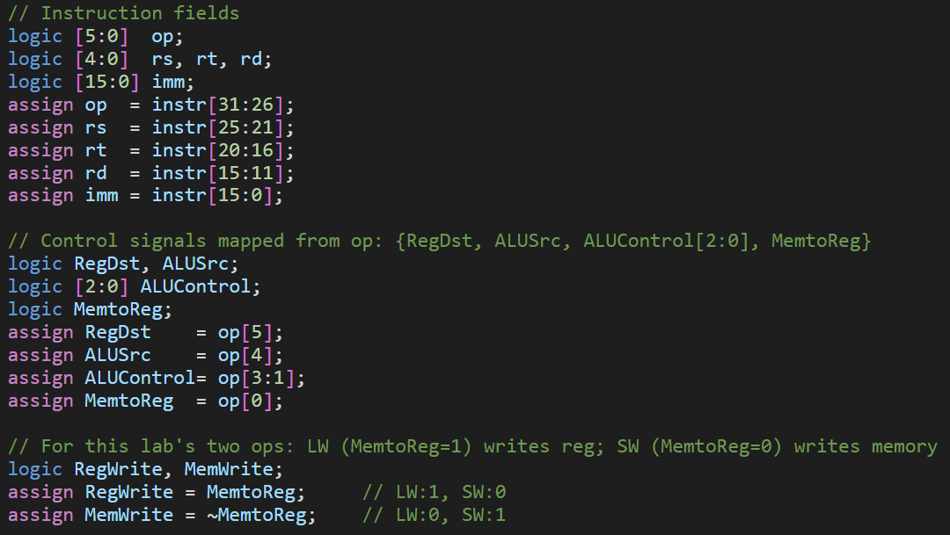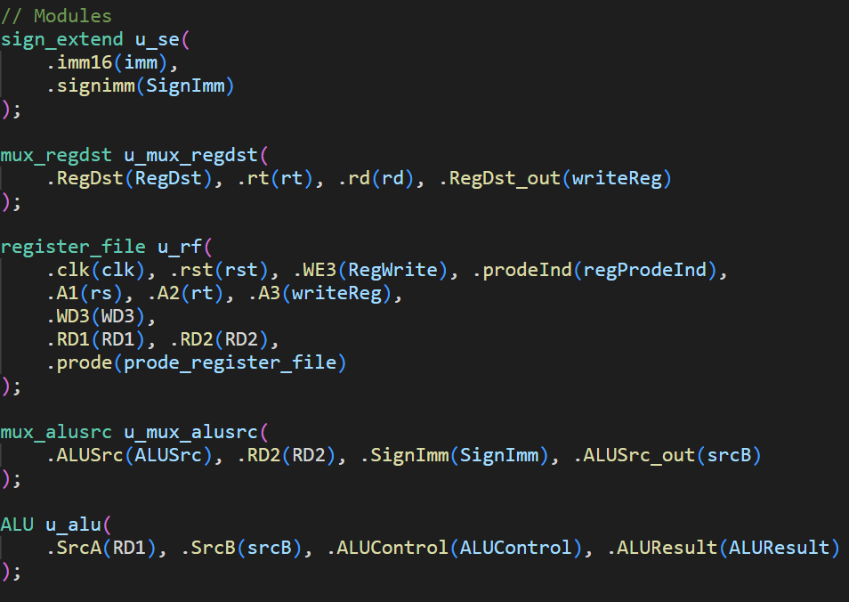
Data_memory.sv
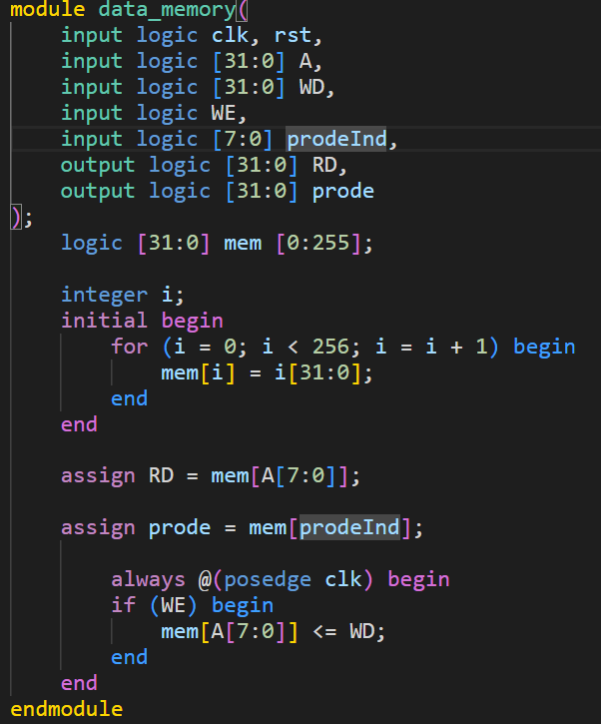

Register_file.sv
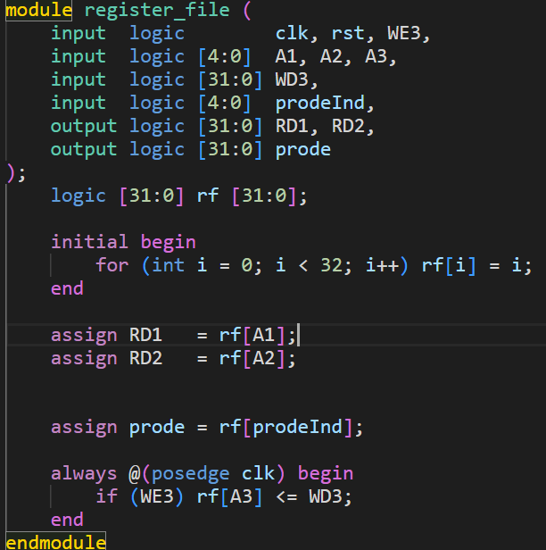

Muxs

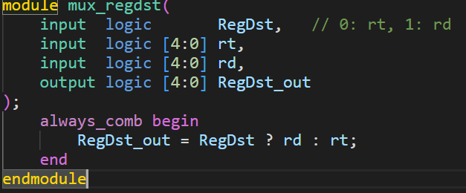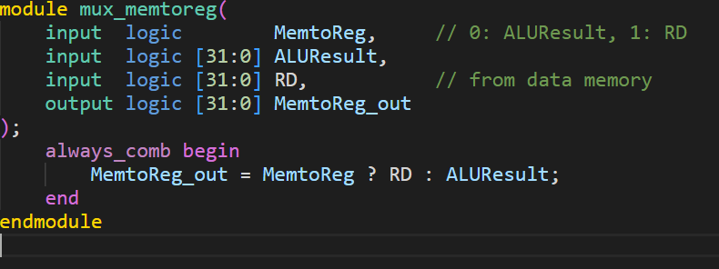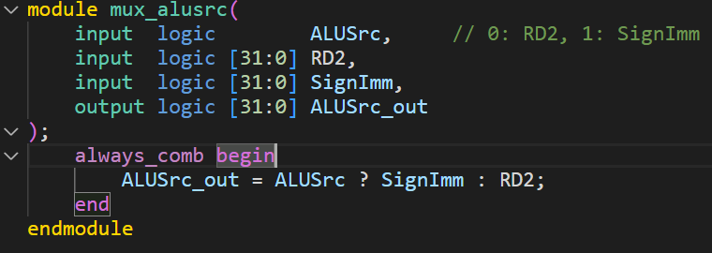

Sign extender
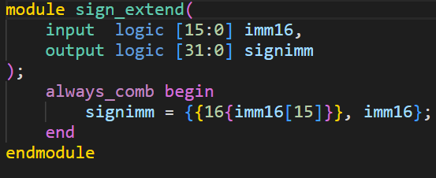
Waveform
