Module Name: Manual Test Execution
Test Case ID: st_06
Tester Name: Dumraliya Piyush (Enrollment No: 2504030100041)
Webpage URL: https://www.demoblaze.com/

- TC 001:-Verify website opens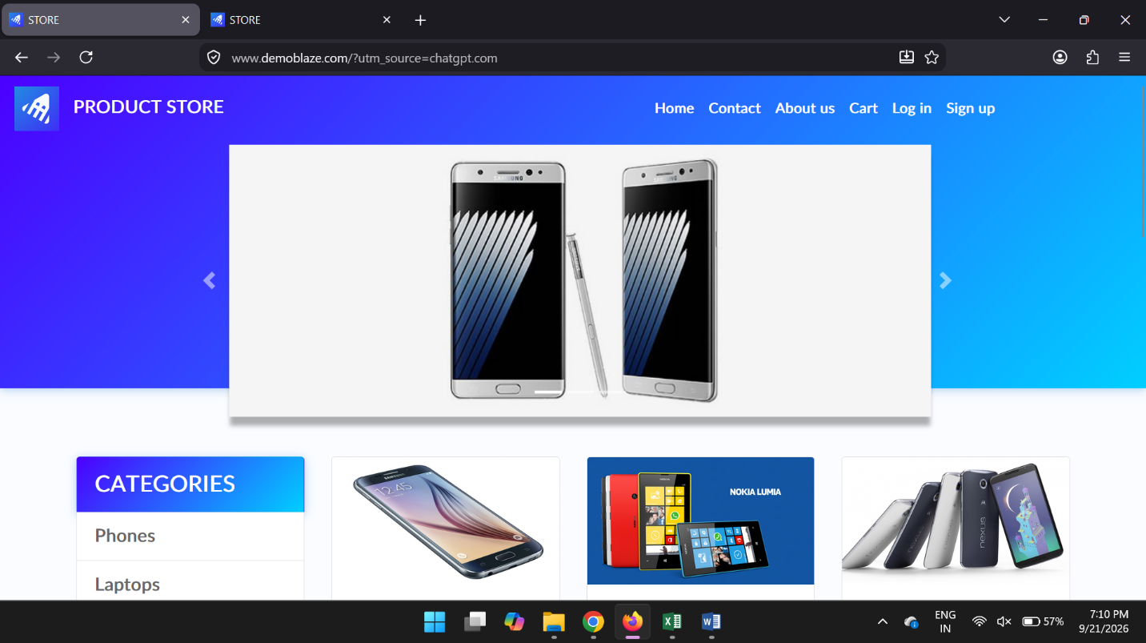
- TC 002:-Verify product selection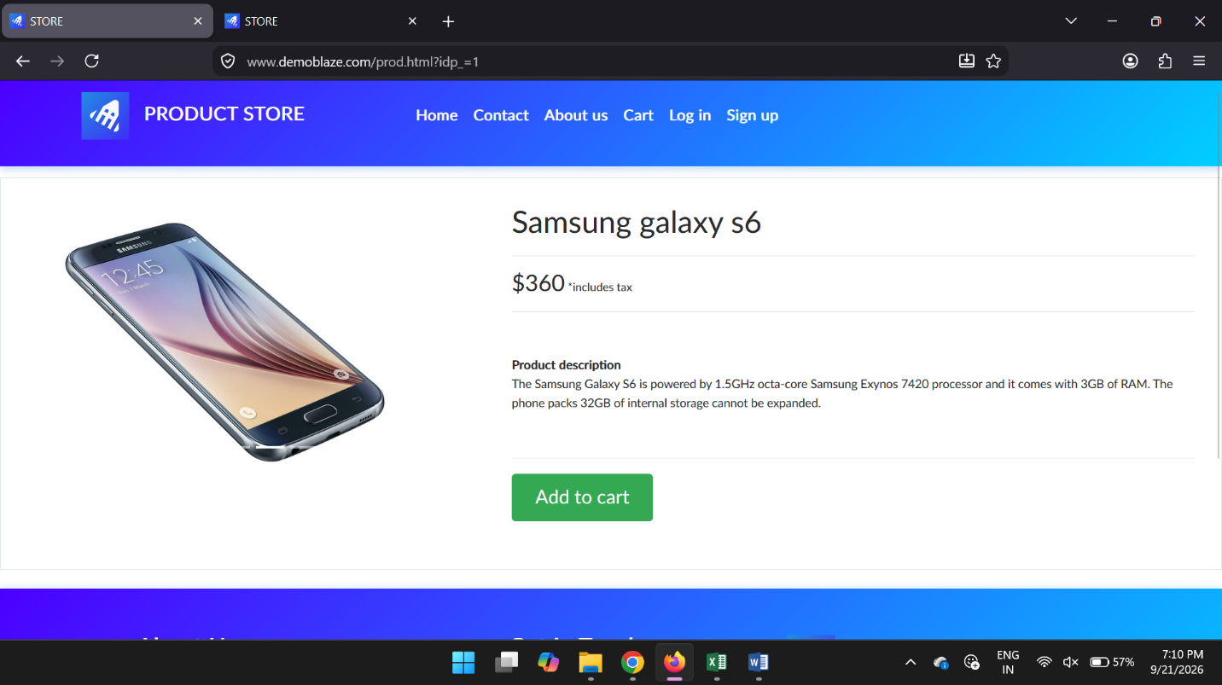
- TC 003:-Verify product details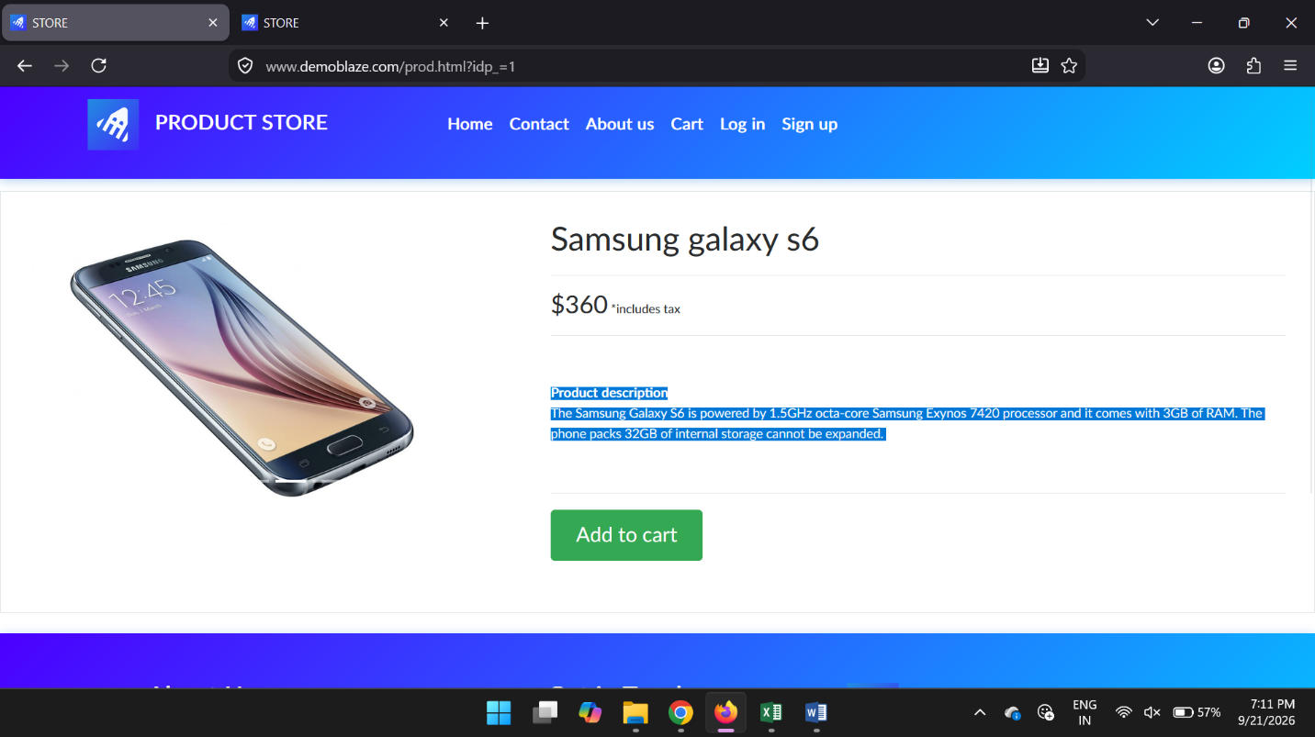
- TC 004:-Verify product is added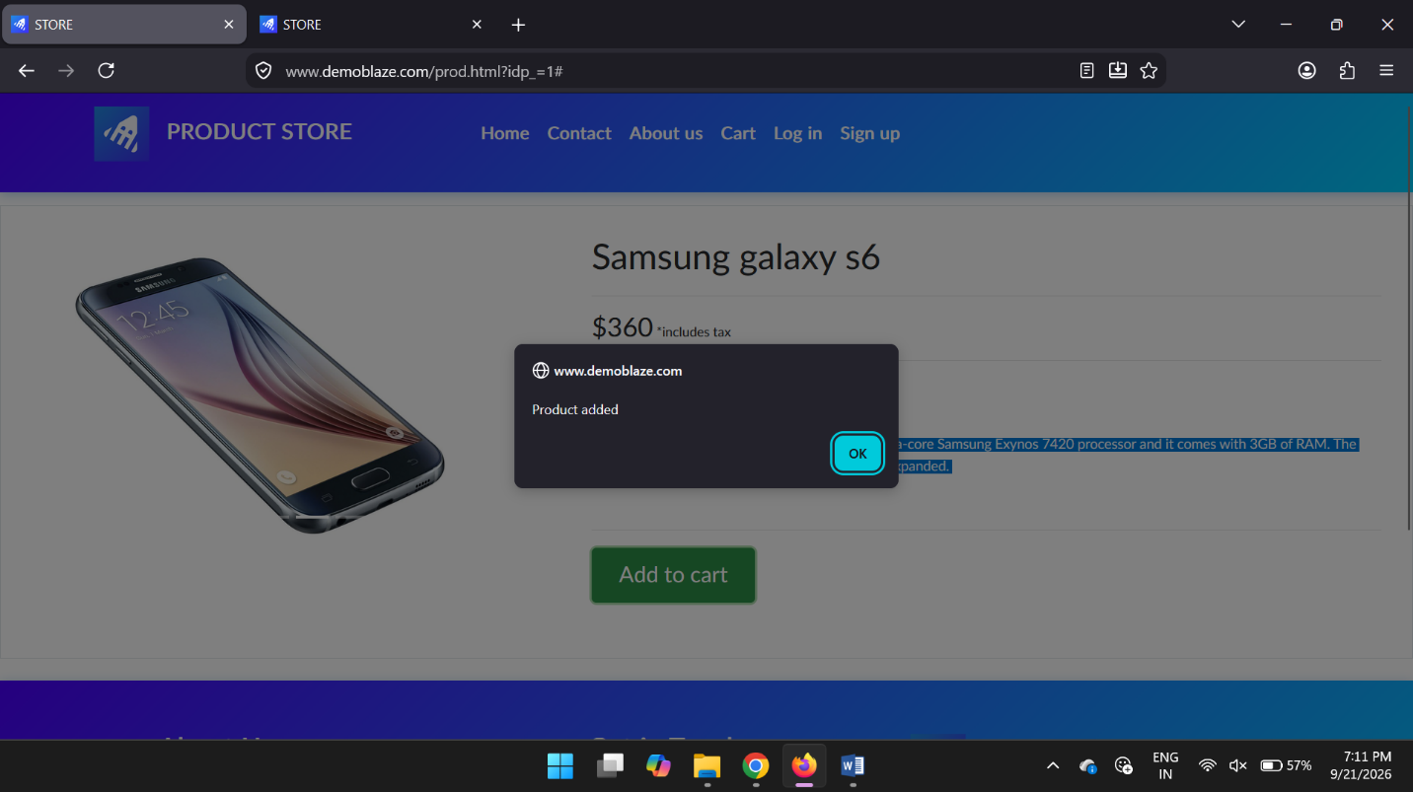
- TC 005:-Verify cart product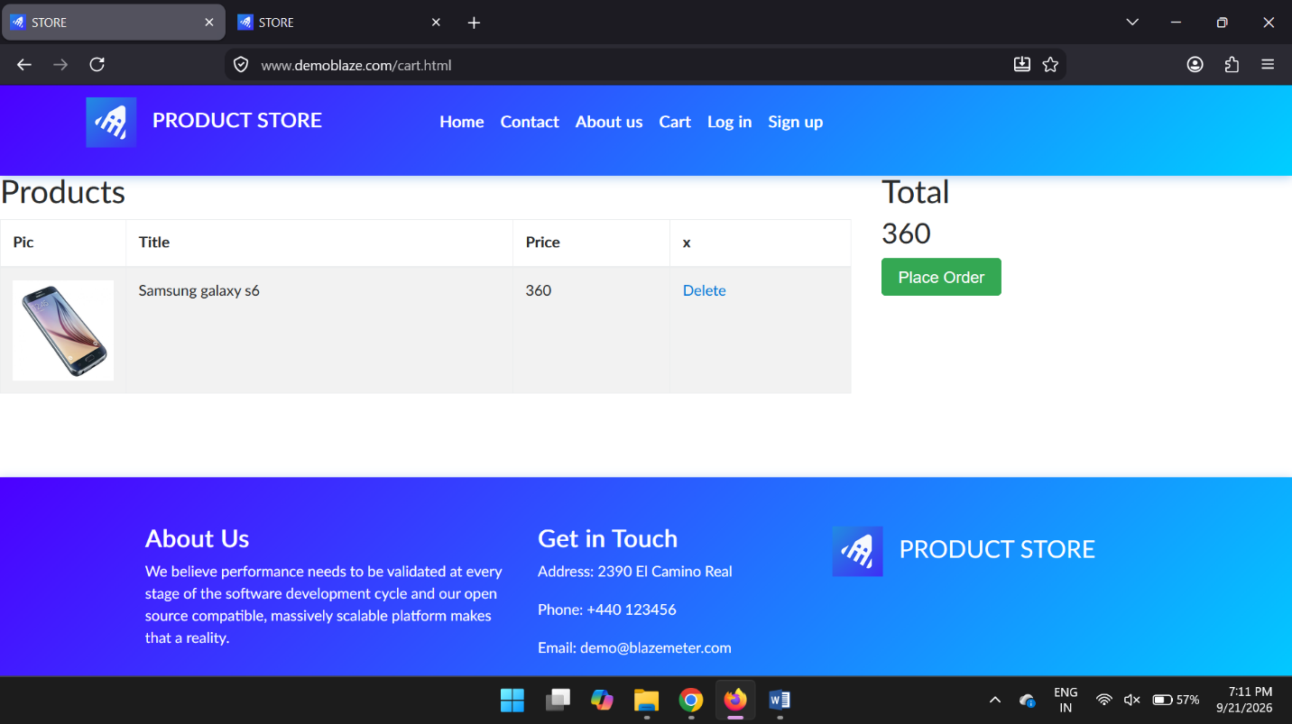
- TC 006:-Verify product price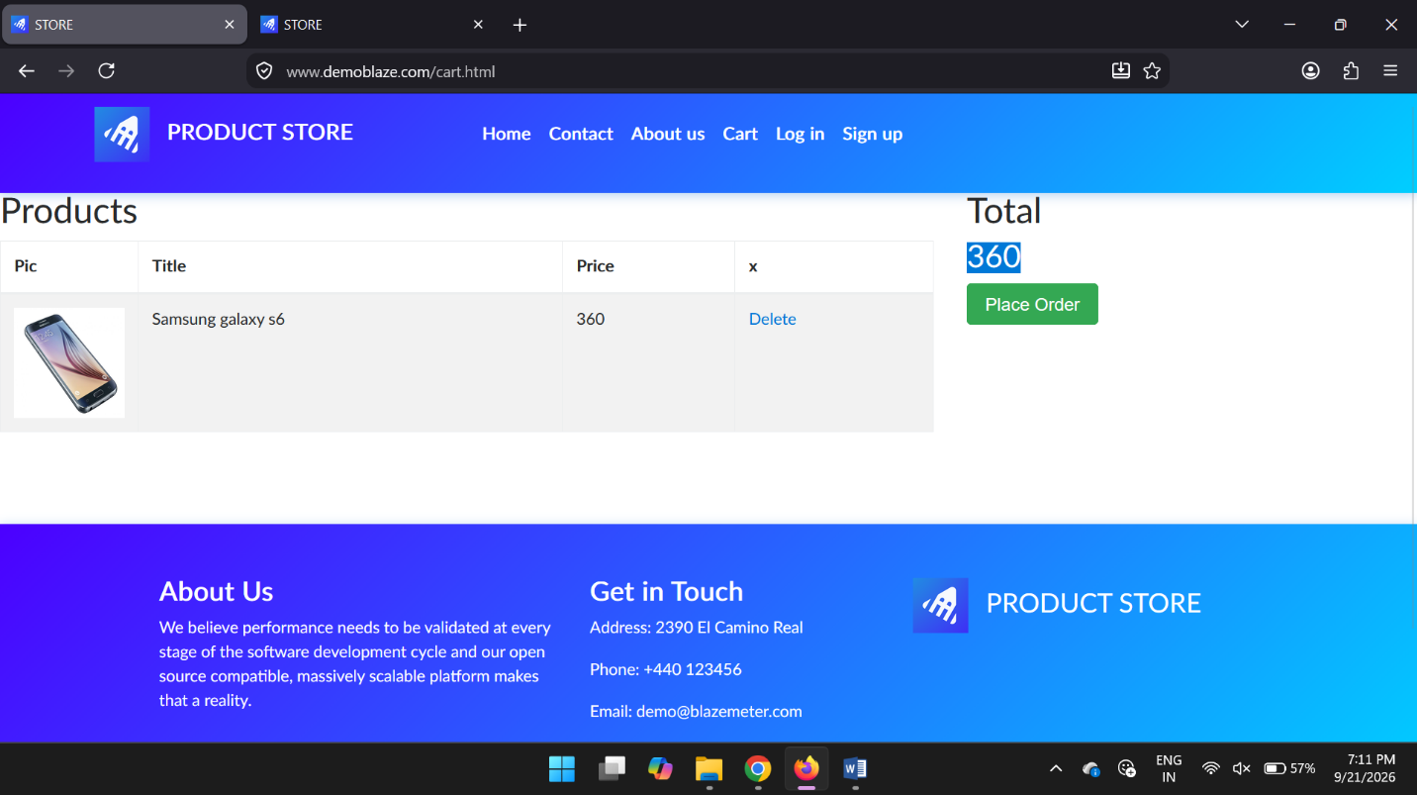
- TC 007:-Verify order form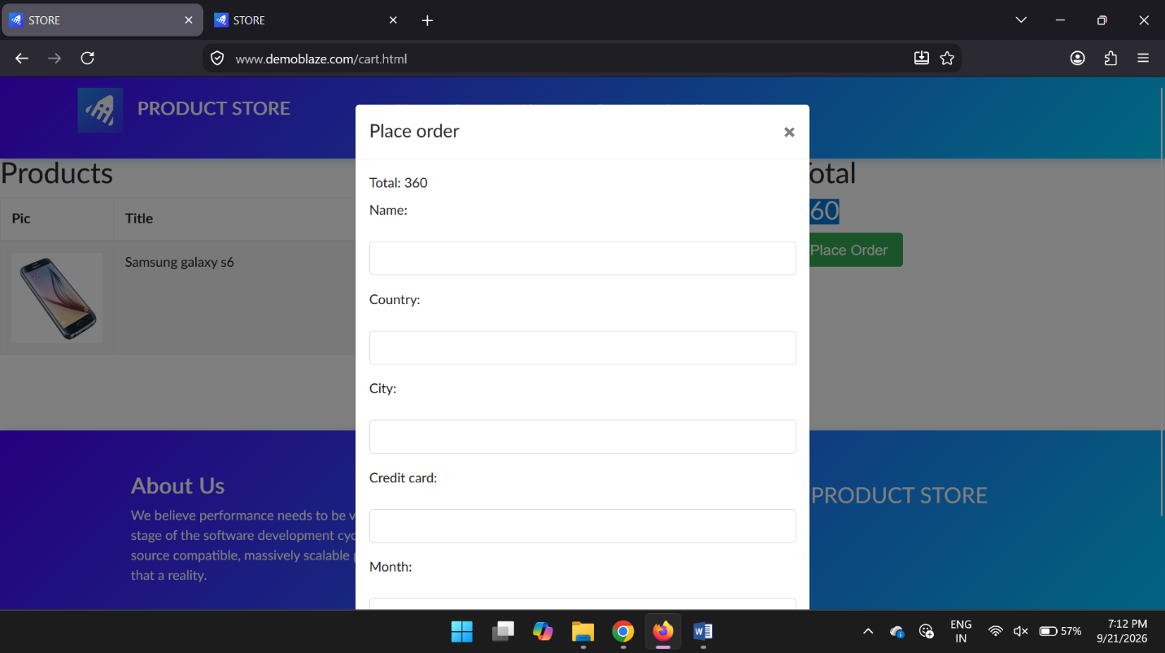
- TC 008:-Verify name field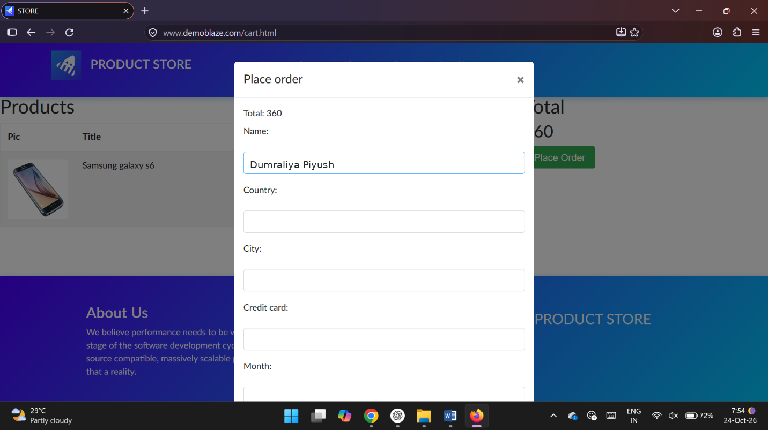
- TC 009:-Verify country field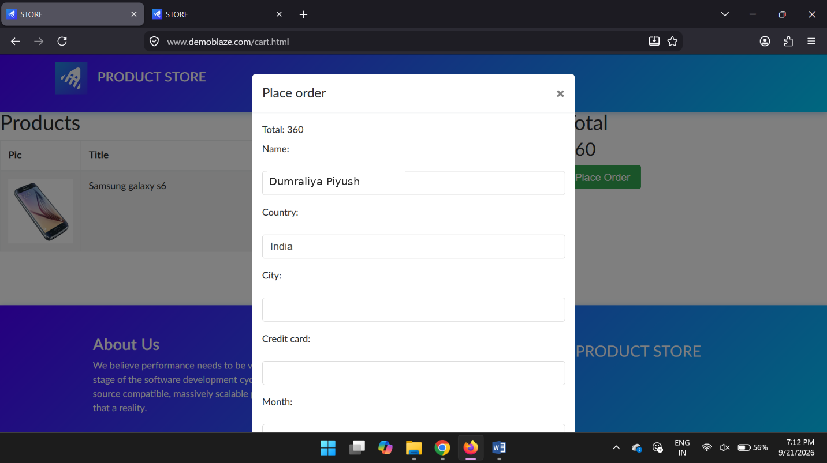
- TC 010:-Verify city field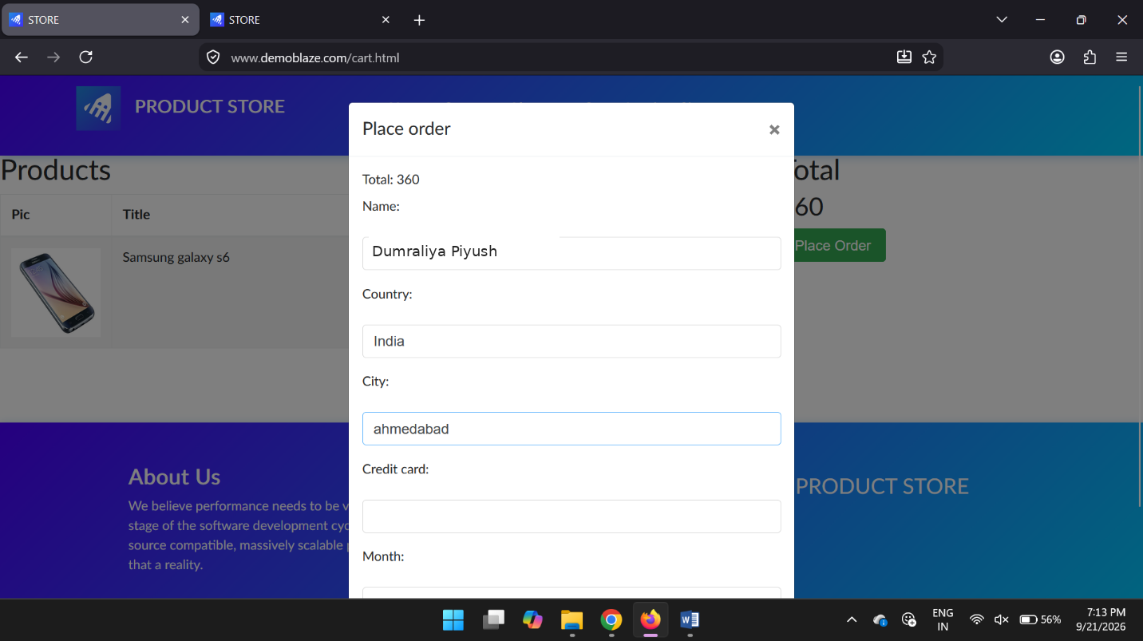
- TC 011:-Verify order submission