Module Name: SDLC & STLC PHASES
Test Case ID: st_01
Tester Name: Dumraliya Piyush (Enrollment No: 2504030100041)
Webpage URL: https://www.automationexercise.com/

TC 001:- login page display
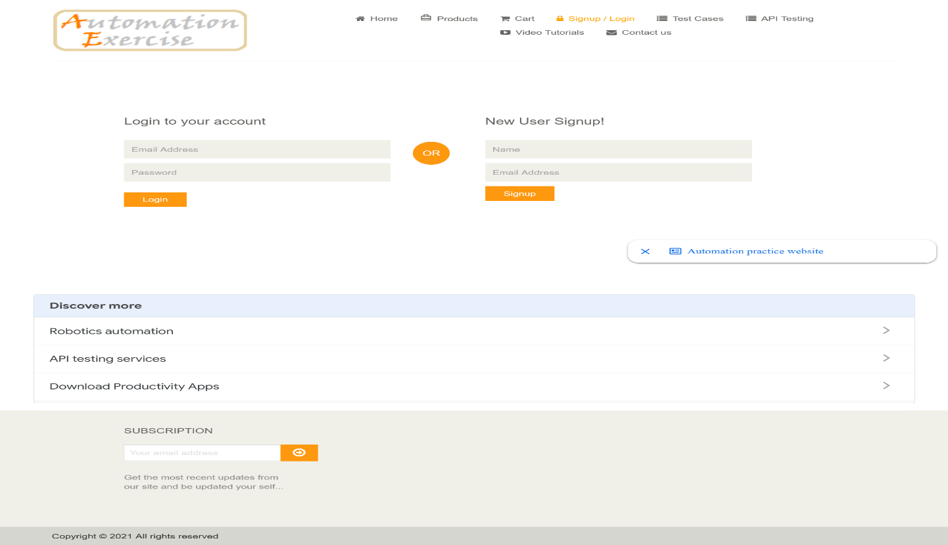
TC 002:- Enter login information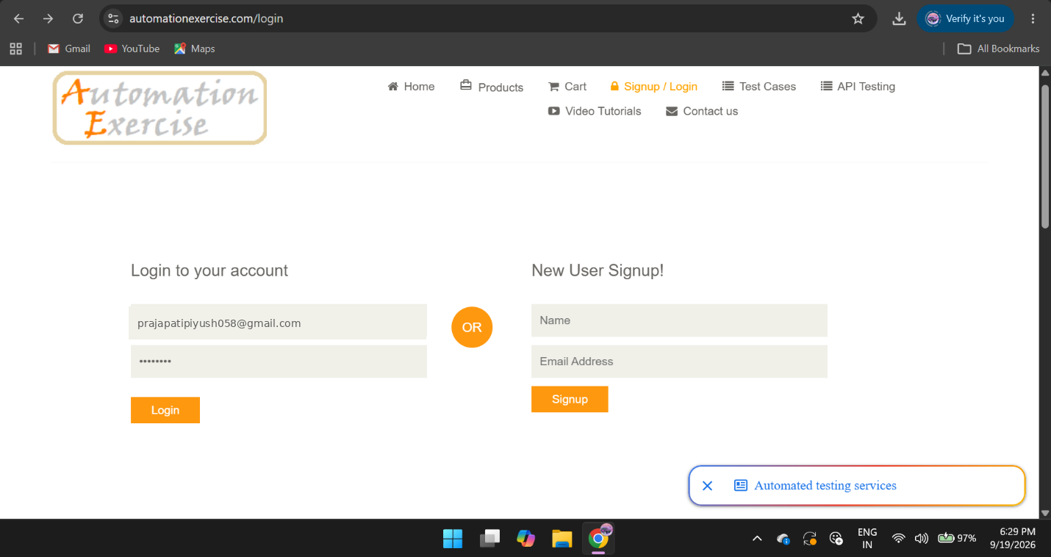
TC 003:- Blank username/email
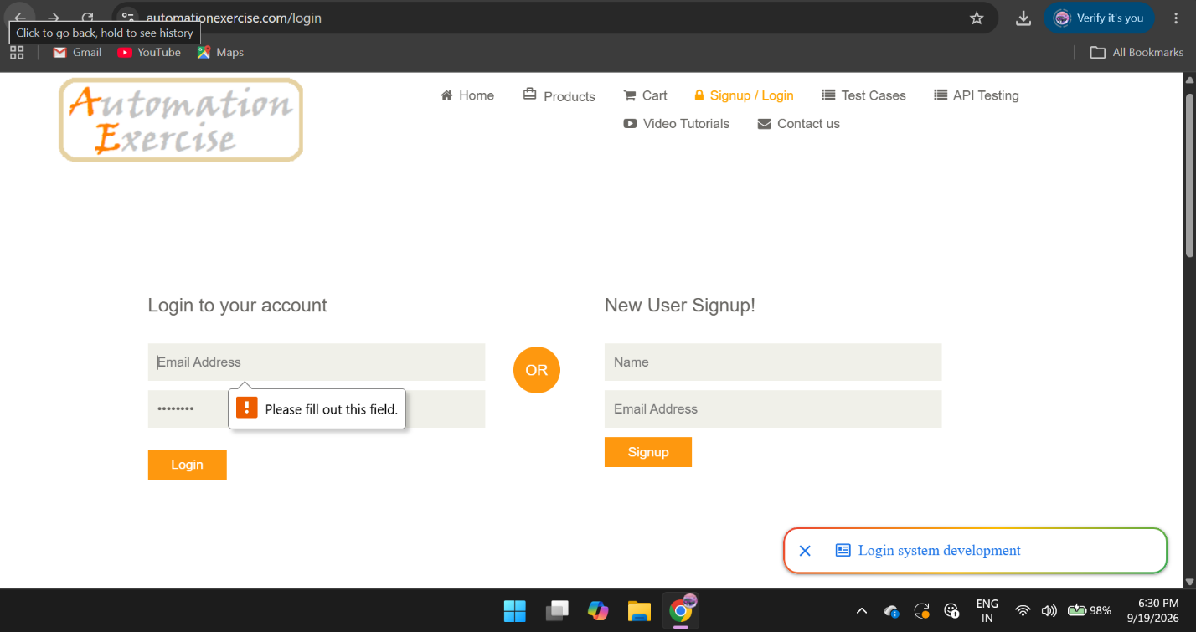

TC 004:- Blank password
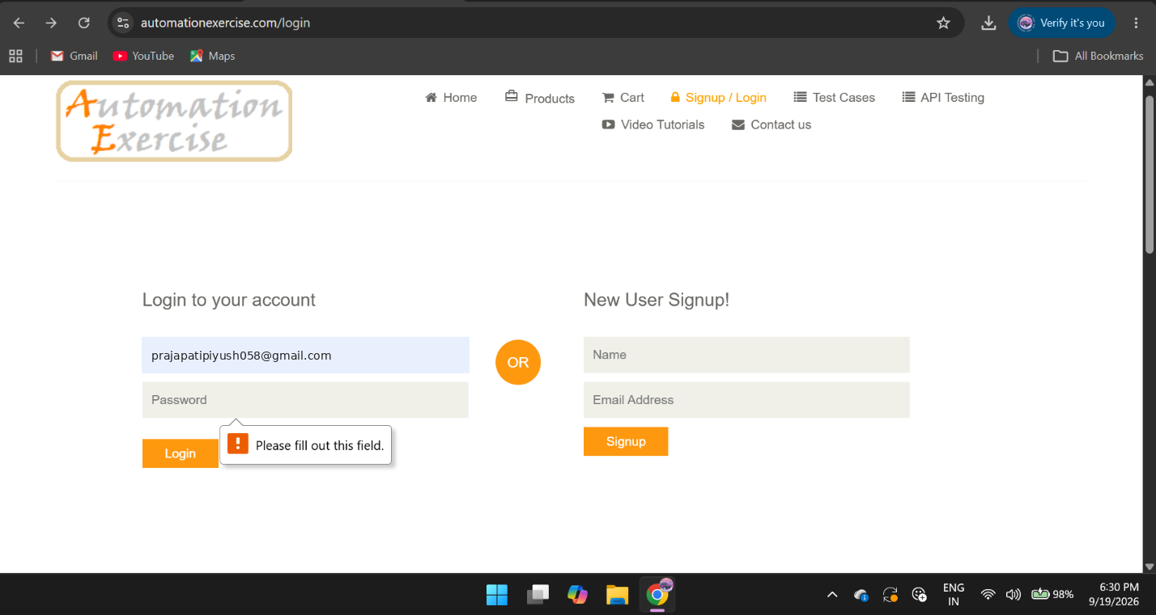TC 005:-wrong password

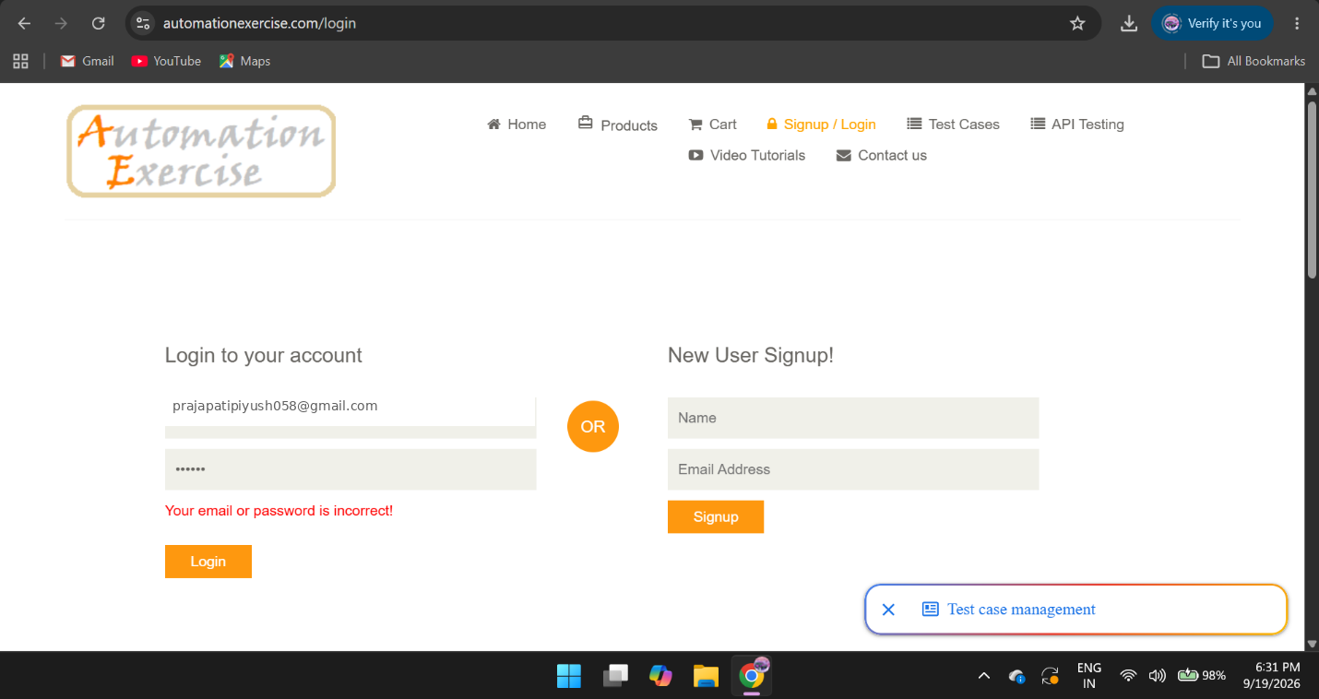
TC:- 006 Logout successful

