Module Name: Automated login testing
Test Case ID: st_15
Tester Name: Dumraliya Piyush (Enrollment No: 2504030100041)
Webpage URL: https://www.saucedemo.com/
TC 001. Valid Login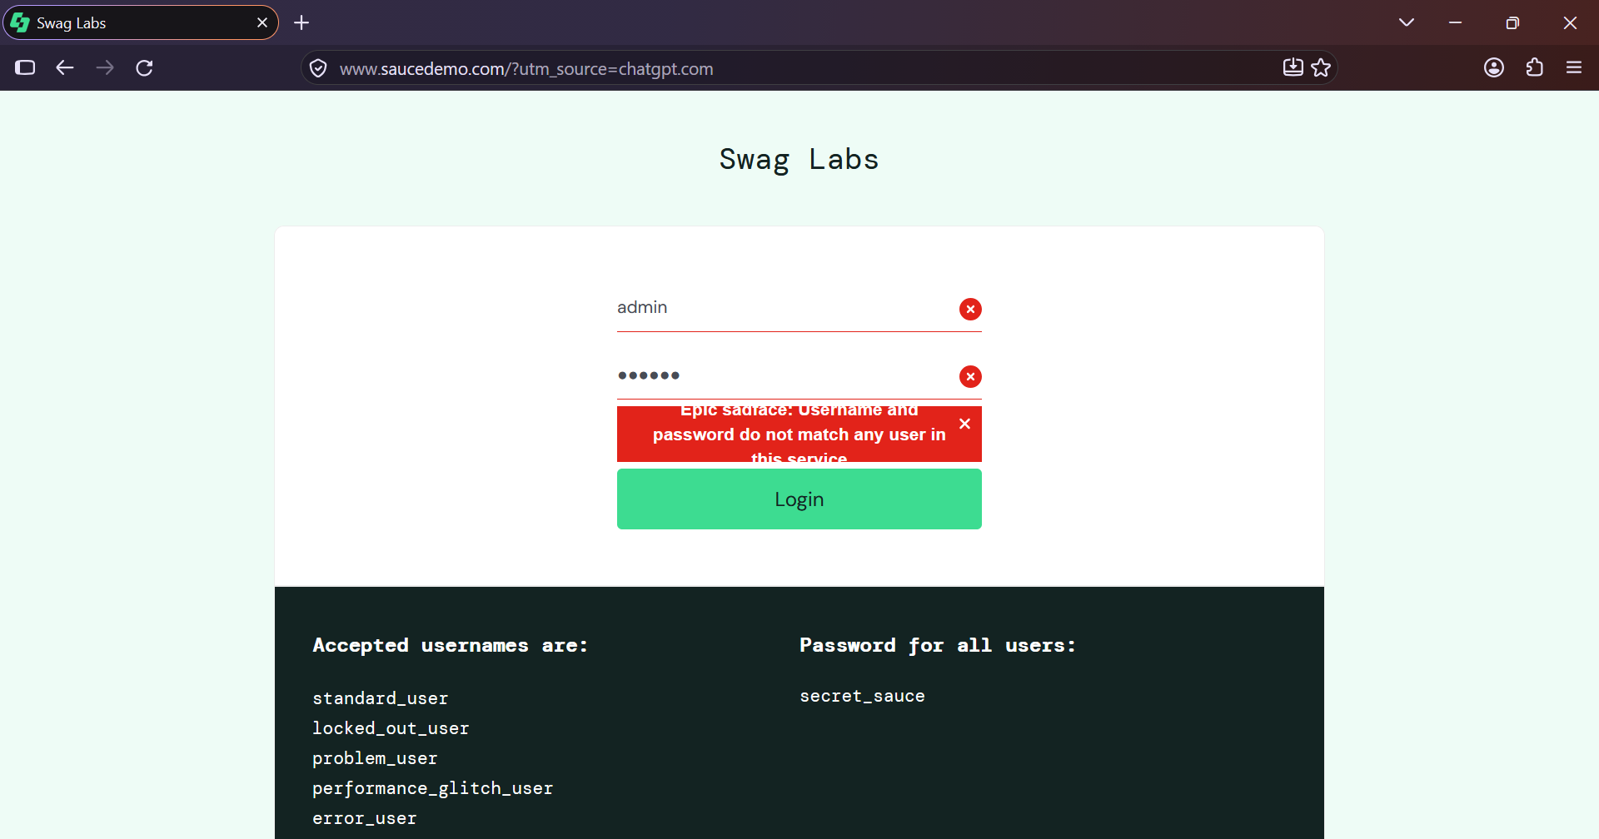
TC 002. Invalid Login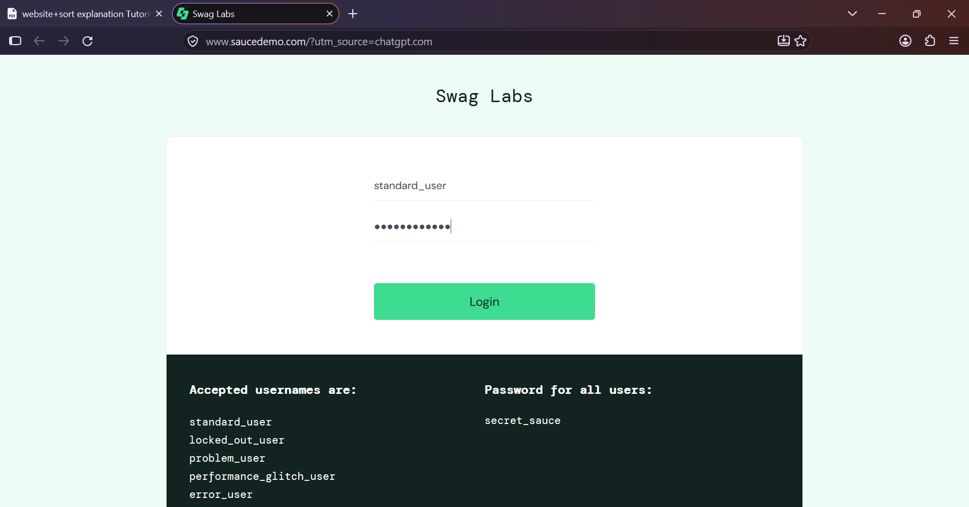
TC 003. Authentication Result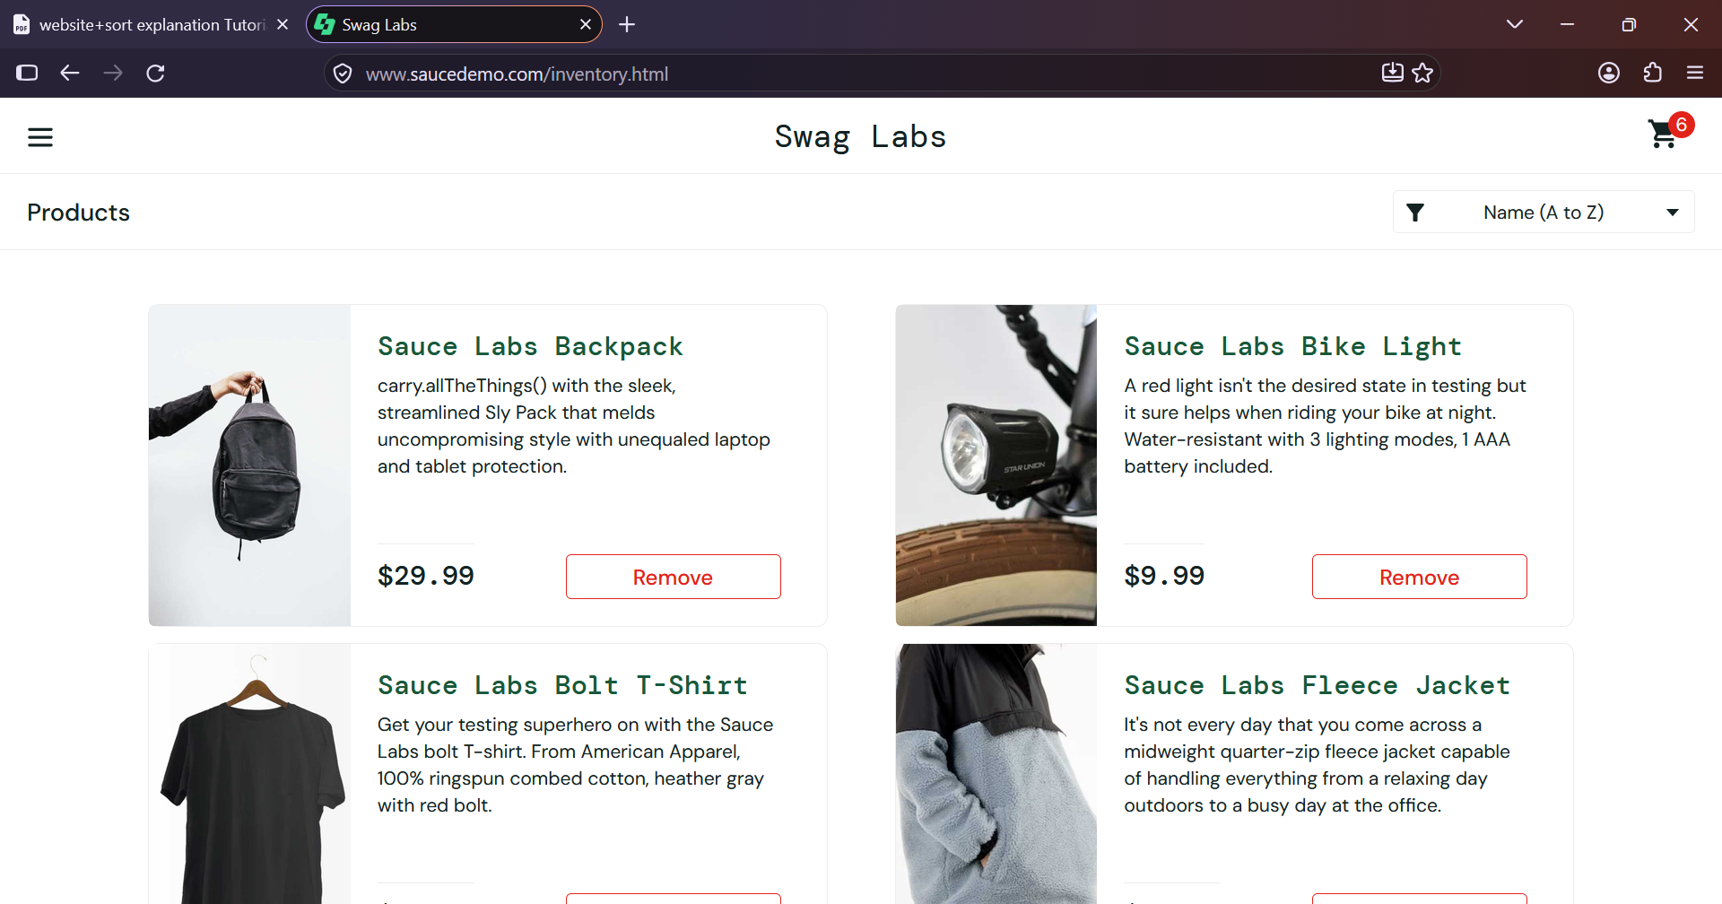
TC 004. Assertion Result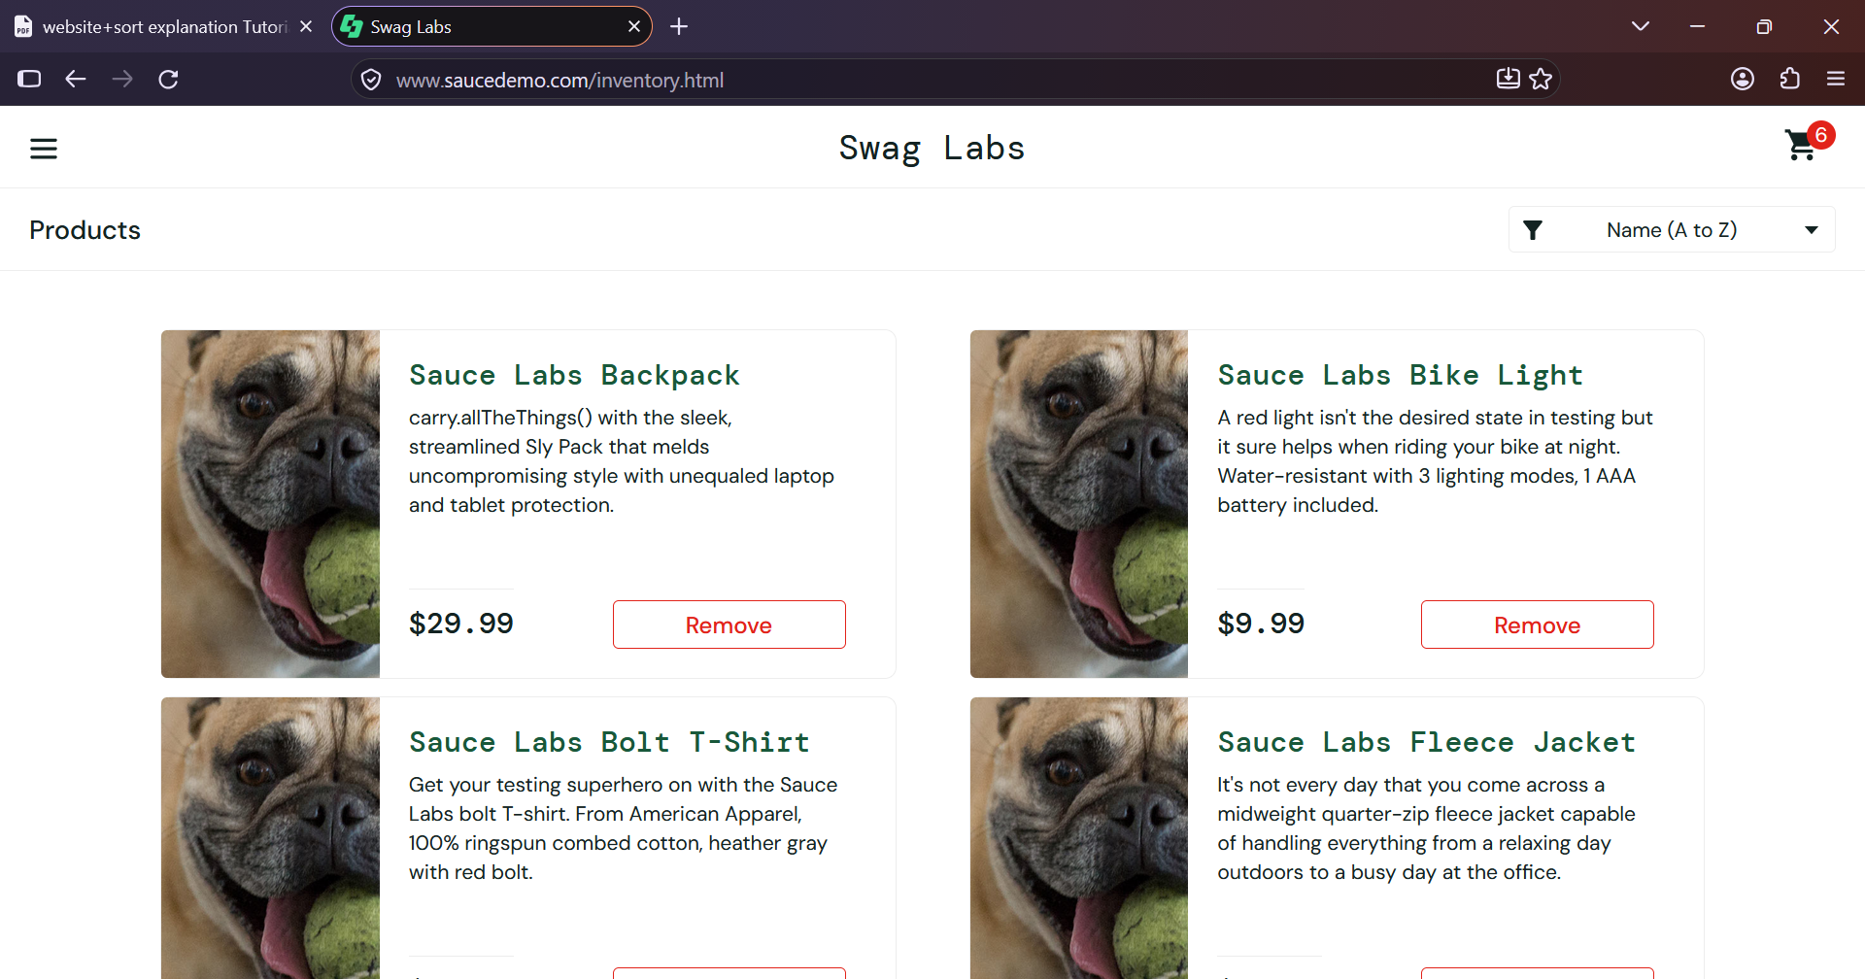

TC 005. Logout