SYSTEM REQUIREMENTS
Real-Time Pan-Tilt Laser Tracking System
Author | Duncan Nam
Version | 1.0
Date | 2026-MAY-02
Status | Draft

1. System Overview
The system shall detect a user-defined colored object in real time using a USB webcam, compute the object's centroid position in the camera frame, and command a two-axis pan-tilt servo mount to center the object. A laser pointer mounted to the pan-tilt assembly shall track the object. The live camera feed shall be accessible from a MacBook Air over the local WiFi network. The system is intended as a personal engineering demonstration project.

2. Functional Requirements
- FR-01 Color Detection: System shall detect a user-specified HSV color range in the camera frame and identify the target object's centroid.
- FR-02 Servo Control: System shall command pan and tilt servo angles to maintain target centroid within a defined deadband of frame center.
- FR-03 PID Tracking: System shall implement a proportional-integral-derivative (PID) control loop to drive pan/tilt error to zero.
- FR-04 Serial Link: Raspberry Pi shall transmit pan/tilt angle commands to Arduino via USB serial.
- FR-05 Video Stream: System shall stream the annotated live camera feed (with centroid overlay) to a MacBook Air via local WiFi network browser.
- FR-06 Laser Output: A 5mW 650nm laser module mounted to the servo assembly shall point at the tracked object.

3. Performance Requirements
- PR-01 Frame Rate: Vision processing pipeline shall operate at >= 30 fps.
- PR-02 Tracking Latency: End-to-end latency from object movement to servo response shall be <= 150 ms.
- PR-03 Angular Range: Pan axis: +/-90 degrees. Tilt axis: +/-45 degrees.
- PR-04 Deadband: Servo shall not be commanded if centroid error is < 5 pixels from frame center (prevents jitter).
- PR-05 Stream Latency: Video stream latency to MacBook browser shall be <= 500 ms.

4. Hardware Constraints
- HC-01 Compute: Raspberry Pi 5.
- HC-02 Microcontroller: Arduino Uno for servo PWM output.
- HC-03 Camera: USB webcam (e.g., Logitech C920), connected to Raspberry Pi.
- HC-04 Servos: 2x MG90S (or equivalent) on a commercial pan-tilt bracket kit.
- HC-05 Laser: 5mW 650nm laser module, 3.3V or 5V compatible.
- HC-06 RPi-Arduino Link: USB serial (via termios.h).

5. Software Constraints
- SC-01 Language: C++ on Raspberry Pi. C++ (Arduino framework) on Uno.
- SC-02 Vision Library: OpenCV C++ API.
- SC-03 OS: Raspberry Pi OS (64-bit, Debian-based Linux).
- SC-04 Streaming: mjpg-streamer running as a background process on RPi.
- SC-05 Version Control: Git / GitHub with README and demo video for portfolio visibility.

6. Out of Scope
- Multi-object tracking.
- Outdoor or variable-lighting operation.
- Autonomous target classification (color heuristic only, no ML).
- Wireless Arduino communication.
- Persistent data logging.

7. Acceptance Criteria
The system shall be considered complete when it can reliably track a handheld colored object across the full angular range of the mount for >= 30 seconds without losing lock, with the annotated feed simultaneously visible in a MacBook Air browser.

Appendix A — System Architecture Diagram
Figure A-1. Hardware and software component interfaces.
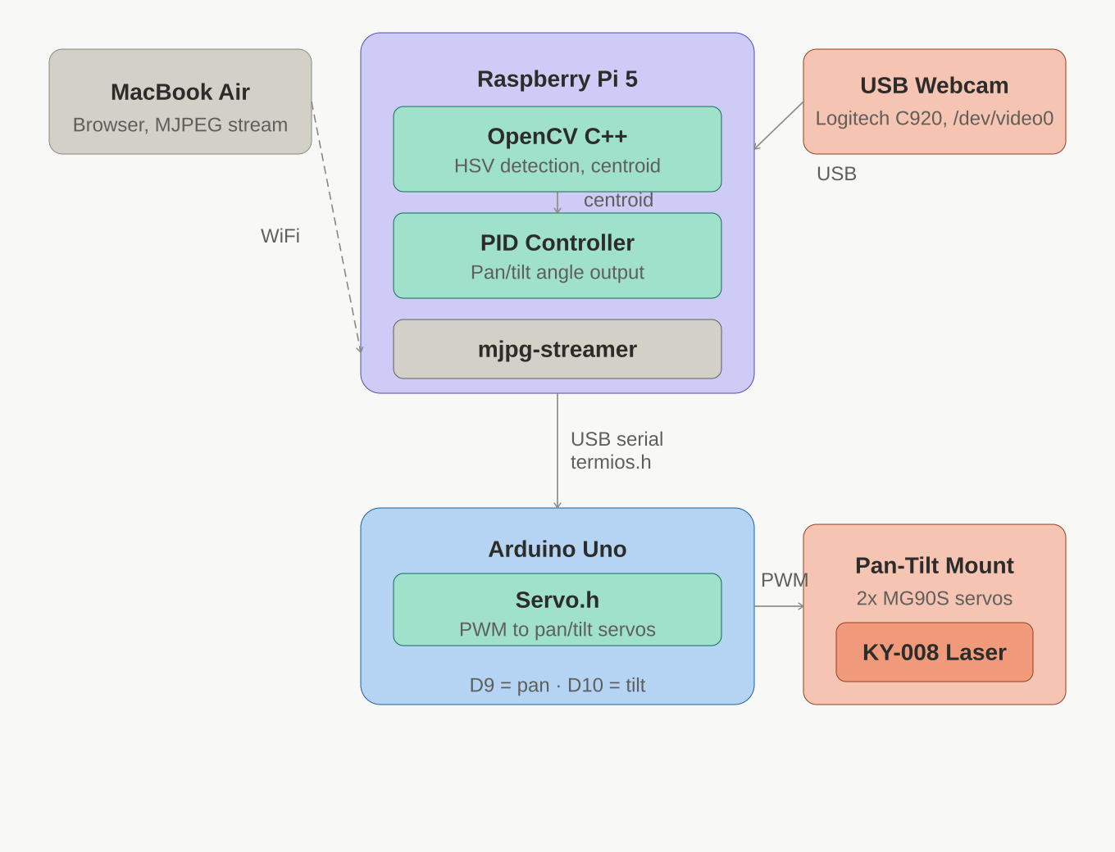

v1.0 — Duncan Nam — 2026-MAY-02

