**Guidance Bulletin** 

**No. 2021-04**

**SPACE THE FINAL FRONTIER!**

**How much space do you need for the works?**

When planning works it is often difficult to gauge how much space is required. This is particularly important when you need to apply for traffic management or Temporary Traffic Orders (TTRO) as the amount of space you need should be part of the plan and communication provided to the Highway Authority as part of the application. 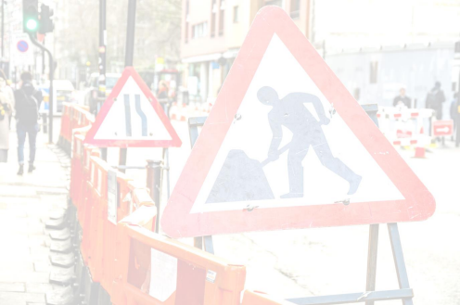

The space you need is formed up of 3 basic areas all of which are required under the Safety Code of Practice (Red Book).

**1.** Safety Zones – These include the lead in taper (**T** in the diagram below), Long ways clearance (**L**), sideways clearance (**S**), Vehicle / working space clearance (**C**) and the exit taper.

**2.** Working Space – The area required to conduct the works this includes the excavation and the area needed for plant, materials and vehicles.

**3.** Works Area – This is the space required for any physical excavation or opening.

When applying for a TTRO or any form of traffic management you **SHOULD** specify the 3 works areas separately so for example:

***Works area****: (Excavation) specify if this is within any TM or TTRO zone = approximately Xm*

***Working Space****: for vehicles plant and materials required to safely conduct works = approximately Xm* ***Safety zones****: including lead in and exit taper = approximately Xm (these are found in the table at the rear of the Red Book)*

***Always*** *use” approximately” as these dimensions may change due to on site conditions.*

**DO** be specific as to why any TM or TTRO is required i.e. for excavations or just for the working space e.g. vehicles.

**DO** provide as much detail as possible on a TTRO or TM application to enable HA to review.

**DO** ensure you communicate clearly with the HA in respect to any application.

**DO** ensure all agreements are confirmed in writing and kept as part of the works record.

**DON’T** assume the HA understand your requirements be clear as to what space you need and why. **DON’T** deviate from your plan without consulting with the HA

**\*HAUC(UK) thanks Morrison Water Services in their help in the creation of this guidance. **

**This information is general guidance only and is not intended to replace specific legal advice. None of HAUC(UK) or its members, accept any liability for any action or omission taken based on this guidance.**