**Guidance Bulletin** 

**No. 2021-05**

**DAMAGE IS DANGEROUS**

**Assessing the condition of the signs and barriers?**

We should put our customers at the heart of everything we do and be committed to delivering services to be proud of. In delivering those services, a Utilities, Contractors or Highway Authorities brand is most prominent on our street works sites which present an opportunity to project a positive image to thousands of road users every day. At the same time, it is recognised that our street works often involve working in wet, muddy conditions where staining and soiling can be unavoidable. 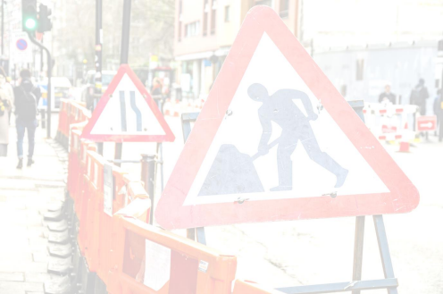

This guidance has been produced for operatives, supervisors and managers to provide some criteria to follow when assessing the condition of signs and barriers used on sites.

**Major** 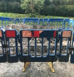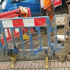

• A broken / damaged sign or barrier that is not safe or fit for

purpose e.g. feet broken or missing, splits in hand rails.

• A sign or barrier that has been defaced (e.g. graffiti)

• A barrier where over 20% of the public-facing surface has been

soiled or damaged

• A sign where over 10% of the surface has been soiled /damaged

• A missing reflective strip from a barrier, sign or cone facing traffic.

• **Any Equipment with the above should be removed from site as soon as practicable**

**Minor** 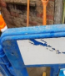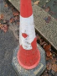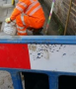

• Minor damage to a reflective strip affecting more than 5%

and/or significantly impacting reflectivity.

• Significant soiling to a sign or barrier which affects less

than 20% of the public facing side.

• Minor damage to a sign (affecting less than 10% of

surface and not impairing its use).

• **Any Equipment with the above should be replaced as soon as practicable or not permitted for reuse until rectified**

**Insignificant / none** 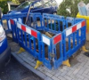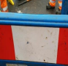

• Minor isolated damage to a sign or reflective strip

• Recent ‘thumb-prints’ on barriers or signs

• Any soiling to the internal face of barriers, not facing the public

**\*HAUC(UK) thanks Morrison Water Services in their help in the creation of this guidance. **

**This information is general guidance only and is not intended to replace specific legal advice. None of HAUC(UK) or its members, accept any liability for any action or omission taken based on this guidance.**