**Guidance Bulletin** 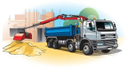

**No. 2021-06**

***DASH and GRAB!***

**The use of Grab and other large vehicles at street works**

Grab and other HGVs are large intimidating vehicles which can cause traffic chaos and a danger to road users if they are not managed effectively when they arrive on a site to conduct their activity. We use these vehicles for a variety of tasks ranging from the collection of spoil to the delivery of materials and plant all of which should be done with the minimum disruption to the road user and the maximum amount of safety for everyone. 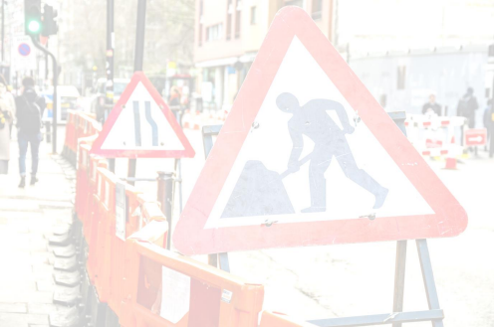

Parking

When arriving on site any driver must report to the site manager / lead operative and be briefed on the Plant and Vehicle Movement Plan (**PVMP**). The vehicle should either be fully incorporated into the site including any Temporary Traffic Management (TTM) or parked away from the works in a safe and legal position until the safe movement and position of the vehicle to carry out its task can be established. The task specific Risk assessment **AND** the Street Works Site Specific Risk Assessment should be completed or amended as appropriate **BEFORE** the task commences.

**DO’S & DON’TS**

▪ **DO** Park Safely and legally without obstructing any footways or cycle ways

▪ **DO** Obey any directions given by the lead operative / Site Manager in respect to manoeuvring or parking the vehicle ▪ **DO** Think about the impact of your vehicle on other road users and avoid arriving on site a peak traffic times such as school pick or rush hour

▪ **DO** Arrange for surplus to be stored in accessible areas away from pinch points etc.

▪ **DON’T** Park your vehicle in a position which causes danger or disruption to road users

▪ **DON’T** Block footways or cycleways

**Use**

**DO’S & DON’TS**

▪ **DO** Complete your *Lorry Loader / Grab Task Specific Risk Assessment*

▪ **DO** Be aware of operatives, pedestrians and other road users during lifting / grabbing operations

▪ **DO** Operate your vehicle in accordance with any training.

▪ **DON’T** use your lifting arm over live footways or carriageways

▪ **DON’T** Manoeuvre without a banks man to assist you.

▪ **DON’T** Assume anything always ask if you are in any doubt about how to undertake operations safely.**\*HAUC(UK) thanks Morrison Water Services in their help in the creation of this guidance. **

**This information is general guidance only and is not intended to replace specific legal advice. None of HAUC(UK) or its members, accept any liability for any action or omission taken based on this guidance.**