**Guidance Bulletin** 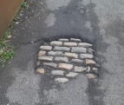

**No. 2021-07**

**UNDERCOVER ROADS**

**How to manage Modular Material within the Excavation?**

All is not what it appears!!! On occasion we excavate in a carriageway or footway with a bituminous surface to find that just underneath there are cobbles, sets or other modular materials which formed the original surface which has over time been overlaid with HRA or DBM material. 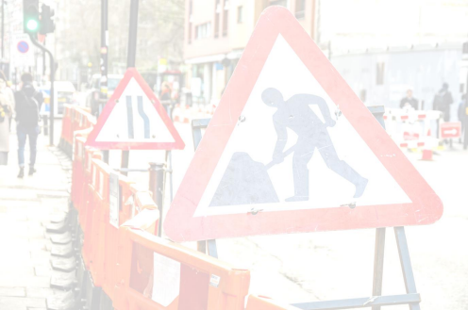

We cannot ignore these situations and we should make every effort to preserve these materials which in some cases have historical value and interest. At the time of uncovering these modules you should contact the Highway Authority and inform them of the discovery and ask them how they would expect the final reinstatement to be conducted. Providing the Highway Authority are reasonable in their request you should endeavor to comply with it **HOWEVER** if they are not reasonable you may revert to **s6.3.8** of the SROH.

Modular materials within the excavation

**S6.3.8** Where cobbles or setts are encountered during excavation, they may be recovered and re-used for reinstatement of the relevant layer. **Alternatively, and at the discretion of the undertaker, the layer may be reinstated using CBGM base laid to a thickness of 100 mm, or to match the original thickness, whichever is greater**.

**S6.3.9** Modules, cobbles, setts, stones, rocks, or other large aggregate materials laid upright in an interlocking fashion, often termed ‘penning’, will exhibit a greater stiffness than an equivalent layer of cobbles/setts laid horizontally. Where such upright interlocking modules are encountered, the layer **MUST** be reinstated using CBGM base laid to a thickness of 100 mm, or to match the original thickness, whichever is greater.

**S6.3.10** Where surplus modules, cobbles or setts are removed from site, they remain the property of the authority. The undertaker must notify the authority and retain them for 10 days following such notification. Thereafter, the undertaker is free to dispose of them.

*.*

• **DON’T** Remove any modules, cobbles or other hidden materials **WITHOUT** informing your supervisor or line manager. • **DON’T** Assume the Highway Authority know what is under the surface of their network.

• **DON’T** Remove any modules or cobbles from site without ensuring they will be stored in a safe place ready for replacement or return to the HA.

• **DON’T** Forget to photograph and measure the materials in situ before removing them.

**DON’T** Reinstate works without consulting the Highway Authority

• **DO** Inform your supervisor or line manager immediately when modules are uncovered.

• **DO** Contact the Highway Authority as soon as modules, cobbles or other materials are uncovered.

• **DO** Always photograph the modules in-situ before continuing excavation works.

• **DO** Store any modules, cobbles or other materials in a safe place and return to HA if not used.

• **DO** Always check with your supervisor or manager before undertaking any reinstatement.

**DO** Always record the final method of reinstatement on ETON using the comments field to capture the detail**\*HAUC(UK) thanks Morrison Water Services in their help in the creation of this guidance. **

**This information is general guidance only and is not intended to replace specific legal advice. None of HAUC(UK) or its members, accept any liability for any action or omission taken based on this guidance.**