Guidance Bulletin 

No. 2021-08

*Abandoned Vehicles*

**Vehicle Parking on Site**

On arrival at a new or established works site you must park your vehicle safely and legally before you unload or set up signs, lights and barriers or start work. Where possible the vehicle should be parked off the road in a position that does not obstruct a footway or cycle route. If you cannot park off the road, the vehicle must be either fully incorporated within the works site *(see page 21 of the Red Book)* or be clearly visible to other road users. Turn on your roof-mounted amber beacon(s), 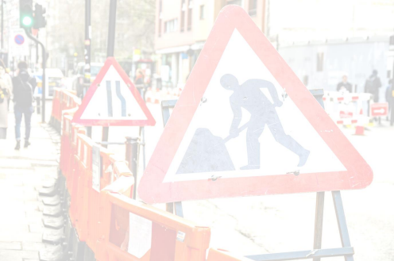

and aim to ensure that any high visibility markings on the vehicle are facing on-coming traffic. It will be safer to get out of the vehicle on the passenger side, rather than stepping into the traffic stream.

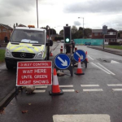 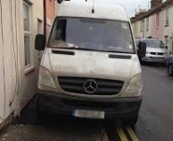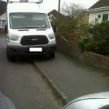

DO’s & DON’Ts

**DO** Park your vehicle with care and consideration to other road users, footway users and residents. **DO** Park your vehicle legally or you could be subject to a Fixed Penalty Notice or even points on your licence. **DO** Incorporate your vehicle properly within any works site this may require alterations to your site. **DO** Adjust any SLG when incorporating vehicles within the works site especially tapers and other safety zones. **DO** Secure your vehicle at all times.

**DO** Make sure you dip you lights when facing oncoming traffic when parking at night.

**DON’T** Park where your vehicle will block a footway or cycle way.

**DON’T** Block residents access, commercial premises, junctions or pedestrian crossings.

**DON’T** Park where your vehicle obstructs any permanent or temporary signage.

**DON’T** Park on yellow lines unless you are within the works site as you could get a Parking Fixed Penalty Notice **DON’T** Leave your vehicle unsecured, lock it or lose it.

**DON’T** Forget to include vehicle parking in your Street Works Site Specific Risk Assessment*HAUC(UK) thanks Morrison Water Services in their help in the creation of this guidance. 

This information is general guidance only and is not intended to replace specific legal advice. None of HAUC(UK) or its members, accept any liability for any action or omission taken based on this guidance.