Guidance Bulletin 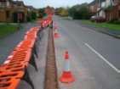

No. 2021-09

*Brace Yourself!*

**Bracing Barriers & Double Clipping**

It’s not just during windy weather that it is important that signs and barriers are stabilised so they remain in position. Signs and barriers can be moved by many things including 3rd parties who find it amusing to push them over or they can be moved or blown over by the wind or passing vehicles all of which can lead to serious problems: 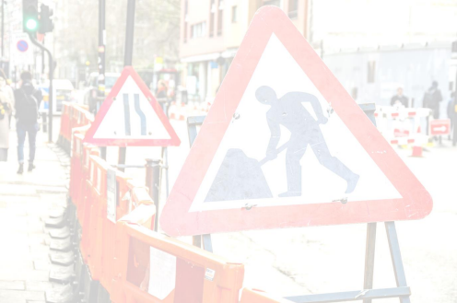

▪ Dangers to pedestrians and traffic from exposed excavations;

▪ Collision and trip hazards from signs and barriers in carriageway and footway;

▪ Inadequate advance warning of works due to signs not being visible;

▪ Highway Authority inadequacies for non-compliant signing and guarding.

Standard one-piece barrier systems are mostly self-ballasted and can withstand a Class C wind (19mph) *(Gentle breeze. Leaves and twig in constant motion. Wind extends a flag)* (check manufactures data sheets for performance) **BUT ONLY** if they are correctly put together and clipped ideally with a **double clip** to add extra security. For long lengths of barrier, you should also be cross bracing every 4 or 5 lengths to increase stability.

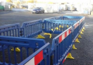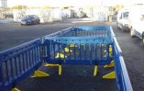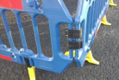

Some new road signs are self-ballasted and can withstand a Class C wind (19mph) (check manufactures data sheets for performance) **BUT** may still require fixing if there were strong persistent winds or heavy traffic caused movement of signs.

**DO’s & DON’Ts**

▪ **DO** Carry out a risk assessment on the weather / road conditions and brace/fix your signs and barriers accordingly. ▪ **DO** Ensure you are carrying enough sandbags to stabilise your signs and barriers if required; ▪ **DO** Fill sandbags with sand or fine granular material;

▪ **DO** Place sandbags at low levels to make signs and barriers as stable as possible;

▪ **DO** Ensure all barriers are **double clipped** at all connection points;

▪ **DO** Ensure barriers are locked together correctly in a stable formation or braced using sandbags or cross bracing particularly for long trench lines.

▪ **DON’T** Substitute sandbags with pieces of spoil, kerbs or other heavy materials. These can be dangerous if hit by traffic

▪ **DON’T** Use single barriers in long lines without any bracing this is not adequate to protect the works and cannot resist the smallest of breezes

*The additional supplementary fixing of barriers and signs is not a mandatory requirement; however, risk assessments* ***should*** *be undertaken to decide when additional fixing may be required e.g. in strong prevailing winds or where heavy traffic causes movement. If in doubt fix it.*

*HAUC(UK) thanks Morrison Water Services in their help in the creation of this guidance. 

This information is general guidance only and is not intended to replace specific legal advice. None of HAUC(UK) or its members, accept any liability for any action or omission taken based on this guidance.