Guidance Bulletin 

No. 2021-10

*Blown Over!*

**Stabilisation of signs and barriers against wind**

During windy weather, it is important that signs and barriers are stabilised so they remain in position. Signs and barriers moved or blown over by the wind can lead to serious problems:

• Dangers to pedestrians and traffic from exposed excavations; 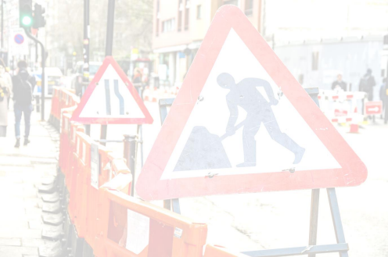

• Collision and trip hazards from signs and barriers lying down in carriageway and footway; • Inadequate advance warning of works due to signs not being visible;

Some non-metal framed signs are self-ballasted or designed to be self-stabilising and can easily withstand a Class C wind (19mph) *(Gentle breeze. Leaves and twig in constant motion. Wind extends a flag)* **BUT** may require additional fixing if there were strong persistent winds. In Scotland there is a mandatory requirement under the Safety Code that all barriers on unattended sites of 24hrs or more need to be able to withstand a Class B (39mph) so all systems would require some form of additional fixing.

DO’s & DON’Ts 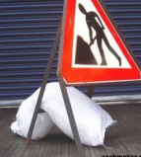

▪ **DON’T** Leave the yard with no, or too few sandbags;

▪ **DON’T** Substitute sandbags with large pieces of spoil, kerbs or other heavy materials. These can be dangerous if hit by traffic

▪ **DON’T** Place sandbags too high, causing signs to be unstable and “top heavy”.

▪ **DON’T** Forget to check that the sandbags are still in place before leaving the site.

▪ **DON’T** Use single barriers in long lines without any bracing this is not adequate to protect the works and cannot resist the smallest of breezes.

▪ **DO** Carry out a **risk assessment** on the weather / road conditions and brace/ballast your signs and barriers accordingly. ▪ **DO** Ensure you are carrying enough sandbags to stabilized your signs;

▪ **DO** Fill sandbags with sand or fine granular material;

▪ **DO** Place sandbags at low levels to make signs as stable as possible;

▪ **DO** Ensure all sand bags are removed when works are complete;

▪ **DO** Ensure barriers are locked together correctly in a stable formation or braced using sandbags or manufactured cross bracing particularly for long trench lines.

*HAUC(UK) thanks Morrison Water Services in their help in the creation of this guidance. 

This information is general guidance only and is not intended to replace specific legal advice. None of HAUC(UK) or its members, accept any liability for any action or omission taken based on this guidance.