Guidance Bulletin 

No. 11 - 2022

**What’s your Number?**

**Using Permit Boards**

All Permit Schemes operating in the UK require each works site to display a board with the permit number allocated to those works clearly marked on it. Failure to display the board can result in a Fixed Penalty Notice of **£80**. 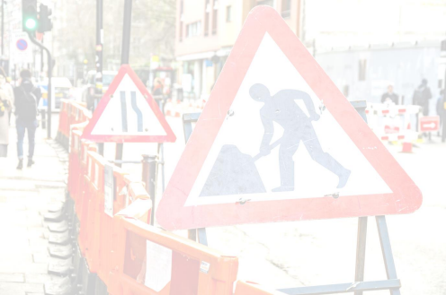

Our current permit boards have a blank white section for this number which is usually written on using a variety of pens from permanent markers to white board pens. Each has its own merits and restrictions with the permanent markers creating a permanent black smear on the board on removal to the white board pens being too easy to wipe off.

Alternative Methods

1. White Duct Tape –This tape is easy to place on the board and the number written on in permanent pen. When the board is finished with the tape is simply removed and disposed of.

2. Temporary Vinyl Labels – A vinyl labeling method for permit numbers is best suited to long term works where the sites are established for some time.

. 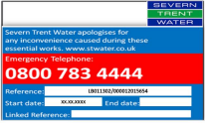

DO’s & DON’Ts

Standard Q Road Sign is self-ballasted and can withstand a Class C wind (19mph) *(Gentle breeze. Leaves and twig in constant motion. Wind extends a flag)* **BUT** would still require sandbags up to 12kg in weight if there were strong ▪ **DO** Make sure your signs are clearly visible, clean and not damaged in any way persistent winds or heavy traffic caused movement of signs.

▪ **DO** Check you have a permit in place for the site you are working on and you know the number. ▪ **DO** Check to make sure you put the **right permit number** applicable to your works on the board ▪ **DO** Write the number clearly as one number or letter wrong could result in a FPN worth **£80** ▪ **DO** Remove any old tape or number before attaching / writing the new

▪ **DO** Take a photograph of the board completed and positioned on site

▪

▪ **DON’T** Start works without displaying your permit board with the correct number. ▪ **DON’T** use damaged or dirty signs.

▪ **DON’T** Display more than one number, make sure the right number is on display and all others removed. ▪

*HAUC(UK) thanks Morrison Water Services in their help in the creation of this guidance. 

This information is general guidance only and is not intended to replace specific legal advice. None of HAUC(UK) or its members, accept any liability for any action or omission taken based on this guidance.