**Guidance Bulletin** 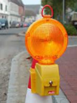

**13-2022**

*Light It Up*

**Proper use road danger lamps**

All street and road works on roads with a speed limit of 40 mph or more **must** have warning lights illuminated in poor visibility or during the hours of darkness. If your risk assessment requires it, warning lights should also be used on lower-speed roads. 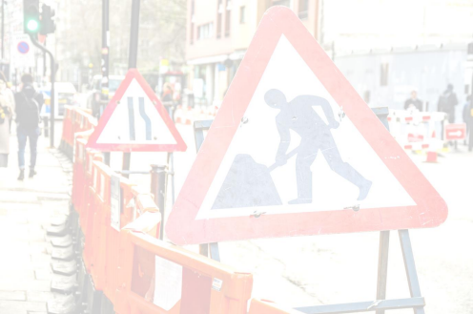

Steady warning lights can be used on all lit or unlit roads regardless of the speed limit. Where street lighting is present and illuminated, and where the speed limit is 40 mph or less, flashing warning lights are permitted as an alternative.

We should only be using approved products and lamps which only operate in steady mode as these can be used on every road type and speed. If your risk assessment requires it, road danger lamps must also be used on lower-speed roads.

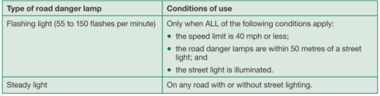

**DO’s & DON’Ts**

▪ **DO** place lamps on **all works** which encroach onto the carriageway.

▪ **DO** check you have working lamps correctly positioned before leaving site.

▪ **DO** try to secure lamps against theft or damage.

▪ **DO** photograph the site with lamps fixed before leaving site as a record of compliance. ▪ **DO** check you are using the right type of lamps for the road speed.

▪ **DON’T** Leave site without checking all SLG including the lamps, information board, barriers and other signage are in place and correct.

▪ **DON’T** use damaged lamps

*HAUC(UK) thanks Morrison Water Services in their help in the creation of this guidance. 

This information is general guidance only and is not intended to replace specific legal advice. None of HAUC(UK) or its members, accept any liability for any action or omission taken based on this guidance.