**Guidance Bulletin** 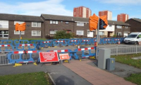

**14-2022**

*Crossing Fever*

**Closure of Pedestrian Crossing Points**

As part of making a site safe and compliant it may be necessary to close a pedestrian crossing point and provide an alternative safe place for pedestrians to cross the road away from our works. 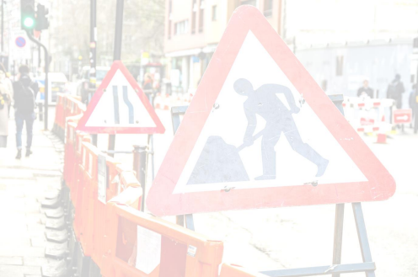

If a Pedestrian, Cycle (Toucan) or equestrian crossing has to be suspended owing to works you **MUST:**

• ensure the suspension has been **authorised** by the highway authority.

• agree with the highway authority what, if any, alternative arrangements will be provided for users of the crossing prior to suspension.

• ensure ‘Crossing not in use’ signs have been erected.

• ensure Zebra crossing globes, signal heads and push button units (including any tactile rotating cones under the push button units for visually impaired people) are covered using suitable covers **NOT** things like black bin liners.

• disable any audible warnings for visually impaired people and cover any tactile paving that can still be accessed. • erect barriers across the accesses to the crossing; and

• close both sides’ crossings if the works spread into one or both sides of a crossing that has a central refuge.

**DO’s & DON’Ts**

**• DO** Consider **ALL ALTERNATIVES** before you close a pedestrian crossing

**• DO** Complete a street works site specific risk assessment that includes pedestrian managment

**• DO** Check you have authorisation to close a crossing from the Highway Authority and it is for the time you are doing it. **• DO** Make sure you walk any alternative routes to ensure they are safe and compliant.

**• DO** Consider the safety of adults, children, wheelchair users and the partially sighted when deciding the right method. **• DO** Use the correct bags and covers to close the crossing and cover the lights and beacons.

**• DO** Consider installing a temporary crossing point if the permanent crossing is going to be closed for a extended period

**• DON’T Close a crossing unless you have to.**

**• DON’T** Forget to bag off all lights, disable audible warnings and cover any push button units

**• DON’T** Leave a site without checking it is still safe for pedestrians.

**• DON’T** Start work until you are sure how you are going to manage pedestrians safely past/ through your works. *HAUC(UK) thanks Morrison Water Services in their help in the creation of this guidance. 

This information is general guidance only and is not intended to replace specific legal advice. None of HAUC(UK) or its members, accept any liability for any action or omission taken based on this guidance.