**Guidance Bulletin** 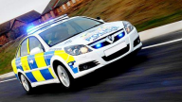

**15-2022**

*Leave it to the Law*

**Dealing with Breaches of TTM**

**Road Closures**

If your works are going to involve the closure of a road you **MUST** have the appropriate **T**emporary **T**raffic **R**egulation **O**rder **(TTRO)** in place to make it a legally enforceable closure. On occasions it may be required to permit vehicles though a closure for purposes of access but at some point, there **MUST** be a positive closure in force that does not permit through traffic of any kind other than pedestrian and in certain circumstances cyclists. 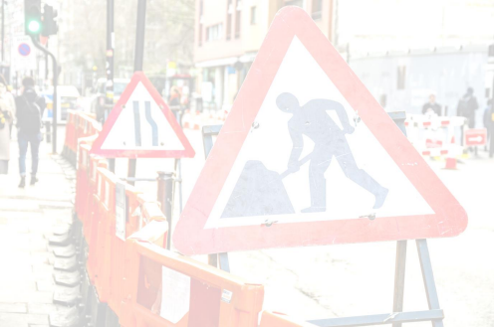

If a vehicle ignores a road closure and tries to travel through the works you should record the incident and report it straight away as a near miss through your appropriate organisations systems or processes with all the details including the make, model, colour, and registration of the vehicle.

**DO NOT** approach any driver who shows signs of verbal or physical aggression.

**Temporary Traffic Lights**

For some unexplained reason many drivers have a warped perception of what temporary traffic lights mean. They would never jump a set of normal traffic lights, but they are often prepared to take that risk with temporary ones placing themselves, other drivers and our operatives at risk. If a vehicle ignores a red light report it straight away as a near miss through your appropriate organisations systems or processes with all the details including the make, model, colour, and registration of the vehicle.

**Do not under any circumstances try to physically prevent a vehicle passing through on a red signal by placing yourself in a position of danger or risk.**

**If the vehicle causes damage, or the driver becomes aggressive in any way, the Police should be called immediately, and evidence gathered including witnesses and photographs**

**DO’s & DON’Ts**

**• DO** Use measures to prevent through access on road closures such as additional barriers, Herras fencing or bollards.

**• DO** Complete a site-specific risk assessment which includes the likelihood of breach of TTM measures **• DO** Report **ALL** breaches of TTM straight away with as much detail as you can

**• DO** Not be afraid to call the Police if the incident causes damage or a driver becomes aggressive in any way

**• DON’T** Under any circumstances try to stop a moving vehicle even if it is committing an offence. **• DON’T** Engage any driver who is showing signs of verbal or physical aggression, leave site and call for the Police

**• DON’T** Leave it for someone else to report it may be too late.

**• DON’T** Put yourself at risk because of someone else’s stupidity or ignorance

*HAUC(UK) thanks Morrison Water Services in their help in the creation of this guidance.



This information is general guidance only and is not intended to replace specific legal advice. None of HAUC(UK) or its members, accept any liability for any action or omission taken based on this guidance.