**Guidance Bulletin** 

**18-2022**

**A Cut Too Far!**

**Over Cutting Bituminous Reinstatements**

The finished quality of reinstatements has become ever more under the microscope from Highway Authorities. With the overall desire to constantly ensure that the performance of completed works is of the required standard, this bulletin outlines one issue that is avoidable. 

**Over cutting** when undertaking edge preparation prior to the reinstatement of bituminous surfaces care must be taken when cutting surface layers to avoid undue damage to the running surface or to the bond between the surface course and binder course. Overlapping edge cuts and corner cut outs should be kept to a minimum. All cuts extending into the existing surface should be filled with a flexible bituminous sealant to prevent water penetrating the surface which could lead to frost damage or structural failure.

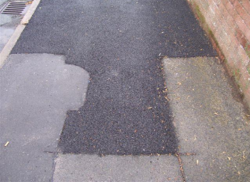 **DO’s & DON’Ts**

**• DO** only cut into the corner – **not** into the adjacent highway to create overcuts

**• DO** use your Stihl saw to cut into the wedge (vertically) that is left in the corner to split it in half **• DO** use a chisel to cut out the “wedge” in the corner to attain a full depth (100mm) vertical edge **• DO** seal any overcuts that occur to prevent the ingress of water

**• DO** use dust suppression when cutting and blades must be changed by a qualified person **•**

**• DON’T** leave corner wedges in *(this may lead to Core failures)*

**• DON’T** leave any cuts unsealed as this will lead to deterioration of the patch and HA DefectsHAUC(UK) thanks Morrison Water Services in their help in the creation of this guidance. 

This information is general guidance only and is not intended to replace specific legal advice. None of HAUC(UK) or its members, accept any liability for any action or omission taken based on this guidance.