**Guidance Bulletin** 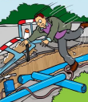

**19-2022**

**Is it Protected?**

**Protection of plant and materials on site**

Excess plant, materials and barriers should always be contained within the confines of a barriered area if they are to be left on site. If the materials, plant or barriers are required for significant works, consideration should be given to the method of protection against vandalism, theft or other loss or damage. Herras fencing should be used to guard temporary storage areas. 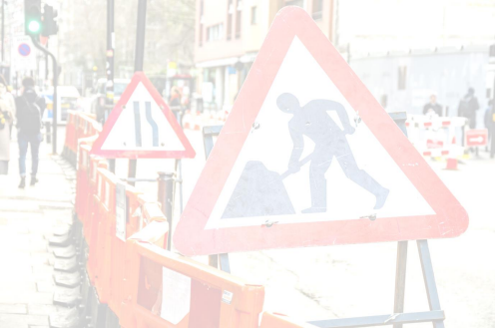

Wherever possible, all materials should be removed from site if no longer required and if this is not possible to do immediately, then collection should be arranged within 24hrs. All materials placed in the Public Highway must be sufficiently signed and guarded to protect members of the public.

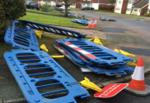

**DO’s & DON’Ts**

**• DO** check you have a valid permit before you store equipment on site before works start.

**• DO** undertake a site risk assessment to check that the area is safe to leave plant, equipment and materials on site, and if not arrange for immediate removal and alternative storage.

**• DO** avoid leaving large quantities of barriers, plant and equipment on site wherever possible.

**• DO** ensure that all materials and equipment is within a barrier system that complies to *“Safety at Street Works and Road Works COP (Red Book)”.*

**• DO** secure all plant & machinery against theft or interference and ensure that it is signed and guarded appropriately. **• DO** arrange for long term sites to be checked outside of normal working hours to maintain any barriers, and check against vandalism and theft.

**• DO NOT** place any equipment on the highway or part **WITHOUT** checking you have a valid permit in place. **• DO NOT** forget to display your permit board on any site used to store equipment on site prior to works commencing. **• DO NOT** store signing, lighting and guarding equipment against walls, fences, buildings or trees, as this could cause damage and could result in a claim.

**• DO NOT** leave large stocks of surplus equipment in areas which can be perceived as being high risk. **• DO NOT** store surplus equipment on private property without obtaining written consent from the owner. **• DO NOT** forget to arrange the collection of surplus equipment and materials.

**• DO NOT** leave Road plates unguarded when not in use. They must be stacked safely within a barrier system or removed from site.

HAUC(UK) thanks Morrison Water Services in their help in the creation of this guidance. 

This information is general guidance only and is not intended to replace specific legal advice. None of HAUC(UK) or its members, accept any liability for any action or omission taken based on this guidance.