**Guidance Bulletin** 

**21-2022**

**Bridging the Gap!**

**The Use of Footway Boards**

When an excavation obstructs the free flow of pedestrians along a footway or footpath it can cause problems with site safety and customer relations. 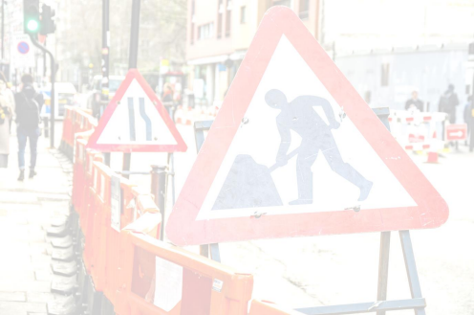

One way to mitigate this problem is the use of a footway board to cover open excavations and allow pedestrians to use the existing footway / footpath instead of a walkway in the carriageway or another alternative.

Make sure you have an approved FOOTWAY board for this purpose.

**DO’S** & **DON’TS**

• **DO** Undertake a site specific risk assessment before starting work

• **DO** Make sure the site is protected by barriers and correct signs are in place and secure. • **DO** Consider where spoil and other materials are stored to release footway space.

• **DO** Double check you are using the correct board for the purpose. Footway Boards are **NOT PERMITTED** as Driveway boards; Road Plates are **NOT PERMITTED** as footway boards.

• **DO** Check that if you place a footway board down it rests on at least **200mm** of firm surface either side of the excavation.

• **DO** Check that the footway board is fit for purpose with a skid resistant surface and free from cracks or broken edges.

• **DO** Fix the footway board (if necessary) in position in accordance with your risk assessment • **DO** Place barriers along any edge of the board where there is an open excavation to prevent access to works. • **DO** Check your site during the day and before you leave to ensure all boards are still in position. • **DO** Take photographs of the boards and the completed risk assessment and upload for record as appropriate.

• **DON’T** Start work without a risk assessment.

• **DON’T** Start work without making sure your barriers and signs are in place.

• **DON’T** Use wood or a footway only board to bridge a driveway always use the approved driveway board. • **DON’T** Span trenches / excavations wider than **800mm**

• **DON’T** Lever boards from their fixings**.** Unscrew them properly to prevent damage!

• **DON’T** Use this board for a driveway or vehicle access.

• **DON’T** Use this board as a road plate in the carriageway it will not take the volume or load of regular traffic. • **DON’T** Leave site until you have checked all of your SLG and ramps are secure and in the correct position •

HAUC(UK) thanks Morrison Water Services in their help in the creation of this guidance. 

This information is general guidance only and is not intended to replace specific legal advice. None of HAUC(UK) or its members, accept any liability for any action or omission taken based on this guidance.