**Guidance Bulletin** 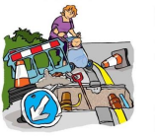

**22-2022**

**Safe Passage!**

**The Use of Walkways in Carriageways to Manage Pedestrians**

It may be necessary to redirect pedestrians into a temporary walkway in the carriageway to provide them with safe passage passed our works. These walkways must be identified as necessary when you complete your street works site specific risk assessment. 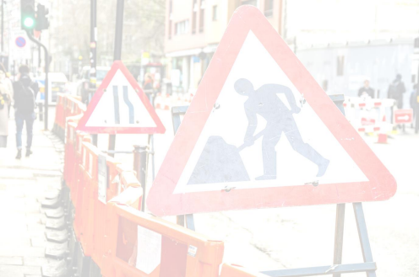

• All pedestrian routes must be fit for purpose and able to be used safely by all pedestrians, including older people, the less able and visually impaired.

• Surfaces should be reasonably smooth without steep gradients or cross falls and be free of all obstructions both at low and high level.

• A suitable barrier must be placed between a pedestrian route and any adjacent drops, steep slopes and the carriageway.

• Remember you will still need your safety zones.

• Footway boards may be used on footways to maintain a route for pedestrians and provide light vehicle access to premises during excavation works

**DO’S** & **DON’TS**

• **DO complete your street works site specific risk assessment BEFORE you start setting out the site.**

• **DO** try to provide a walkway using the existing footway where possible with an absolute minimum width of **1m**

• **DO** try to provide at least **1.2m** unobstructed width if you have to use a temporary walkway in the carriageway

• **DO** make sure all ramps are in place and secured.

• **DO** make sure that Ramps and Boards are fit for purpose.

• **DO** make sure the signing and guarding barriers are put into place **before** the footway is blocked. • **DO** site checks on all walkways throughout the day

• **DON’T** block the footway, a minimum width of **1m** must be maintained on the footway at all times • **DON’T** leave any spoil or materials within the walkway

• **DON’T** leave barrier systems unlocked.

• **DON’T** erect the walkway unless you can maintain absolute minimum running widths of carriageway

**PAGES 28 – 34 Safety Code of Practice (Red Book)** 

**DO HIGHWAYS THE RIGHTWAYS**

**For any queries or problems, please contact your immediate supervisor / manager in the first instance** HAUC(UK) thanks Morrison Water Services in their help in the creation of this guidance.

This information is general guidance only and is not intended to replace specific legal advice. None of HAUC(UK) or its members, accept any liability for any action or omission taken based on this guidance.