**Guidance Bulletin** 

**23-2022**

**What No Barriers?**

**The Removal of Barriers during Backfill or Reinstatement**

It has become common practice that barriers and signs are removed from around excavations while backfill or reinstatement works are undertaken. **THIS IS NOT ACCEPTABLE and is an offence under Section 65 of NRSWA 1991**. Often the public still have a right of way along footways during these works and could encounter plant, materials or grab operations which place them in danger. Barriers and signs **must** remain in place during all operations and consideration **must** be given to pedestrians and other road users. 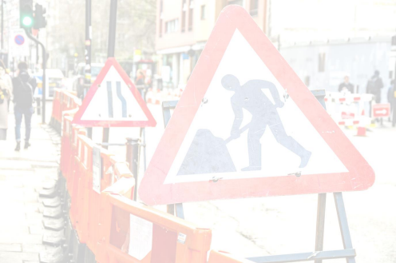

The following points should be considered at all times during reinstatement operations: -

**DO’S** & **DON’TS**

**• DO** conduct a site-specific risk assessment before commencing works

**• DO** be aware of pedestrians and other road users during backfill and reinstatement operations **• DO** provide a safe alternative walkway wherever possible

**• DO** suspend grab operations over a footway if pedestrians’ approach and wish to pass. **• DO** be polite when requesting pedestrians to wait until grab operations over a footway are completed **• DO** in exceptional circumstances, guide pedestrians safely through works where no alternative footway can be provided.

**• DO** consider temporarily closing the footway using “Footway Closed” signs placed at least 20m in advance of the works to enable pedestrians to find a safe alternative. **Check with the office before using this measure.**

**• DO** check your **PERMIT CONDITIONS** and make sure any information board is clearly visible and the permit number is correct and clear.

**• DO NOT** remove barriers from around open excavations under any circumstances. **• DO NOT** block footways with plant or materials such as wheelbarrows or rakes.

**• DO NOT** operate grabs over footways accessible by the public.

**• DO NOT** leave plant or materials where they can cause a danger or hazard to road users and pedestrians. **• DO NOT** block footways without considering alternative routes for pedestrians.

**• DO NOT** leave open excavations exposed for any time during reinstatement even if they are backfilled.**DO HIGHWAYS THE RIGHTWAYS**

**For any queries or problems, please contact your immediate supervisor / manager in the first instance** 

HAUC(UK) thanks Morrison Water Services in their help in the creation of this guidance.

This information is general guidance only and is not intended to replace specific legal advice. None of HAUC(UK) or its members, accept any liability for any action or omission taken based on this guidance.