**Guidance Bulletin** 

**24-2023**

**ALL CHANGE!**

**Changes on site, Permit Conditions and Fixed Penalty**

**Notices**

Changes to certain aspects of a works without communicating the change to the Highway Authority can lead to a FIXED PENALTY NOTICE being issued with a potential value of £120 each.

**What changes matter?** 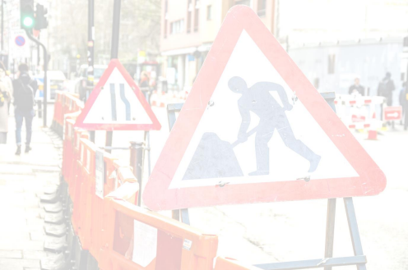

• **Pedestrian Management** – If you need to close the footway on a site you should contact your Site Manager or Streetworks Team to ensure the permit is updated to reflect the fact that the footway will be closed BUT you must adhere to the Hierarchy for pedestrians as closing a footway is a last resort.

• **Traffic Management** – If the TM changes on a site you should contact your Site Manager or Streetworks Team to ensure the permit is updated to reflect the new TM type for example the permit stated Give and Take but on site you are now using Traffic Lights.

• **Working Method** – If the working method changes on a site you should contact your Site Manager or Streetworks Team to ensure the permit is updated to reflect the new method for example the permit stated trenchless but on site you are now using open cut.

• **Works Location** – If the Works Location substantially changes on a site you should contact your Site Manager or Streetworks Team to ensure the permit is updated to reflect the location type for example the permit stated Footway but on site you are now working in the Carriageway.

**Permit Conditions**

• **Failing to Display** – It is an offence worth £120 if you do not display the correct permit number on site at all times.

• **Breach of Conditions** – It is an offence worth £120 if you do not make sure you have complied with all the conditions of the permit. These must be in your work pack.

**DO’S & DON’TS**

• **DO** Check that you know the Permit Conditions for your works, and you have a copy of them and the permits for all the streets in your project pack on site

• **DO** Talk to your Site Manager or Streetworks Team if you are in any doubt what the conditions mean and what you must do to comply with them.

• **DO** Check that the conditions are always available on site when the site is occupied • **DO** Ensure that all site operatives are aware of what conditions they are working to. • **DO** Contact your Site Manager or Streetworks Team if ANYTHING CHANGES on site just in case, we need to update the permit

• **DON’T** Assume - always check that the permit is granted, and you can start works • **DON’T** Accept a work pack without a copy of the permits and conditions for the whole project so ALL STREETS

• **DON’T** Change anything on site without checking with your Site Manager or Streetworks Team

HAUC(UK) thanks Morrison Water Services in their help in the creation of this guidance 

**DO HIGHWAYS THE RIGHTWAYS**

This information is general guidance only and is not intended to replace specific legal advice. None of HAUC(UK) or its members, For any queries or problems, please contact your immediate supervisor / manager in the first instance accept any liability for any action or omission taken based on this guidance.