**Guidance Bulletin** 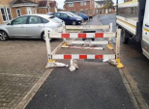

**25-2023**

**Close To The Edge!**

**Works close to the kerb edge**

When excavating on a footway there may be a requirement for the provision of a sideways safety zone in the carriageway even if all the works are on the footway. 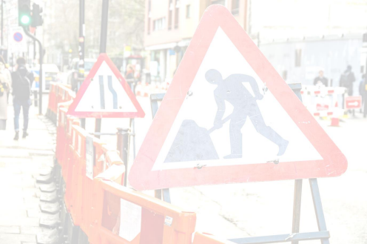

**Page 20 – Safety at Street Works & Road Works Code of Practice**

*“When working in a footway, remember you must provide a safety zone in the carriageway if the working space is closer to the edge of the carriageway than the width of the sideways clearance (S). If cones are placed in the road, advance signing will be required.*

*These same principles apply when working in a verge or cycle track adjacent to the carriageway.”*

**

**

• Roads up to **40mph** – If the works are closer than **0.5m** to the c/w edge then a safety zone is required. • Roads up to **60mph** - If the works are closer than **1.2m** to the c/w edge then a safety zone is required.

**DO’S** & **DON’TS**

• **DO** make sure you install this safety zone if required

• **DO** place the cones so they touch the kerb

• **DO** place Road Works Ahead and Road Narrows if this zone is required

• **DON’T** assume that you do not need a sideways safety zone when working on a footway check your distances

• **DON’T** leave site without putting the sideways safety zone in place or the correct signs

**DO HIGHWAYS THE RIGHTWAYS**

**For any queries or problems, please contact your immediate supervisor / manager in the first instance** HAUC(UK) thanks Morrison Water Services in their help in the creation of this guidance. 

This information is general guidance only and is not intended to replace specific legal advice. None of HAUC(UK) or its members, accept any liability for any action or omission taken based on this guidance.