**Guidance Bulletin** 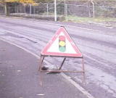

**26-2023**

**Well Placed!**

**Placement of Temporary Road Signs**

Road signs are required to identify a potential hazard to road and footway users, however if not placed properly, they can become the hazard themselves. Misplaced signs can become trip hazards to pedestrians or obstacles to vehicles. Signs must be placed so they are clearly visible to approaching vehicles and are not obscured by vegetation, parked vehicles or bends in the road. Additional signs may be added to increase visibility. 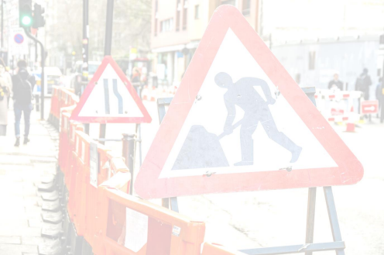

In an ideal world, where there is a grass verge the signs should normally be placed there. Placing signs in the footway is permitted, but they must be positioned to minimise inconvenience or hazard to pedestrians, with consideration given to those with visual impairments, pushchairs, wheelchairs, and mobility scooters. A minimum usable footway width of **1 metre** must be maintained.

The lower edge of all signs should be no less than 300 mm from ground level, and care should be taken that signs are level, particularly if the ground is uneven.

**DO’S** & **DON’TS**

• **DO** Undertake a site-specific risk assessment including the safe positioning of signs to ensure clear visibility and stable placement. The risk assessment should also consider the nature of traffic and pedestrian flows.

• **DO** check if a sign placed on the footway allows for the current absolute minimum of **1 metre** clear passage for pedestrians. Do not forget that the footway is for use by pedestrians and should not be unnecessarily obstructed.

• **DO** check that a sign placed on the carriageway does not reduce the passing width below the minimum required for two-way traffic unless Traffic Management is already deployed.

• **DO NOT** Place Signs or Barriers across a kerb or other uneven surfaces unless stabilised by the use of sandbags or other compliant fixing products.

• **DO NOT** Use signs that are in poor condition or are not approved for use on Streetworks sites • **DO NOT** Leave site without checking all signs and barriers are safely positioned and sandbags or other compliant fixing products are used if required.

For further guidance on the safe signing and guarding of Streetworks refer to the Safety at Street Works & Road Works Code of Practice **OR** contact your immediate supervisor or Street Works Team. 

**DO HIGHWAYS THE RIGHTWAYS**

HAUC(UK) thanks Morrison Water Services in their help in the creation of this guidance.

This information is general guidance only and is not intended to replace specific legal advice. None of HAUC(UK) or its members, accept any liability for any action or omission taken based on this guidance.