**Guidance Bulletin** 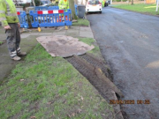

**29-2023**

**Bowling Green or Battlefield!**

**The Reinstatement of Verges and Grassed Areas**

The reinstatement of verges and grassed areas is often an afterthought and not treated with the same level of care as the reinstatement of bituminous or moduler surfaces. The improper reinstatement of these areas can lead to defects and reworks just the same as those in surfaced areas, this can also lead to additional costs for inspection fees and reworks. 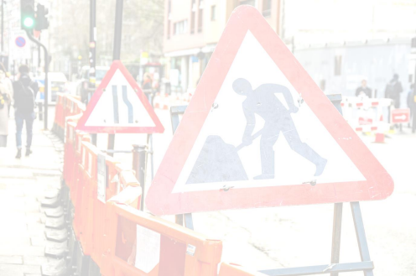

**Common failures are:**

• Damaged verge and grassed areas due to the storage of materials/parking of vehicles/plant and the provision of walkways across these surfaces.

• Excessive aggregate content in Topsoil when replaced (greater than 20mm)

• Topsoil not seeded or incorrect seeds used (lawn/verge).

• Verges reinstated in adverse weather/incorrect time of the year.

• Where interim surfaces are replaced, notices are closed as permanent.

**How to reduce failure:**

• **DO NOT** under any circumstances permit or direct vehicles to be driven / parked on verged/grassed areas. • **DO NOT** make excessive plant movements during works in adverse weather as this causes additional works to reinstate area back to a satisfactory condition.

• **DO NOT** store excavated materials on verges or grassed areas unless this is the only option. If this is the only option, use a board/sheet to provide protection.

• **DO NOT** attempt to lay turf or undertake permanent verge reinstatements in adverse weather conditions

• **DO** ensure a walk board or matting is used and secured when incorporating a verge or grassed area into a walkway.

• **DO** use bog matts or similar protective boards to prevent vehicle damage to the verge • **DO** ensure segregation of topsoil/turf and excavated materials.

• **DO** remove all aggregates over 20mm in size by raking the area thoroughly

• **DO** replace any shrubs or other planted vegetation as part of the reinstatement. Advice should be sought from your supervisor as to where and how these can be purchased and approved to do so.



r HAUC(UK) thanks Morrison Water Services in their help in the creation of this guidance.

**IF YOU ARE IN ANY DOUBT, CONTACT YOUR SUPERVISOR FOR FURTHER ADVICE DO HIGHWAYS THE RIGHTWAYS**