

A guide to NUAR

National Underground Asset Register

2

About us

The Geospatial Commission is an independent,

expert committee responsible for setting the UK?s

geospatial strategy and coordinating public sector

geospatial activity.

We are part of the Department for Science,

Innovation and Technology.

UK's

Geospatial Strategy

3

M ission 1: Promote and safeguard the use of location data

M ission 2: Improve access to better location data

M ission 3: Enhance capabilities, skills and awareness

M ission 4: Enable innovation

W hy ~~do w~~e 4

need

NUAR?

4

- 4 million kilometers of buried pipes and cables in the UK

- 4 million holes dug every year

- c. 60,000 accidental strikes per year

- Planners and excavators need the data to do their jobs safely and efficiently

- Data is held by over 650 organisations

- Asset owners are legally required to make their data available for free to statutory undertakers

5

W hat is

NUAR?5

NUAR is an interactive, digital map of underground

pipes and cables.

It will revolutionise the way we install, maintain,

operate and repair our buried infrastructure.

6

W hat will NUAR do?



Standardise

?data from 650+ asset owners

Secure

?data shared through the platform to safeguard and protect against misuse

Streamline

?data sharing between asset owners and those planning and carrying out excavations

Support

?improvement in data quality through missing or erroneous data being fed back

Building on existing

initiatives

7

- Research projects such as VISTA, M apping the Underworld and Project Iceberg

- London?s Highways Apparatus Data Exchange System (HADES) project 2017

- Northumbrian Water Group 2018 Innovation Festival

- Scottish Roadworks Commissioner VAULT system

- Operational systems in Belgium,Germany and Netherlands

- NUAR Pilot Projects from 2019 to 2020

8

Benefits for a

wide range of users

Asset Owners ~~-~~ efficiencies in sharing data

Planners ~~-~~ efficiencies in sourcing data and reduced risks of asset strikes

Excavators -reduced risks of asset strikes

Plant protection officers -greater knowledge of activity near assets

Data managers ~~-~~ improved data quality

General public and businesses ~~-~~ reduced delays from accidental strikes

£350m pa economic benefits

9

- The estimated economic cost of accidental strikes on underground pipes and cables is £2.4 billion a year

- The economic benefits of NUAR are estimated to be £350m per year

- This consists of benefits in efficiencies, reduced asset strikes and reduced delays to the public and businesses

- We have published the approach taken to estimate the relevant benefits

2018

2019-20

Timeline Sep 2021

Apr 2023

10

2024/25

Geospatial

Commission established

NUAR research

Pilot projects

completed

Preparation phase starts

NUAR build

programme starts

M inimum viable product (M VP) goes live in North East England,Wales and London

NUAR covers rest of England and

Northern Ireland

phase starts

11

Building a great service Navigate a map and see the

Login securely using 2 factor authentication

Specify and edit an Area of Interest by a circle or polygon

contextual information about above~~-~~ground features text

Display and query asset data

Search by: street name, UPRN, USRN and postcode

Share locations with

other users

Theplatform128f8 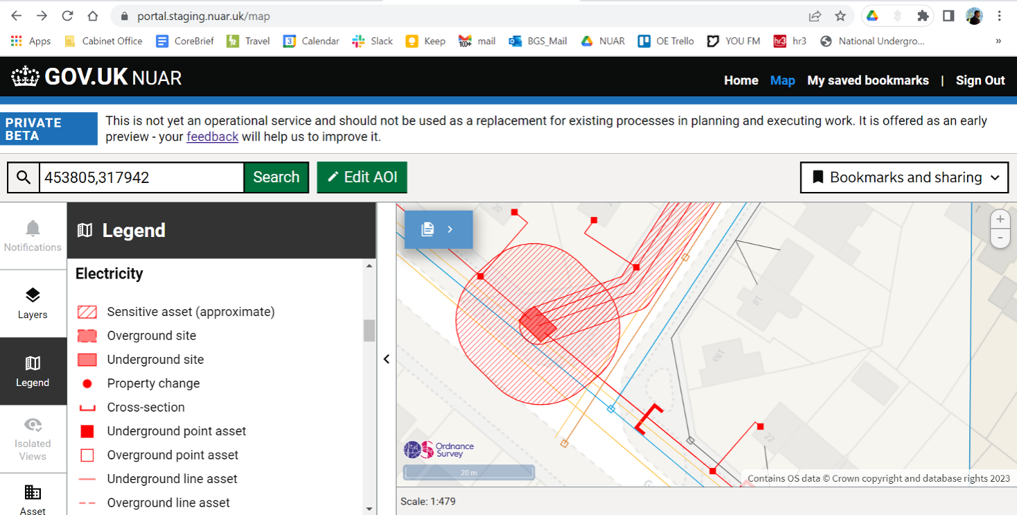

13

Public consultation

- A preference for a single database containing all data to be controlled by

government due to legitimate commercial and security sensitivities

164 responses in total

- No consensus on who should fund NUAR in the operational phase but general agreement that those who benefit from the service should contribute

- Acknowledgement that legislation is required to maximise the value of the service

- A potential opportunity for NUAR to be commercialised beyond the intended use case

14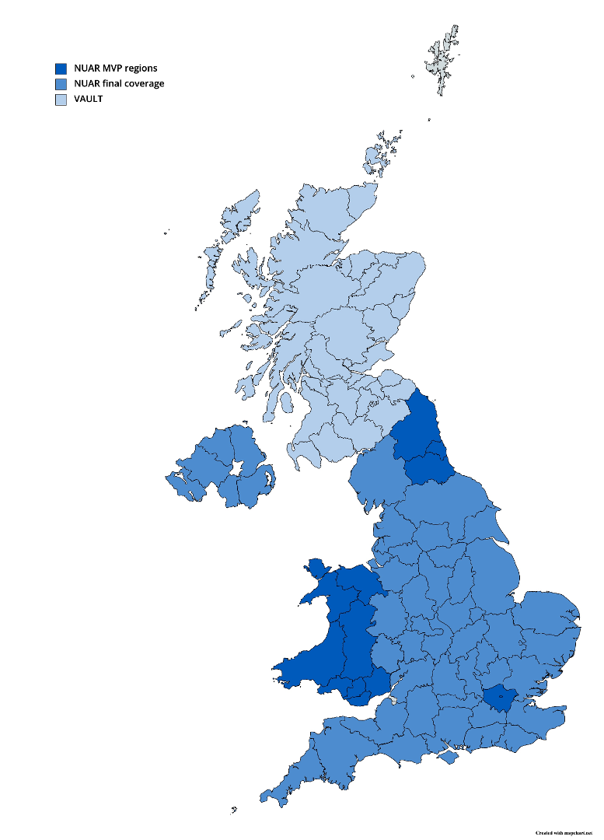

Growing

participation\*

- 500+ Asset Owners engaged across England

and Wales

- 285 Data Exploration Agreements (DEAs) signed

- 172 organisations?data uploaded to NUAR

- 167 datasets?transformations agreed

- 155 Data Distribution Agreements (DDAs) signed

\*~~-~~ Data correct as of 5 April 2023

Working

withexperts

-Asupplychainofworld leadingexperts intheir field

-Othergovernmentdepartments

-Existingnetworksofassetowners

- Industryandprofessional bodies

-Academiaand international partners -Users

15

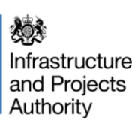



16

Support from industry

W hen we find that assets are not in the place that we thought they were, the ability to push back information to the central

repository and have this

information available for everyone's benefit, as opposed to it sitting in silos, is very exciting for industry.

Shelley Copsey, Co~~-~~Founder & CEO, Fyld

In our increasingly digitalised world, NUAR?s accessibility to visualised information which has been aligned across multiple sectors?data is incredibly useful and powerful, enabling whole system collaboration for the benefit of customers and society as a whole.

Steven Gough, DSO Technical Authority, Scottish and Southern Electricity Networks

I am so glad to see that NUAR will really make a national records system a reality. I have waited a long time for this.The water industry especially will benefit as their assets are generally below the other utilities so to carry out work on them safely and effectively it is essential to know the location of other utility assets.

Jo Parker,Vice President of Engineering, Institute of Water