

|  |  |
| --- | --- |
| **Lane Rental Charges:**  **Waiver, Reduction**  **and Exemption Requests**  **Supplementary Guidance** |  |

**e**l V7.0 May 2023



**TfL Lane Rental Scheme**

**EVERY JOURNEY MATTERS**

Overview Page 3



TfL Lane Rental Scheme

How to apply (Where does LR apply, when does LR apply, what is the daily charge) 4

Map guide 8

Major infrastructure improvements 9

Collaborative works 10

Extraordinary measures 11

Use of innovative technology 12

Redefined road space (Change in use, Final layout, Dead space & no net loss) 13

Side road closures/filter lanes 19

Diversionary works 21

Continuous USRN 22

Bays 23

Road plates/footway boards 24

Temporary pedestrian footways 25

Works wholly confined to white hatched areas 26

(l) Replicating permanent traffic signals 27

**-I-)**

**C** Within footprint of Highways Act.1980 Licence (excl. pit lanes) 28

W Legal order disapplying s.74A NRSWA (i.e. TWA 1992) 29

4—)

C Abortive Days 30

0

U General information (Deliveries, Damage by third parties, High performance & location of vehicles) 31

Feedback Form 33

**Overview**

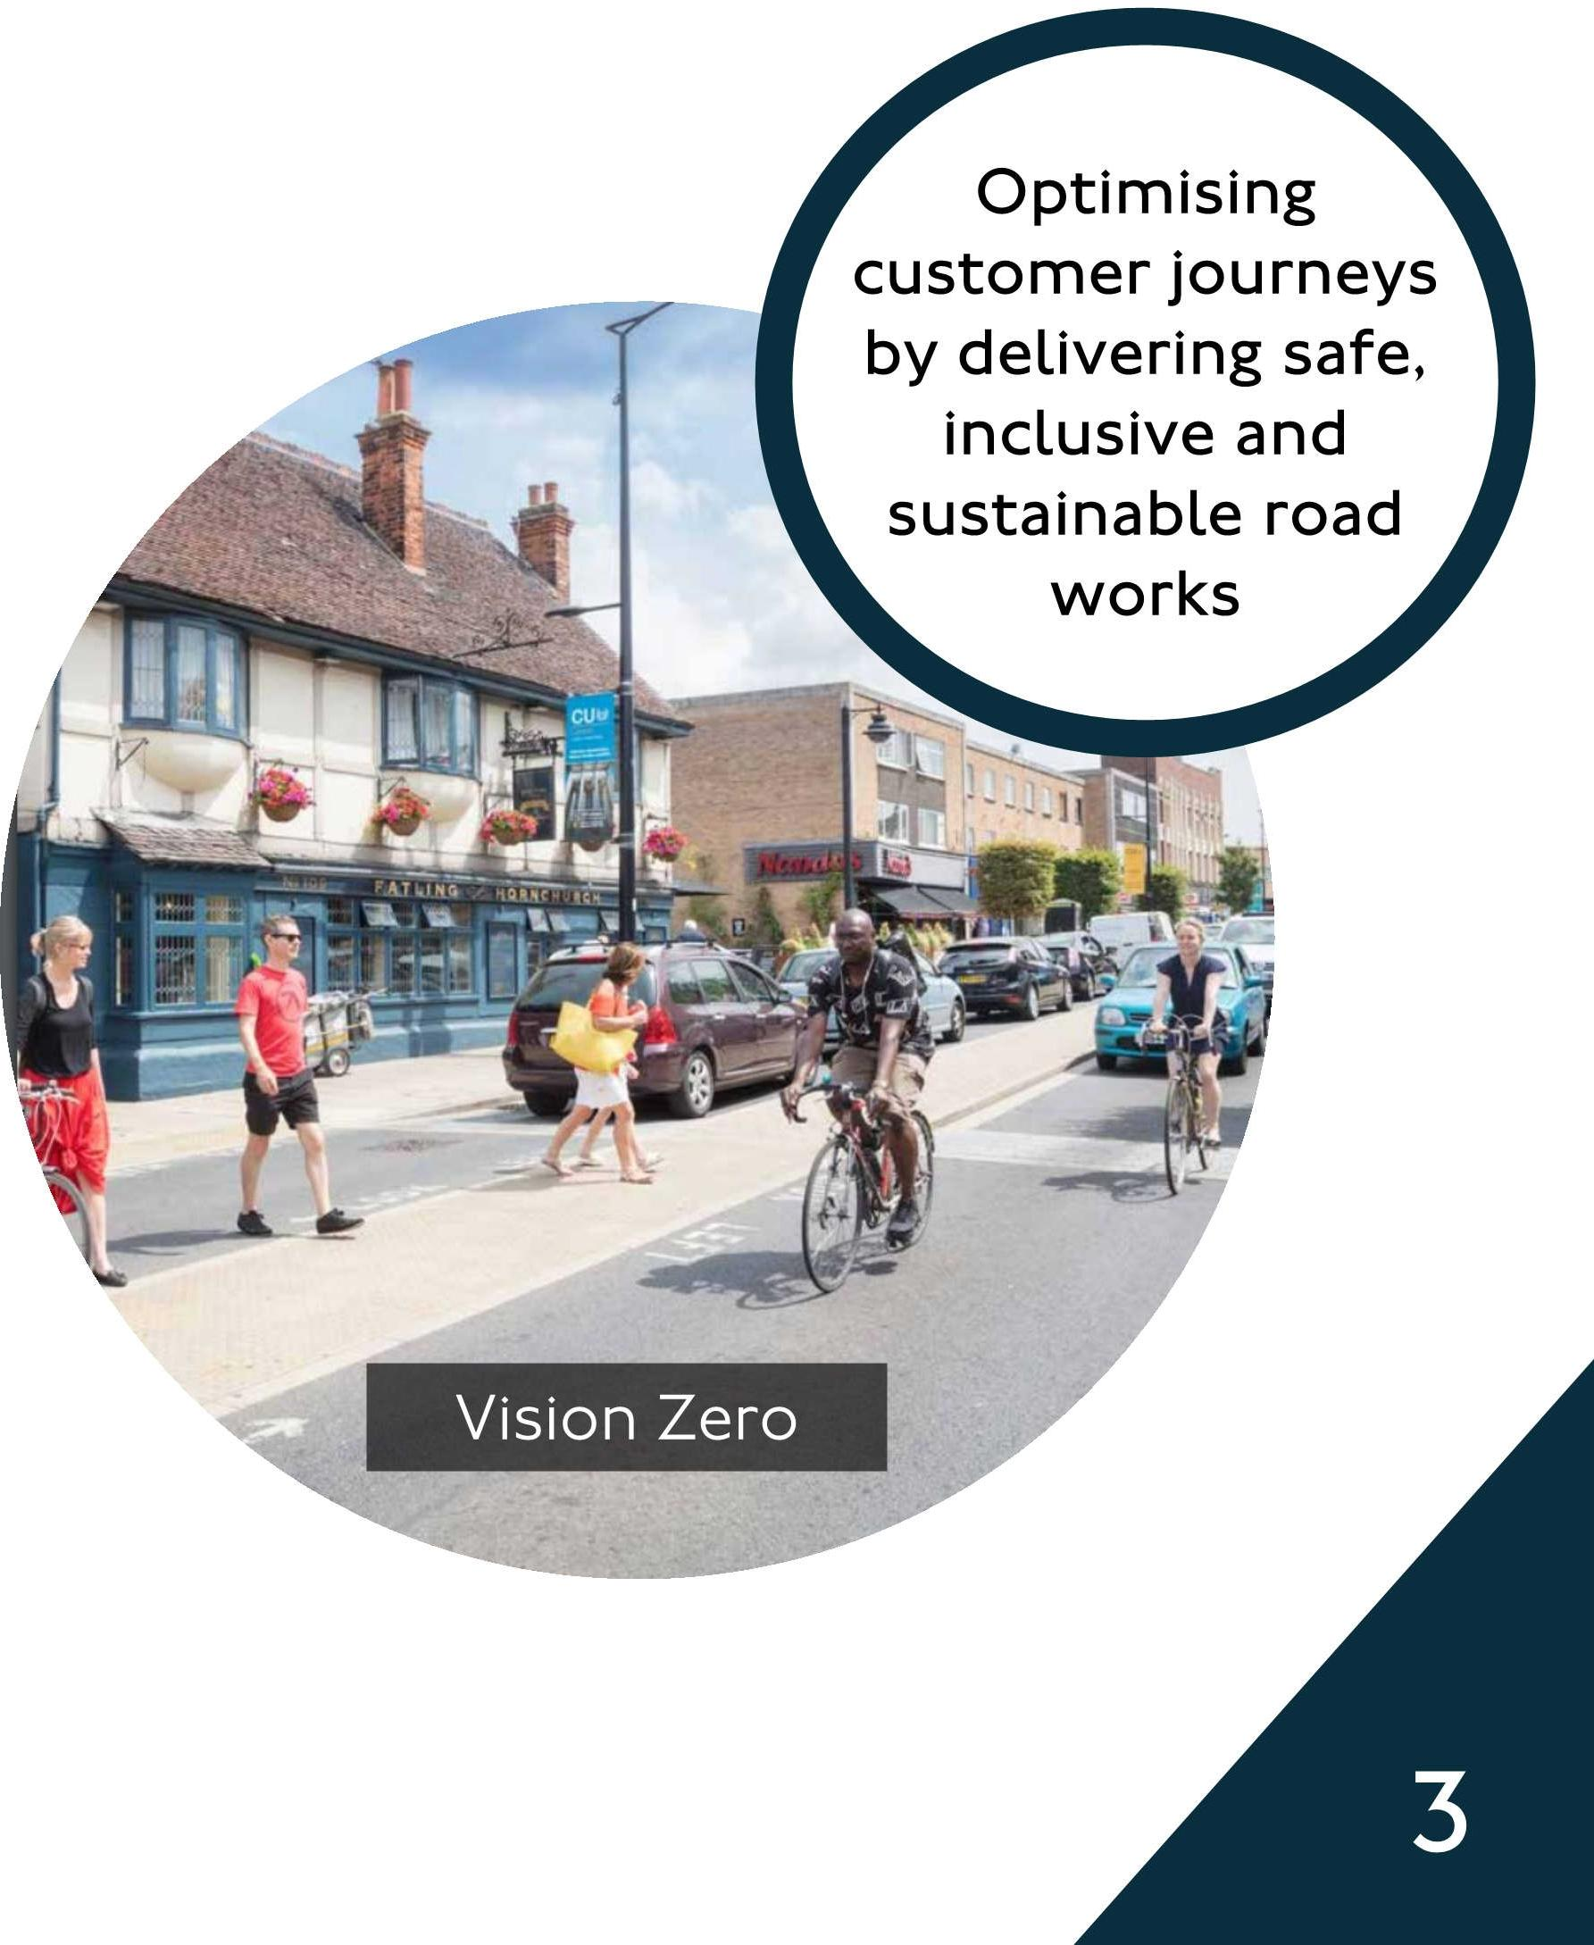

**Optimising
  
customer journeys
  
by delivering safe,**

**inclusive and
  
sustainable road
  
works**

Vision Zero

This document provides work promoters with guidance on scenarios where consideration will be given to reduce, waive or exempt Lane Rental charges, and should be read in conjunction with published scheme documents on [TfL.gov.uk/LaneRentaL](http://TfL.gov.uk/LaneRentaL)

Note: The safety of road users and operatives must not be compromised when developing traffic management proposals designed to either avoid Lane Rental charges or qualify for a reduction. Lane Rental waivers and discounts are therefore approved on condition that work sites are compliant with the statutory code of practice for Safety at Street Works and Road works. And adhere to the guidance provided in the Temporary Traffic Management Handbook.

Lane Rental waivers and discounts may be withdrawn for the duration of non-compliance.

TfL Lane Rental Scheme

**How to apply**

There is now an
  
online
  
application
  
process. Go to
  
the portal.



**To qualify for a waiver, you must make an application via the online portal, providing the permit reference and traffic management drawing. For requests covering scenarios other than those stated in this document, please select other and provide justification, noting that it must be in line with the spirit of the scheme.**

**Important:** The waivers, reductions and exemptions contained within this document are at TfL's discretion and are subject to promoters using this guidance within the spirit of which it is intended.

Waivers, reductions and exemptions will not be applied retrospectively for planned works and will only be applied if requested in advance of the works starting and once agreement has been reached with the Lane Rental Management Team (LRMT). For unplanned works, or in the event that a scenario where a potential request may be applicable to WRE Lane Rental charges is put in place on site, retrospective applications to waive charges will only be considered if an application is submitted within 2 calendar days of works/scenario starting or in the case of collaborative works, within 2 calendar days of collaborative working period commencing.

The Lane Rental Management Team meet weekly to review applications and as such further information may be requested. Applications are ordinarily determined within 10 working days, however depending on complexity or type of application, it may take longer.



In the event of a dispute, it is for the applicant(s) to evidence their adherence to the supplementary guidance and scheme. For further information or advice, please email LaneRentalQueriesTfLgov.uk

TfL Lane Rental Scheme

|  |  |
| --- | --- |
| **Where does Lane Rental apply?** |  |

|  |  |  |  |  |  |  |  |  |
| --- | --- | --- | --- | --- | --- | --- | --- | --- |
|  |  | | | | |  | | |
|  |  |  |
|  |  |  |  |
| Carriageways including bus lanes and bays |  | Cycle tracks on the Lane Rental Network | | |  |  | 20 Footway locations mainly around transport  hubs | |

Lane Rental charges apply to traffic management of a registerable activity, as defined by the London Permit Scheme, that is in situ on part of a chargeable Lane Rental street during Lane Rental chargeable hours, irrespective of when the actual site works are undertaken.



TfL Lane Rental Scheme