1. Team Number: 012-4
2. Team Name: Team Rocket
3. Team Members:

* Duncan Britt; Duncan-Britt; Duncan.Britt@colorado.edu
* Jason Hunter; jasonhunter95; [jahu8701@colorado.edu](mailto:jahu8701@colorado.edu)
* Ayla Tabi; aylatabi; ayla.tabi@colorado.edu
* Jacey Fischer; jafi1775; jafi1775@colorado.edu
* Simon Wickersham; kiwickersham; [kawi8779@colorado.edu](mailto:kawi8779@colorado.edu)

1. Application Name: Pokedex
2. Application Description: An integrative database of Pokémon and their corresponding stats, where users can track and maintain a personal collection as well as a trainer profile. The application should have a search feature to look up and pull certain data about Pokémon, as well as a user profile where the user can keep track of Pokémon they have collected.
3. Vision Statement: For Pokémon enthusiasts, Who want to track their virtual personal collection of Pokémon. The Pokédex is a Pokémon online database that tracks data about Pokémon and Pokémon collected by the user. Unlike other products, our product is accessible to beginner Pokémon users that might feel overwhelmed by tracking physical cards and are disorganized.
4. Version Control: <https://github.com/Duncan-Britt/Team-Rocket.git>
5. Development methodology: Waterfall methodology
6. Communication Plan: We will set up a discord channel for communication about this project.

<https://discord.gg/7yX9aNUm>

1. Meeting Plan:
   1. We will meet on Wednesdays after recitation at 4:30 in person.
   2. We will meet with our TA on Wednesdays whenever there are meetings available (6-7:45)
2. Use Case Diagram:

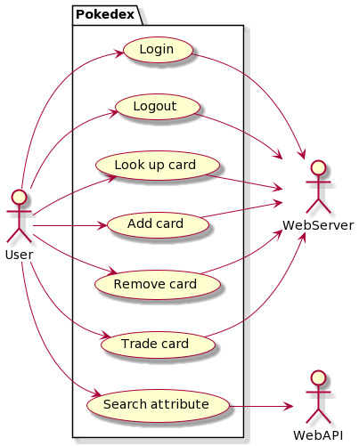

1. Wireframes: <https://www.figma.com/file/H2TmHw01G3f3TkQ8FLjdjF/Pokedex-Wireframing?type=design&node-id=0%3A1&mode=design&t=wI7xmtlOJepZaYvh-1>