My Lincolnshire Collection: An App to Foster Engagement with Local Heritage

E. Le Moignan, D. Rowland, A. Cruse, C. Lewis and M. Cragoe
University of Lincoln, Brayford Pool, Lincoln, UK
{elemoignan, drowland, clewis, mcragoe}@lincoln.ac.uk, anna.cecilia.cruse@gmail.com

Abstract. My Lincolnshire Collection represents a collaborative project between the areas of Human-Computer Interaction (HCI) and Heritage to develop a software application designed to promote local heritage visitation within Lincolnshire, UK. The app aimed to gather data on which heritage types are most appealing to local residents and visitors to the area and to widen the public perception of what constitutes cultural heritage. Designed to leverage the popularity of web enabled mobile devices and desktop/laptop PCs alike, and utilizing the sharing power of social media, the app creates a novel platform through which to promote heritage and explore the demographic appeal of a web-app in this context. Findings indicate a positive response to the app but indicate that this medium requires a significant amount of targeted publicity and promotion to recruit participants.

Keywords: Cultural heritage, HCI, Human-Computer interaction, web-app, mobile devices

- Introduction
Lincolnshire is located on the east coast of the UK and contains a rich variety of heritage. The local geography includes extensive low-lying gently-contoured areas with highly fertile soils, and this has led to intensive agriculture. In addition, these features provide ideal terrain for airbases and thus Lincoln has a rich aviation history which continues to the present day with several Royal Air Force bases and the Red Arrows aerobatic display team based within the county. Lincoln houses the Bomber Command Centre commemorating WW2 aviation which was centred intensively in Lincolnshire. The surrounding countryside and fens provide a network of waterways that lay the basis of set of interconnected routes for both walking and cycling.
Lincoln was founded as a fortress and then city by the Romans in the first century AD and has been continuously inhabited ever since. It is now home to a range of cultural heritage sites including Lincoln Cathedral, housing a significant collection of rare 15th century books and manuscripts held in the Wren Library designed by the architect Sir Christopher Wren, one of only two surviving in existence. Adjacent to this, the castle contains one of only four original copies of the 1215 Magna Carta document and two copies of the 1217 Charter of the Forest. 2015 marked 800 years since Magna Carta was issued and significant investment was made in renovating the castle for this anniversary year.
The Lincolnshire economy is partially based on the tourism industry. Beyond the historic attractions of the city of Lincoln are the Lincolnshire Wolds, a range of hills within the county is a designated Area of Outstanding Natural Beauty (AONB), deemed to be of significant conservation value protected to manage and retain them. The Lincolnshire coastline draws in large numbers of tourists, primarily to seaside resorts of Skegness, Mablethorpe and Cleethorpes. The county has a wide distribution of other heritage attractions including Woolsthorpe Manor, the birthplace of Isaac Newton; Burghley House, built for Elizabeth I’s treasurer William Cecil and surrounded by a Capability Brown landscaped park and Gainsborough Old Hall, one of the best-preserved medieval houses in the UK. The extensive range of artefacts, museums and heritage sites across Lincolnshire are both visited and valued by residents and local people.
Lincoln itself is densely packed with heritage sites and locations which are well known and report high visitor numbers. The ‘our Lincolnshire’ project was intended to explore the attitudes of local residents to the lesser known (and less frequently visited) heritage beyond the city and their engagement with it.

- Background
The overall project was funded by Arts Council England, with the aim of exploring attitudes to heritage from a number of perspectives and using a creative range of approaches. My Lincolnshire Collection was one of four main project strands, and was intended to explore how a digital ‘app’ could engage audiences with heritage and inform researchers about their attitudes to heritage. The resulting web-app was iteratively developed through a collaboration between researchers in the School of History and Heritage and the School of Computer Science at the University of Lincoln (with the School of Computer Science acting as the technical lead and the School of History and Heritage sourcing content and managing delivery).

The web-app was developed to promote a varied sample of local heritage, beyond the most frequently visited localities within Lincoln city centre itself. Titled My Lincolnshire Collection it presented an interactive gallery of local heritage objects, aimed at users comprising local residents and visitors to the area.

It was hoped the development of this exploratory app would meet several key aims:

- To provide an innovative and creative method of engaging Lincolnshire residents with heritage
- To ascertain the demographic appeal of a web-based heritage app and usability of an app in this user context
- To broaden public attitudes towards what constitutes heritage
- To generate data on what aspects and types of heritage users find most engaging and generate public interest
- HCI and Cultural Heritage
Today mobile and ubiquitous technologies are accelerating change by enabling users to participate, spontaneously and continuously, in activities of collection, preservation and interpretation of digitized heritage content and new digitally mediated forms of heritage practice [1].

Material to enhance the individual visitor experience of cultural heritage sites has been explored in various forms for a significant period of time. Early examples include audio tours on analogue tape players, including a commercial tour of Eleanor Roosevelt’s home from the 1950s [2]. In the 21st century the rapid development of mobile technologies presents new device affordances and opportunities to exploit these characteristics within heritage settings. The ubiquity and integrated nature of mobile device use into daily life, combined with their interaction modalities raise issues of user experience, interaction design and accessibility. [3] In addition, factors pertaining to the environment in which mobile devices are used such as noise, lighting, mobility and other physical actions required in navigation or interaction with the physical objects or surroundings may introduce additional constraints and issues. [4]
Mobile devices can provide a range of additional formats, ranging from audio [5], textual information [6], GPS location, augmented reality (AR), 3D modelling and animation, narrative participation (for example by RFID prompted responses to exhibits [7]]), group interaction with other visitors [8] and gamification of the experience [9]. The development of mobile devices with internet access provided scope for interactivity to be presented to users on devices in emergent, novel ways, from online representations of the Marble Museum of Carrara [10] to Carletto the Spider who dramatised the story of a noble family’s home, moving traditional tour guiding into a more dynamic, storytelling experience and increase engagement with the site [11]. Other examples include Explore!, a treasure hunt style game in which groups of school children are guided on a tour of a 9th century city ruin.[9] With up to 80% of visitors comprising school and educational trips [4], identifying an age appropriate user interface (UI) and suitable cognitive load required to use an app as part of the overall experience is required. Explore! combined narrative elements, (puzzle solving, characters) with 3D modelling in a game style treasure hunt. Examples of work that extend the app beyond a single site location visitation includes MobileDOK that provides a mobile accessible map and database of the Finnish city Oulu. [12] Described as “an edutaiment tool that arouses the interest in local culture” it encompassed contemporary sites (local culture, plazas, bars) along with those which included heritage as historical interest. Along with shifts in technological advances which render devices more powerful and ubiquitous than ever, Malcolm-Davies [13] asserts there has been “a discernible shift from historical monument to heritage product”. This commodification of heritage would assume that a ‘product’ would benefit from promotion and justification of its value to consumers. In this light, the increase in engagement gained from technology may be viewed as a method of adding value and creating a more performative, gadget driven or theme park style approach to heritage in order to compete in an increasingly technological societal context.
Other work focusses on the potential of mobile devices in other areas, including socialisation surrounding heritage visitation experiences. In promoting a shared experience, it has been highlighted that cultural heritage is frequently visited in small groups comprised of family units or friends. [8] This work highlights the importance of fostering and supporting interaction between visitors when implement technological based features into heritage sites. Others [14] demonstrate that interactivity strengthens joint-attention in parents and children, prompting discussion around the exhibit and providing a mechanism for increasing educational value and retention of information from the resulting dialogue. Formal educational visits are likely to be accompanied by preparatory lessons in advance, and be accompanied by quizzes or activities which require information finding during the visit. In contrast, [15, 18] is work addressing the balance which must be struck between curation and exhibit planning, with heritage centres used as family days out where there is little or no explicit educational or learning agenda and the visitation is based around entertainment for the family. This complex multi-use and visitation type forms the background for the development or implementation of any interactive or technological expansions to the traditional heritage experience. This leads Hope et al [16] to speculate that the museum can be conceived as an actor-network between the museum architecture, visitors and interactive elements housed within the museum space.

Falk [18] summarises the complexity of these factors, positing that there are multiple subjective elements which form interpretation and response to heritage. These include the personal and identity related responses within the broader socio-cultural context. In addition, there is an additional facet in the temporality of apps and HCI within heritage. Visitation may be prepared for, as mentioned previously in formal learning capacities, however there is an increasing use of museum websites to research exhibits, accessibility, facilities and plan visits by personal and family outings in advance. [19]

“Visitors tend to be very attentive to objects, and only occasionally attentive to labels” [20]. This description of a heritage curation as a visual stimulus that elicits a personal response or prompts questions is one supported by other works. In contrast, Gadsby [21] has outlined the design considerations taken to provoke emotional response to exhibits while others outline the links with personal history (particularly childhood) and search for contemporary parallels for historical objects that visitors use to formulate emotional resonance with museum artefacts [5]. This work provides support for Falk and Dierking [20], concluding that when participants were asked to provide an emotional response to museum visitation, they formulated responses based upon seeking meaningful and personal connections to the exhibits. In doing so, information provided, curatorial layout and museum design decisions were notably absent from the process of emoting. Others frame curated exhibits as provocations, open to subjective interpretation and emotion by the visitors and less as fixed historical reference points to be conveyed as factual information [22].

The apps and technologies described above are characterised by high specificity. They are generally aimed at one locality (whether a city or individual museum) tailored to meet this single purpose, for use in-situ during a visit. By using personalisation and individual response to artefacts, My Lincolnshire Collection sought to extend the use of apps beyond planning visits or engaging during visits, to engaging users with heritage more broadly before the visit planning stage. The app provided an image-based means for users to generate a personalised list and map of objects to which they were drawn towards aesthetically or intellectually. It was hoped that the finding of Gadsby [21] could be leveraged to exploit the response visitors present to visually engaging primarily with objects themselves in favour of information or curatorial facts presented about the object. It was hoped this would provide a novel mechanism for increasing engagement with heritage via a mobile device, while recording which images participants were selecting would simultaneously gather data on attitudes to heritage.
- Technical Development
The software requirements for this development emerged from a series of conversations with the key stake-holders (specifically the academic grant holders and the local council). The original concept had called for university students to develop 'an app' that would be 'a game' to engage local participants with their county's heritage whilst collecting data about the relative sense of value that these items had. This iteration involved the collection of images and associated details of a large number of artefacts that gave a good cross-section of the county's heritage asset. Each item was to be assigned a pseudo-monetary value and the game to involve the user in ‘buying’ selected items using a finite (virtual) budget. This was intended to allow researchers to discern which types of heritage object the public deemed most appealing and most valuable.
In discussion during development, it was recognised that this initial concept would need to be revised due to a number of concerns. First, it was clear that assigning initial monetary values to the assets would be liable to introduce experimenter bias, by implying relative worth from an ‘expert’ or accepted perspective. This would prove methodologically problematic to an outcome which required a sense of relative value for each item to be developed organically from participant choices only. Secondly, the association with a financial value was felt to be unnecessarily gauche and prone to interpretation as a ‘way of deciding which things to sell’ in a time of governmental economic austerity. Finally, the involvement of students in the development of a 'game' to foster engagement of the University's (games development) students as well as the public participants was problematic in a number of ways. Modern computer games are complicated cultural items and require sophisticated development for them to be successful (at the time of writing there are over 100 new games released on the iPhone app store every week; the majority are downloaded only a handful of times). The timeline for the project required that the app be available for in-house testing within two months; for this reason, the involvement of a student development team was considered to introduce too high a risk. As a consequence, a simpler app was proposed that involved participants in the curation of their own 'My Lincolnshire Collection', to be developed by a staff member of faculty. In the task, participants were asked to pick up to ten items from one hundred items made available from the county's heritage asset to form their own exhibition. A link to the exhibition showing where the items could be found in the county was then made available for sharing via social media with the hope of snowballing participants into the project. The following section described the implementation details of this app.
  - Platform Choice
The application was required to enable the participation of as wide a subject demographic as possible, meaning that the solution should run on as many hardware platforms as feasible and that the task should be engaging to as many people as practical. Native applications (those that require downloading from an App store and installing onto a phone or laptop) were therefore discounted as requiring duplication of development effort (outside the scope of the available timeframe) and as having too high a barrier to engagement. A web-app platform was therefore selected as it could be immediately accessed using a web browser on a wide variety of platforms without any ‘purchase’ or installation process being required. There are a number of such platforms, and given the limited time available and the requirement for a cross-platform solution, it was felt that the Meteor [23] platform (Javascript, node.js, MongoDB with good community support) provided an adequate set of base functionality. According to the Meteor documentation - http://docs.meteor.com/#/full/ :

Meteor is a full-stack JavaScript platform for developing modern web and mobile applications. Meteor includes a key set of technologies for building connected-client reactive applications, a build tool, and a curated set of packages from the Node.js and general JavaScript community. Meteor allows you to develop in one language, JavaScript, in all environments: application server, web browser, and mobile device. Meteor uses data on the wire, meaning the server sends data, not HTML, and the client renders it. Meteor embraces the ecosystem, bringing the best parts of the extremely active JavaScript community to you in a careful and considered way. Meteor provides full stack reactivity, allowing your UI to seamlessly reflect the true state of the world with minimal development effort. [23]

The application required two distinct interfaces. As well the 'task' interface that was to be presented to the participants, an 'administration' interface was also required that allowed the images of the artefacts to be uploaded along with their textual descriptions and associated GPS co-ordinates. Meteor includes a MongoDB database and this was used to maintain storage of these hundred items and subsequently participant data.
  - Task Interface
The task was designed to be as simple and inclusive as possible whilst being both engaging and delivering the required preference information. After the participant had registered their email address, one hundred randomly ordered items were presented in a window. These images were comprised of heritage items from around the county, ranging from 21st century sculptures to artefacts from archaeological excavations. All images were cropped to 512 X 512 pixels and edited to create uniform presentation: this aimed to ensure aesthetic parity and remove sample bias derived from the visual appeal of some items being higher than others. 44 of the images were submitted by external heritage sites for inclusion with the remaining 66 taken specifically by project staff for inclusion in the app.

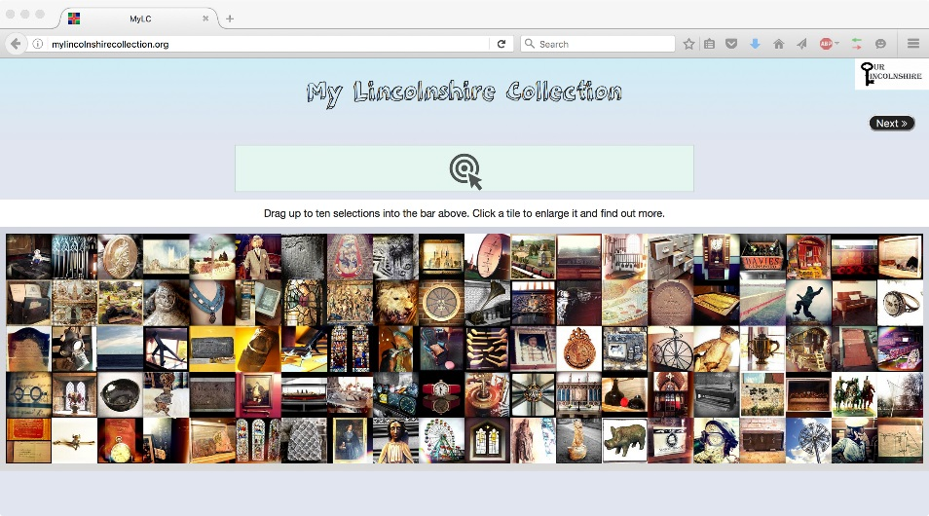
App users were asked to "Drag up to ten selections" to construct their own Lincolnshire heritage collection. Layout of the items was dynamically constructed to make good use of the available screen real estate and would immediately adapt if the window size was changed. Figures 1 and 2 shows the differing layout for a wide (e.g. laptop) screen vs a tall (e.g. mobile phone) screen

Fig. 1. My Lincolnshire Collection web-app in widescreen

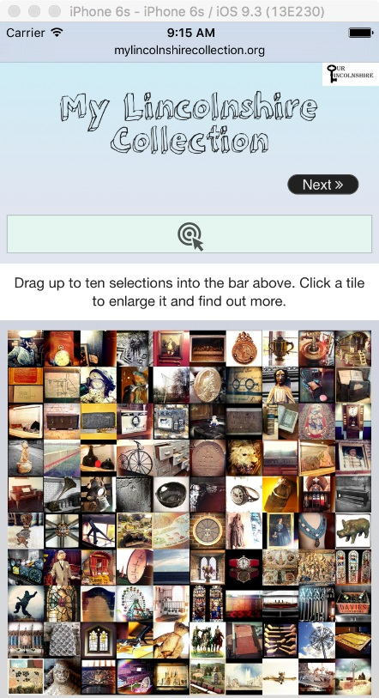
Fig. 2. My Lincolnshire Collection app layout on a mobile screen

As well as dragging and dropping their selected items, participants were informed that they could "Click a tile to enlarge it and find out more". This launched a 'fancybox' [http://fancybox.net/] window containing an enlarged version of the image along with its associated text.
After the participant had selected their items they could formally submit their choices, with this preference data stored anonymously in the database and used to create a map for the user showing the location of the items selected by the user. This user-generated map of the 10 items which were submitted by the user as their collection could then be shared by social media. This personalisation was key in fulfilling the aims of both promoting engagement with a range of heritage objects across the county and in stimulating consideration of what constitutes heritage. It was hoped this integration would both lead to additional participants taking part via the publicity gained through user sharing and additionally provide a tangible result for users of the app by giving them ownership of their own curated collection.

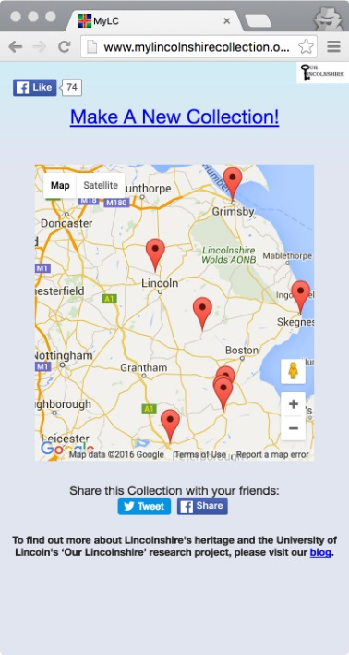
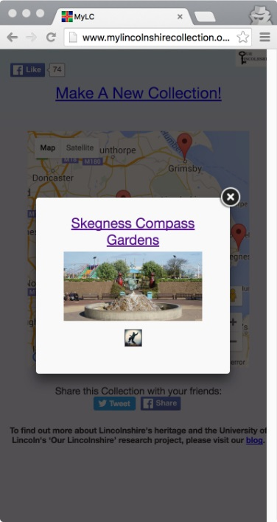
Fig. 3. My Lincolnshire Collection map Fig. 4. Map location site information
  - Iterative Refinements
After an initial low-key pilot (a beta release restricted to a University of Lincoln-wide announcement) the following changes were implemented:

1) Removal of login. Informal feedback indicated that many potential participants were being put-off engaging with the activity by the requirement to register with an email address. It was decided to remove the login functionality entirely (and its associated mailgun account for password retrieval account) and have anonymous accounts generated automatically for each page visit. This allowed users to participate without registering, and whilst the inability to contact participants with follow-up questionnaires was a disadvantage, the anticipated increased rate of engagement along with the potential addition of basic anonymous user statistics (see below) was seen as outweighing this cost.

2) Giphy Instructions. Other feedback indicated that the initial presentation of a static screen did not immediately grab the attention of the participant, and that the instructions (minimal as they were) were still a barrier to engagement. A brief gif animation showing how to use the app was created and was installed as a pop-up 'splash screen' to greet the user.
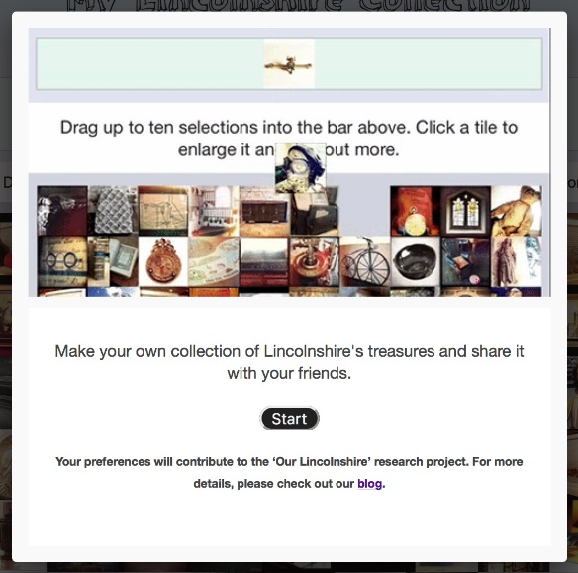
Fig. 5. Giphy instructional animated gif
3) Fancybox Select. Feedback on the pop-up fancyboxes showed that while very useful, users felt it annoying to be required to close the box in order to add the item to their collection, or view a different item. To address this, three buttons were added to the fancybox: 'previous', 'next' and ‘select’. These allowed the collection of images to be traversed gallery-style and selected without requiring a drag-drop interaction. (Figure 6)

4) Analytics. From server load statistics it became apparent that many more people were visiting the site than were completing the task (or in the beta version, registering) and engaging in curation of objects and map generation on submission. It subsequently became clear that the Meteor platform did not, by default, generate traditional access logs as other web servers do (e.g. apache access logs can be configured to show information such as IP address, browser/platform type and referring URL). Given more time there are a number of solutions that could have been deployed. However, given the need to deliver an engaging user experience and collect participant data to a deadline, more sophisticated analytics were not implemented due to these time constraints. Nevertheless, the removal of the manual login functionality and its replacement with a per-visit automated account generator (as above) allowed some basic conversion rate analytics to be performed (e.g. visits to the web-app / collections submitted, although this process was somewhat complicated by consecutive streams of phantom logins which needed to be filtered out and are still of an unknown source).The project Source code is available at: [24] https://github.com/DuncanRowland/MyLC
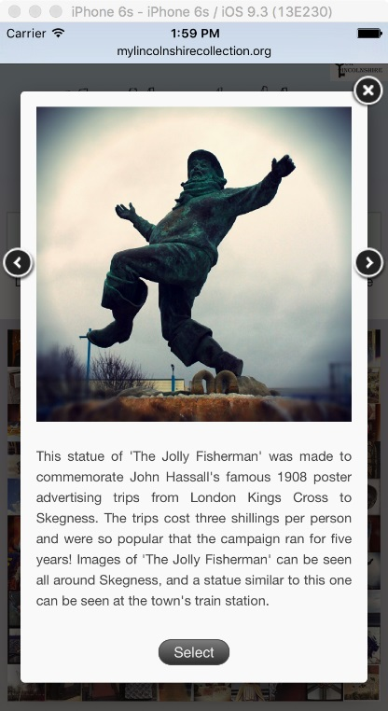
Fig. 6. Fancybox selection
  - Publicity
A substantial effort was made to promote the app through a variety of local media and articles about the web-app featured in a number of press platforms. These included articles in a range of local region newspaper publications (7 in total) and coverage on their respective websites. Additionally, coverage featured twice in the Lincolnshire-wide publication The Lincolnshire Echo, which has high levels of readership within the county. In addition, radio interviews were given and emails sent to several local heritage groups and staff at the University of Lincoln. Substantial blogs posting were made about ‘My Lincolnshire Collection’ on the ‘Our Lincolnshire’ project website. Additionally Instagram was used to promote the activity by releasing some of the available images as teasers and a Buzzfeed quiz setup.
- Results
Due to the Meteor visitor statistics collection, the actual number of visitor numbers can only be approximated (by estimating the number of researcher and study staff visitations and deducting these from the total count). It is estimated the final number of visitors which visited the site to be approximately 2700 (comparable to the 2700 responses gained to the TV Historian quiz launched on Buzzfeed as another element of the project). However, only 168 of these site visits submitted completed 10 object selections and generated a map. This equates to 6.2% of app visitors overall completing the task.
The project estimated 1000 submissions would be generated, based upon the level of publicity generated and nature of the project. As a result, the final figure recorded represents an approximately 83% lower response than was initially forecast. However, a range of qualitative data was generated from the study which provides both app feedback and contributes towards assessing the success of the stated aims of the project as outlined in the introduction. Face-to-face engagement sessions were run at a local school (participants aged 12-18), with university students (average age of 20) and staff, plus three heritage events (average age of participants as over 50), which outlined the app and allowed participants to provide feedback about the app user experience and their thoughts on the app content and heritage items. Overall feedback was positive in nature to the app experience. Comments from the 12 – 18 demographic include those which demonstrate the aims of promotion and engagement were met successfully in some cases:

“Overall a great range of different images I found it challenging to find my top 10 as all of the images were great. I am also setting myself out to find my top 10 in real life”

“I chose these because they look cool. The teddy bear surprised me because it doesn’t look historic”

“Overall I chose more modern photos as they appeal to me more”

Thematically, the 12-20 age group responded positively to the app experience and highlighted the quality of the photography as a key strength of the app. The ‘drag and drop’ mechanism required minimal explanation, with the task approached as a familiar and simple one. Engagement and meeting of the app’s aims were similarly reflected in the university student’s feedback:

“Good to see the pictures of these collections, made me interested to find out more/visit the locations of them”

“Highlighted all the treasures of the area”

The over-50s reported lower levels of satisfaction with the app interface, the pop up image descriptions and quality of the photographs despite reporting the app as an interesting concept and easy to use.

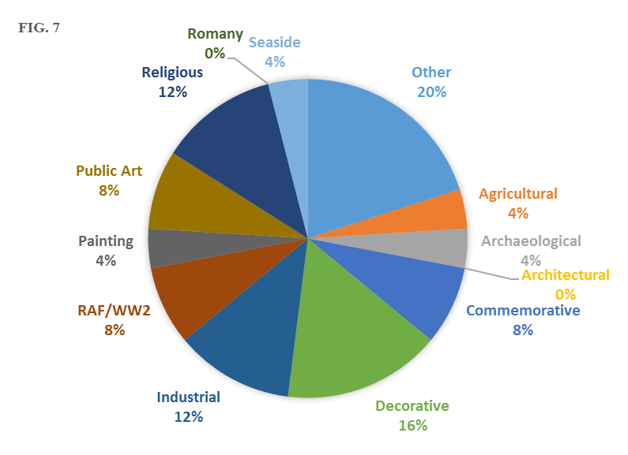
In terms of the results gained from the app, the favourite image was a piece of public art, ‘The Jolly Fisherman’ statue located at Skegness seafront. The 12-18 age group demonstrated a significant preference towards objects of a more contemporary nature and aesthetic, citing the term “modern” multiple times as justification for their decisions in selecting objects for their personalised Lincolnshire collection. In addition, despite the aim of highlighting heritage beyond the city of Lincoln, heritage sites within this locality featured strongly in the selections submitted by participants with 32% of the 25 most chosen objects located within the city. The top 25 objects selected for participants’ Lincolnshire collections overall included multiple types as seen below
Fig. 7. Top 25 selected objects by heritage type
- Discussion
In meeting the stated aims for the app, the qualitative data presents some interesting findings which are indicative of attitudes to heritage in Lincolnshire [25]. This data was generated from guided presentation sessions with users, and addresses the exploratory nature of this app in terms of demographic appeal. Findings indicate that the 12-20 age group (school aged and university students) responded favourably to the use of a mobile platform to promote heritage. In part this may be attributed to their perception of the UI and app task as a familiar, simple interface which required a low cognitive load and no reference to the instructional GIF supplied required in order to commence using the app. The ubiquitous nature of mobile devices presents an opportunity to further leverage this format within a cultural heritage context for this high ownership demographic.
The constraints of the study design and timeframe have resulted in a lack of sufficient data to draw wider conclusions about the demography of participants who independently submitted the 168 completed collections. As this number fell far short of the projected target of 1000, there is a significant gap in this metric as a singular measure of the app’s impact and success. In meeting the aims of increasing engagement, interest and perception of what constitutes local heritage, particularly in promoting visitation to lesser known sites outside of Lincoln city centre, the attitudes of users who visited the web-app but did not submit a completed collection remain unquantifiable in terms of measuring the impact of the web-app design. A follow-up study of visitation numbers to sites featured in the web-app would be an appropriate method to further explore the app as a long term method of heritage promotion, particularly due to the significant amount of local press and radio coverage of the My Lincolnshire Collection app received locally while live.
In meeting the aim for the project of data generation on the relative popularity of differing heritage types and how they generate interest, the lack of user data from non-completers remains a challenge in drawing large scale conclusions. However, the qualitative data demonstrated a strong preference by the younger demographics for modern objects, which is reflected in the analysis of the app collections data. This suggests that the diversity of the app photographs may have worked well in terms of representing cultural heritage as being significantly more broad than the traditional perception of archaeological artefacts in museums, with the introduction of items relating to public art, the seaside and agriculture broadening the range of types and historical time periods. The sample of 100 heritage images represented on the app, whilst selected to be diverse, was randomly arranged and not selected with this agenda specifically in mind, was heavily weighted towards items/sites created in the 18th century onwards. This was reflected in the top 25 items selected by users of the app which mirrored this composition. This bias in the sample, whilst challenging perceptions of heritage as primarily antiquated, may have inadvertently led the results to be skewed towards more modern objects in demographic groups who might not otherwise have demonstrated such high levels of engagement with more contemporary heritage.
This mechanism of presentation by predominantly visual means (with the option to explore individual items in more detail) could be considered to be the key contribution of this app. This allowed users to register an immediate aesthetic response to the characteristics of the photograph, whether it was an item they were familiar with or could identify, or not. This bypassed any preconceptions or attitudes towards particular heritage types sounding dry, unappealing or liable to be uninteresting. Essentially, the photographs acted as a visual provocation to users free from textual confusion or the sense the app was educating as opposed to opinion seeking.
It could be hypothesised that the app sample included too many images and that participants were discouraged by being given too much choice and the sense that it would take a long time to scroll through, look at each image and select favourites. This could account for users who used the app but did not complete their collection, who after a period spent browsing may not have wished to dedicate additional time or energy to formally submit a collection and generate a personalised map.
- Conclusion
The exploratory ‘My Lincolnshire Collection’ web-app provided data on local attitudes towards heritage and met the aims of exploring the demographic appeal of an app for a heritage context. Whilst the app itself was stable, the Meteor platform posed a number of challenges in both analytics and de-bugging.
The app clearly demonstrated that in order to form part of a research agenda or generate a substantial sample of participant users, significant effort and resources must be allocated in order to promote and recruit users to the app itself in order that take-up achieves levels sufficient to generate valid data. Even though a web-app solution was deployed rather than a native app (to maximise uptake through the removal of an installation process) in an age of ubiquitous smartphone ownership and usage, the novelty value and inherent appeal of a digital app is minimal in attracting participation in its own right. Even with substantial promotion and minimal barriers to completion, submission rates were low. The usefulness and richness of the qualitative data gathered from the presentation sessions run by study staff highlight the importance of user studies in the development and roll-out of HCI interfaces, even when using familiar and ubiquitous devices. The feedback fed into iterative modifications to the implementation of the app during the project.
The study design overall, combined with time constraints in development and testing, has resulted in a lack of data on the demographic makeup of participants who did complete the app task. The significant number of users who visited the app but did not complete the task means that the impact of the overall aim of promoting lesser-known heritage and visitation cannot be quantified as no metric was available to capture this possible influence on participants. The authors suggest that follow-up studies that incorporated a methodology to capture the data not recorded, conduct analysis on visitor figures to assess real world impact or implement an improved iteration of the app incorporating the findings and observations would all be beneficial. Overall the web-app presents an example of successful multi-disciplinary collaboration between HCI and Cultural Heritage researchers and provides a case study on the contribution that human-computer interaction can make in heritage and tourism contexts, which remains under-explored.
- References
1. Giaccardi, E.: Heritage and social media: Understanding heritage in a participatory culture. Routledge, Abingdon (2012)
2. Grinter, R. E., Aoki, P.M., Hurst, A., Szymanski, M.H., Thornton, J.D. and Woodruff, A.: Revisiting the Visit: Understanding How Technology Can Shape the Museum Visit. In Proc. CSCW, New York: ACM, 146-155. (2003)
3. Ardito, C., Buono, P., Costabile, M. F., Lanzilotti, R., Piccinno, A.: Enabling interactive exploration of cultural heritage: an experience of designing systems for mobile devices. Knowledge, Technology & Policy,22, 1, 79-86. (2009).
4. Danesh, A., Inkpen, K., Lau, F., Shu K., Booth, K.: Geney: designing a collaborative activity for the palm handheld computer. Proc. CHI 2001, ACM Press, New York.388– 395 (2001)
5. Ciolf, L., McLoughlin, M.: Designing for Meaningful Visitor Engagement at a Living History Museum. In proceedings of NORDICHI 2012. Copenhagen, Denmark (2012)
6. Kakarountas, A., Dragoumanos, S., Kakarountas, K.: Extending Visitor’s Reality at Museums. (2012)
7. Tesoriero, R., Gallud, JA., Lozano, M., Penichet, V.M.R.: A Location-aware System using RFID and Mobile Devices for Art Museums. In proceedings of Fourth International Conference on Autonomic and Autonomous Systems. (2008)
8. Suh, Y., Shin, C., Woo, W., Dow, S., & Macintyre, B.: Enhancing and evaluating users’ social experience with a mobile phone guide applied to cultural heritage.Personal and Ubiquitous Computing,15, 6, 649-665. (2011)
9. Constabile, M.F., Ardito, C., Lanzilotti, R.: Enjoying Cultural Heritage thanks to mobile technology. Interactions. 17, 3, 30. (2010)
10. Paternò, F., Mancini, C.: Effective levels of adaptation to different types of users in interactive museum systems. Journal of the American Society for Information Science,51, 3, 5-13. (2000)
11. Damiano, R., Gena, C., Lombardo, V., Nunnari, F., Pizzo, A.: A stroll with Carletto: adaptation in drama-based tours with virtual characters. Interaction, 18, 5, 417-453. (2008)
12. Kukka, H., Ojala, T.: mobileDOK: culture in your pocket. In Proceedings of the 3rd international conference on Mobile technology, applications & systems. ACM. (2006)
13. Malcolm-Davies, J. A.: The educational role of front-of-house staff in the visitor experience at heritage attractions. Proceedings: Hawaii International Conference on Social Sciences. (2004)
14. Tison Povis, K., Crowley, K.: Family Learning in Object-Based Museums: The Role of Joint Attention. Visitor Studies 18(2). (2015)
15. Bennett, T.: The Birth of the Museum: History, Theory, Politics. Routledge. (1999)
16. Hope, T., Nakamura, Y., Takahashi, T., Nobayashi, A., Fukuoka, S., Hamasaki, M., Nishimura, T.: Familial Collaborations in a Museum. In Proceedings of SIGCHI Conference on Human-Computer Interaction. Boston, MA. (2009)
17. Petrelli, D., Ciolfi, L., Van Dijk, D., Hornecker, E., Not, E., Schmidt, A.: Integrating Material and Digital: A New way for cultural heritage. Interactions, 20, 4, 58-63. (2013)
18. Falk, J.: Identity and the museum visit experience. Left Coast Press., Walnut Creek, CA (2009)
19. Poria, Y., Givili, Y. Heritage Site Websites Content: The Need for Versatility. Journal of Hospitality & Leisure Marketing, 15, 2 (2007)
20. Falk, J,H., Dierking, LD.: The Museum Experience Revisited. Routledge (2012)
21. Gadsby, J.: The Effect of Encouraging Emotional Value in Museum Experiences. Museological Review 15, 1–13 (2011)
22. Casella, G., Coelho, M.: Augmented heritage: situating augmented reality mobile apps in cultural heritage communication. In Proceedings of the 2013 International Conference on Information Systems and Design of Communication 138-140. ACM. (2013)
23. Meteor: https://github.com/meteor/meteor (2016)
24. Rowland, D. My Lincolnshire Collection. Github, https://github.com/DuncanRowland/MyLC (2015)
25. Lewis, C., Scott, A., Cruse, A., Nicholson, R. and Symonds, D. “Our Lincolnshire” County-wide public consultation on public attitudes to Lincolnshire’s heritage. Report by the University of Lincoln (2016)

