Mobile Money Investigations with PostgreSQL and Neo4j
Advanced Big Data Analytics, Project 2. Report: Sections 1 to 7
Ndanyuzwe Duncan, Student ID: [add ID]
[Member 2 name, Student ID]
[Member 3 name, Student ID]
26 October 2026
Table of Contents

Scope. This report covers:
- capturing the September 2026 records (Section 1);
- building PostgreSQL (Section 2) and Neo4j (Section 3);
- the routine business questions Q1 to Q3 (Section 4);
- the connected-account investigations Q4 to Q7 (Section 5);
- correctness and performance (Section 6);
- concurrent requests (Section 7).
Each screenshot shows the executed command, its result, and the macOS menu-bar clock and Dock. Full outputs, raw timing runs and plans are in outputs/ in the code submission.

1 Capture the data

1.1 Prepare your workspace
Item | Value
CPU | Apple M2, 8 cores
RAM | 8.6 GB (8 GiB)
OS | macOS 14.6.1 (arm64)
PostgreSQL | 16.8 (Postgres.app), project database momo, TimeZone = Africa/Kigali (ALTER DATABASE momo SET timezone)
PostgreSQL memory | shared_buffers 128MB, work_mem 4MB, maintenance_work_mem 64MB (512MB in the index-build session), effective_cache_size 4GB
Neo4j | 5.26.0 Community, dedicated instance, default neo4j database, Java 17
Neo4j memory | heap initial/max 2 GiB, page cache 2 GiB
Python and drivers | Python 3.13.2, psycopg 3.3.6, neo4j driver 6.4.1, numpy 2.5.4, matplotlib 3.11.2
Generator | unchanged, sha256 2ea0e59d…e9455a
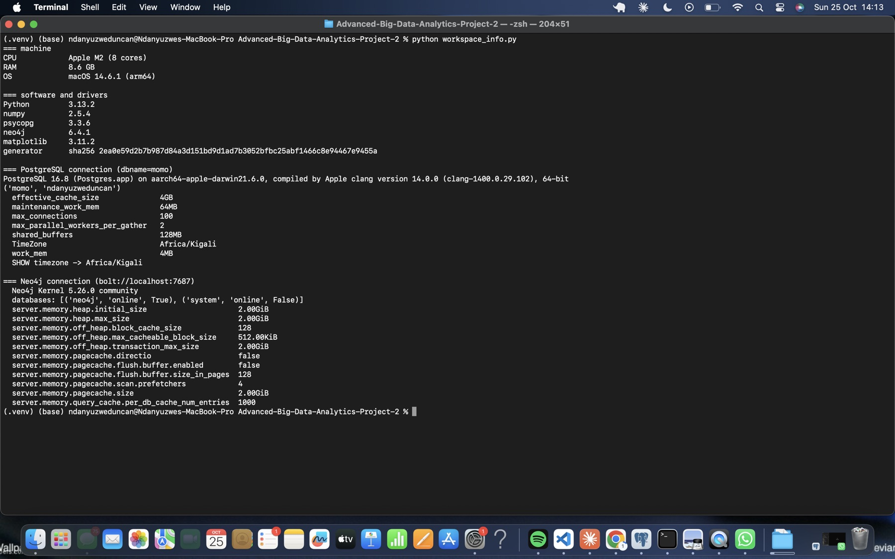
Figure 1. Workspace report: hardware, versions, both connections and memory settings (workspace_info.py).
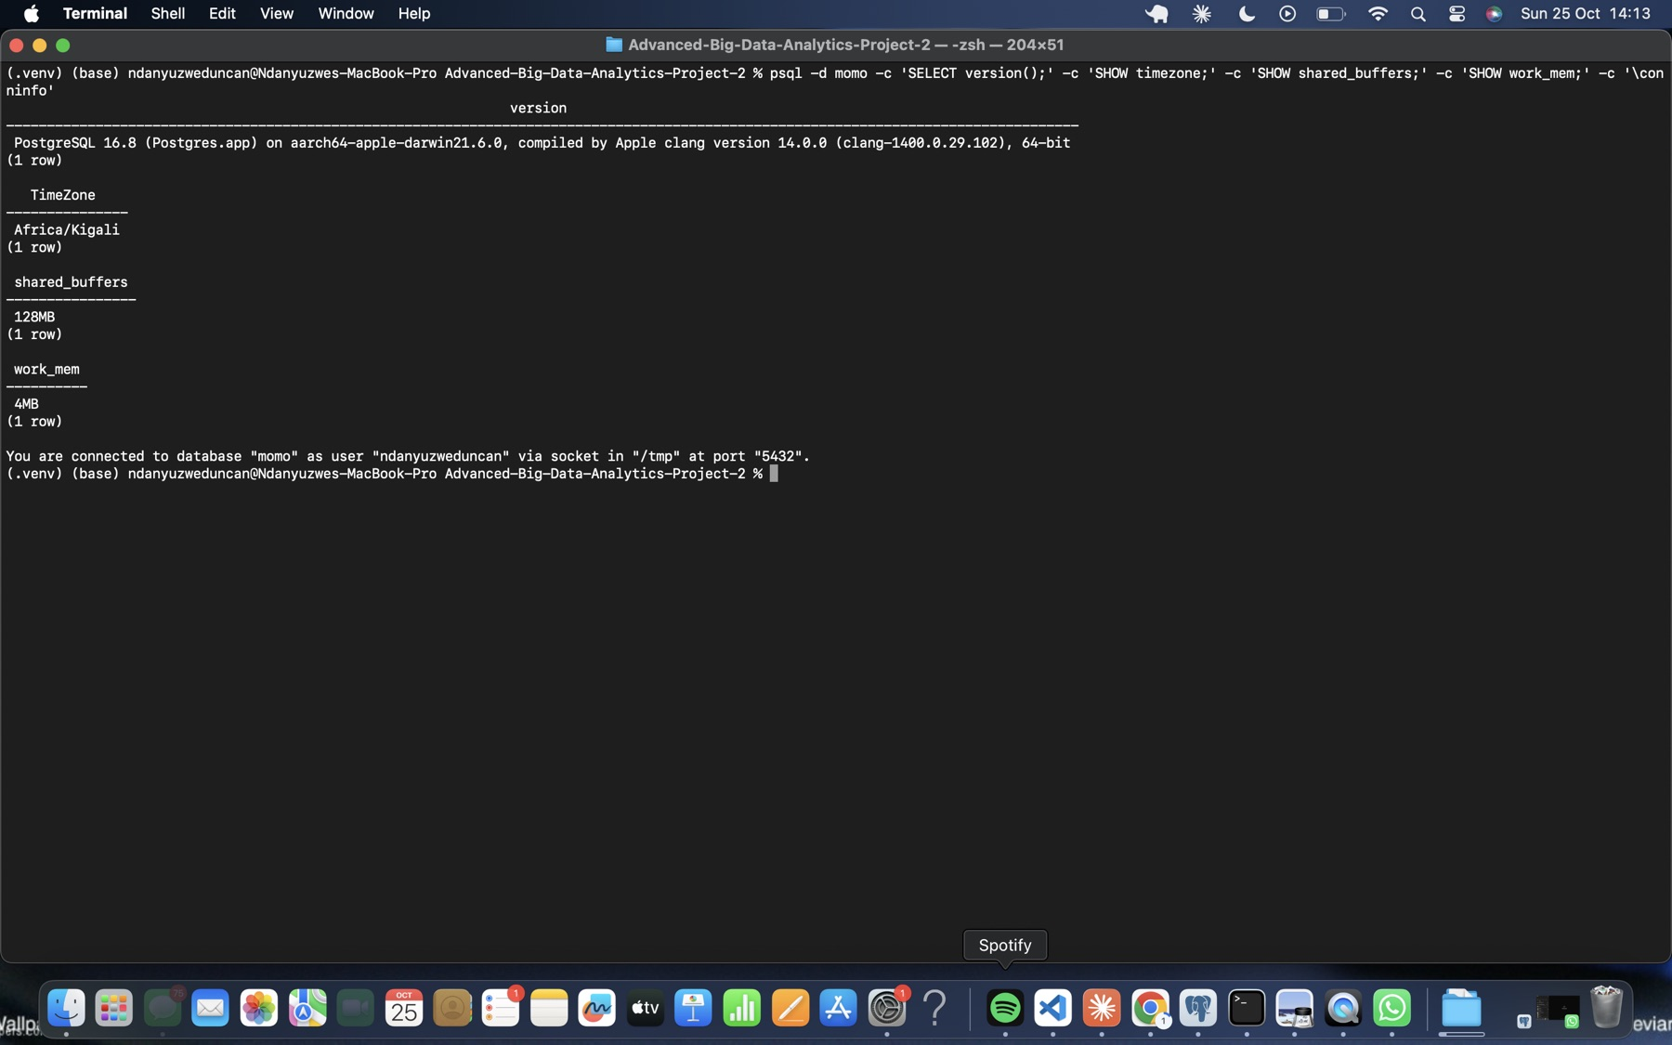
Figure 2. PostgreSQL connection and settings, including the Africa/Kigali time zone.
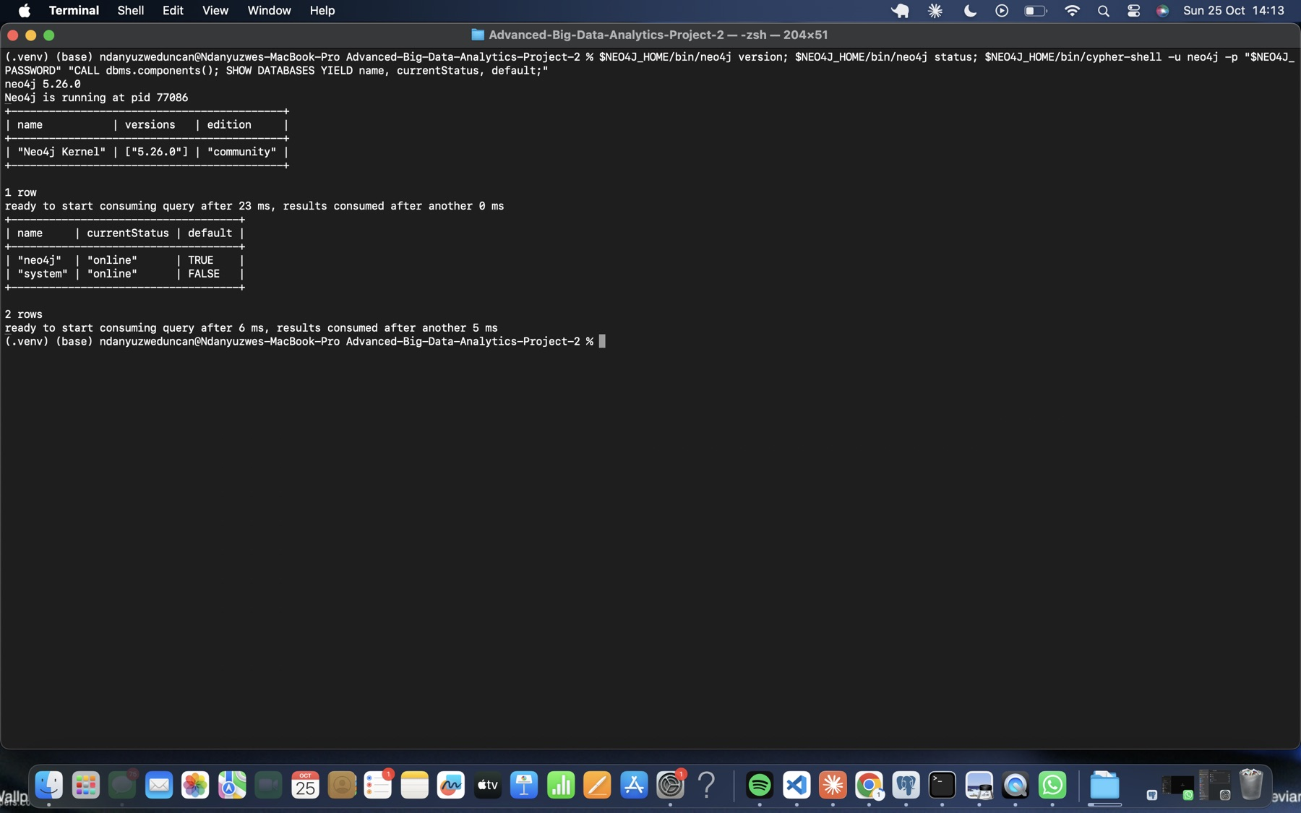
Figure 3. Neo4j 5.26.0 Community running, with the default neo4j database online.

1.2 Build capture.py
capture.py imports the generator as g, prints g.dataset_info() and g.FIELDS, and previews ten records per stream with itertools.islice. Because each iter_<stream>() call creates a fresh generator, previewing doesn’t consume rows from the capture. Rows are written one at a time with csv.DictWriter, so no stream is held in memory. The script logs every million transfers and keeps running audit totals. Earliest and latest times are tracked with explicit min/max checks, because transfers aren’t time-sorted.
Stream | Consumed | Written | Expected | Match | Seconds | CSV MB
customers | 228,000 | 228,000 | 228,000 | yes | 0.4 | 3.6
accounts | 248,000 | 248,000 | 248,000 | yes | 0.5 | 5.2
devices | 228,600 | 228,600 | 228,600 | yes | 0.3 | 3.6
account_devices | 285,600 | 285,600 | 285,600 | yes | 0.7 | 6.3
transfers | 20,003,300 | 20,003,300 | 20,003,300 | yes | 70.6 | 780.2
Total | 20,993,500 | 20,993,500 | 20,993,500 | yes | 72.4 | 798.8
Transfer audit:
Audit item | Value
Transfer count | 20,003,300
Earliest occurred_at | 1788235200 (2026-09-01 06:00:00 CAT)
Latest occurred_at | 1790798399 (2026-09-30 21:59:59 CAT)
Sum of amount_rwf | 231,482,327,870 RWF
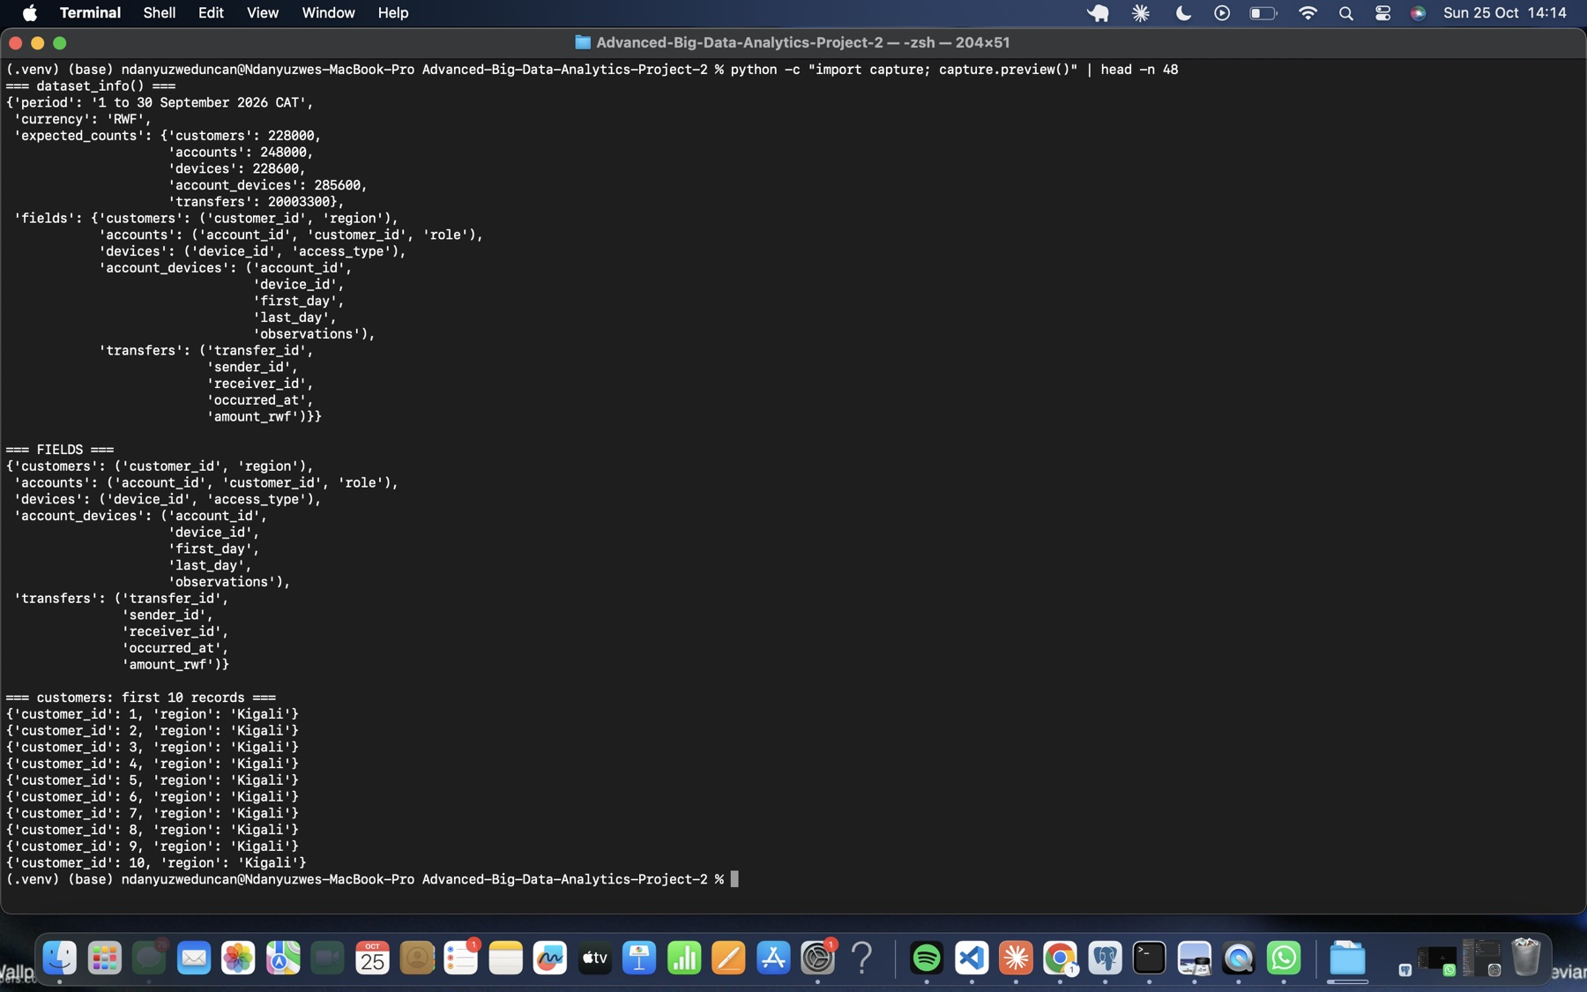
Figure 4. Preview, part 1: dataset_info(), FIELDS and the first ten customers.
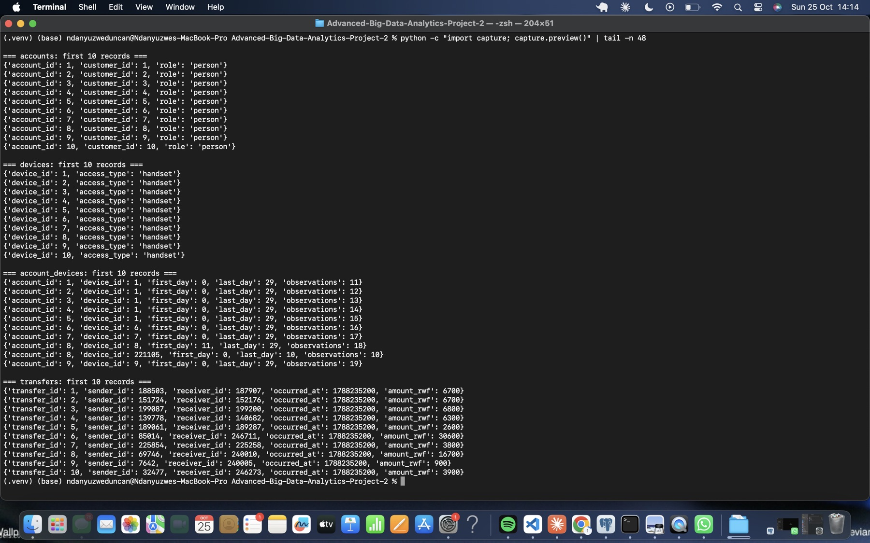
Figure 5. Preview, part 2: the first ten accounts, devices, account_devices and transfers.
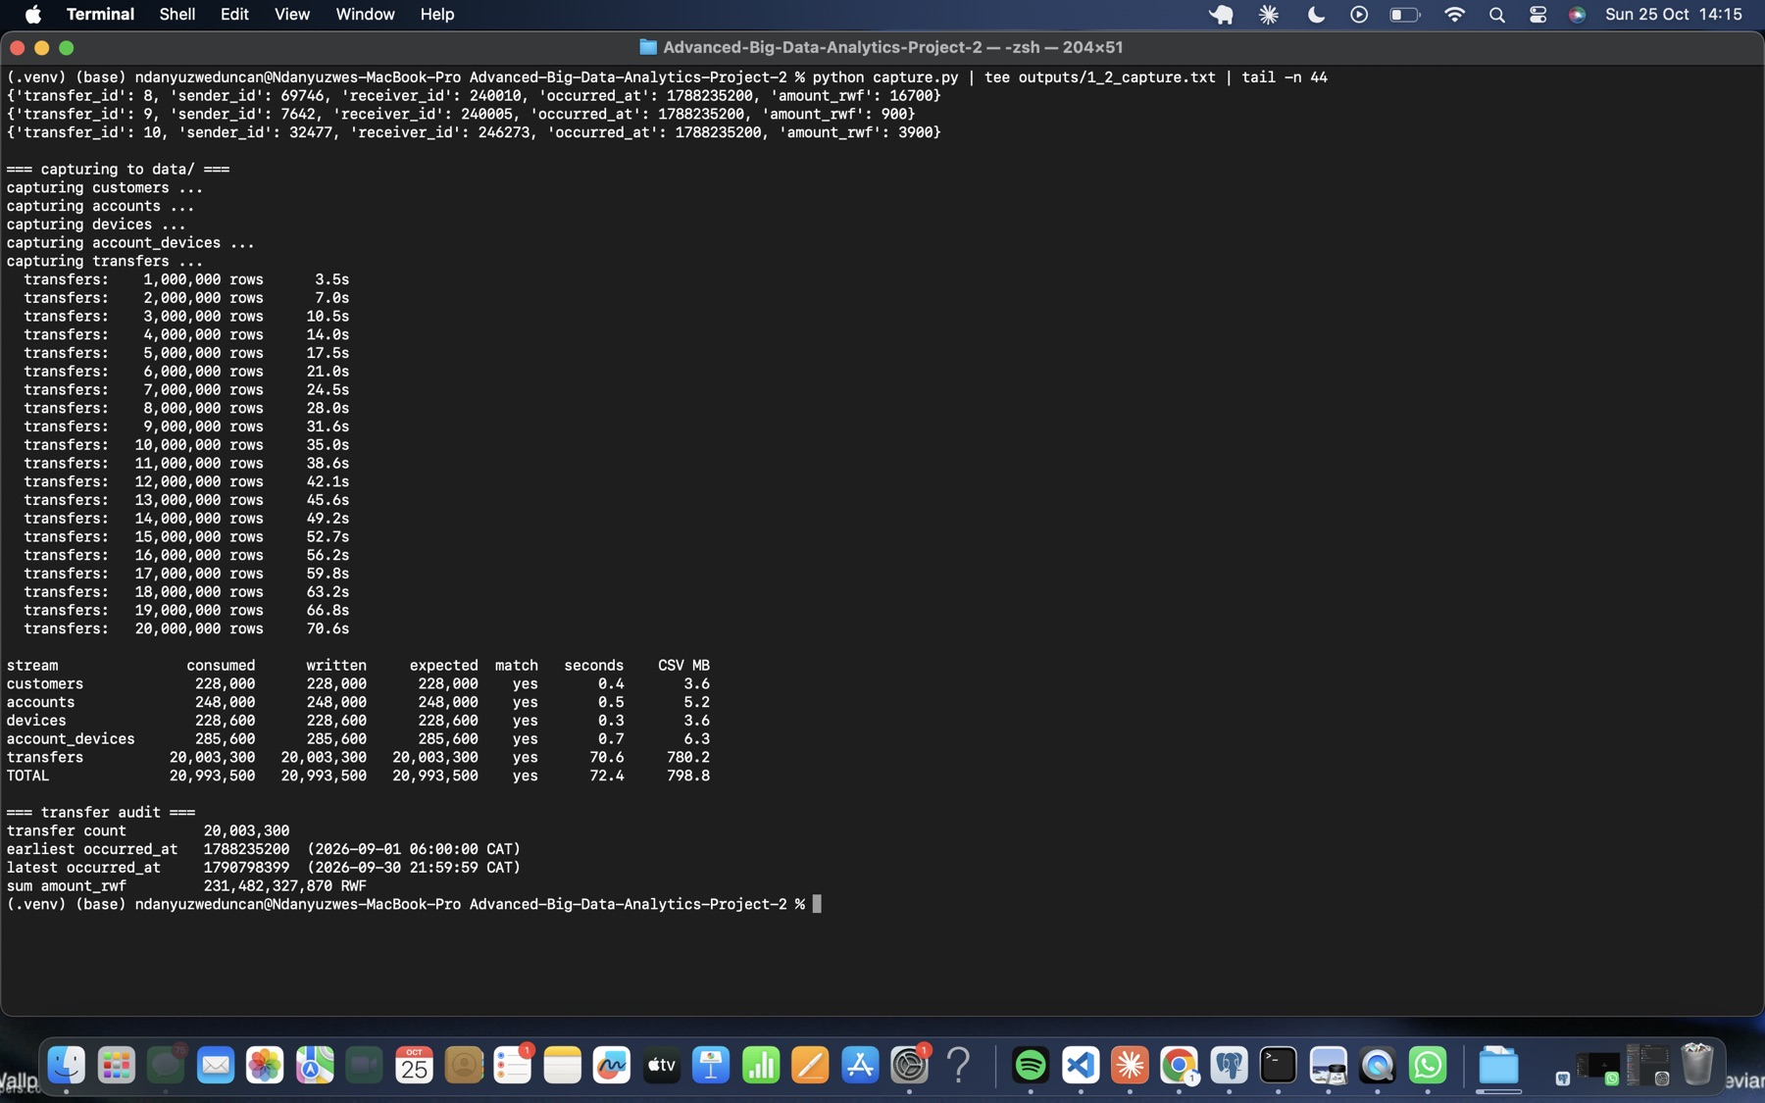
Figure 6. Completed capture: million-row log, five-stream totals and the transfer audit.

2 Build PostgreSQL

2.1 Define the five tables
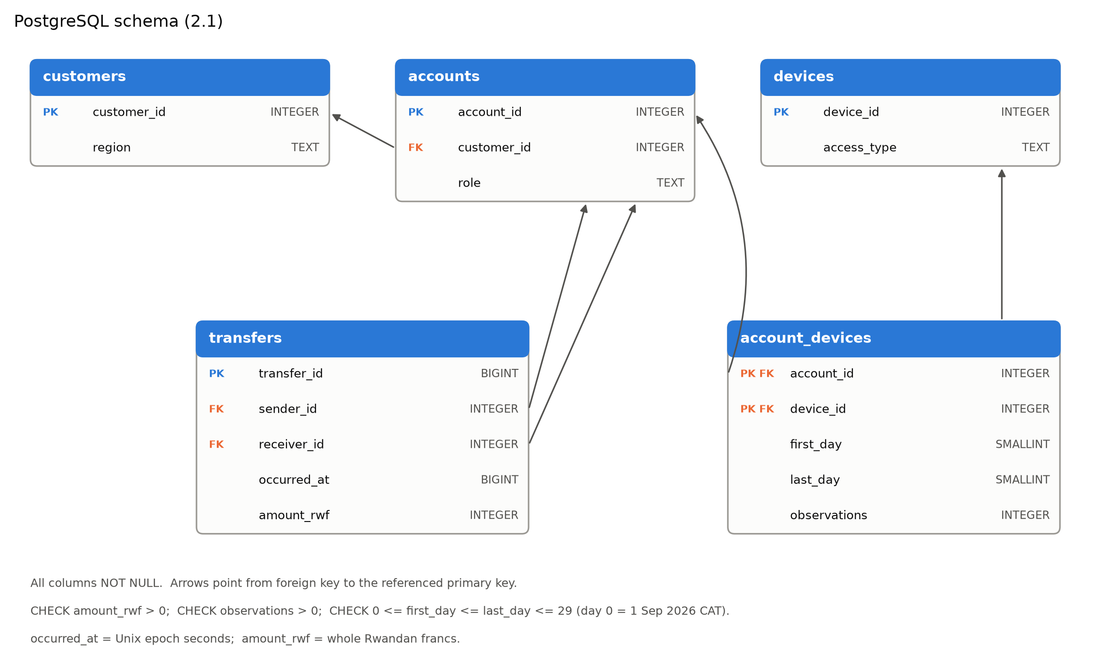
Figure 7. PostgreSQL schema. Arrows point from each foreign key to the primary key it references.
Table.field | Meaning and unit
customers.customer_id / region | Customer identifier; Kigali, Northern, Southern, Eastern or Western
accounts.account_id / customer_id / role | Wallet; owning customer (FK, ownership); person, merchant or agent
devices.device_id / access_type | Device identifier; handset or public_terminal
account_devices.first_day / last_day | Inclusive observation interval, as day numbers 0 to 29 (day 0 = 1 Sep 2026 CAT)
account_devices.observations | Number of observations of the wallet on the device within the interval. This is observed use, not ownership.
transfers.transfer_id | Event identifier (BIGINT)
transfers.sender_id / receiver_id | Paying and receiving wallets (FKs, both endpoints)
transfers.occurred_at | Unix epoch seconds (BIGINT); CAT = UTC+2
transfers.amount_rwf | Positive whole Rwandan francs
Constraints:
- Every column is NOT NULL.
- Primary keys are the entity and event IDs, plus (account_id, device_id) for account_devices.
- Five foreign keys cover ownership, device use (account and device), and both transfer endpoints.
- CHECK constraints: amount_rwf > 0, observations > 0, and 0 <= first_day <= last_day <= 29.
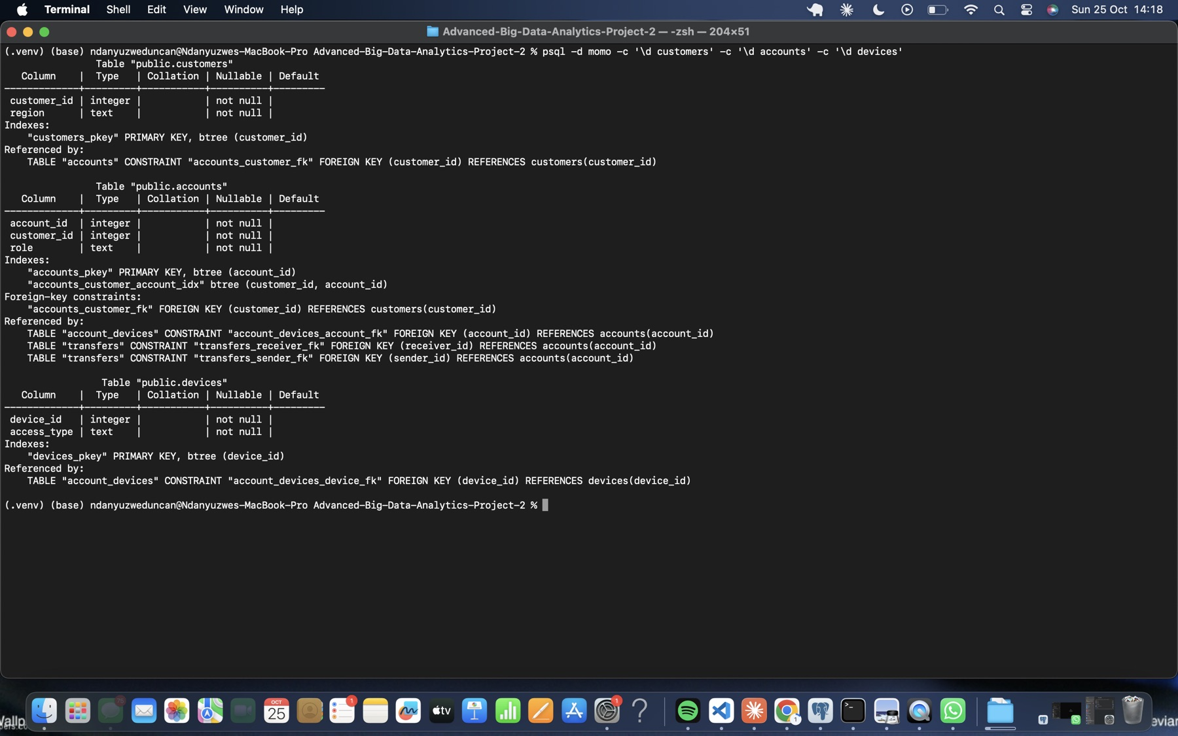
Figure 8. Definitions of customers, accounts and devices (\d).
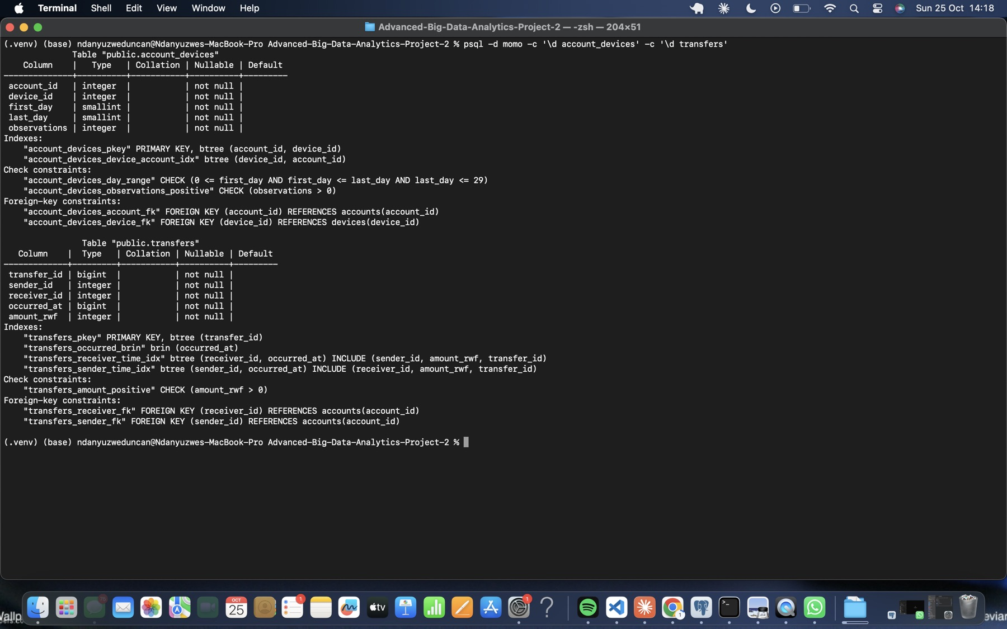
Figure 9. Definitions of account_devices and transfers, with check constraints, foreign keys and indexes.

2.2 Bulk-load and check
Tables were loaded parents first (customers, devices, accounts, account_devices, transfers) with \copy … CSV HEADER. Keys and indexes were added after the load, so that each index is built once and its setup time is measured separately.
Step | Seconds
Load customers / devices / accounts / account_devices | 0.134 / 0.117 / 0.164 / 0.195
Load transfers | 18.961
Total loading | 19.57
Primary keys (transfers: 28.51) | 29.23
Foreign keys (two transfer FKs: 3.44 + 3.42) | 7.11
Secondary indexes (covering transfer indexes 27.83 + 30.24, BRIN 2.57) | 60.84
ANALYZE | 1.08
Total index/constraint setup | 98.25
Indexes:
- accounts(customer_id, account_id)
- account_devices(device_id, account_id)
- transfers(sender_id, occurred_at) INCLUDE (receiver_id, amount_rwf, transfer_id)
- transfers(receiver_id, occurred_at) INCLUDE (sender_id, amount_rwf, transfer_id)
- BRIN on occurred_at
Checks. All row counts match capture.py (20,993,500 in total). Roles are 240,000 person, 6,000 merchant and 2,000 agent. The transfer audit is identical to capture.py. All 13 constraints show convalidated = t.
Size (1 GB = 10⁹ bytes) | Data GB | Index GB | Total GB
transfers | 1.206 | 2.434 | 3.639
all five tables | 1.250 | 2.468 | 3.718
database momo |  |  | 3.726
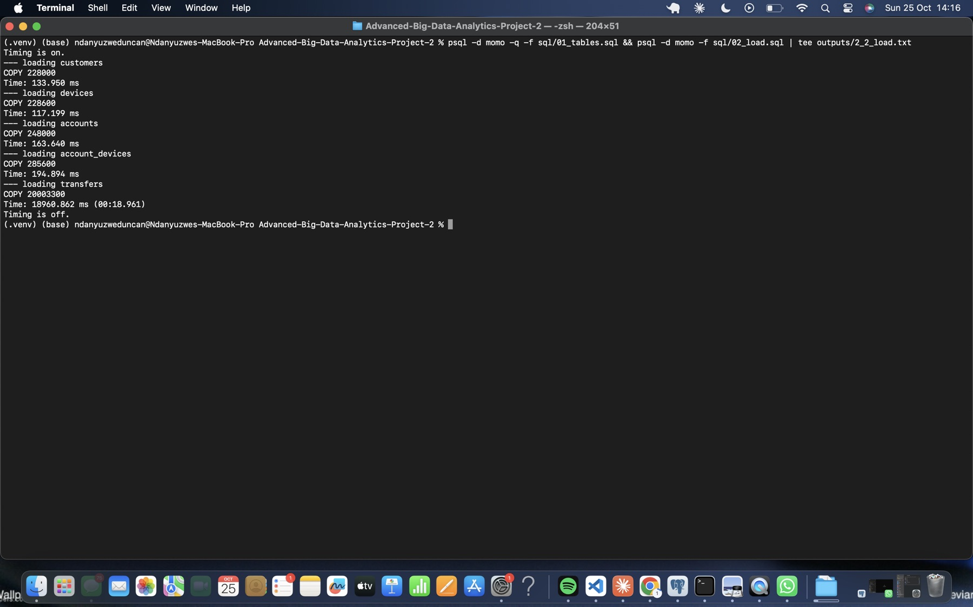
Figure 10. Bulk load with \copy, with per-table load times.
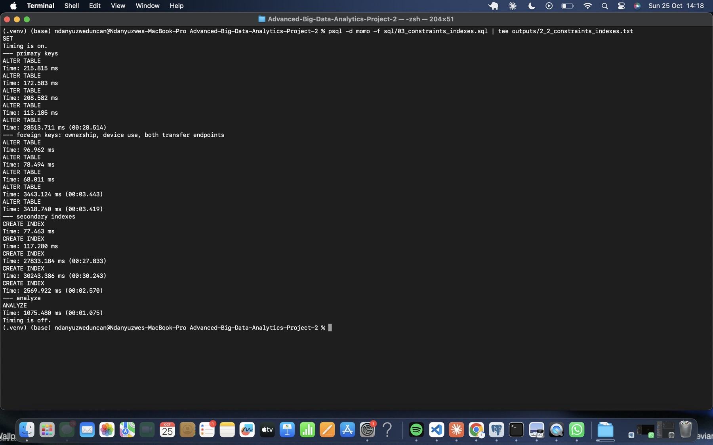
Figure 11. Primary key, foreign key, index and ANALYZE setup times.
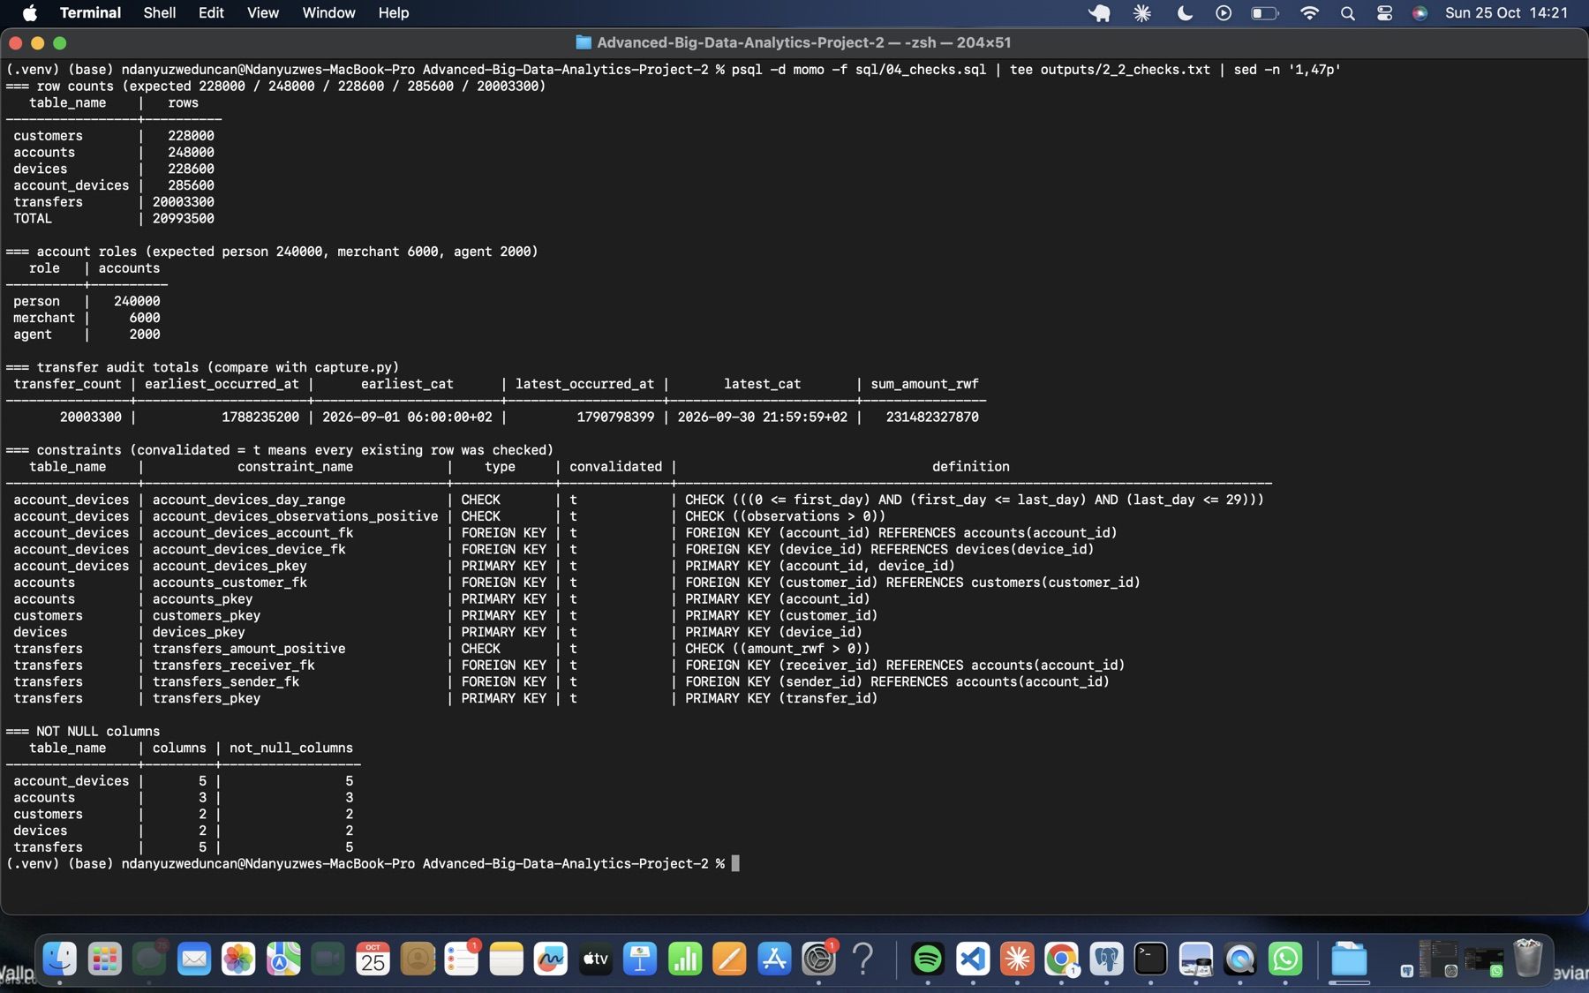
Figure 12. Checks: row counts, roles, transfer audit totals and validated constraints.
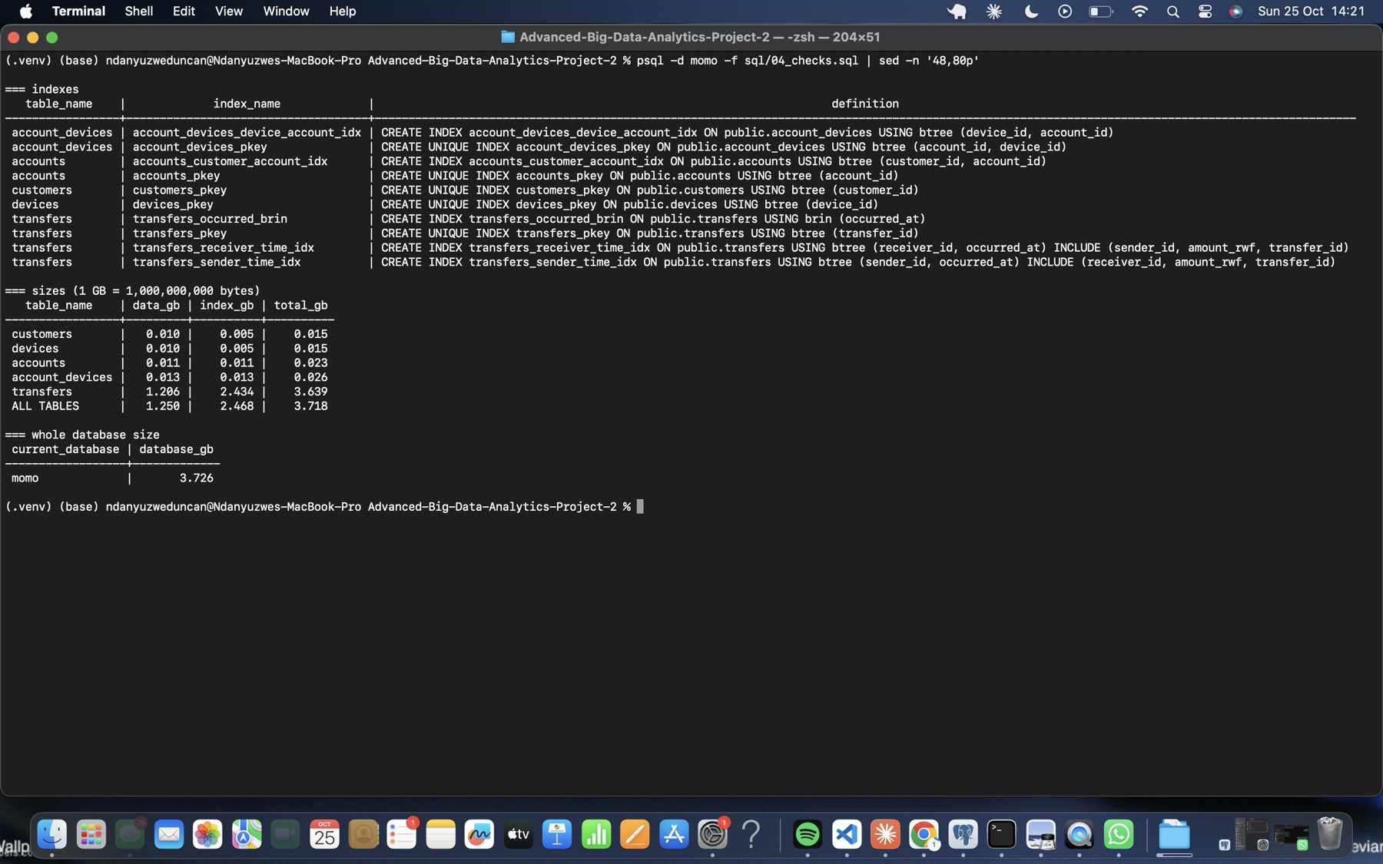
Figure 13. Checks: index definitions, and data, index and database sizes.

3 Build Neo4j

3.1 Map the same facts
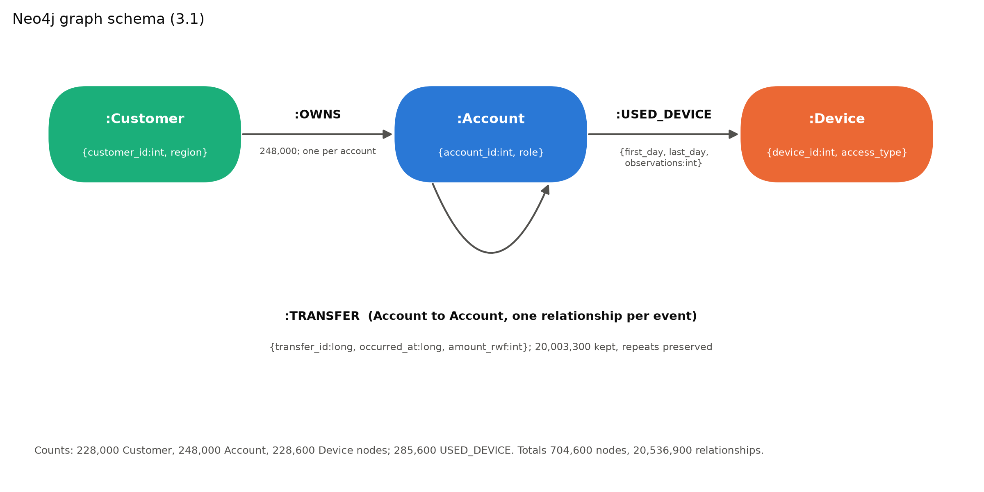
Figure 14. Neo4j graph schema.
Source field | Graph element
customers.customer_id, region | Customer.customer_id (int), Customer.region
accounts.account_id, role | Account.account_id (int), Account.role
accounts.customer_id | (:Customer)-[:OWNS]->(:Account). The column is :IGNOREd on the node and becomes this relationship.
devices.device_id, access_type | Device.device_id (int), Device.access_type
account_devices.account_id, device_id | (:Account)-[:USED_DEVICE]->(:Device) endpoints
account_devices.first_day, last_day, observations | USED_DEVICE properties (int)
transfers.sender_id, receiver_id | (:Account)-[:TRANSFER]->(:Account) start and end
transfers.transfer_id, occurred_at, amount_rwf | TRANSFER properties (long, long, int). Each event is a separate relationship.

3.2 Prepare and import CSVs
prepare_import.py writes temporary copies to import/ with typed headers, using separate Customer, Account and Device ID groups. It replaces only the header line and streams the remaining rows, leaving the source CSVs unchanged. It also derives owns.csv (:START_ID(Customer),:END_ID(Account)) from accounts.csv. The full import was run with the database stopped:
neo4j-admin database import full neo4j --overwrite-destination --id-type=integer
--nodes=Customer=import/customers.csv --nodes=Account=import/accounts.csv
--nodes=Device=import/devices.csv --relationships=OWNS=import/owns.csv
--relationships=USED_DEVICE=import/used_device.csv --relationships=TRANSFER=import/transfers.csv
Step | Result
Import | 35.3 s (40.3 s wall). 704,600 nodes, 20,536,900 relationships, 62,275,900 properties, peak memory 1.04 GiB, empty bad-row report
Constraints and index | 3 uniqueness constraints plus a range index on TRANSFER.occurred_at, all ONLINE 100%: 33.2 s
Store / transaction logs | 2.064 GB / 0.000016 GB (the offline import writes no transactions)
Across three runs, the import took 35–70 s. In this run the importer warned that only 135 MiB of memory was free. The slower runs most likely reflect memory pressure on an 8 GB machine with PostgreSQL also running.
Checks.
- Customer 228,000, Account 248,000 and Device 228,600 nodes (704,600 in total).
- OWNS 248,000, USED_DEVICE 285,600 and TRANSFER 20,003,300 relationships (20,536,900 in total).
- Roles match PostgreSQL. Every account has exactly one owner.
- There are 20,003,300 distinct transfer IDs.
- Audit totals are identical to capture.py and PostgreSQL.
The temporary import copies were then removed.
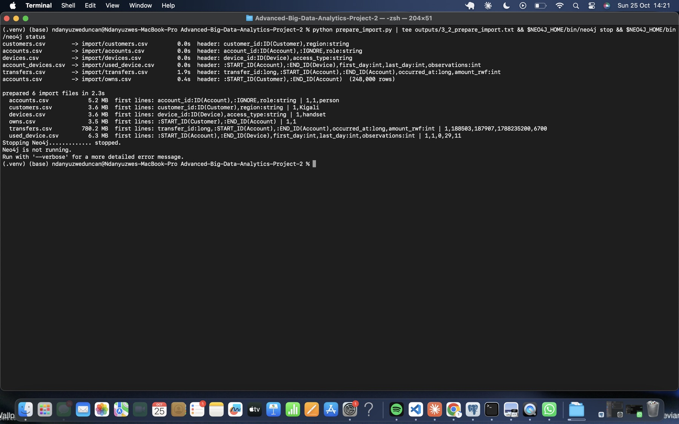
Figure 15. Typed import copies and owns.csv, followed by stopping Neo4j.
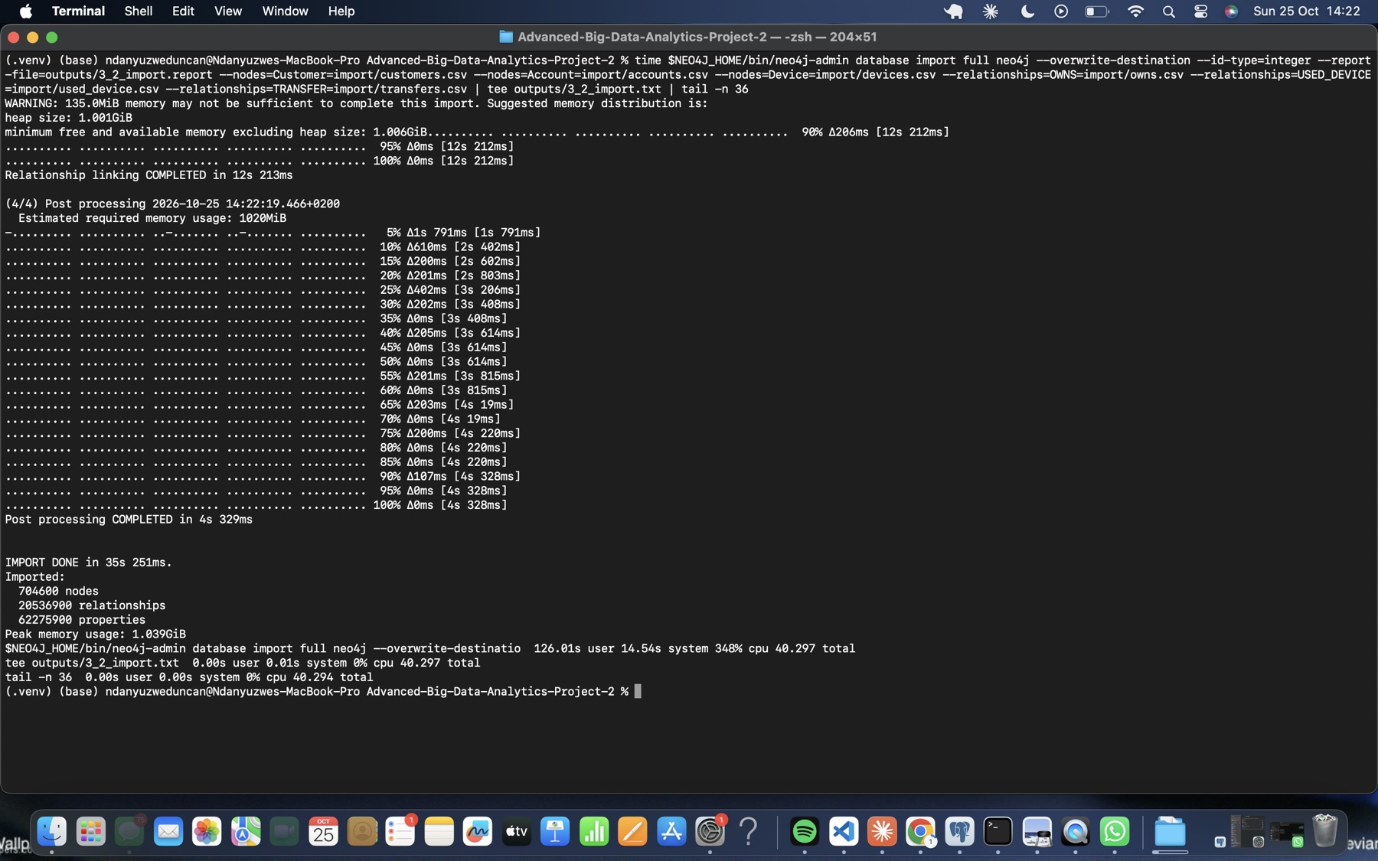
Figure 16. Full offline import completed.
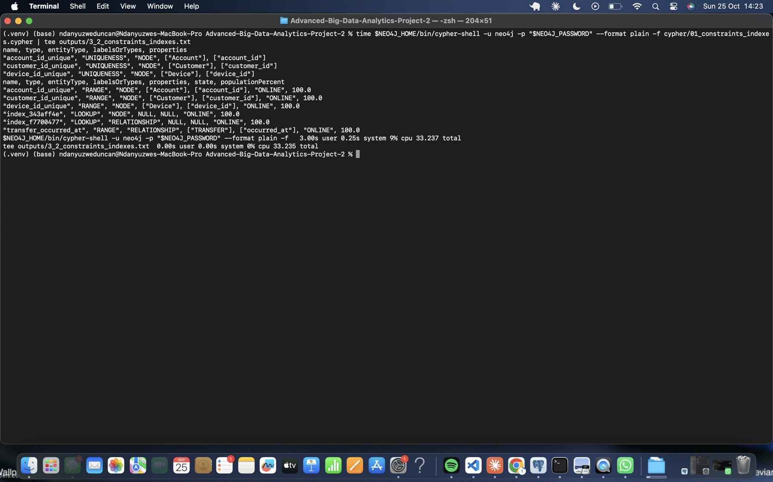
Figure 17. Uniqueness constraints and range index, all ONLINE.
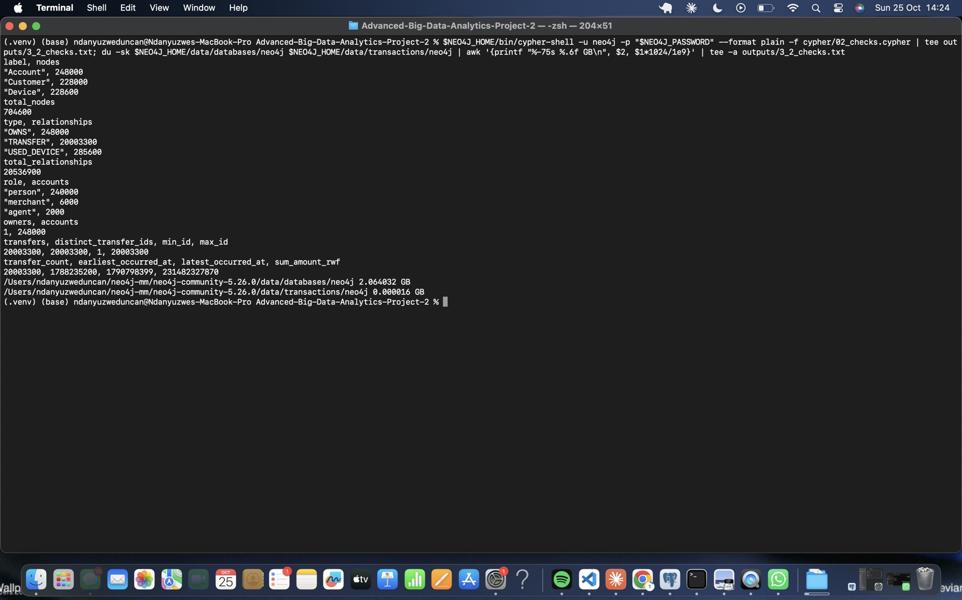
Figure 18. Neo4j checks, plus store and transaction-log sizes.
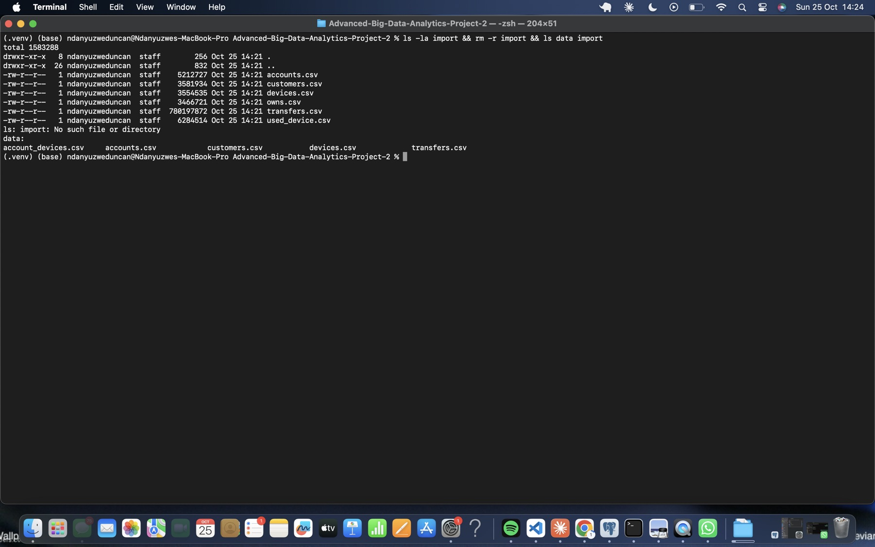
Figure 19. Temporary import copies removed; the source CSVs are kept.

3.3 Inspect one account in both models
Account 998 (set A) was traced to its owner, a device and an outgoing transfer with a SQL JOIN and a Cypher MATCH. Both return the same row: owner 998 (Kigali), handset 998 (days 0–29, 39 observations), and transfer 113540 to account 240004 at 2026-09-01 08:43:29 CAT for 2,100 RWF.
How foreign keys become relationships. Each FK column becomes a stored, directed relationship:
- accounts.customer_id becomes OWNS.
- The junction table account_devices becomes USED_DEVICE, and its non-key columns become relationship properties.
- transfers.sender_id and receiver_id become the start and end of a TRANSFER relationship, which carries the event columns.
SQL matches key values at query time through an index. Neo4j follows the stored link from the node.
What collapsing repeated payments would lose. The month has 20,003,300 transfers but only 8,103,289 distinct sender→receiver pairs, so one edge per pair would erase 11,900,011 events. Account 998 alone repeats payments to 16 receivers; for example, it paid account 1111 nine times between 2 and 29 September (117,700 RWF in total).
A single edge would lose:
- each transfer_id
- each timestamp, and with it the order of events and the gaps between them
- each individual amount
Without those, the hour windows (Q1), daily totals (Q2), and time-ordered chains and cycles (Q5 and Q6) could no longer be computed.
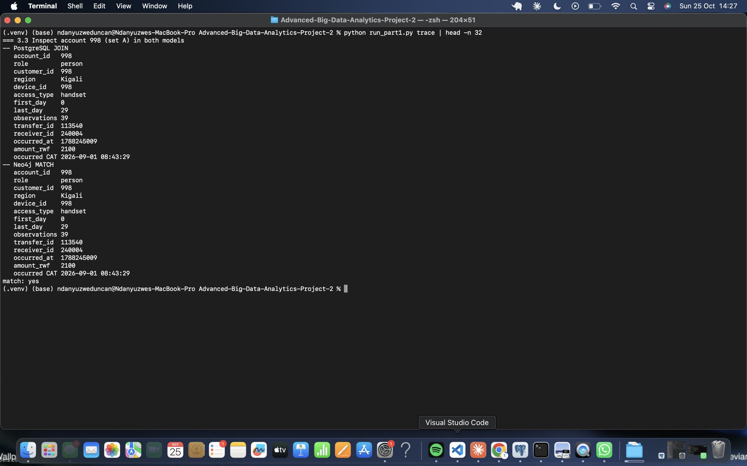
Figure 20. Identical PostgreSQL JOIN and Neo4j MATCH records for account 998.
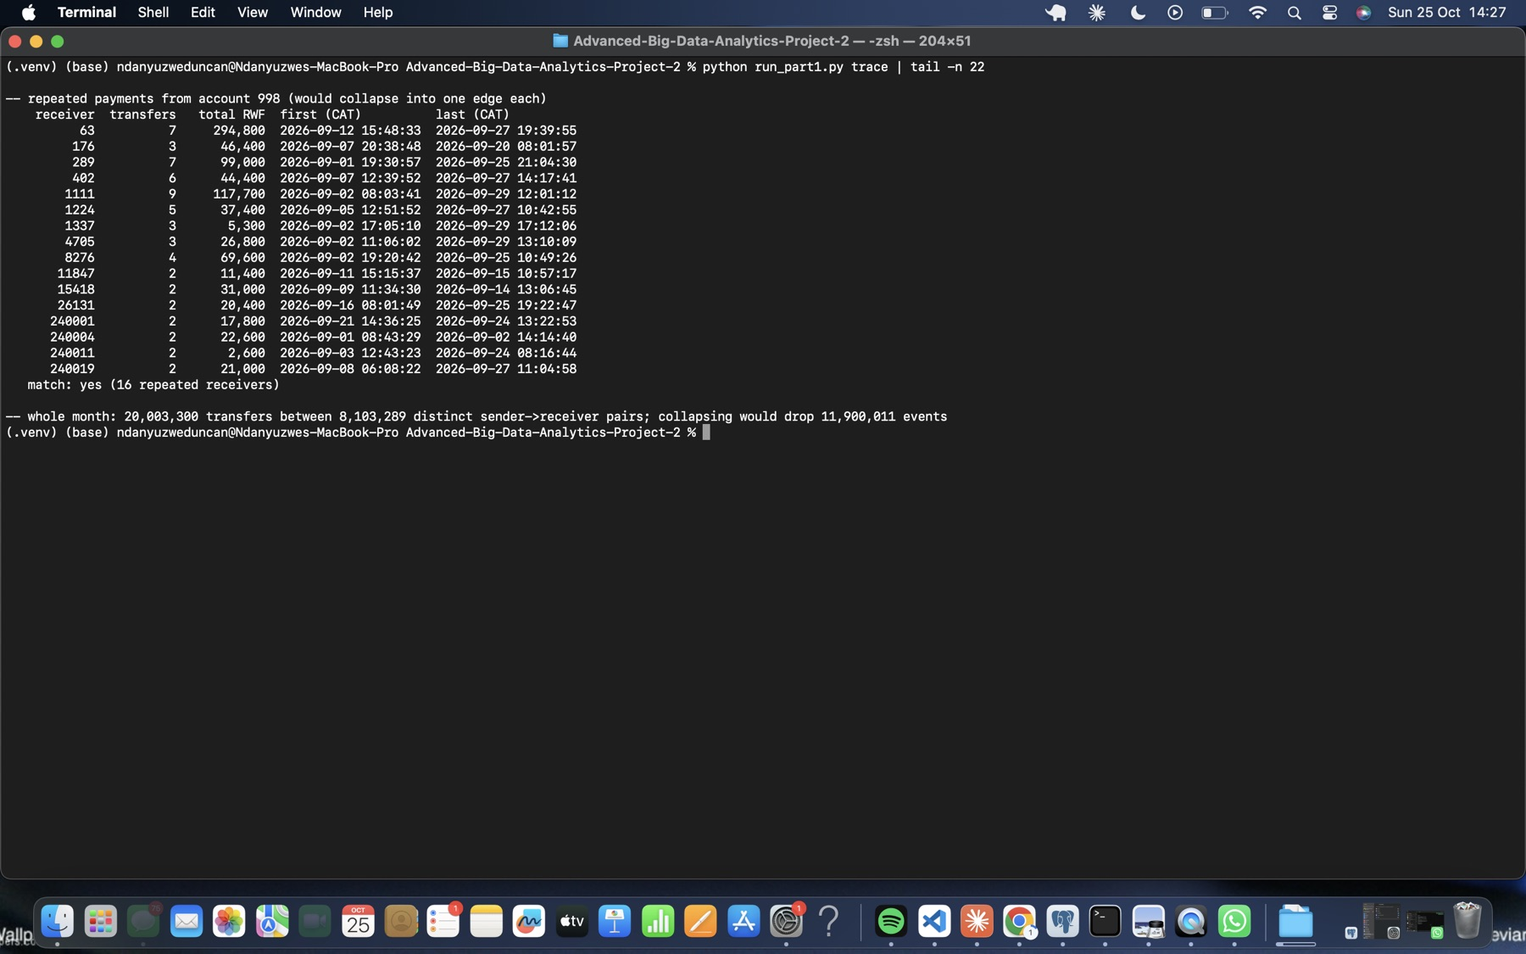
Figure 21. Repeated payments from account 998, and the month-wide count of events a collapsed edge would lose.
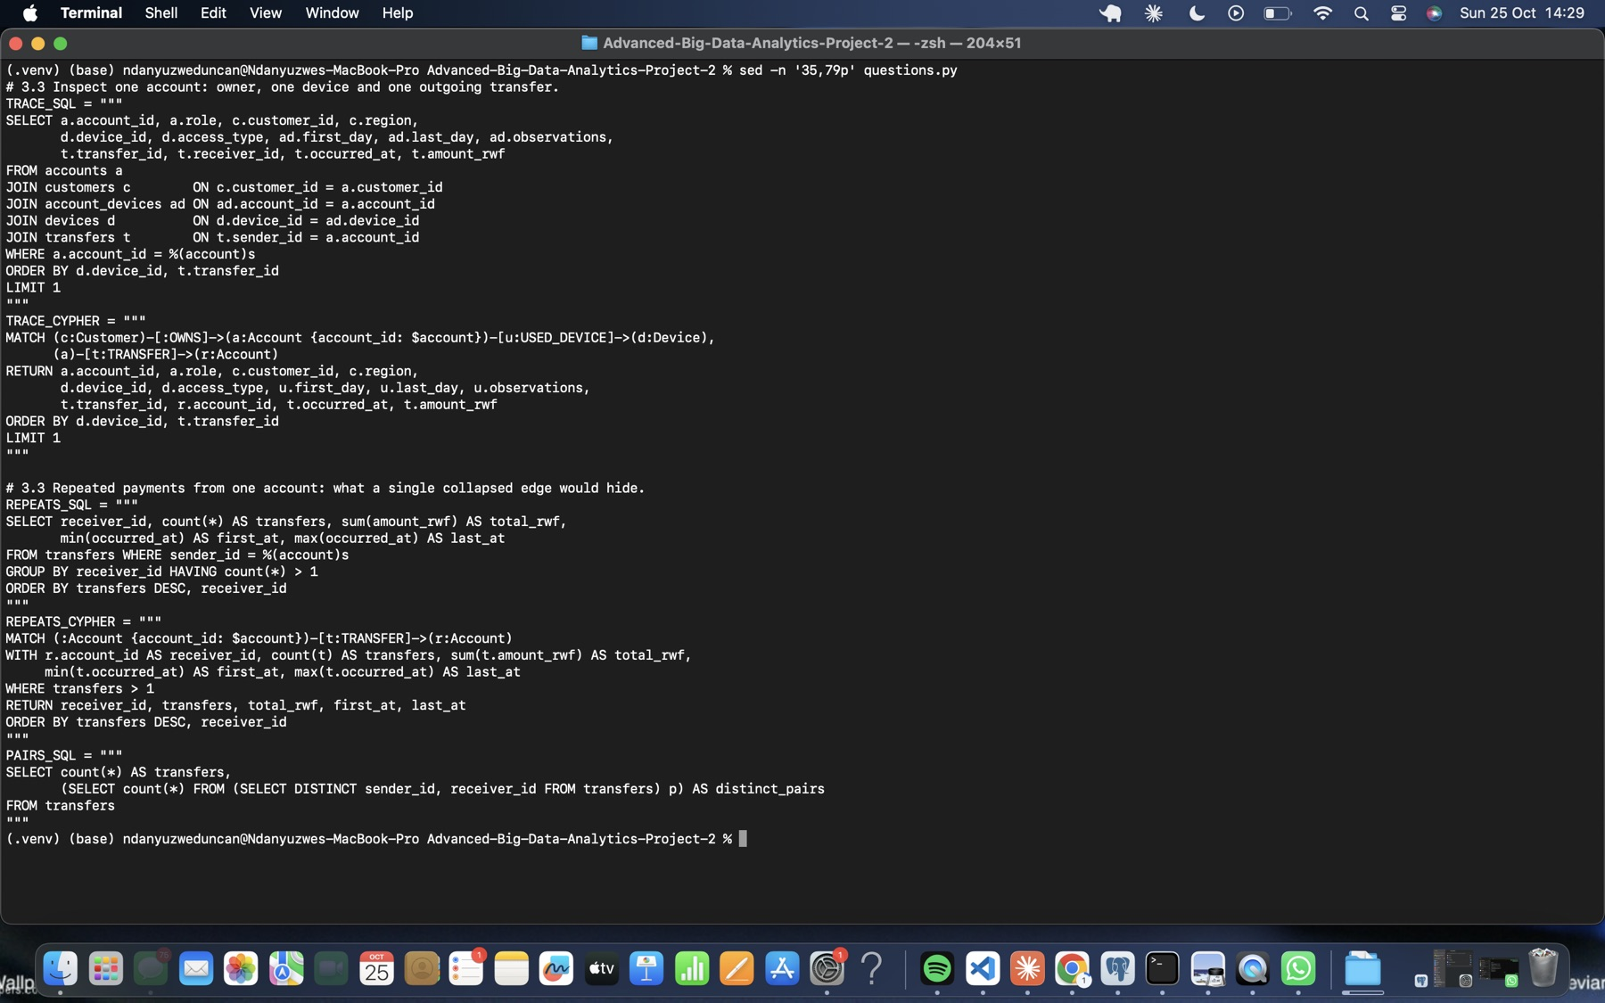
Figure 22. Query pairs for the trace and for repeated payments.

4 Answer routine business questions
The review hour is 09:45:00 inclusive to 10:45:00 exclusive CAT. The boundaries are converted to epoch seconds in Python with zoneinfo('Africa/Kigali').

4.1 Q1 Account activity
Set | Account | Date | Start epoch | End epoch | PG count / RWF | Neo4j count / RWF | Match
A | 998 | 6 Sep | 1788680700 | 1788684300 | 1 / 200,000 | 1 / 200,000 | yes
B | 147228 | 13 Sep | 1789285500 | 1789289100 | 1 / 1,050,000 | 1 / 1,050,000 | yes
C | 206978 | 8 Sep | 1788853500 | 1788857100 | 1 / 300,000 | 1 / 300,000 | yes
D | 237998 | 6 Sep | 1788680700 | 1788684300 | 1 / 45,000 | 1 / 45,000 | yes
E | 144228 | 13 Sep | 1789285500 | 1789289100 | 1 / 40,000 | 1 / 40,000 | yes
F | 203978 | 8 Sep | 1788853500 | 1788857100 | 1 / 30,000 | 1 / 30,000 | yes
Why outgoing value is not a balance. A balance is opening balance + money in − money out − fees ± reversals, measured at a point in time. Q1 counts only outflows in one hour. It ignores incoming transfers, the opening balance, and cash moved outside wallet-to-wallet transfers. The dataset is explicitly not a complete ledger: it has no fees, reversals or cash balances.
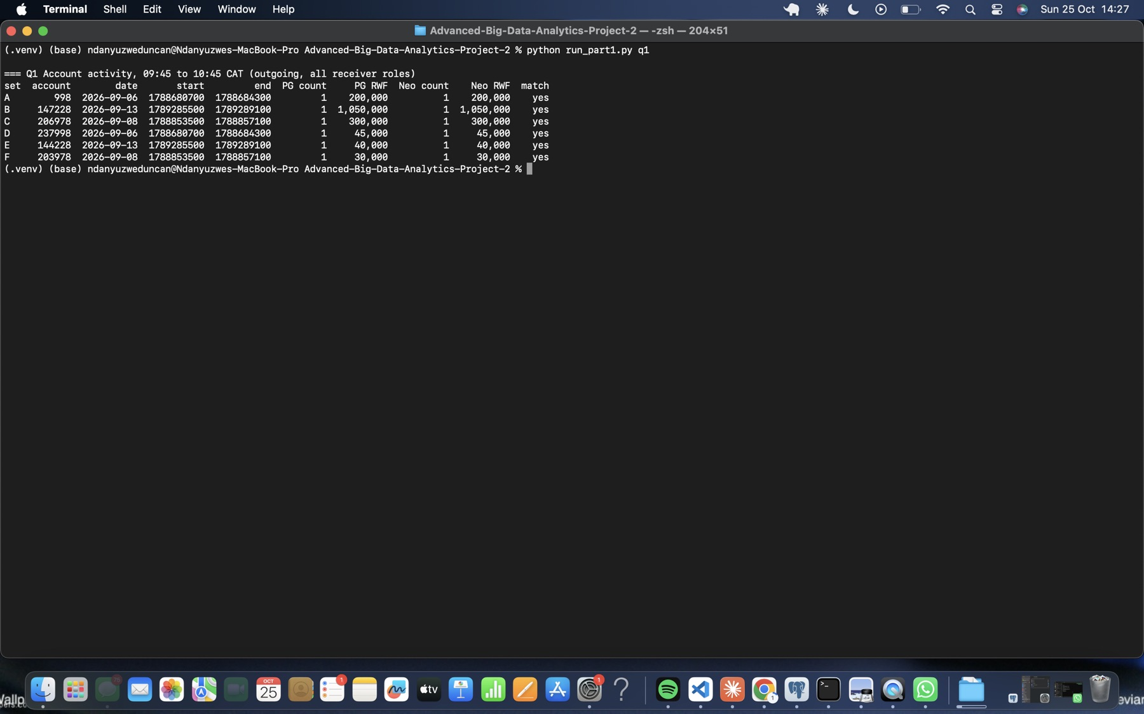
Figure 23. Q1: six paired PostgreSQL and Neo4j results.
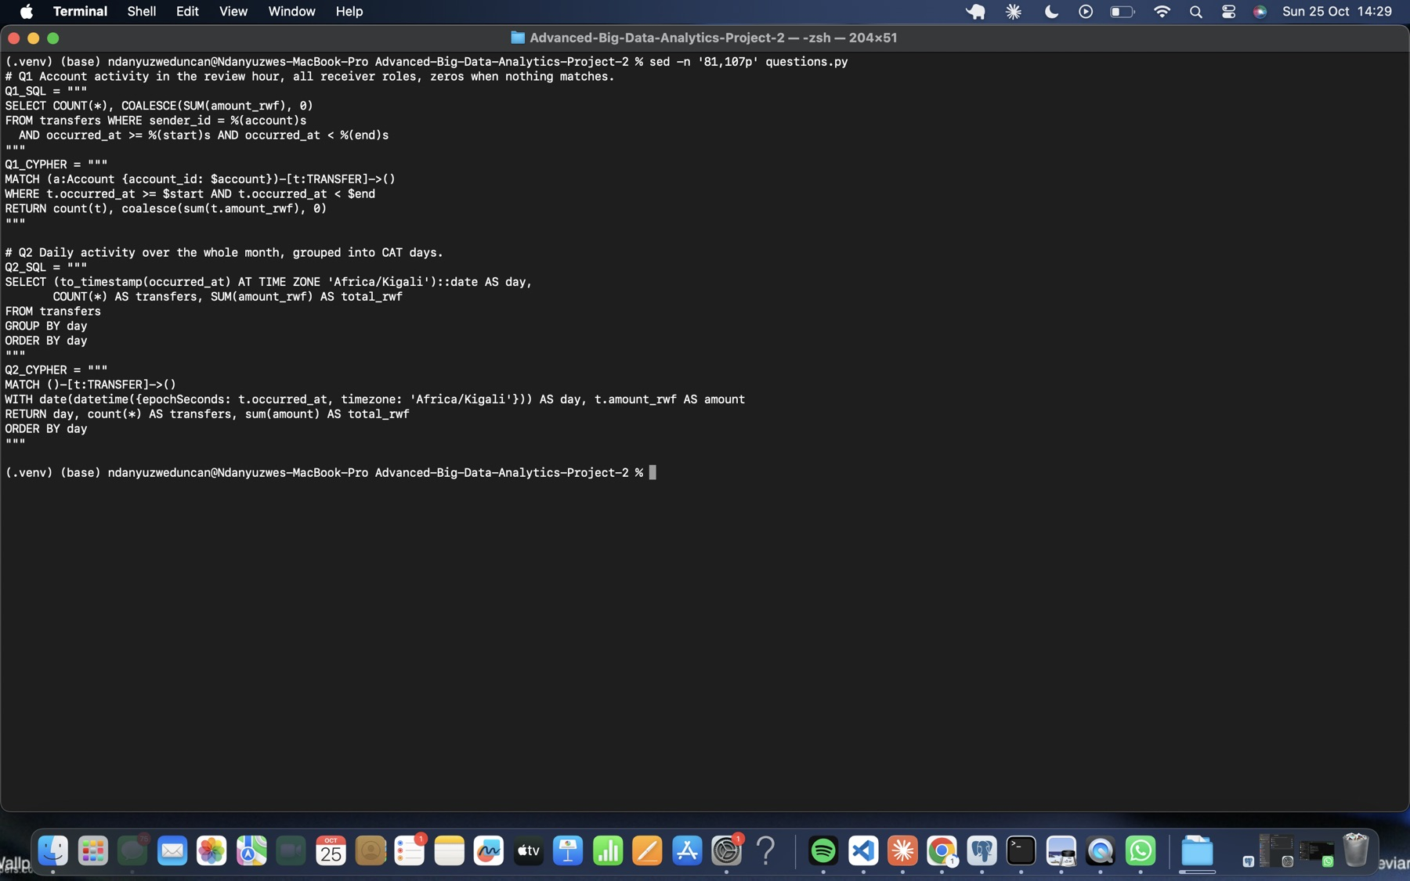
Figure 24. Q1 and Q2 query pairs (SQL %(name)s, Cypher $name).

4.2 Q2 Daily activity
Both engines return the same 30 CAT days, row for row. The daily sums reconcile exactly to the capture: 20,003,300 transfers and 231,482,327,870 RWF.
Pattern. Most days carry an almost constant 666,666–666,667 transfers worth about 7.67 billion RWF.
- 6–15 September: 150–331 extra transfers per day (2,496 in total). Daily value is 50–190 million RWF above the baseline, so these extra transfers are few but large.
- 16–27 September: a smaller excess of 30–121 transfers per day, with value back near the baseline, so these extra transfers are small.
The deviations are below 0.05% of the daily count and at most about 2.5% of the daily value. That’s why the chart’s y-axes don’t start at zero; the structure isn’t visible in a zero-based chart. The bump coincides with the review dates (6, 8 and 13 September).
Why transfer value isn’t provider revenue. Revenue comes from fees and commissions, which aren’t in the data. Many transfers may carry low or zero fees. Agent commissions are a cost to the provider. The same money is counted again each time it moves on. So 231 billion RWF is gross payment flow, not income.
As a single run (not a benchmark), PostgreSQL took 5.5 s and Neo4j 67.4 s. Formal timing follows in Section 6.2.
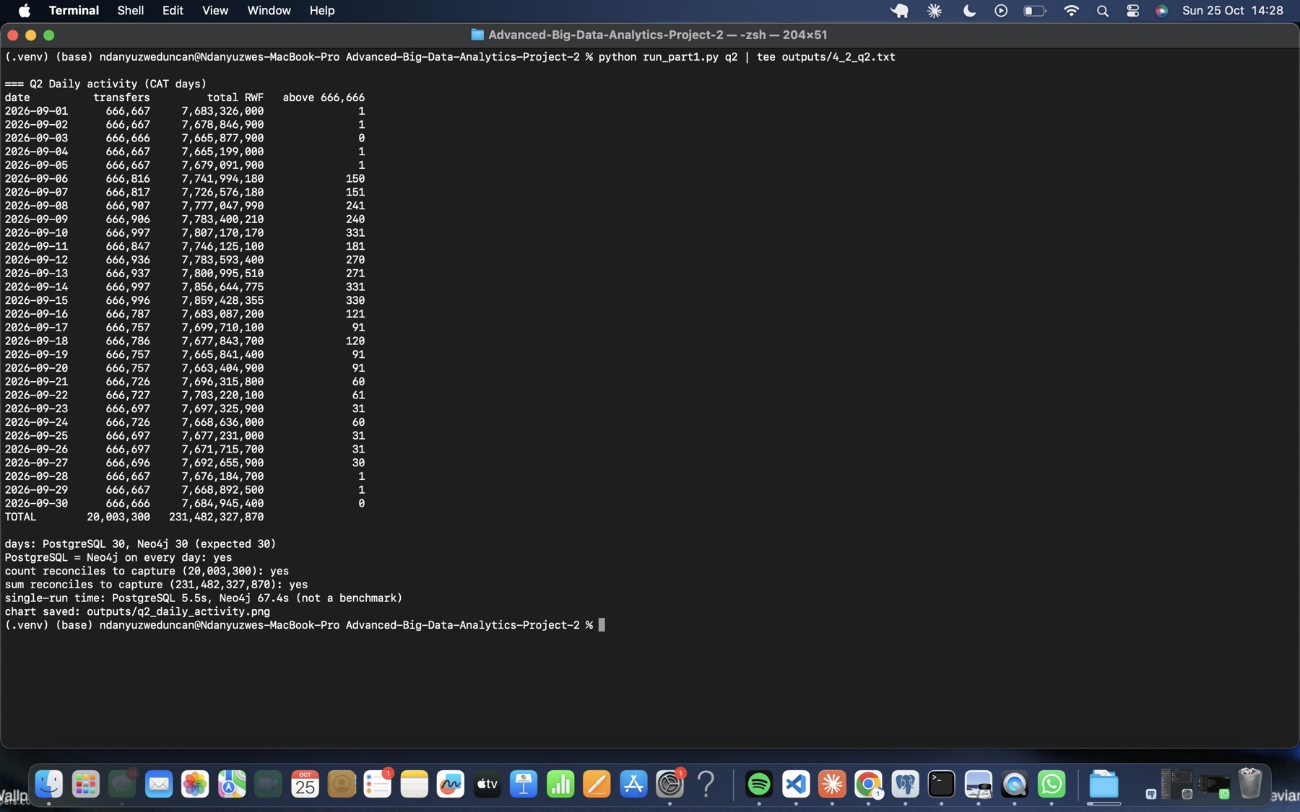
Figure 25. Q2 daily results with the PostgreSQL = Neo4j check and the reconciliation to capture totals.
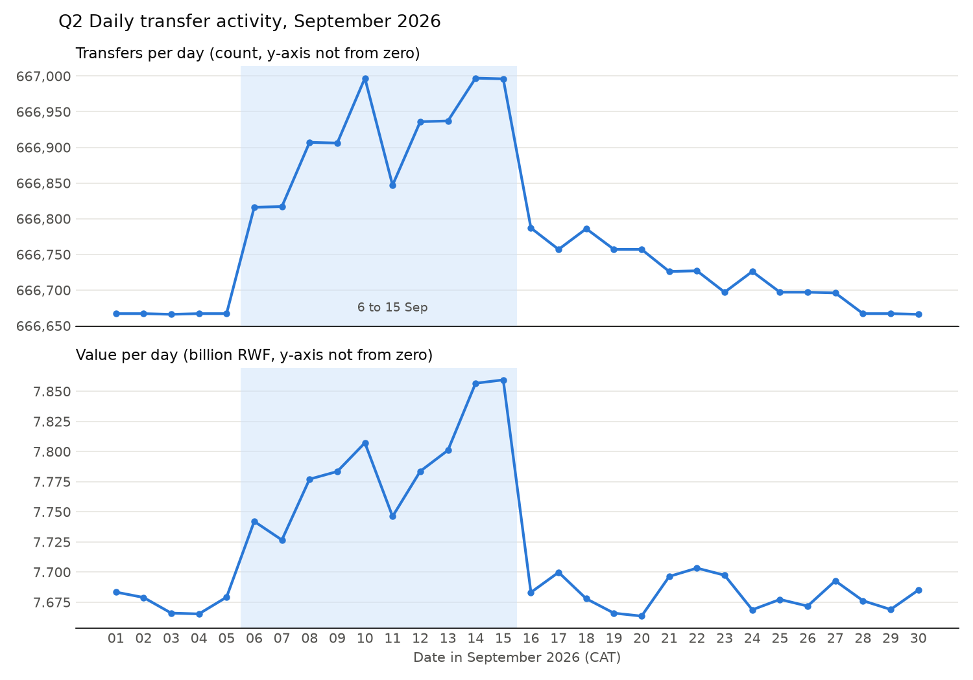
Figure 26. Q2 daily transfer count and value, September 2026 (CAT).
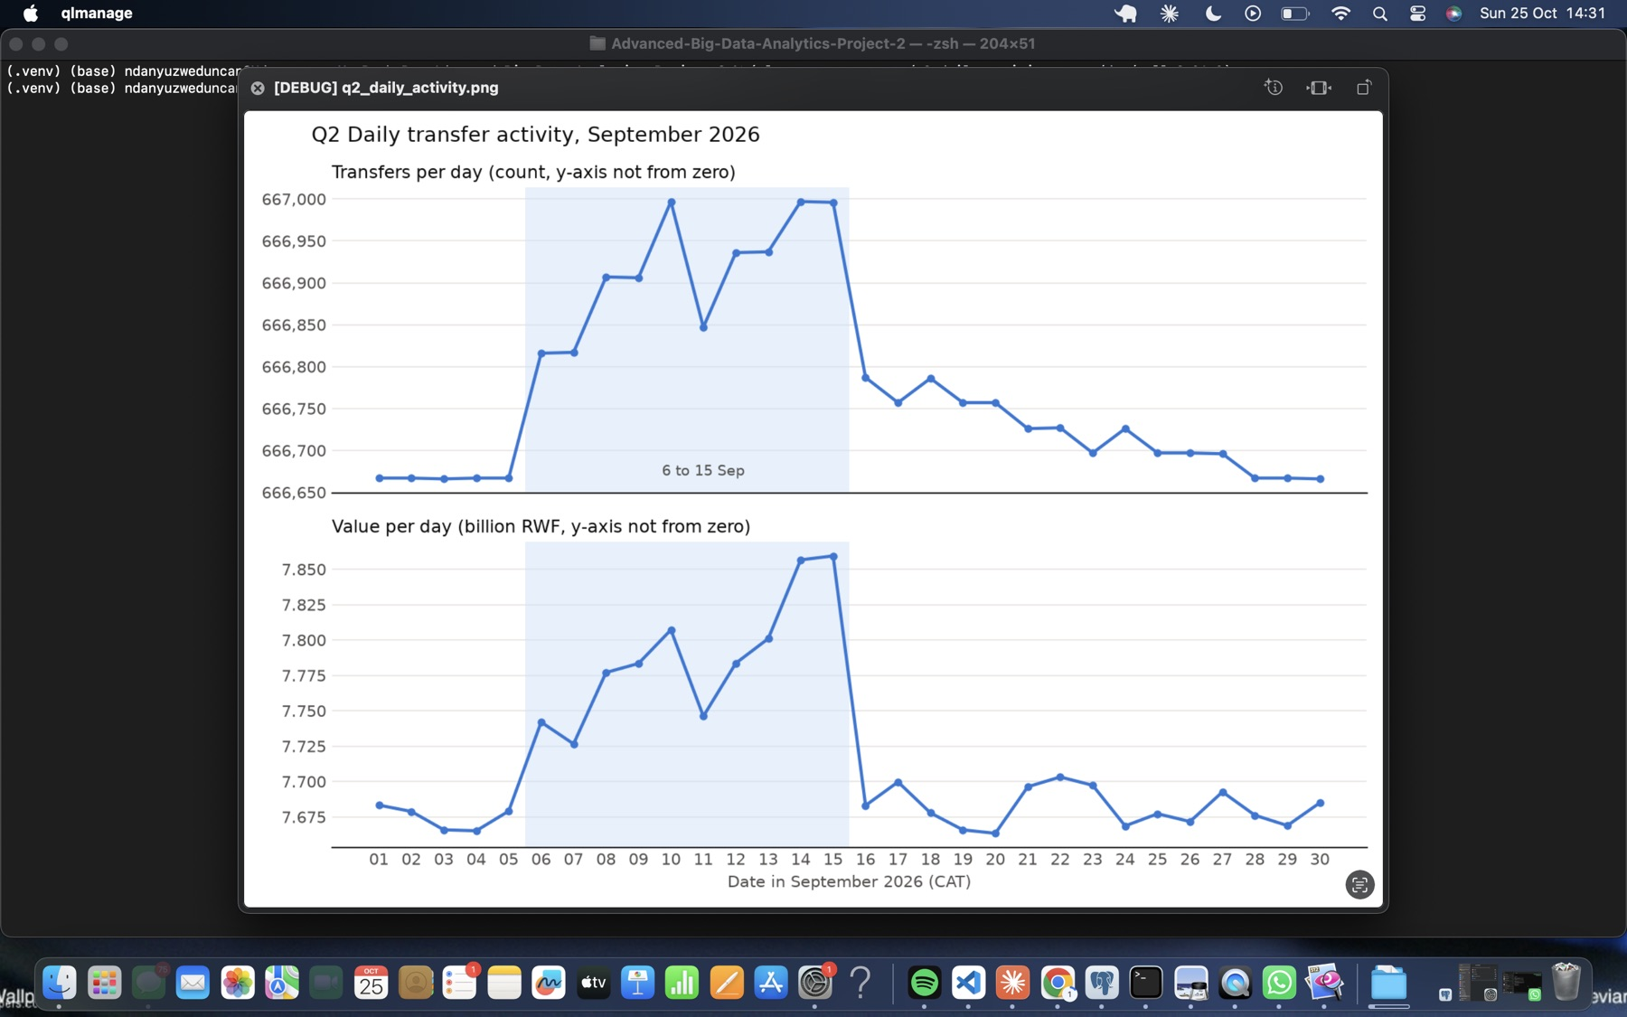
Figure 27. The Q2 chart, shown on screen.

4.3 Q3 Shared devices
The SQL self-joins account_devices on device_id. The Cypher matches (Account)-[:USED_DEVICE]->(Device)<-[:USED_DEVICE]-(Account). Both keep overlaps where max(first_day) <= min(last_day) and exclude the review account.
Set | Review account | Rows (PG / Neo4j) | Match
A | 998 | 4 / 4 | yes
B | 147228 | 9 / 9 | yes
C | 206978 | 9 / 9 | yes
D | 237998 | 4 / 4 | yes
E | 144228 | 9 / 9 | yes
F | 203978 | 9 / 9 | yes
Each review account’s sharing falls into two groups:
- Its own phone, shared with close connections.
  - Account 998 shares handset 998 with account 220998, owned by the same customer. Account 237998 likewise shares with 17998.
  - In sets B, C, E and F, four accounts with neighbouring IDs, owned by different customers in the same region, share one handset. This looks like a household phone. In C and F, one member’s interval starts on day 11.
- A second handset (device IDs 228xxx). It is shared with 3–5 accounts owned by different customers, often in other provinces. Each of these devices includes that set’s destination account. This is a lead for Sections 5 and 8, not a conclusion. No public terminals appear.
A legitimate sharing scenario. Family members without their own phones use one household handset for their separate wallets. Similarly, one person may keep a personal and a secondary wallet on the same phone.
Why overlap does not prove simultaneous use. Intervals are whole days, recording only the first and last day of observation. [2,7] and [5,11] overlap on days 5 to 7, but the two accounts may have been observed on different days within that range, or hours apart on the same day. The phone could also have been handed over or resold in between. An observation shows that a wallet was seen on a device, not that it initiated a payment.
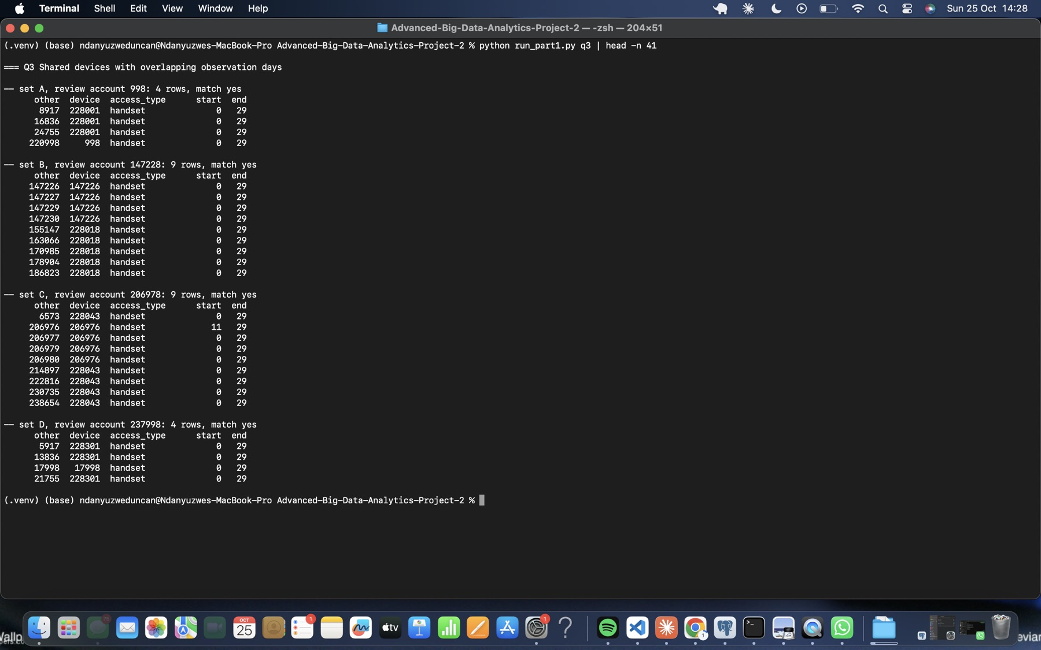
Figure 28. Q3 results for sets A to D.
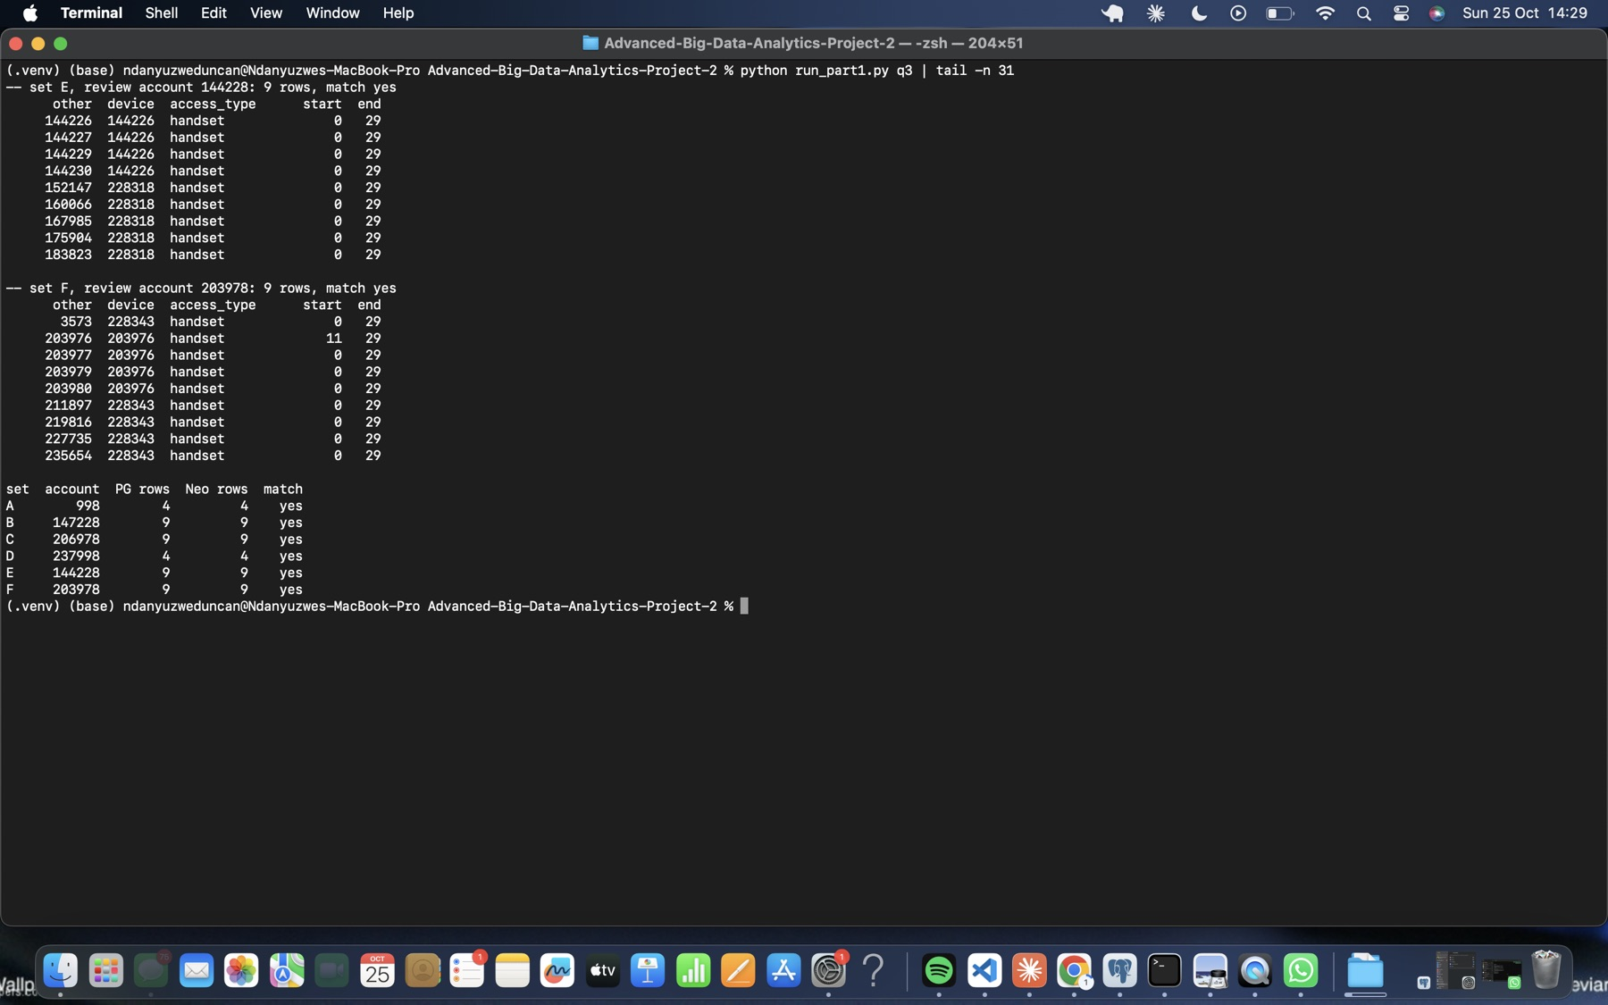
Figure 29. Q3 results for sets E and F, and the six-set count summary.
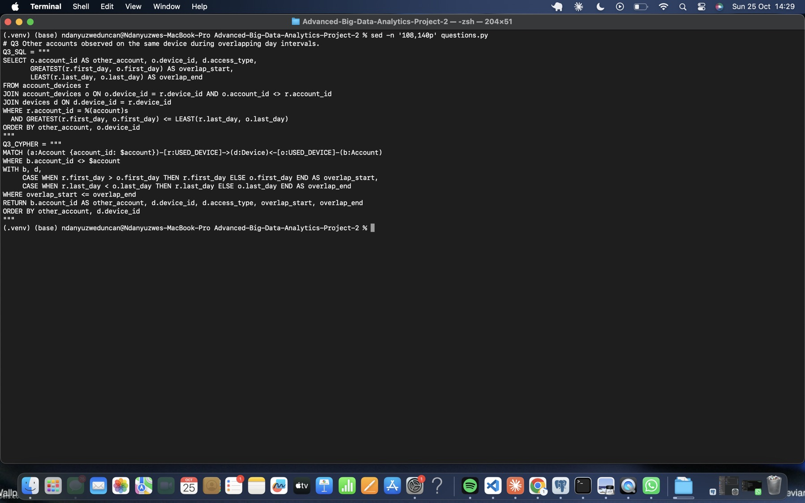
Figure 30. Q3 query pair.

5 Investigate connected accounts

5.1 Q4 Ownership and device network
The SQL builds an edges CTE from ownership and device-use rows in both directions. Each node carries a kind, so Customer 7 and Account 7 stay distinct. The recursive walk follows those edges up to the depth limit. The Cypher matches a bounded undirected path, (a)-[:OWNS|USED_DEVICE*1..d]-(b:Account), and takes DISTINCT b before grouping by the owner’s region. Neo4j can then use a pruning breadth-first expansion instead of enumerating every path. All 24 comparisons match.
Set | Depth 4 | Depth 6 | Depth 8 | Depth 10
A (998) | 10 | 43 | 175 | 187
B (147228) | 46 | 178 | 188 | 228
C (206978) | 146 | 483 | 832 | 1,433
D (237998) | 10 | 44 | 180 | 192
E (144228) | 47 | 183 | 193 | 230
F (203978) | 147 | 488 | 837 | 1,426
Prediction. [Group: record here the counts you predicted for depths 8 and 10, and why, before running them.] The structure suggests the following expectation. Each extra pair of links adds one more “account, then shared device” hop. Growth should therefore slow once the shared handsets near the review account are exhausted (A/D and B/E level off at about 180–230 accounts). It should keep growing wherever a replacement handset or a shared phone links into other households (C/F reach about 1,430).
How deeper links introduce weak associations. The supporting path below reaches account 2984 from set B’s account 147228 in 10 links. It passes through five different devices and four intermediate accounts, with no shared owner anywhere along the way. Each hop only means “seen on the same device at some time in September”. After several hops, the reached account has no meaningful relation to the review account. At depth 10, sets C and F reach over 1,400 accounts spread evenly across all five regions. Most of these are artefacts of shared phones, phone replacements and household handsets, not evidence about the account under review.
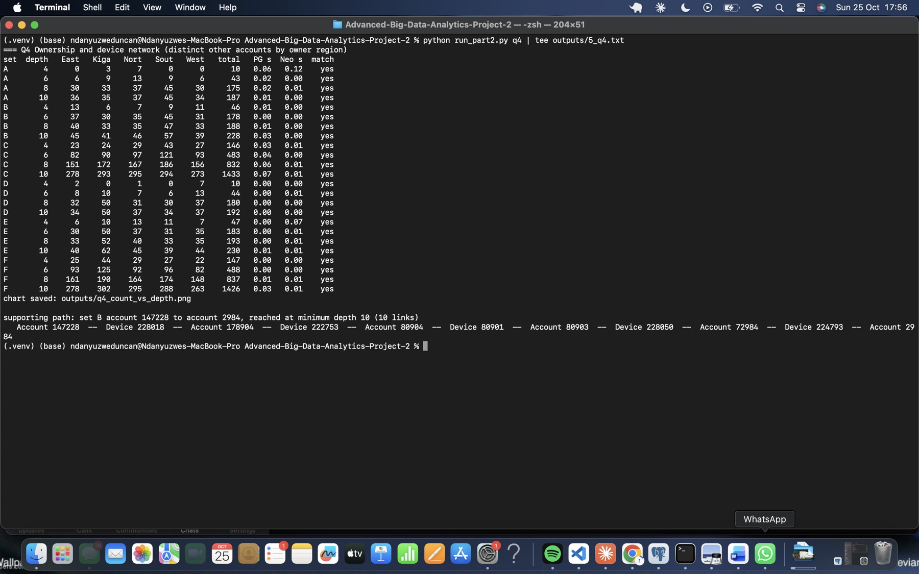
Figure 31. Q4: 24 paired PostgreSQL and Neo4j results by region, plus one supporting 10-link path.
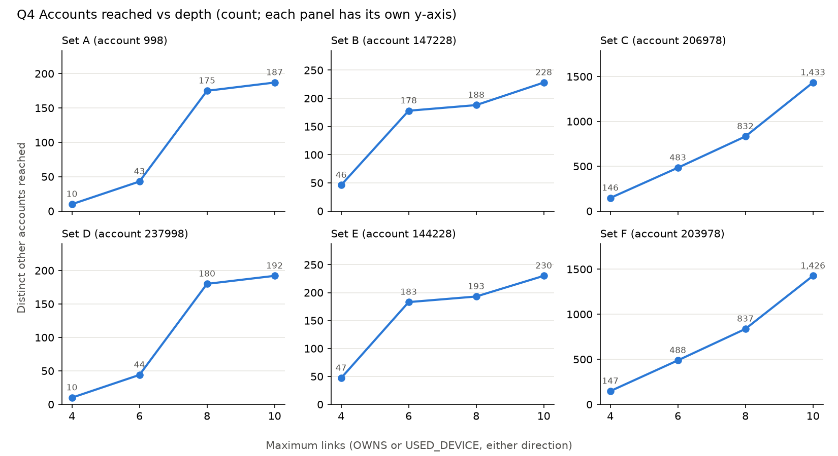
Figure 32. Q4 accounts reached against depth (count; each panel has its own y-axis).
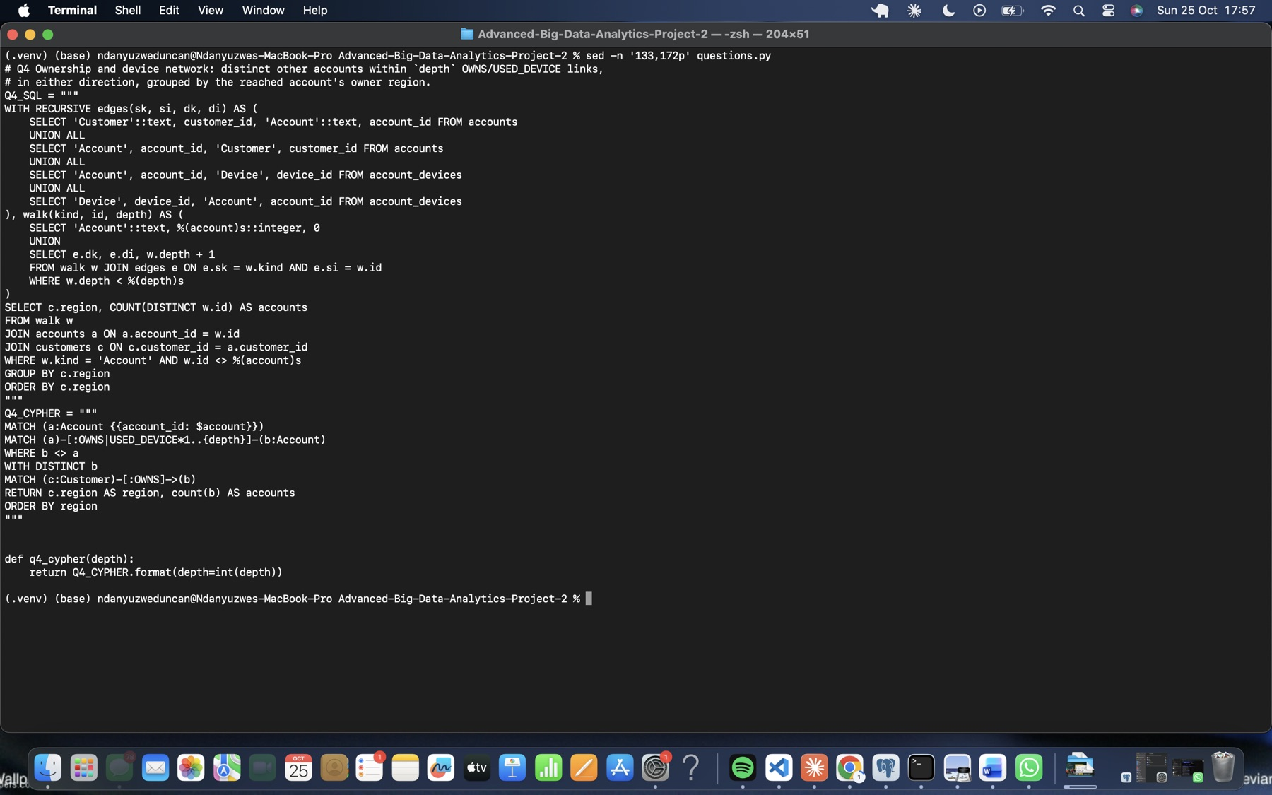
Figure 33. Q4 SQL (recursive edges/walk) and Cypher (bounded undirected path) pair.

5.2 Q5 Rapid onward payments
The query looks for three directed transfers through four distinct accounts:
- The first transfer leaves the review account within its hour.
- Each later transfer is at most 600 seconds after the previous one.
- Each amount satisfies 90*previous <= 100*next <= 105*previous. In SQL, these are BIGINT comparisons.
SQL joins three transfer aliases on receiver equals next sender. Cypher matches three directed relationships. All six sets match:
Set | A | B | C | D | E | F
Chains | 1 | 1 | 1 | 0 | 0 | 0
Example (set A).
Transfer | From → to | Time (CAT) | Amount (RWF)
20000001 | 998 → 8917 | 6 Sep 10:00:00 | 200,000
20000002 | 8917 → 16836 | 6 Sep 10:00:40 | 196,000 (98%)
20000003 | 16836 → 24755 | 6 Sep 10:01:20 | 192,080 (98%)
Why this does not prove that the same funds moved. Wallet balances are fungible, and the data has no balances. Account 8917 may already have held 196,000 RWF, or received money from elsewhere, before paying 16836. Similar, steadily declining amounts are consistent with passing money on minus a fee, but they’re equally consistent with independent payments that happen to look alike. The records only show a sequence of events, not which money was spent.
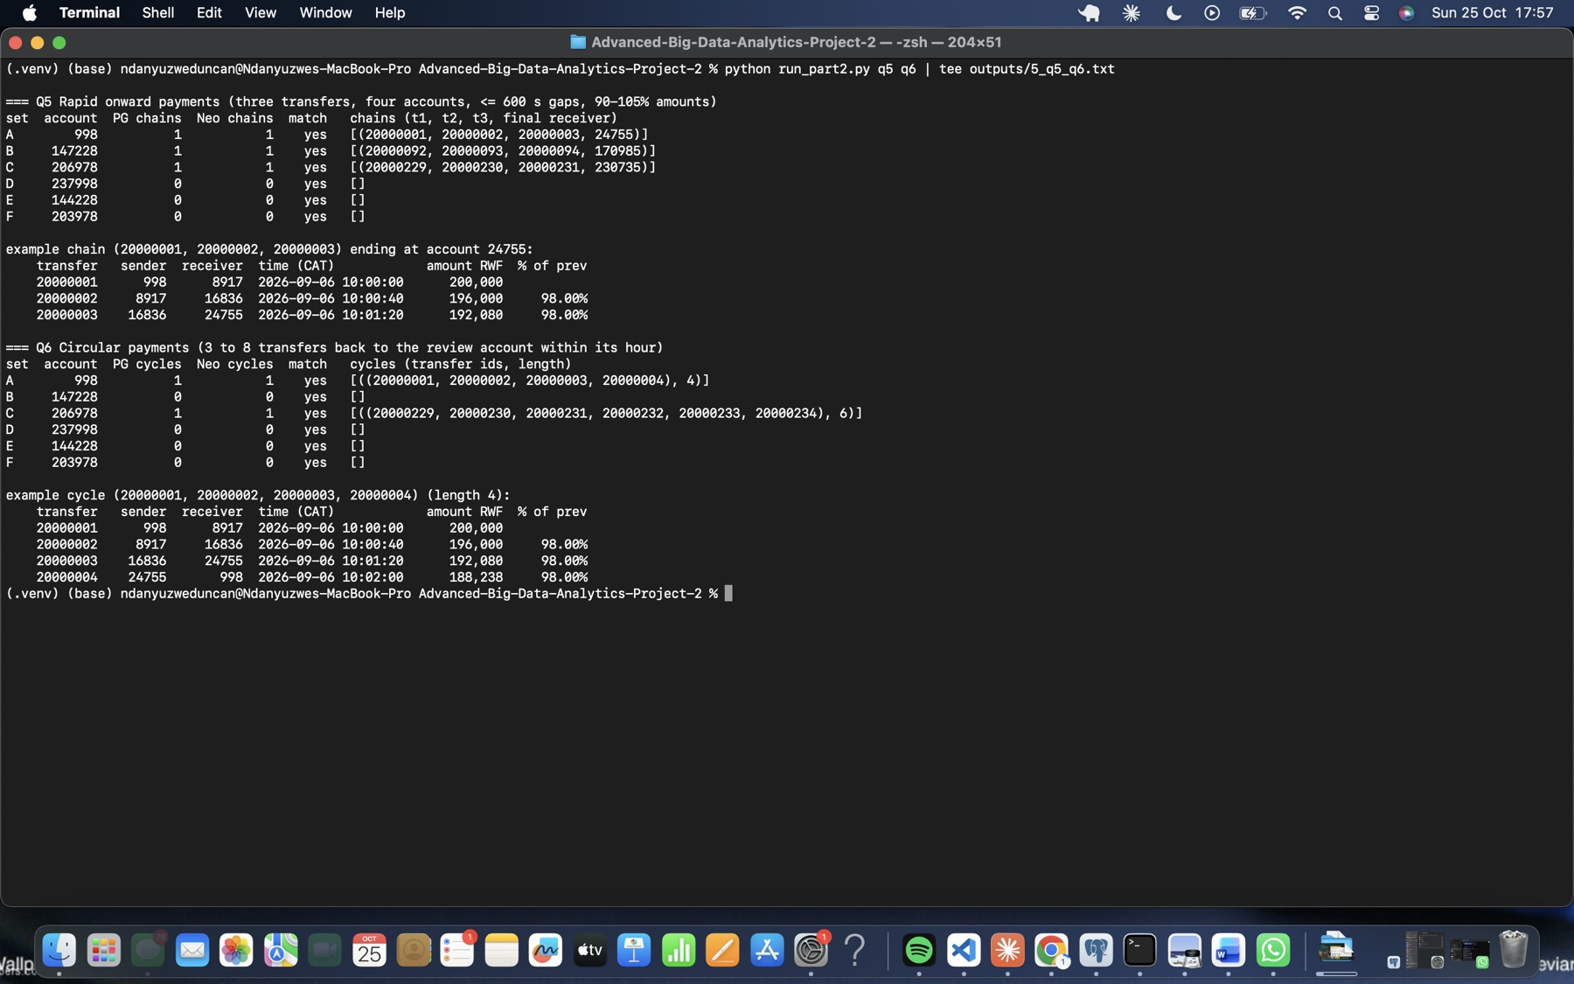
Figure 34. Q5 and Q6: paired counts for all six sets, one chain and one cycle with transfer IDs, CAT times and amounts.
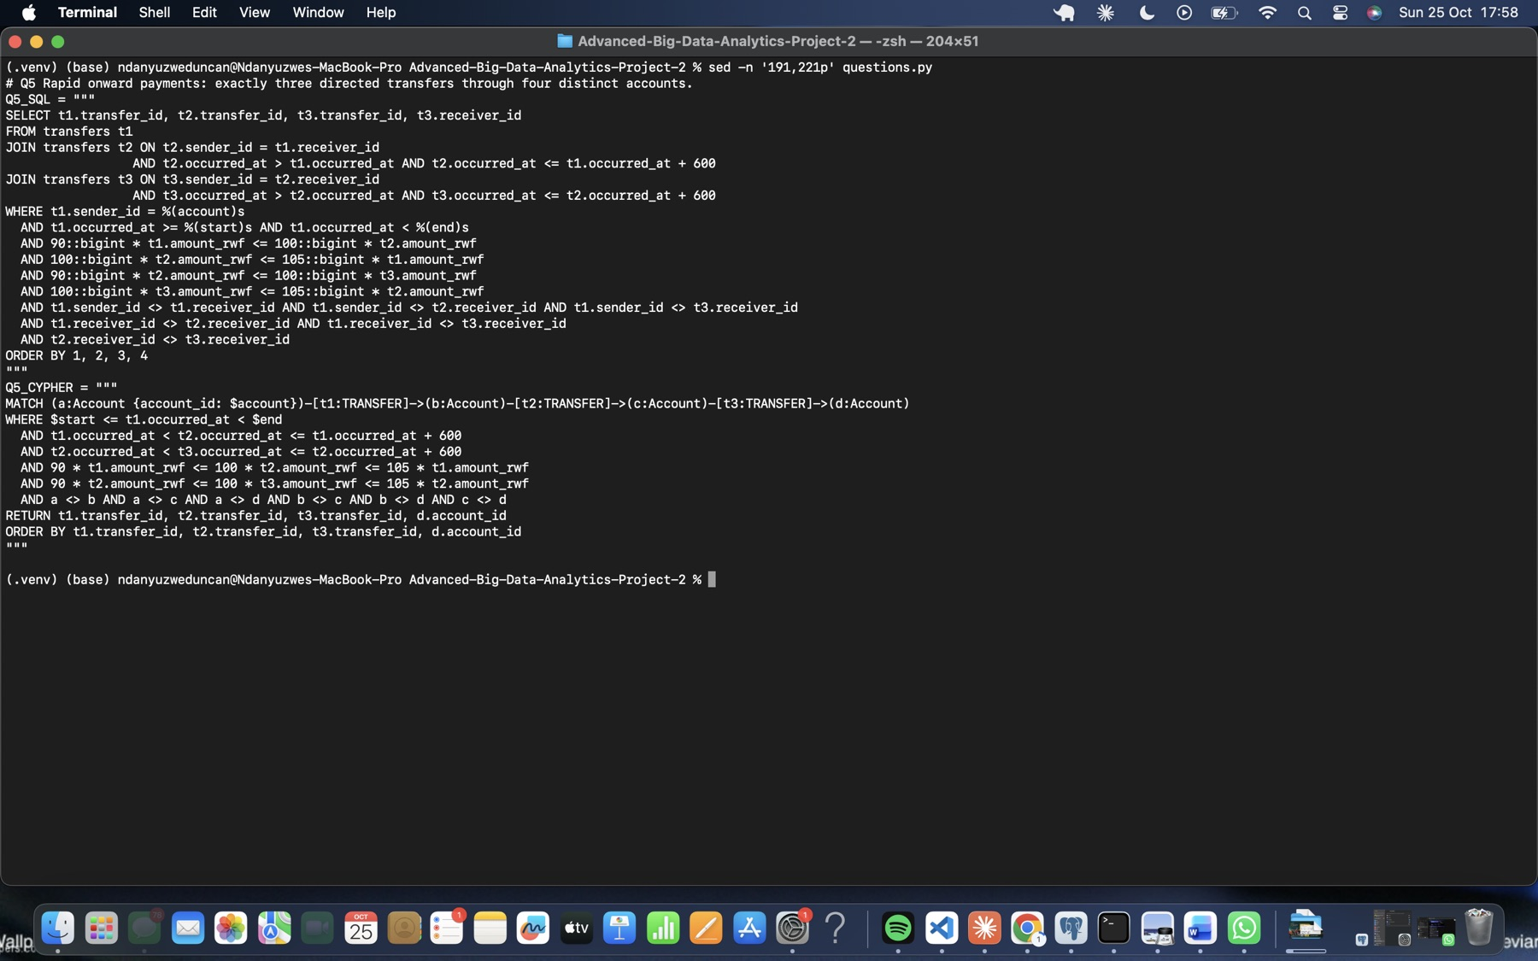
Figure 35. Q5 SQL (three joined aliases) and Cypher (three directed relationships) pair.

5.3 Q6 Circular payments
The search looks for 3 to 8 transfers that start and end at the review account. Every transfer must fall within the review hour, in strictly increasing time, with the whole sequence spanning at most 1,800 seconds, and each amount must follow the Q5 rule. The search stops at the first return to the review account.
- SQL: a recursive CTE carries the current account, the transfer IDs so far, the first and last times and the last amount, and only extends with eligible transfers.
- Cypher: a bounded quantified path, (a)((…)-[t:TRANSFER WHERE in hour]->(…)){3,8}(a), applies the same checks to the list of transfers.
All six sets match:
Set | Cycles found
A | 1 cycle of 4 transfers: 998 → 8917 → 16836 → 24755 → 998, 10:00:00 to 10:02:00, 200,000 down to 188,238 RWF
C | 1 cycle of 6 transfers
B, D, E, F | none
Further evidence to request:
- Which device and location initiated each payment.
- Wallet balances before and after each transfer.
- Know-your-customer (KYC) identity and any relationships between the owners.
- Cash-in and cash-out at agents around these times.
- Activity before and after September.
- Any customer complaints or reversals.
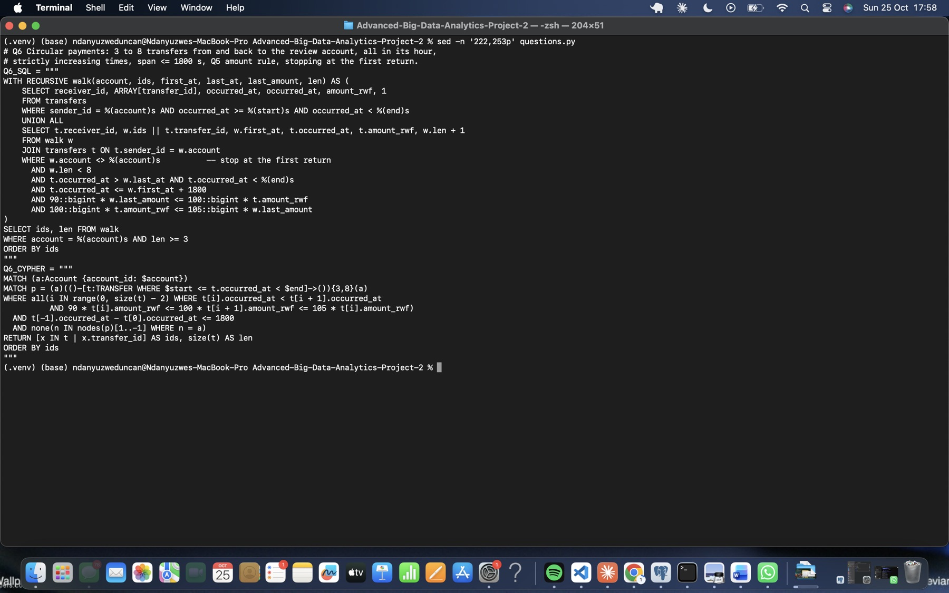
Figure 36. Q6 SQL (recursive walk) and Cypher (quantified path) pair.

5.4 Q7 Shortest transfer connection
Q7 finds the fewest directed transfers from each review account to its destination, using only person accounts and ignoring amounts and time order. The bounds are 4 and 6. The person restriction is applied during the search: in the SQL join to accounts at each step, and in the Neo4j SHORTEST 1 quantified path’s inline WHERE n.role = 'person'.
Set | Bound 4 | Bound 6 | Supporting path (bound 6)
A | 3 | 3 | 998 → 8917 → 16836 → 24755
B | none | 5 | 147228 → 155147 → 163066 → 170985 → 178904 → 186823
C | none | 5 | 206978 → 214897 → 222816 → 230735 → 238654 → 6573
D | 3 | 3 | 237998 → 5917 → 13836 → 21755
E | none | 5 | 144228 → 152147 → 160066 → 167985 → 175904 → 183823
F | none | 5 | 203978 → 211897 → 219816 → 227735 → 235654 → 3573
All 12 lengths match. Each supporting path from Neo4j was checked in PostgreSQL: every transfer exists, the transfers link in order, every account is a person, and the path length matches. Equally short paths may exist.
Every route runs through exactly the accounts that share each set’s 228xxx handset in Q3.
Why no route within four transfers does not establish no connection.
- The bound cuts the search off: sets B, C, E and F connect at length 5.
- The person-only rule excludes routes through merchants and agents.
- The data covers September only and excludes cash, bank and other channels.
Why a structural route need not show onward movement of funds. Q7 ignores time order and amounts. A route can use a later transfer before an earlier one, or link unrelated payments of different sizes. It shows that the accounts are connected, not that money flowed from one end to the other.
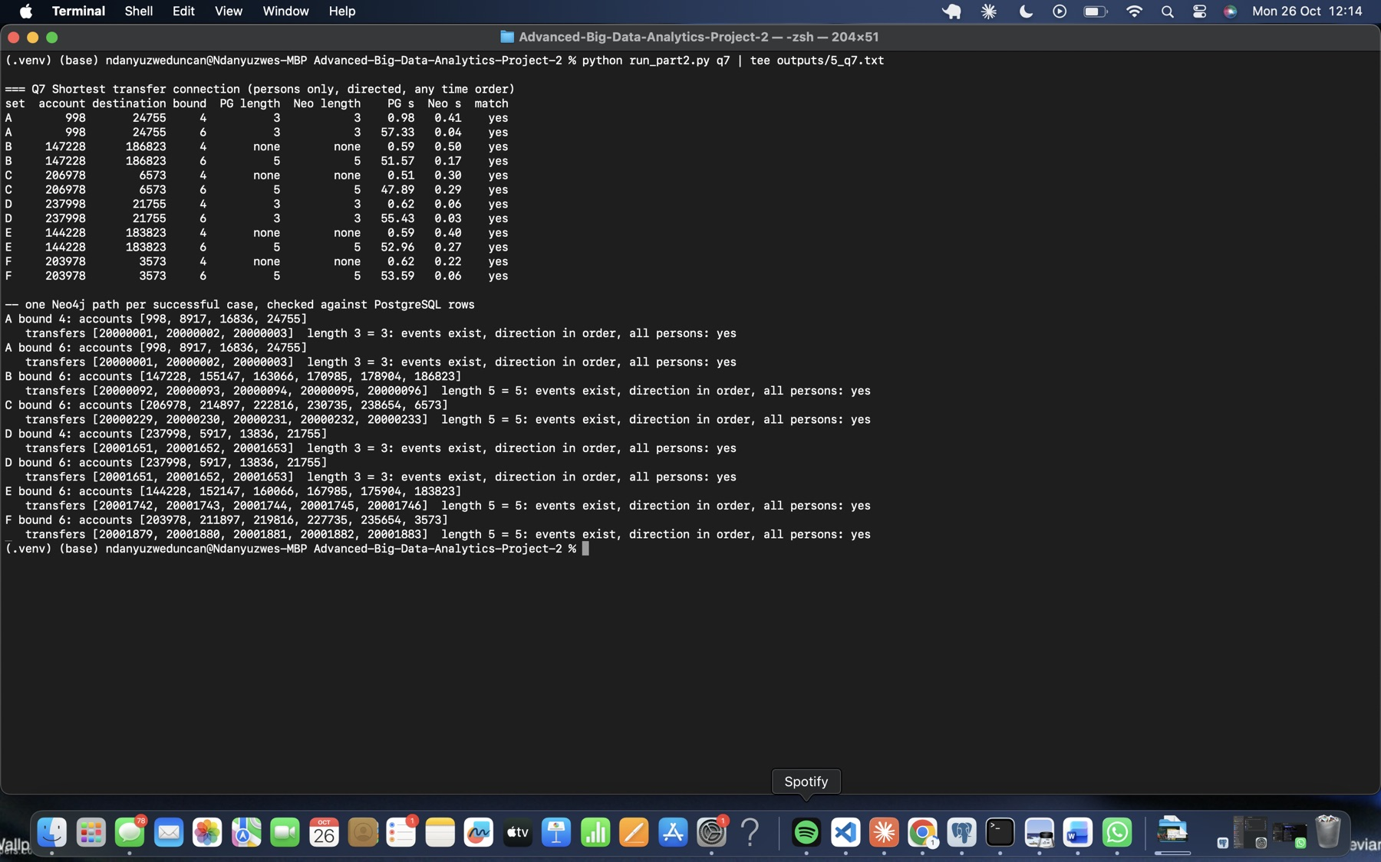
Figure 37. Q7: 12 paired lengths, and one supporting path per successful case checked against PostgreSQL rows.
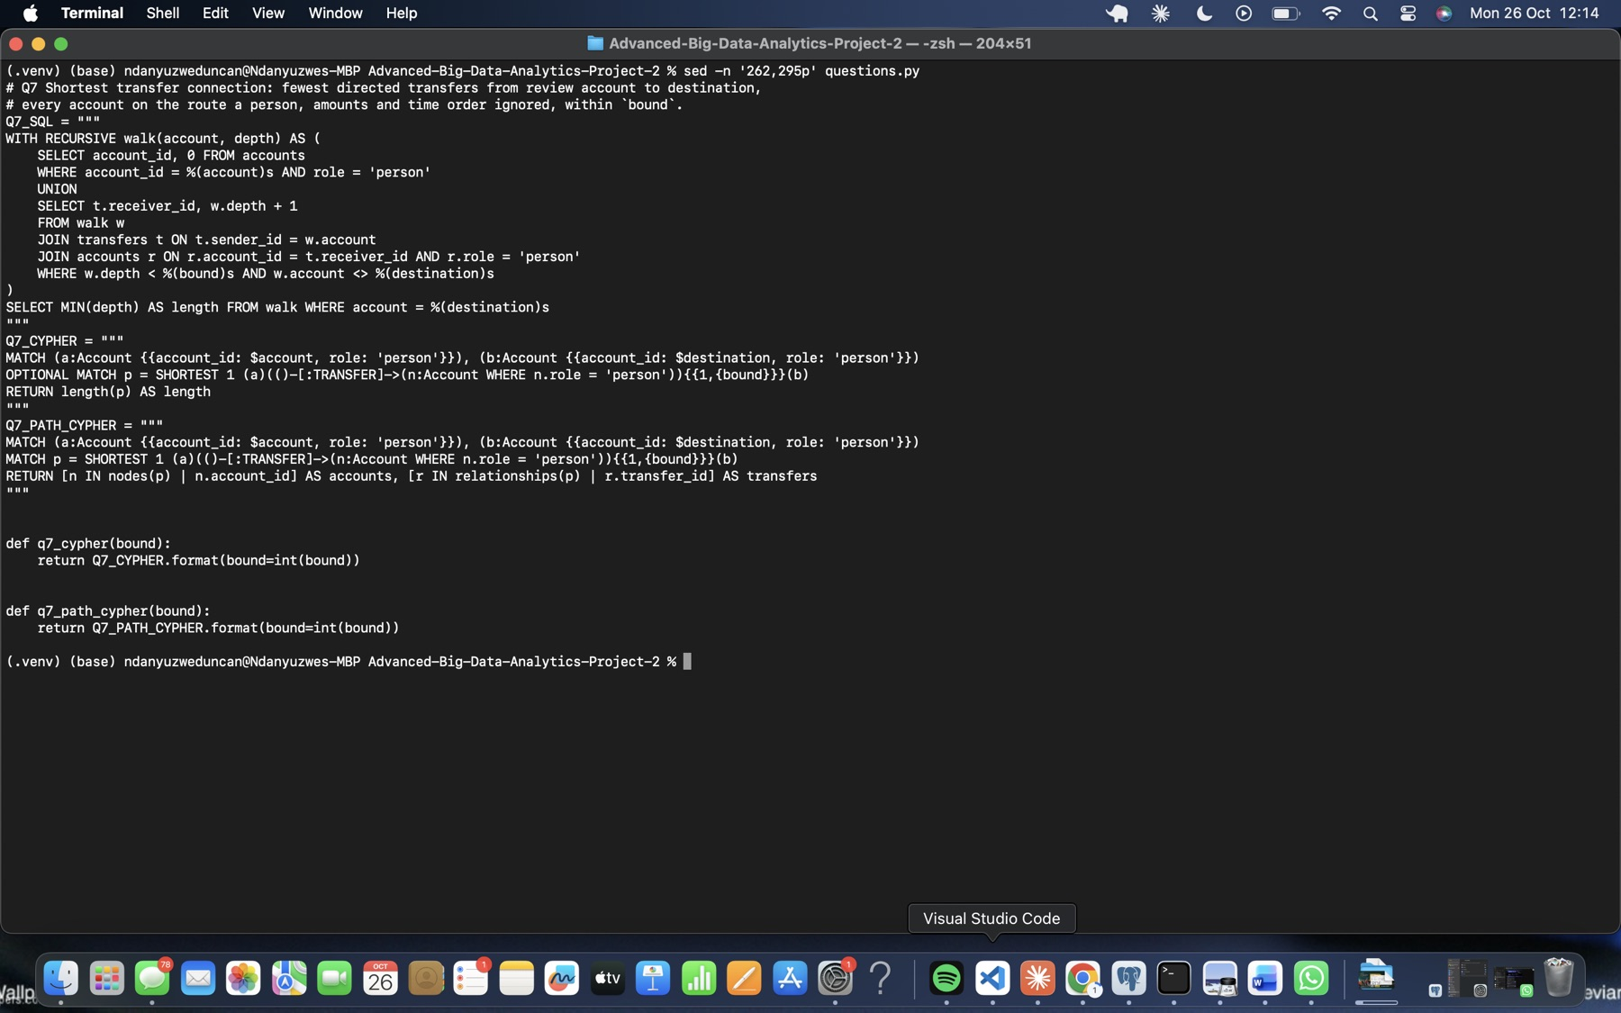
Figure 38. Q7 SQL (recursive directed walk) and Cypher (SHORTEST 1 with the person restriction inside the path) pair.

6 Check correctness and performance

6.1 Build one comparison program
compare.py runs every case through run_pg(query, params) and run_neo(query, params), using the wrappers in db.py. These return every result row. Integers, decimals and dates are normalised to plain Python values and the rows are sorted before an exact comparison.
Result: 61 of 61 cases are identical.
Question | Q1 | Q2 | Q3 | Q4 | Q5 | Q6 | Q7
Cases matching | 6/6 | 1/1 | 6/6 | 24/24 | 6/6 | 6/6 | 12/12
Q7 lengths were compared on their own. The 8 supporting paths were then validated separately: every transfer exists, the transfers link in order, every account is a person, and the length matches.
Independent checks in plain Python against the captured CSVs, with no database involved:
- Device overlap (set C). account_devices.csv gives account 206978 the interval [0, 29] and account 206976 the interval [11, 29] on device 206976. Their overlap is [11, 29], matching Q3.
- Q5 chain and Q6 cycle (set A). These were rebuilt from transfers.csv. Both are linked, strictly increasing in time, within 90–105% amounts, start in the review hour, and meet the 600 s (chain) or 1,800 s (cycle) rule. Both are valid.
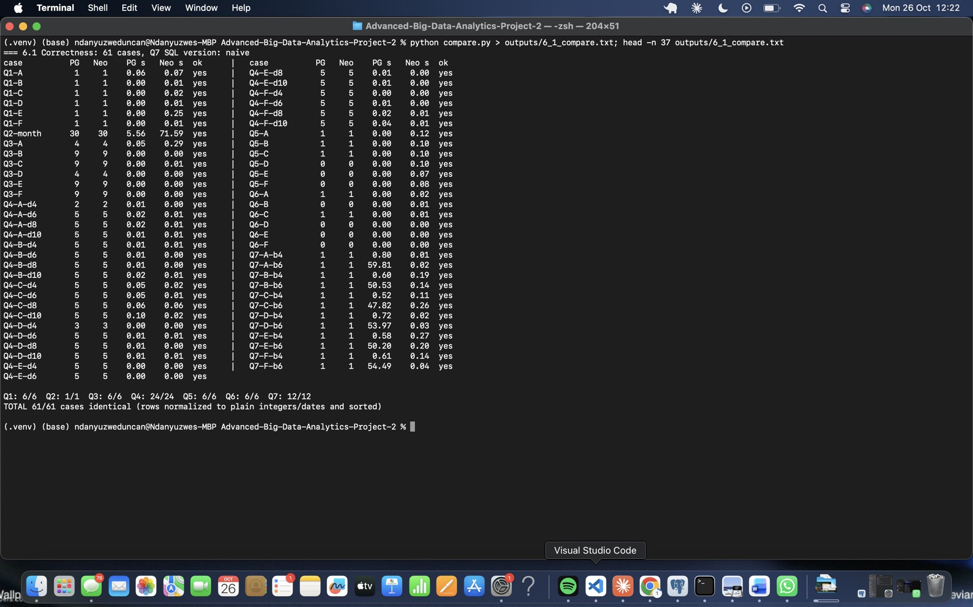
Figure 39. 6.1: the 61-case status table.
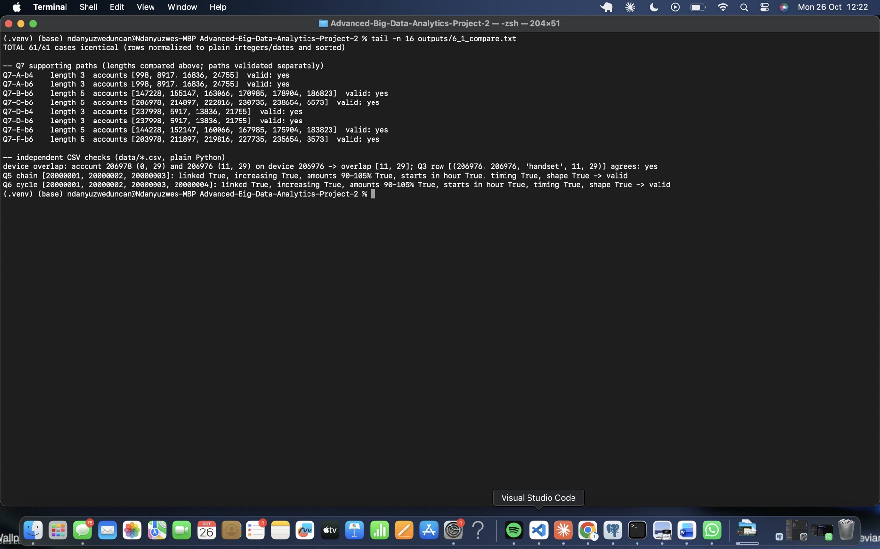
Figure 40. 6.1: Q7 path validation and the independent CSV checks.

6.2 Time a fixed selection
Method.
- Same machine, with one database service at a time: Neo4j was stopped while PostgreSQL was timed, and the other way round.
- Persistent connections and fixed settings (Section 1.1).
- 21 cases per engine, each with 3 untimed warm-ups (180 s limit) and 5 measured runs (60 s limit).
- perf_counter measures from submission until the final row is received. Answers are checked against 6.1 outside the timer.
- Timeouts are recorded separately and never counted as completed timings.
The raw runs are in outputs/6_2_runs_*.csv, with case, parameters, engine, CAT start time, duration, row count and status.
Case | PG median ms | Neo4j median ms | PG/Neo4j
Q1 B / E | 0.1 / 0.1 | 4.4 / 2.9 | 0.02 / 0.03
Q2 month | 4,748 | 58,720 (2 of 5 runs timed out) | 0.08
Q3 B / E | 0.5 / 0.2 | 4.0 / 2.6 | 0.12 / 0.08
Q4 B depth 4 / 6 / 8 / 10 | 1.0 / 2.0 / 4.7 / 7.8 | 3.1 / 3.6 / 3.7 / 3.7 | 0.32 / 0.56 / 1.27 / 2.11
Q4 E depth 4 / 6 / 8 / 10 | 0.5 / 2.1 / 4.8 / 7.9 | 2.1 / 2.9 / 2.5 / 2.6 | 0.24 / 0.72 / 1.92 / 3.04
Q5 B / E | 0.7 / 0.3 | 6.1 / 4.3 | 0.11 / 0.07
Q6 B / E | 0.5 / 0.1 | 3.4 / 1.5 | 0.15 / 0.07
Q7 B bound 4 / 6 | 239 / 29,741 | 10.7 / 7.6 | 22 / 3,913
Q7 E bound 4 / 6 | 247 / 28,926 | 5.7 / 7.4 | 43 / 3,909
PostgreSQL is faster for indexed look-ups (Q1, Q3, Q5, Q6) and for the full-month report (Q2). Neo4j is faster once traversals deepen (Q4 at depths 8 and 10) and for shortest paths (Q7). Q2 on Neo4j takes about 59 s, close to the 60 s limit, and 2 of its 5 measured runs timed out.
One processing difference: the Q2 plans. PostgreSQL runs a Parallel Seq Scan over the 1.2 GB transfers heap. Three workers each build a partial hash aggregate of 30 days, and a Gather Merge combines them (6.6 s under EXPLAIN ANALYZE). Neo4j performs a DirectedRelationshipTypeScan over all 20,003,300 TRANSFER relationships with about 100 million dbHits. That’s one store read per relationship plus its occurred_at and amount_rwf properties, followed by building a datetime for each row, all in one thread (68.8 s under PROFILE). The record store is built for following links, not for scanning and aggregating a whole column.
For Q7, the reverse holds. Neo4j’s ShortestPath operator answered with 26,600 dbHits. The naive SQL recursion took 55 s; see 6.3.
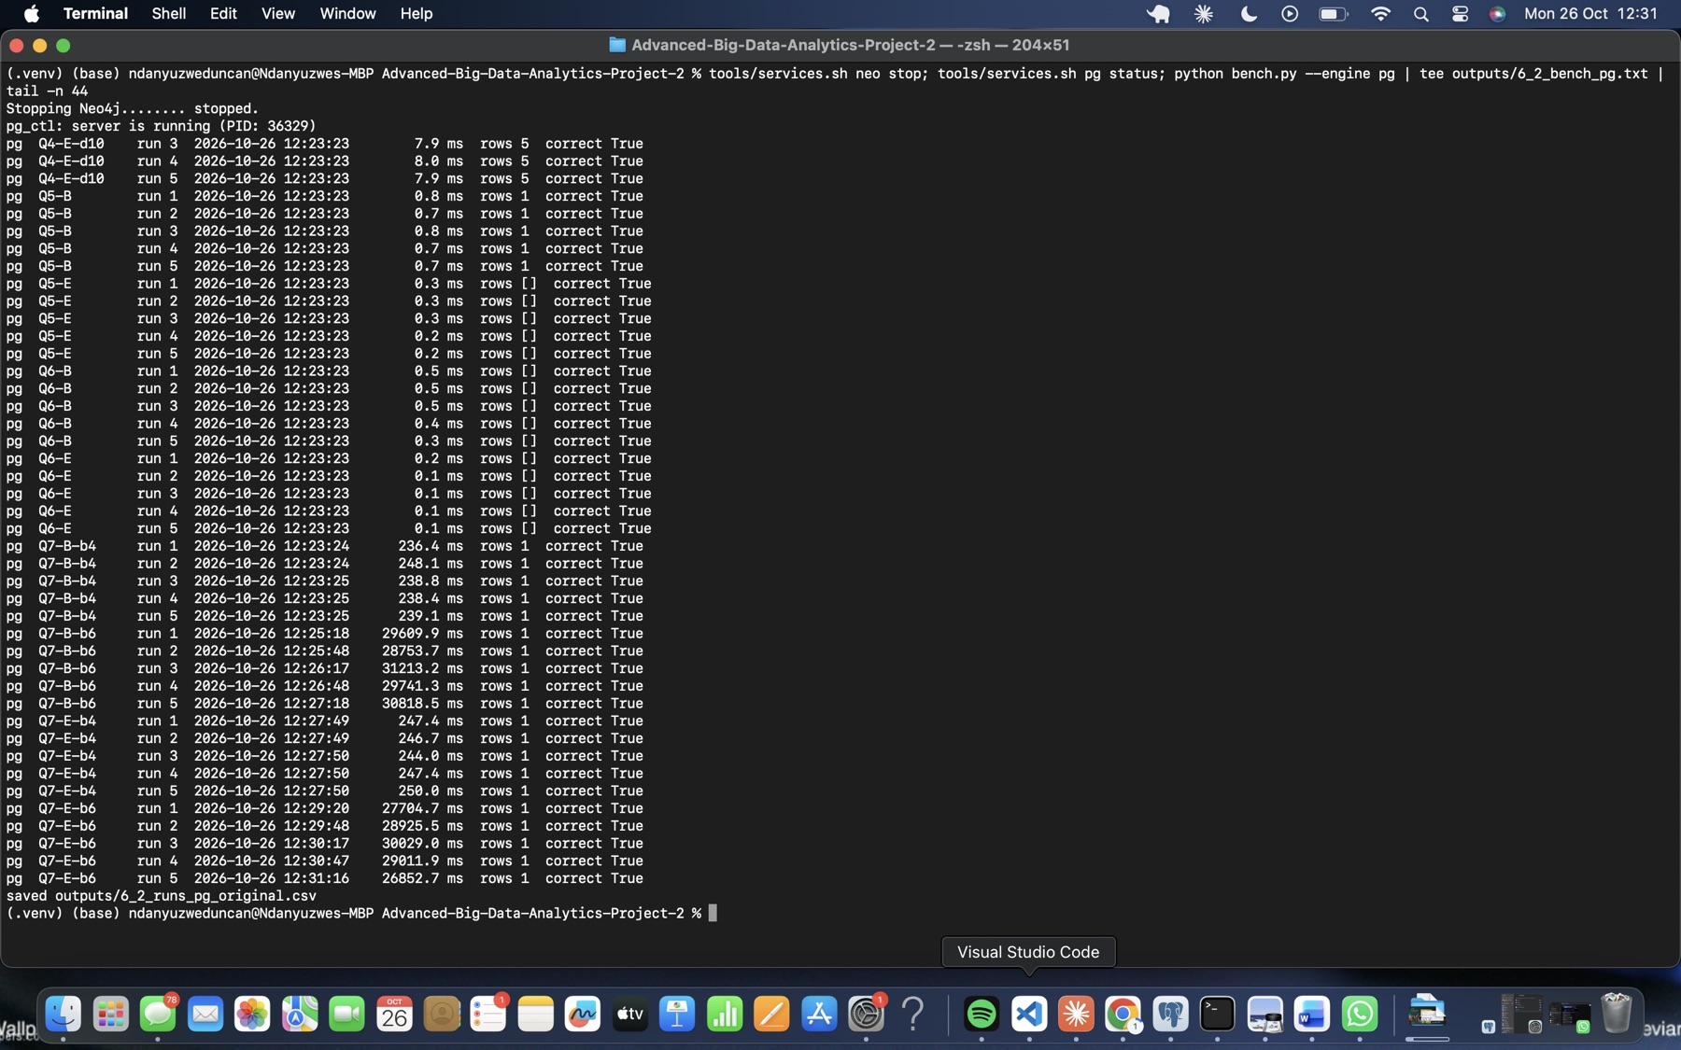
Figure 41. 6.2: PostgreSQL measured runs (Neo4j stopped).
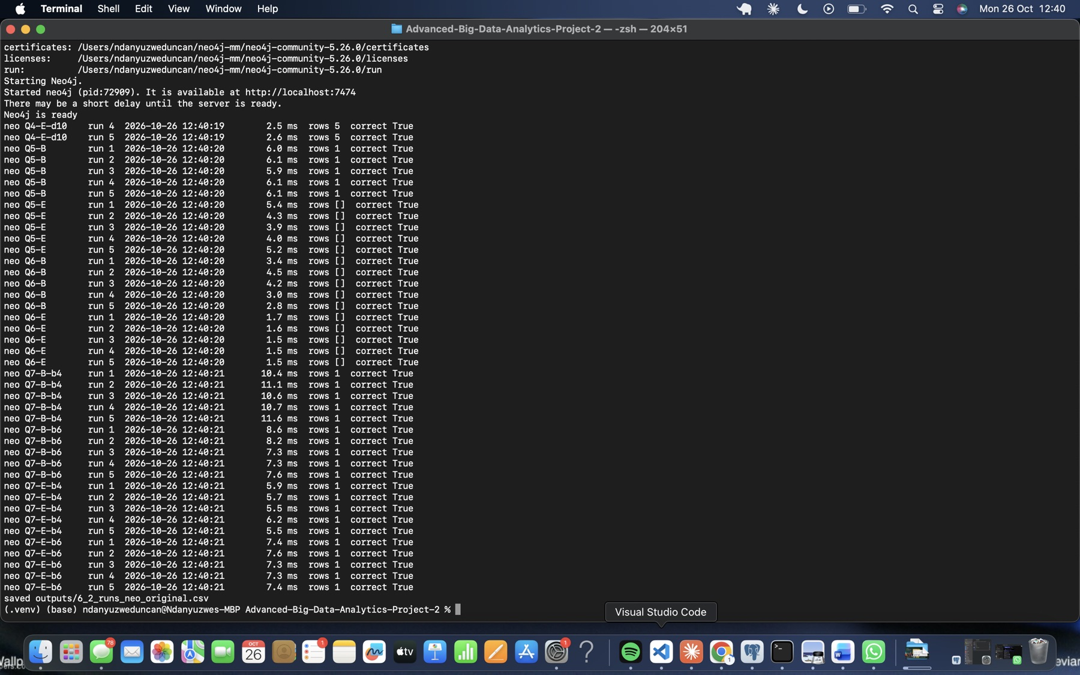
Figure 42. 6.2: Neo4j measured runs (PostgreSQL stopped).
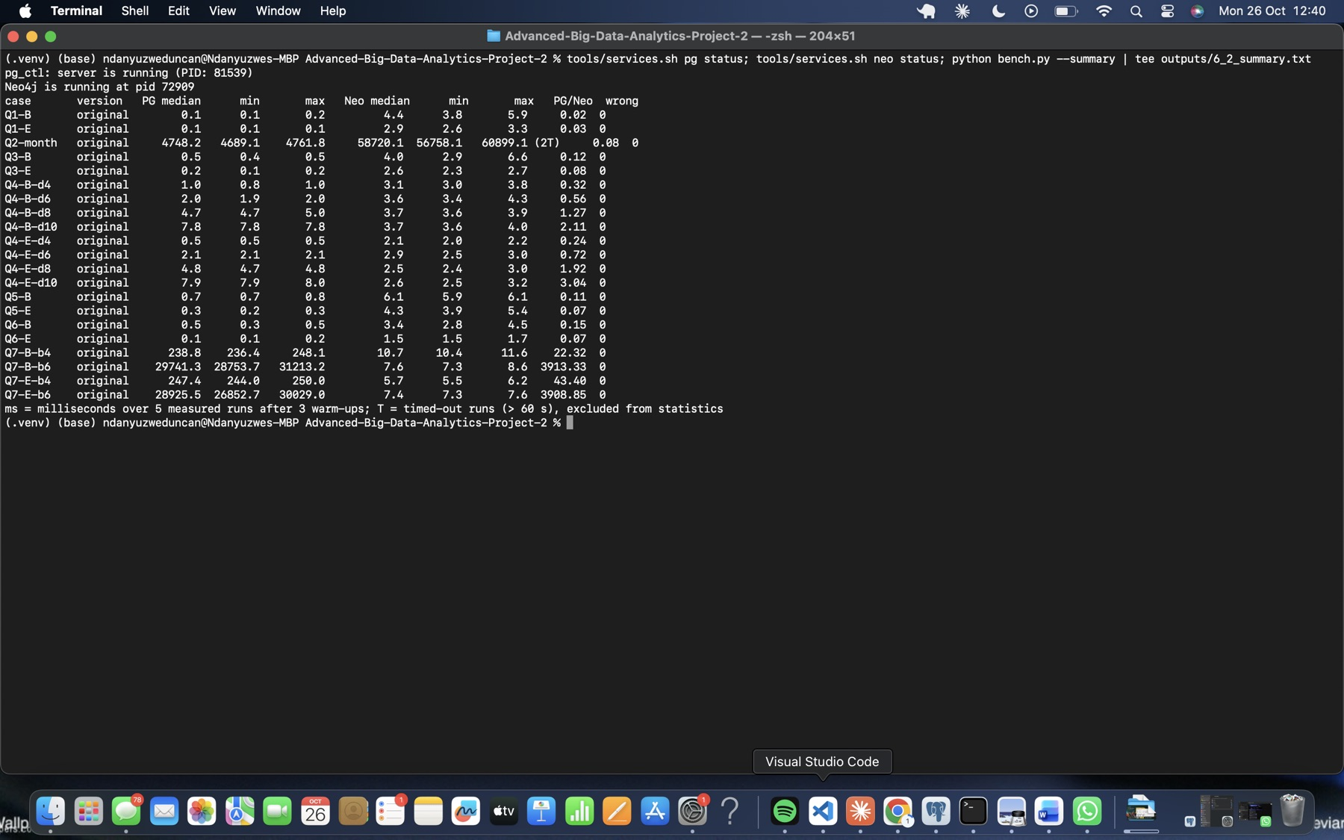
Figure 43. 6.2: timing summary (median, minimum and maximum ms, and PostgreSQL/Neo4j ratio).
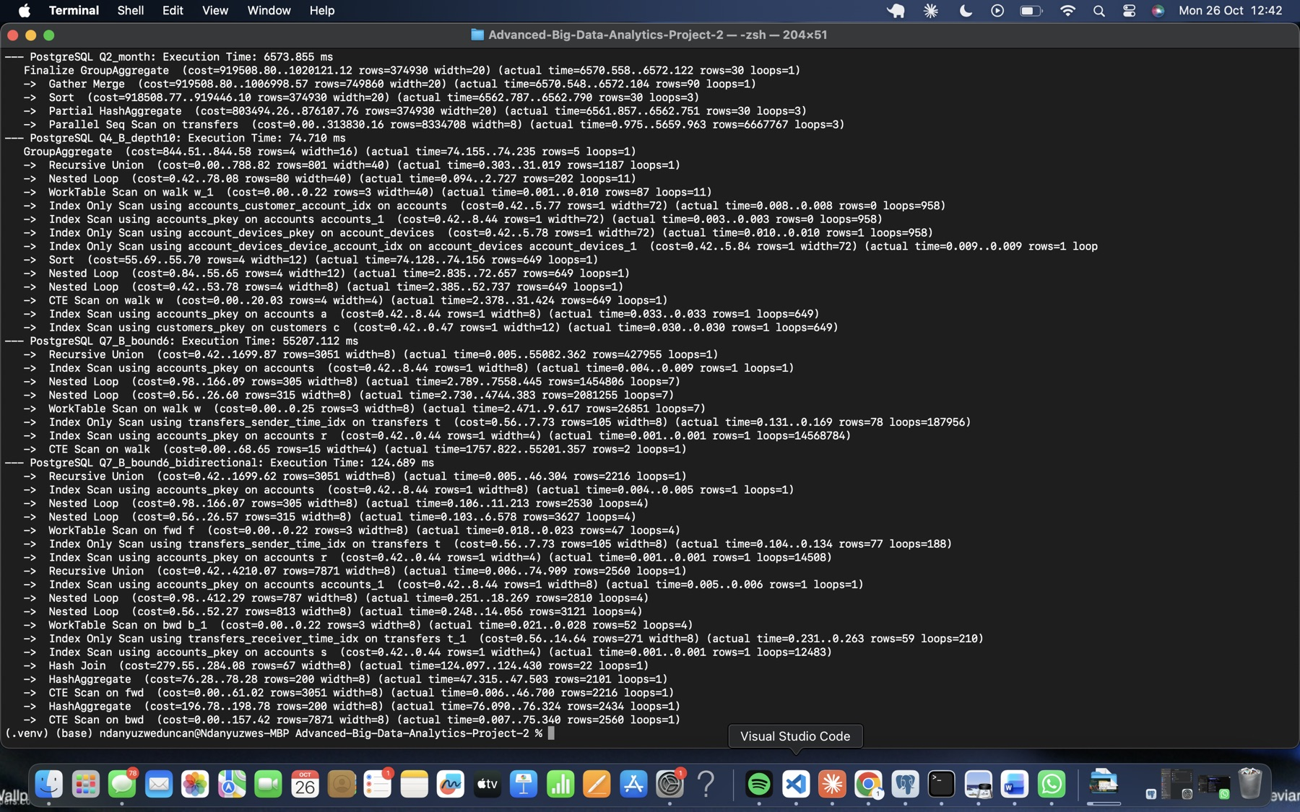
Figure 44. EXPLAIN (ANALYZE, BUFFERS) digests for Q2, Q4 B depth 10, and Q7 B bound 6 (original and improved).
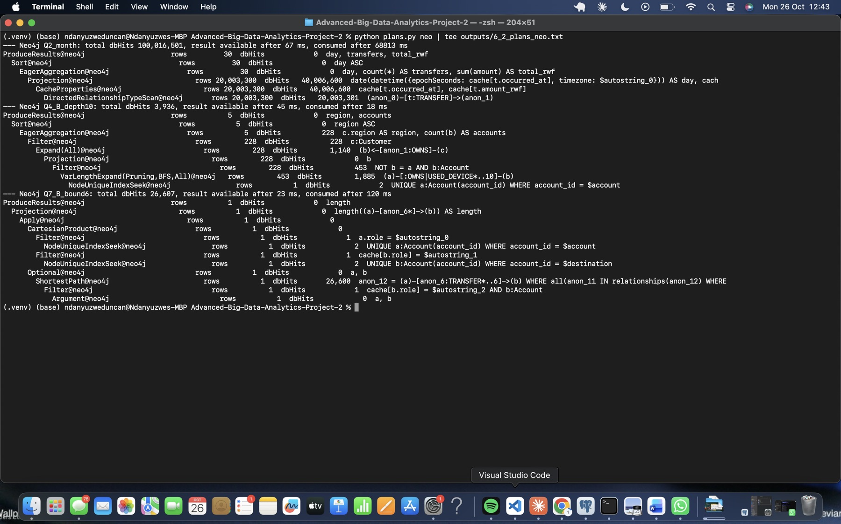
Figure 45. Neo4j PROFILE for Q2, Q4 B depth 10 (VarLengthExpand Pruning BFS) and Q7 B bound 6 (ShortestPath).

6.3 Try one SQL improvement
Wasted work in the Q7 plan. The recursive CTE’s UNION only removes duplicate (account, depth) rows, so an account reached at depth 2 is expanded again at depths 3, 4, 5 and 6. For set B at bound 6:
- The recursion produced 427,955 working rows over 7 iterations.
- It probed the sender index 187,956 times.
- It looked up the receiving account’s role 14.6 million times.
- All of this took 55 s, only to find a single account at depth 5.
Prediction and attempt. We searched from both ends. The forward walk takes at most ceil(bound/2) steps from the review account, and the backward walk at most floor(bound/2) steps from the destination along incoming transfers. Each side keeps the minimum depth per account, and the shortest length is the minimum of forward depth + backward depth over accounts where the two walks meet. Any route of length L ≤ bound splits this way, so the result is exact.
The expected effect is roughly two orders of magnitude, because each side only explores about 3 levels (about 2,000 to 3,000 rows each) instead of 6. No answers are hard-coded; the split is derived from the bound.
Outcome.
- All 12 Q7 cases still match Neo4j.
- The plan now processes 2,216 forward and 2,560 backward rows (124.7 ms under EXPLAIN ANALYZE).
- The timed medians fell sharply:
Case | Original | Improved | Speed-up
B bound 4 | 239 ms | 3.8 ms | about 60×
E bound 4 | 247 ms | 3.5 ms | about 70×
B bound 6 | 29,741 ms | 38.2 ms | about 780×
E bound 6 | 28,926 ms | 39.0 ms | about 740×
The improved version is selected for Section 7 and the final comparison. On the B/E bound-6 medians, PostgreSQL takes 38.2 / 39.0 ms against Neo4j’s 7.6 / 7.4 ms. The gap shrank from about 3,900× to about 5×. Most of the original gap came from the implementation, not from the data model.
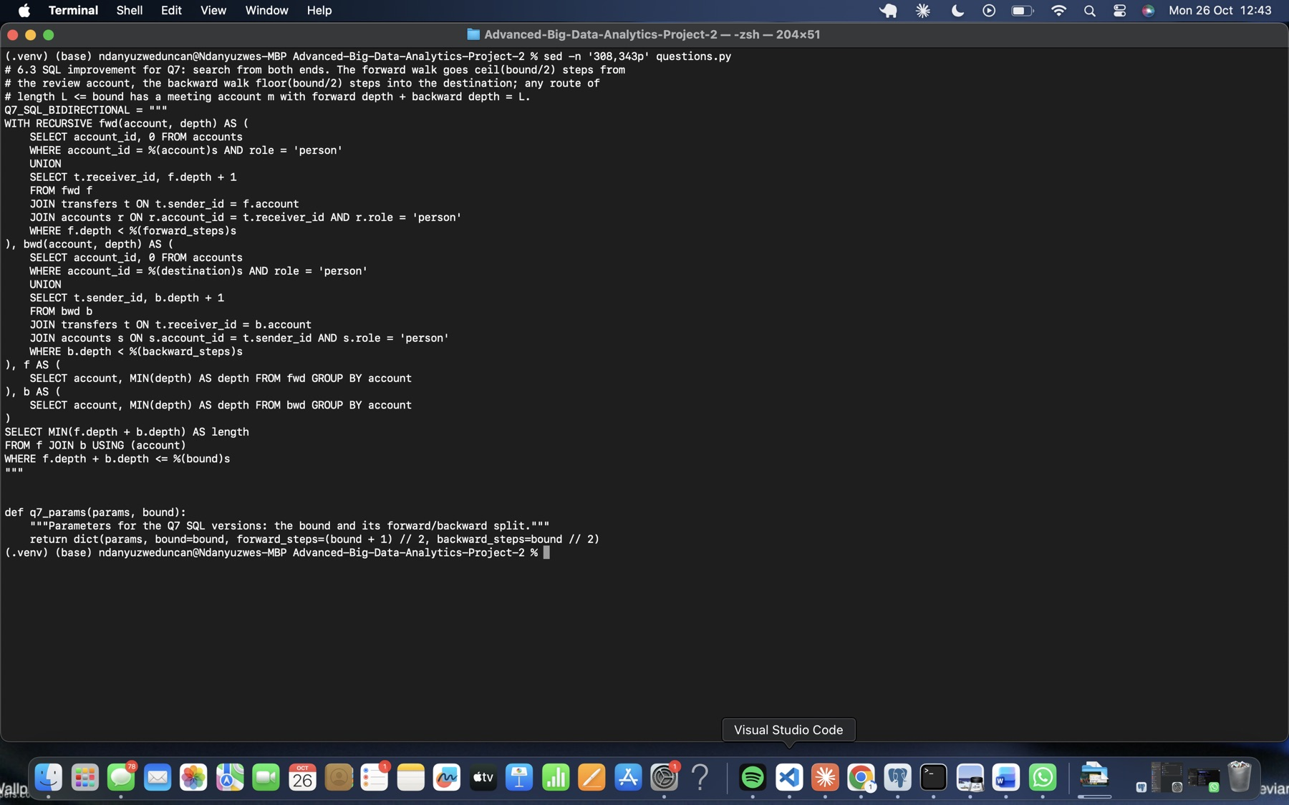
Figure 46. 6.3: the improved, search-from-both-ends Q7 SQL.
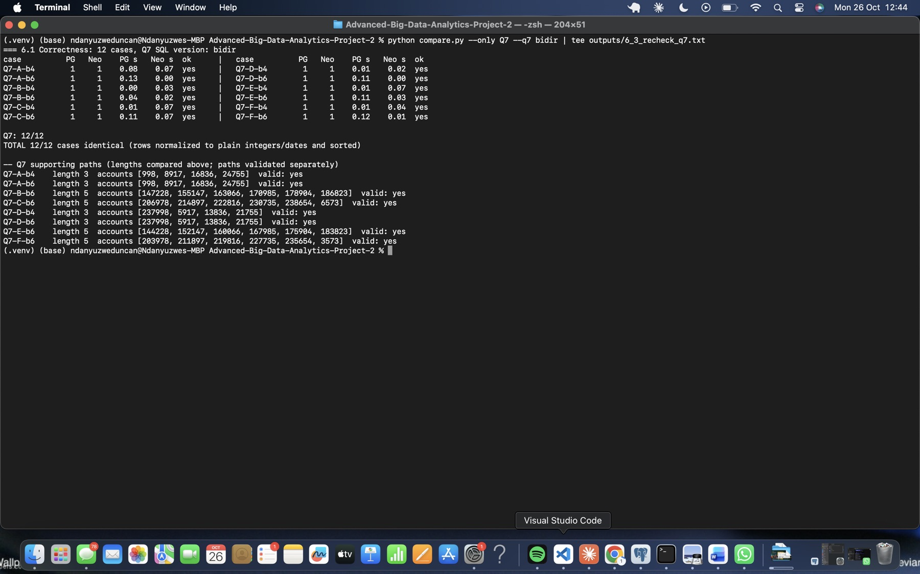
Figure 47. 6.3: all 12 Q7 cases rechecked with the improved SQL.
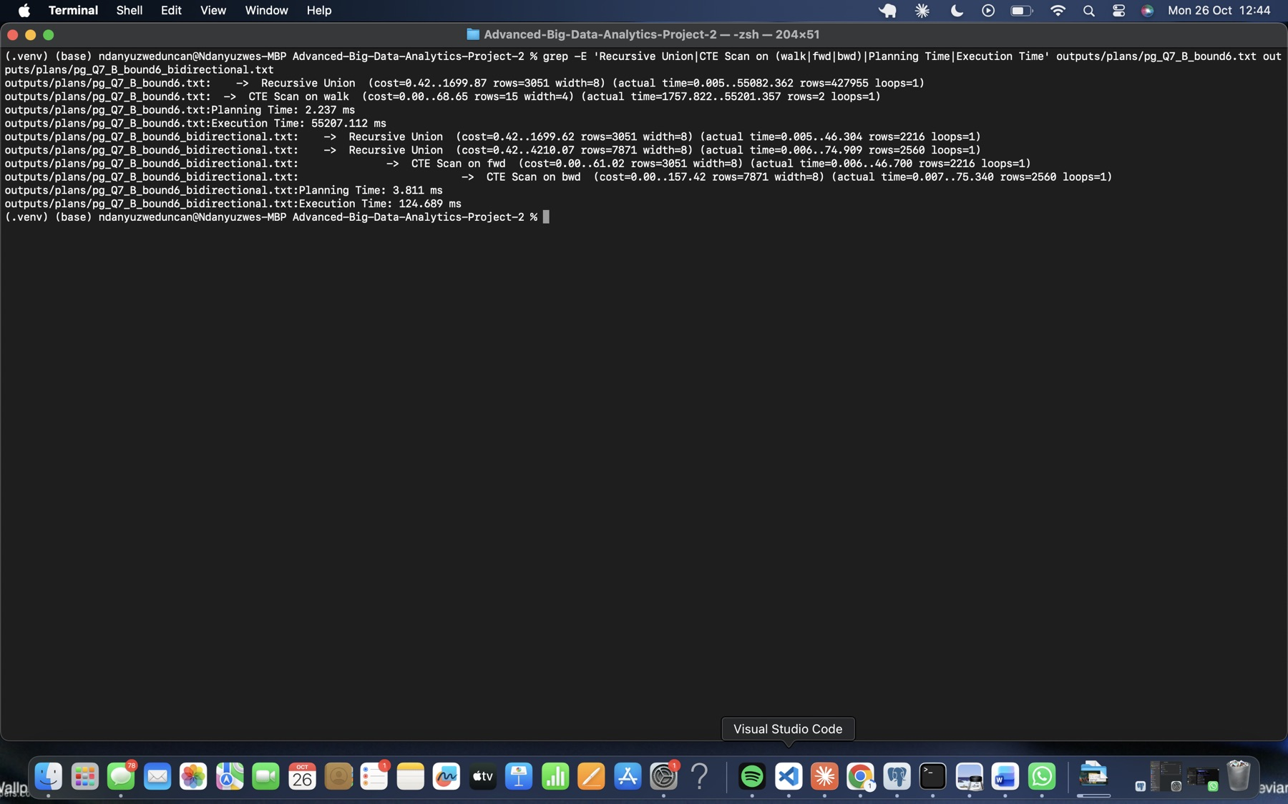
Figure 48. 6.3: plan before and after (recursive rows and execution time).
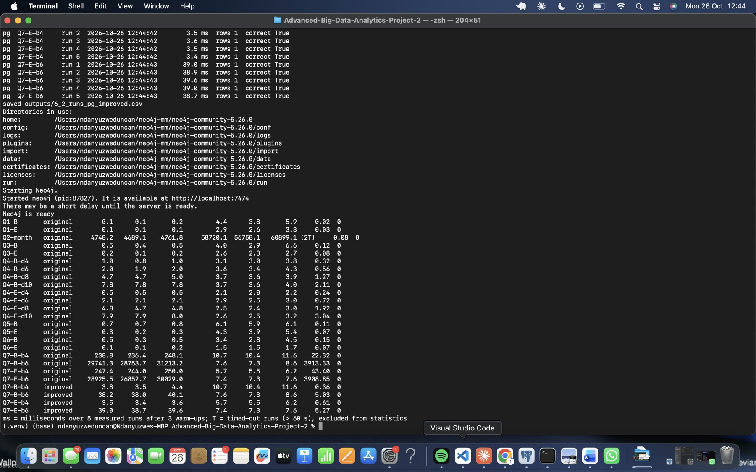
Figure 49. 6.3: four revised SQL cases retimed, and the combined summary.

7 Test concurrent requests

7.1 Build a small load test
Method. loadtest.py uses Python multiprocessing:
- One process per client, each with one persistent connection.
- Each client warms up once with sets A, B and C, then waits at a Barrier.
- The barrier’s release fixes a common start time and a deadline 15 s later.
- Clients keep starting new A-B-C cycles until the deadline, finish any cycle already started, and send each request as soon as the previous one completes. The query timeout is 60 s.
Workloads. Q4 at depth 10, and Q7 length-only at bound 6 using the improved SQL. Each was run with 1, 4, 8 and 16 clients, 3 repetitions each, on each engine with the other service stopped. That’s 48 runs. Every request is logged in outputs/7_requests.csv, and correctness is checked after timing.
Measures. Throughput is correct completions divided by the time from barrier release to the end of the last cycle. p95 is the sorted successful latency at position ceil(0.95n). Each row below is the median of 3 repetitions. Across all 48 runs there were 0 errors, 0 timeouts and 0 wrong answers.
Engine | Workload | 1 client req/s (p95 ms) | 4 clients | 8 clients | 16 clients
PostgreSQL | Q4 depth 10 | 69 (31) | 161 (60) | 202 (96) | 202 (197)
PostgreSQL | Q7 bound 6 | 26 (42) | 54 (92) | 61 (152) | 59 (341)
Neo4j | Q4 depth 10 | 402 (4.5) | 1,149 (7.3) | 1,446 (13.8) | 1,340 (36.2)
Neo4j | Q7 bound 6 | 245 (6.6) | 706 (11.4) | 825 (23.6) | 524 (71.8)
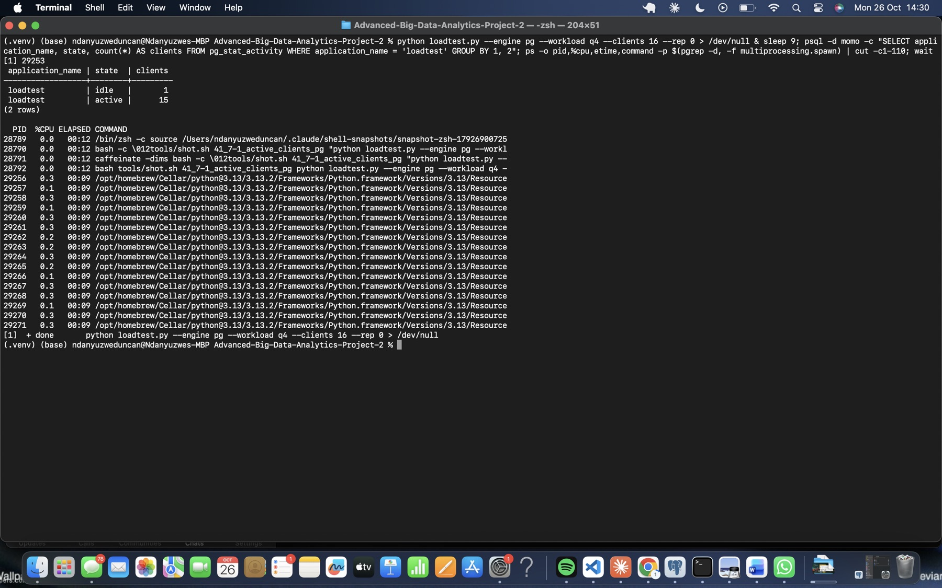
Figure 50. 16 PostgreSQL load-test clients active (pg_stat_activity and the client processes).
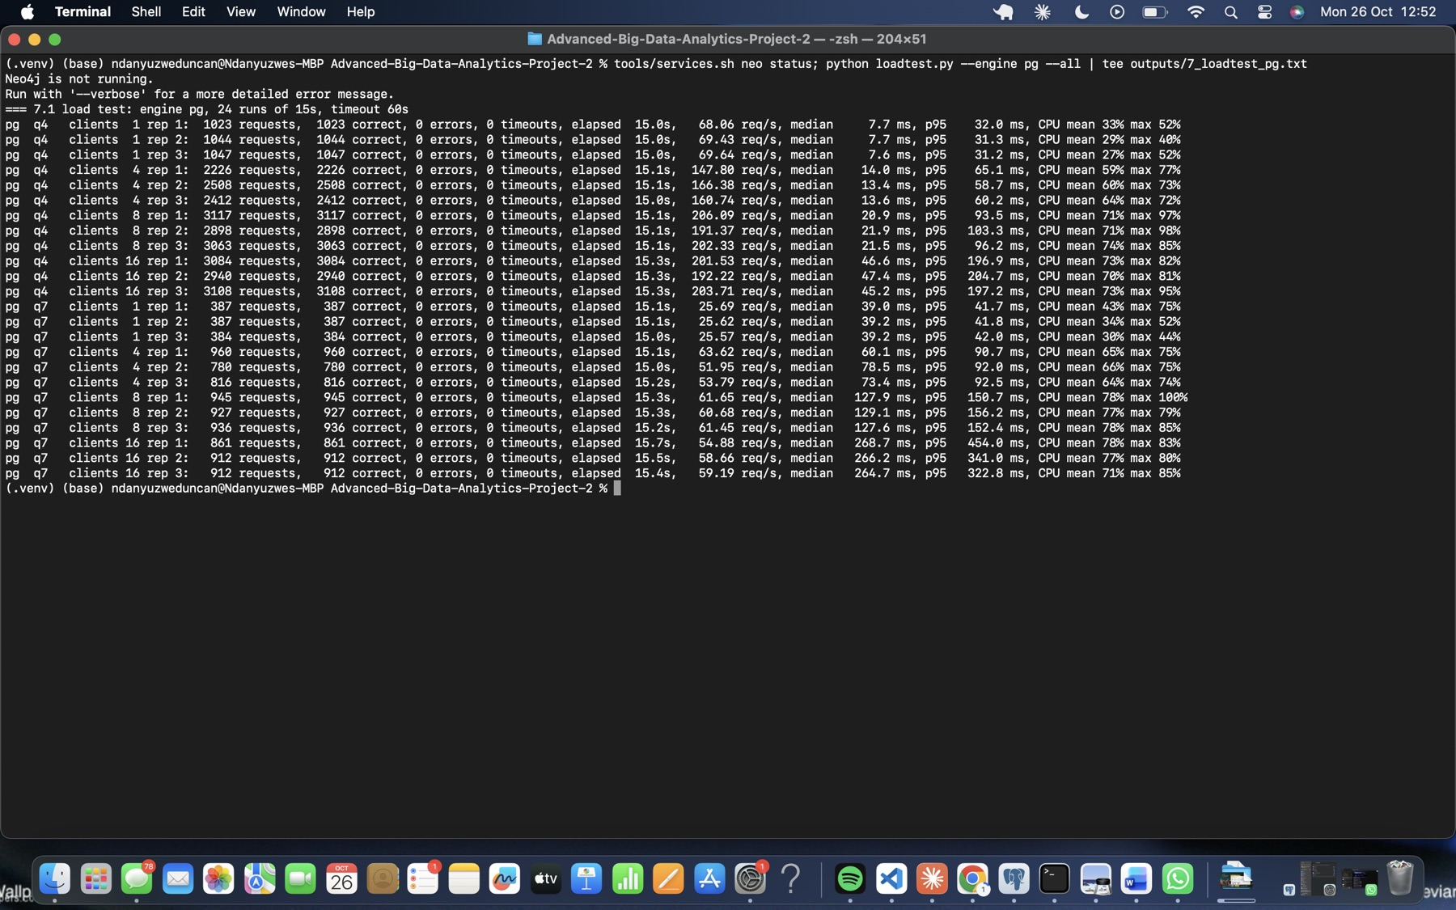
Figure 51. PostgreSQL load test: 24 runs (Neo4j stopped).
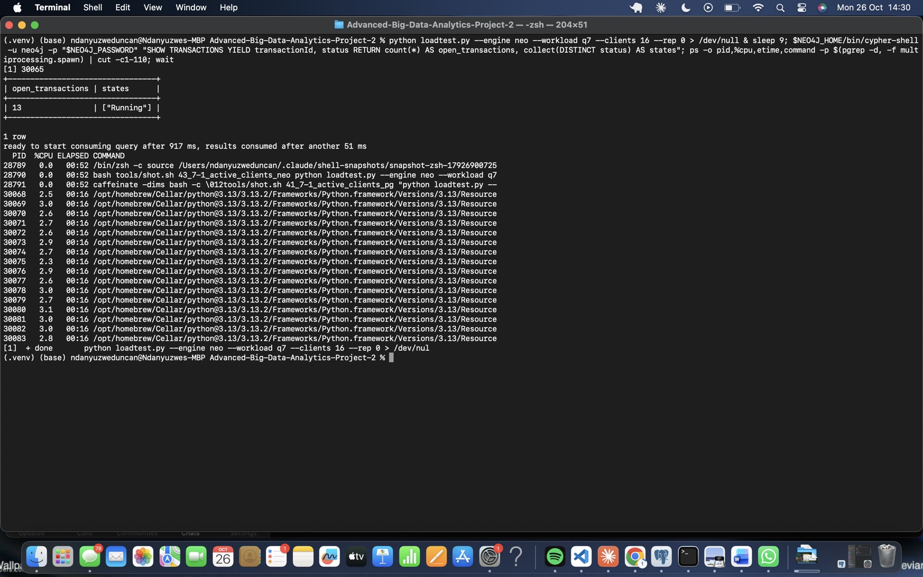
Figure 52. 16 Neo4j load-test clients active (SHOW TRANSACTIONS and the client processes).
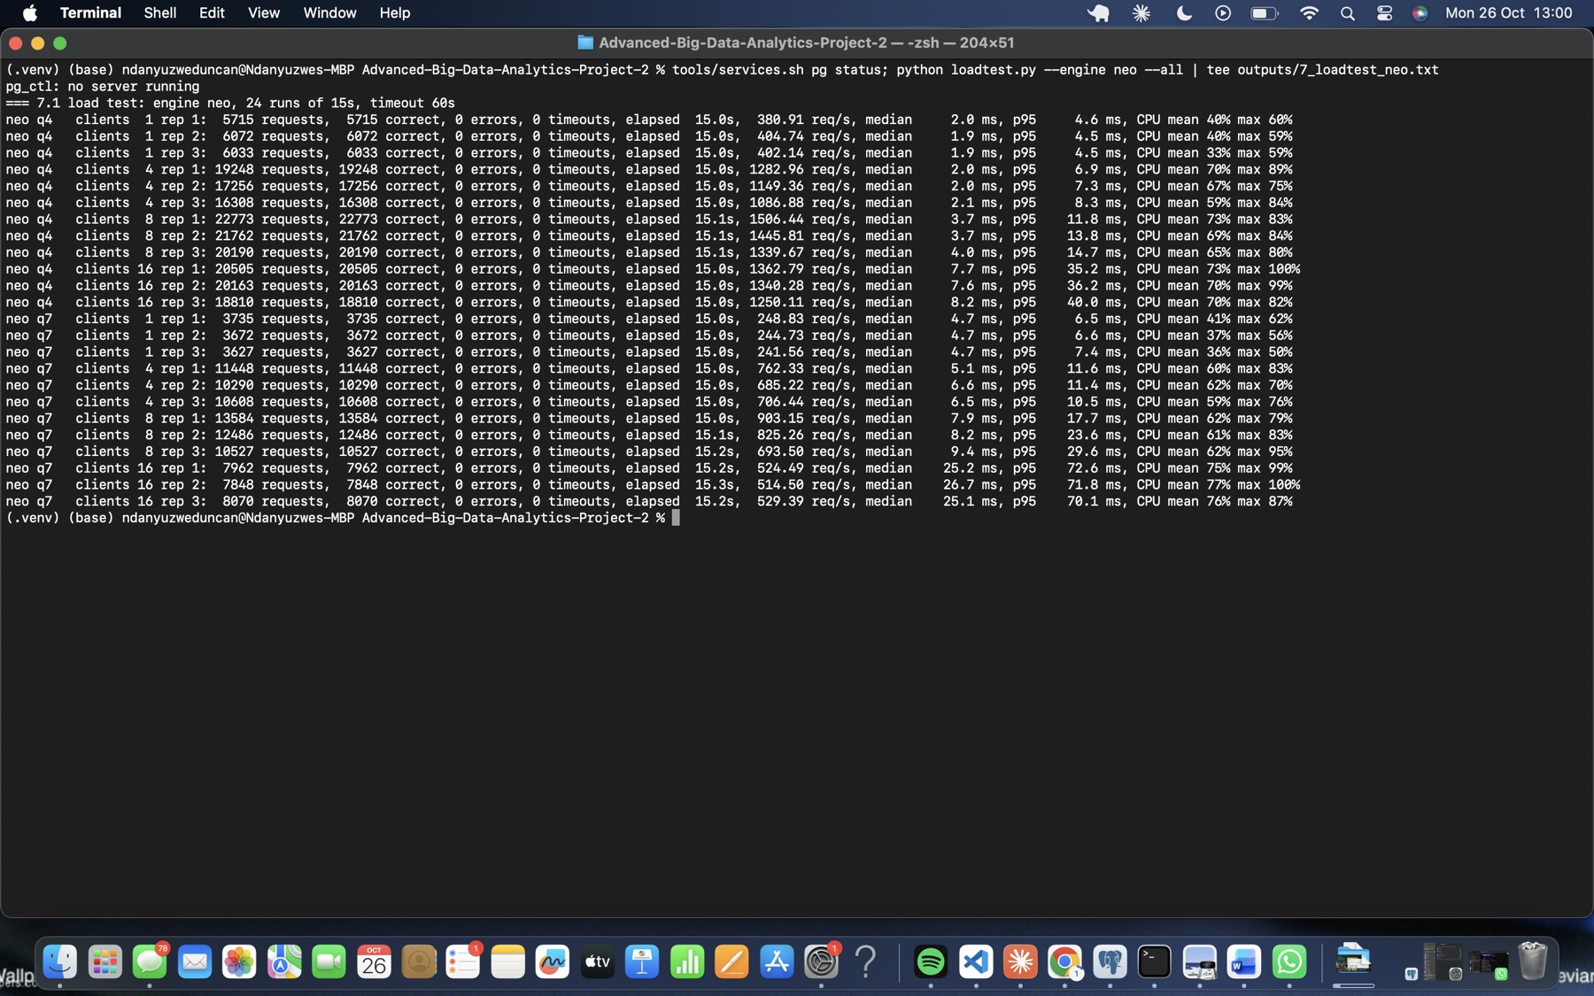
Figure 53. Neo4j load test: 24 runs (PostgreSQL stopped).
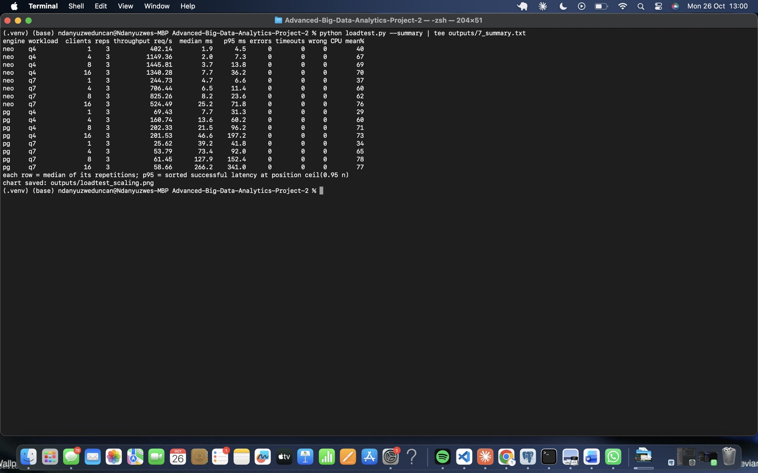
Figure 54. Summary of all 16 engine, workload and client-count combinations (medians of 3 repetitions).

7.2 Explain scaling
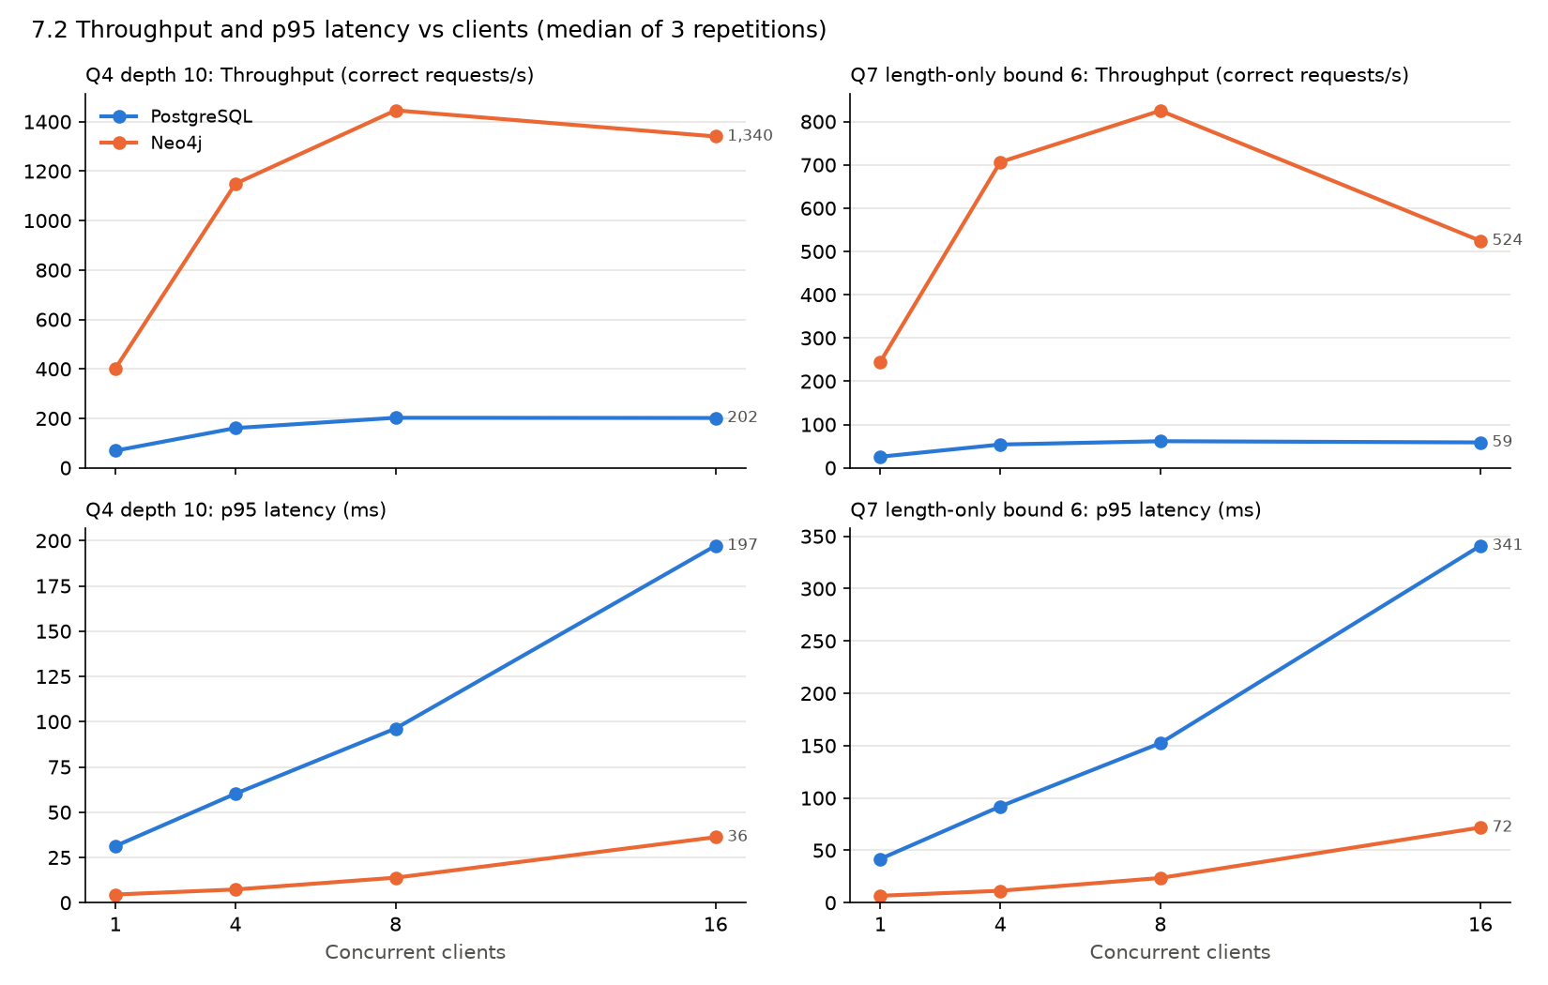
Figure 55. Throughput and p95 latency against client count, for both workloads and engines.
1 versus 16 clients.
- Throughput rises 2.3–3.3× from 1 to 16 clients, but only up to about 8 clients.
- Beyond 8 clients it flattens (PostgreSQL Q4 202 → 202 req/s, PostgreSQL Q7 61 → 59 req/s) or falls (Neo4j Q7 825 → 524 req/s).
- p95 latency keeps growing throughout: PostgreSQL Q7 goes from 42 to 341 ms, and Neo4j Q7 from 6.6 to 71.8 ms.
Saturation. The machine has 8 cores (4 performance and 4 efficiency). The 16 Python client processes run on the same machine and compete with the database for those cores. Mean CPU rose from 29–40% at 1 client to 70–78% at 8–16 clients. Once there are more concurrent requests than cores can serve, extra clients just queue: each request waits longer, so latency grows roughly in proportion while throughput stays flat. The efficiency cores and client-side work limit how close CPU gets to 100%.
The plans explain why the engines saturate at different levels. A PostgreSQL Q7 request performs about 400 index probes plus hash aggregates and a hash join in its own backend process (about 38 ms each). A Neo4j request is a ShortestPath search of about 26,600 dbHits served from the page cache by a worker thread (about 5–7 ms).
Throughput versus response time. Throughput is the work completed by all clients per second; response time is how long a single request waits. Between 8 and 16 clients, throughput barely changes, but every analyst’s request takes about 2–3 times longer.
Does a graph advantage survive the SQL improvement? In this experiment it does, but it is much smaller:
- With 1 client, Neo4j answers Q7 about 6× faster than the improved SQL.
- At 16 clients, Neo4j delivers about 9× the Q7 throughput with a p95 roughly 5× lower.
- For Q4 at depth 10, Neo4j’s throughput is about 6–7× higher.
These claims are limited to this experiment: one 8 GB laptop, clients and database on the same machine, September data, these two queries, and unequal memory settings (PostgreSQL shared_buffers 128 MB against Neo4j’s 2 GiB page cache). Before the SQL improvement, the Q7 gap was about 3,900×, which shows how much of an apparent “graph advantage” can come from implementation choices.

8 Make and defend decisions

8.1 Prioritise investigation
Each pair has the same structure. In every set:
- the review account shares one handset (228xxx) with 3–5 accounts owned by other customers (Q3);
- the shortest person-only route to the destination runs through exactly those accounts (Q7);
- the ownership and device network reached at depth 10 is about the same size within each pair (Q4).
What separates the pairs is tempo and value (Q5, Q6).
Pair | Evidence from Q3–Q7 | Review first
A / D | A (998): a Q5 chain and a Q6 cycle of 4 transfers, 998 → 8917 → 16836 → 24755 → 998. The transfers are 40 s apart, 200,000 → 188,238 RWF, each 98% of the previous one. Q7 length 3. Shares handset 228001 with all three route accounts.D (237998): no chain and no cycle. Its length-3 route to 21755 runs 6 → 8 → 10 Sep, 2 days per hop, at a constant 45,000 RWF. It shares handset 228301 with the same route accounts. | A
B / E | B (147228): a Q5 chain of 1,050,000 → 1,029,000 → 1,008,420 RWF, 40 s per hop. The Q7 route continues for 5 transfers in under 3 minutes, leaving Eastern for Western. No cycle.E (144228): a length-5 route at a constant 40,000 RWF, 13 → 21 Sep, 2 days per hop. No chain. | B
C / F | C (206978): a Q5 chain and a 6-transfer Q6 cycle through Southern → Eastern → Northern → Southern → Western → Southern. The cycle starts at 300,000 RWF, takes 4 minutes and returns 271,176 RWF. It has the widest Q4 network (1,433 accounts at depth 10).F (203978): a length-5 route, 8 → 16 Sep, at a constant 30,000 RWF. F’s Q4 network is just as wide (1,426), so the width is not distinctive. | C
Pair A/D in detail. Both review accounts share a handset with the very accounts their money reaches:
- A shares device 228001 with 8917, 16836 and 24755.
- D shares device 228301 with 5917, 13836 and 21755.
All of these are observed on days 0–29, so device evidence alone cannot separate them.
The transfers can. On Sunday 6 September, A sent 200,000 RWF to 8917 at 10:00:00. 8917 passed on 196,000 RWF at 10:00:40, 16836 passed on 192,080 RWF at 10:01:20, and 24755 returned 188,238 RWF to A at 10:02:00. That is four hops in 120 seconds, each 98% of the previous amount, ending where it began.
D’s three payments of exactly 45,000 RWF moved one hop every two days. That pattern is easier to read as ordinary repeated payments.
A’s own second wallet, 220998, sits on A’s handset 998 and is owned by the same customer. That link is unremarkable.
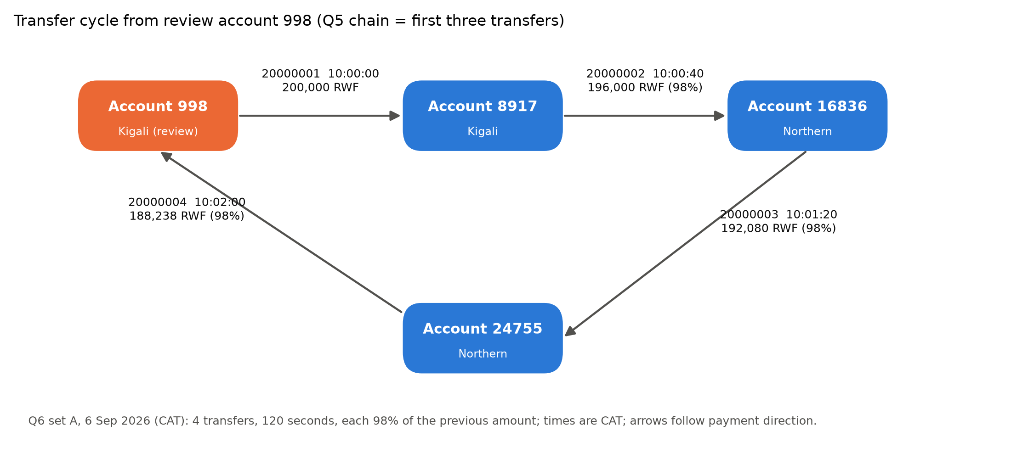
Figure 56. Transfer cycle for set A (Q5 chain plus the Q6 return), with IDs, CAT times and amounts.
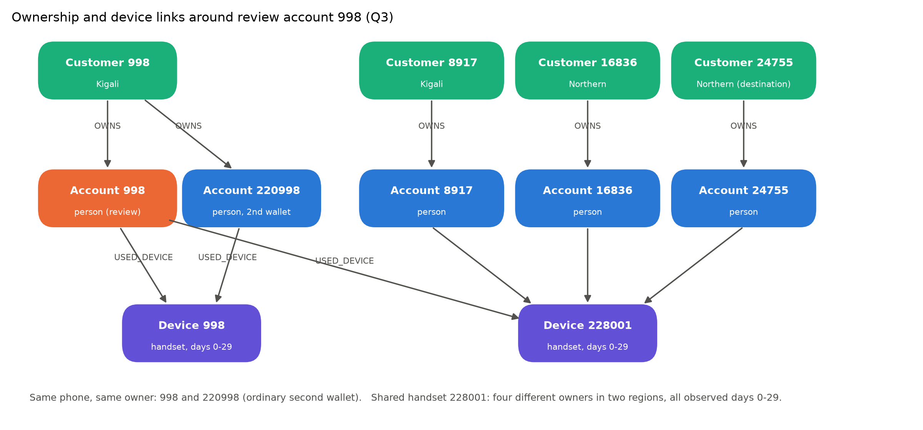
Figure 57. Ownership and device links around account 998 (Q3).
An ordinary explanation. Four people who share one handset and pass money around quickly could be running a rotating savings group (ikimina): one phone is used to make each member’s contribution in turn. A family might also move a sum through relatives’ wallets to stay under per-wallet limits before paying a shared expense. The 2% drop per hop could simply be transfer fees.
Missing evidence and how it could change the judgement. The records don’t show:
- which device actually initiated each payment;
- wallet balances before and after each transfer;
- identity (KYC) links between the four owners;
- what happened to the money after it returned;
- any activity outside September.
If the owners turn out to be registered members of one savings group, or relatives, with the cycle repeating monthly, priority should drop. If the balances show that the cycle inflated apparent turnover, or the money was cashed out at an agent straight afterwards, priority should rise. These records do not establish fraud.

8.2 Recommend a model
Reporting goes to PostgreSQL. For the full-month daily report (Q2), PostgreSQL’s parallel sequential scan and hash aggregation take 4.7 s. Neo4j scans all 20 million TRANSFER relationships with about 100 million dbHits in a single thread: 58.7 s, with 2 of 5 runs over 60 s. Single-account lookups (Q1, Q3, Q5, Q6) also run 7–50× faster in PostgreSQL through covering indexes.
Traversal investigations go to Neo4j. For Q7 at bound 6, the Cypher SHORTEST 1 path with an inline person filter is planned as a single ShortestPath operator (26,600 dbHits, 7.6 ms). The recursive SQL re-expanded every account at every depth: 427,955 working rows and 14.6 million role lookups, taking 29.7 s. For Q4 at depth 10, Neo4j’s pruning breadth-first expansion takes 3.7 ms against PostgreSQL’s 7.8 ms. Under concurrency, Neo4j sustained 1,340 Q4 and 524 Q7 requests/s at 16 clients against PostgreSQL’s 202 and 59, with p95 latency 5× lower.
Load time and storage. PostgreSQL took 19.6 s to load and 98 s to build keys and indexes, using 3.73 GB. Neo4j took 35 s to import offline and 33 s to build constraints, using 2.06 GB. However, the Neo4j import required preparing CSVs and stopping the database.
Evidence against preferring Neo4j. Rewriting Q7 in SQL to search from both ends cut it to 38 ms. That narrowed a 3,900× gap to 5×, so most of the original gap was the algorithm, not the data model. PostgreSQL also wins every reporting and point-lookup case. Running both systems doubles operations work.
Modelling benefit versus implementation effect. The graph model’s benefit is that relationships are stored as links and patterns are short to write. The quantified path for Q6 is 8 lines; the recursive CTE is 18. The speed of Q7, by contrast, comes mostly from Neo4j’s built-in bidirectional search, which SQL can partly reproduce.
Freshness. If transfers are copied into Neo4j, the copy should be no more than 5 minutes behind, fed from change data capture. Q5 chains span 10 minutes, so a stale copy would miss chains still in progress. Analysts could wrongly report “no route”, or prioritise using yesterday’s network. Q4 and Q7 answers from an out-of-date graph could also contradict the PostgreSQL reports.
Limits.
- One 8 GB laptop, with clients on the same machine and unequal memory settings (shared_buffers 128 MB against a 2 GiB page cache).
- One month of generated data, six review sets and read-only queries. Write load and update cost were not tested.

8.3 Explain individual judgement
Individual notes. Each member writes 150–200 words in their own words about a different measured finding: what it is, why it happened, and a check that could overturn it. The notes must be the members’ own work.
[Ndanyuzwe Duncan, 150–200 words]
[Member 2, 150–200 words]
[Member 3, 150–200 words]
Suggested findings, one per member:
- the 3,900× → 5× Q7 change after the SQL rewrite;
- Q2 taking 4.7 s in PostgreSQL against 58.7 s in Neo4j;
- throughput levelling off at about 8 clients.
Contributions. [Group: list who did what.]
LLM and external assistance. Claude (Anthropic), a large language model, used in Claude Code, helped with:
- writing the Python, SQL and Cypher code;
- running the capture, loads, queries, benchmarks and load tests on this machine;
- capturing the screenshots of those real runs;
- drafting the report text and figures.
How the work was checked:
- every answer was compared between two independent engines (61/61 identical);
- one device overlap, one chain and one cycle were re-checked directly from the CSV files in plain Python;
- row counts and audit totals were reconciled across capture.py, PostgreSQL and Neo4j;
- timings come from saved raw runs (outputs/6_2_runs_*.csv, outputs/7_runs.csv).
[Group: confirm or edit this statement. Each member must be able to explain the work.]

9 Submit reproducible work

9.1 Prepare the report
This PDF follows milestone order. It contains the models, summaries, charts and embedded evidence, with explanations kept brief. Complete outputs, raw repetitions and plans are in outputs/ in the code submission.

9.2 Provide code and verification
Code. GitHub: https://github.com/Duncanwar/Advanced-Big-Data-Analytics-Project-2, with a matching ZIP.
The repository contains:
- the unchanged generator;
- the capture and import programs;
- the SQL and Cypher definitions;
- the queries, checks, benchmarks and load test;
- raw results and plans;
- a README listing the commands in execution order.
Secrets are placeholders (.env.example). The CSVs and database stores stay local. The generator’s SHA-256 matches the value recorded in Section 1.1 (2ea0e59d…e9455a).
The submitted 61-case comparison was re-run, and both database services were then stopped. Their stores are retained.
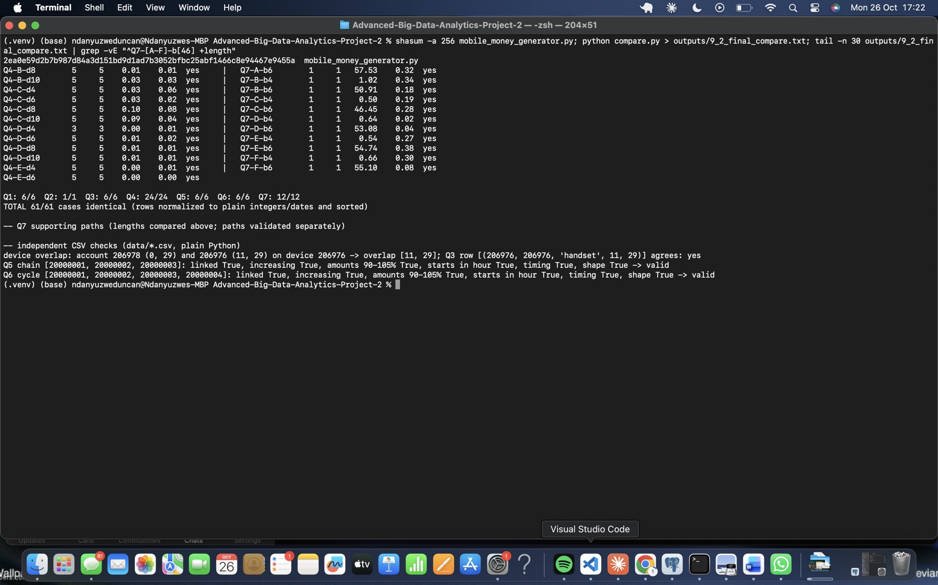
Figure 58. Final re-run of the 61-case comparison, with the generator hash.
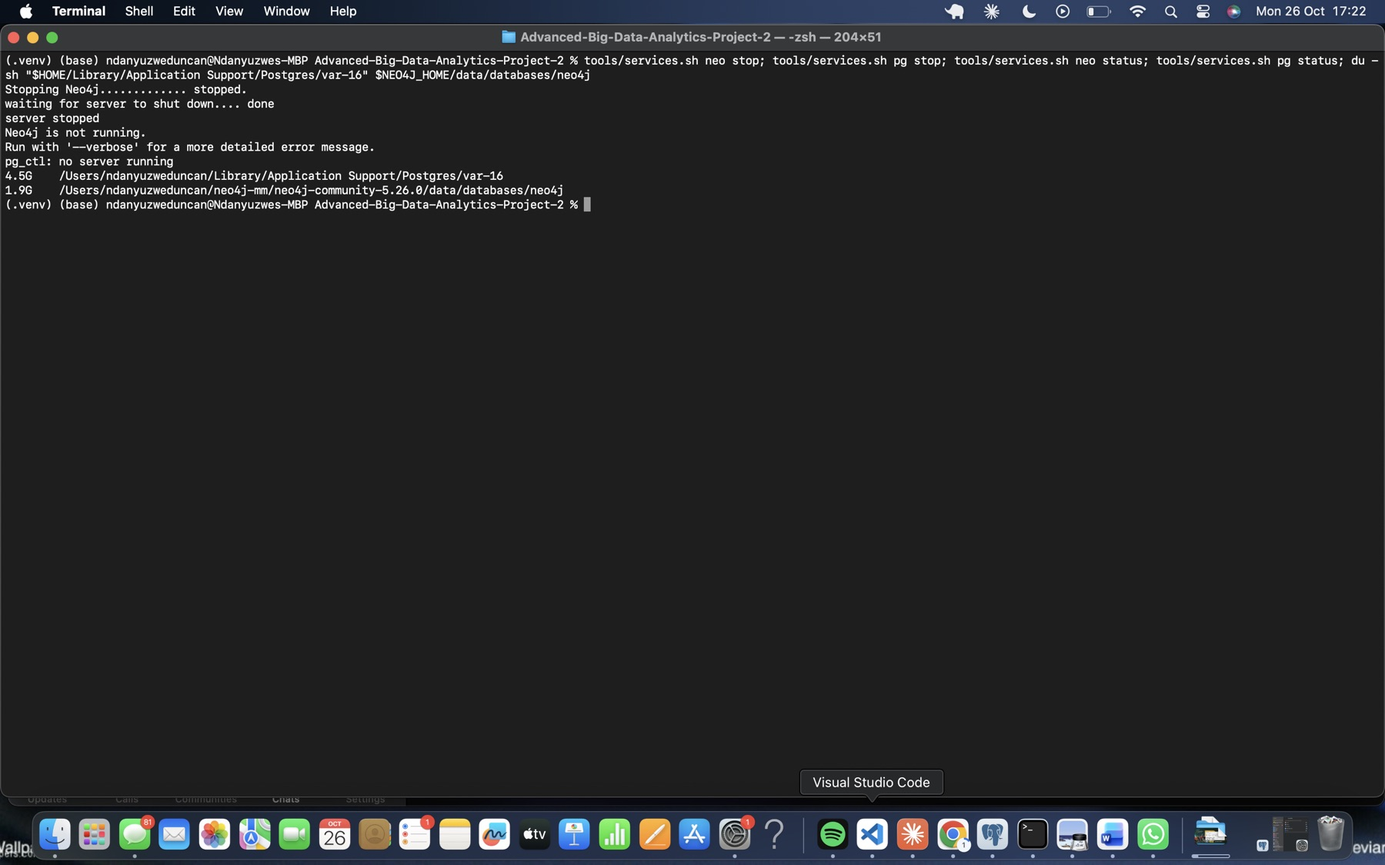
Figure 59. Both database services stopped; the stores are retained.

