Advanced Big Data Analytics
Assignment I: Smart Energy Grid Analytics
AUCA MSc | Issued 1 October 2026 | Due 15 October 2026, 23:59 CAT

Group member | Student ID
ERIC BYIRINGIRO | 101389
SANDRINE MFURANZIMA | 101411
NDANYUZWE DUNCAN | 101413

All times are CAT (UTC+02:00). Measurements were taken on one machine (RSA06-B). Observations (what was measured) are kept separate from explanations (why we think it happened).

Contents
Contents 2
1 Build the ingestion pipeline 4
1.1 Confirm the environment 4
1.2 Create the database structures 8
1.3 Capture and publish a pilot stream 12
2 Capture and prepare the historical dataset 14
2.1 Capture and load the complete stream 14
2.2 Investigate data quality 15
2.3 Clean and preserve a consistent benchmark 17
3 Compare chunk intervals 18
3.1 Create and verify three configurations 18
3.2 Implement and time the five workloads 20
3.3 Explain the chunk results 25
4 Compare compression strategies 25
4.1 Create the two compressed configurations 25
4.2 Measure storage and compression cost 29
4.3 Repeat the query comparison 31
4.4 Select a storage configuration 36
5 Investigate the utility data 36
5.1 Identify demand patterns 36
5.2 Compare regions and customer types 39
5.3 Assess reporting quality 40
5.4 Investigate abnormal consumption 41
5.5 Management recommendation 42
6 Create and investigate continuous aggregates 43
6.1 Create the three aggregate views 43
6.2 Test freshness and delayed arrivals 49
7 Build and compare dashboards 52
7.1 Build the Raw dashboard 52
7.2 Build the Aggregate dashboard 53
7.3 Verify matching results 54
7.4 Measure performance and judge the tradeoff 54
8 Forecast the next day 57
8.1 Prepare chronological data and features 57
8.2 Evaluate the previous-day baseline 58
8.3 Train and evaluate one regression model 59
8.4 Judge forecast usefulness 60
9 Submit the report and code 62
9.1 Organize the report 62
9.2 Make the work reproducible 62
9.3 Document contributions 62
Appendix A: dashboard panel queries 64
Raw dashboard 64
Aggregate dashboard 64

1 Build the ingestion pipeline

1.1 Confirm the environment
Item | Value
Machine | RSA06-B (Windows 11 Pro, build 26200)
CPU | Intel Core Ultra 9 185H, 16 cores / 22 logical processors
RAM | 31.5 GB
Storage | KIOXIA BG6 1 TB NVMe SSD
Python | 3.13.6 (psycopg 3.3.6, paho-mqtt 2.x)
EMQX | 6.3.1, running in WSL2 (broker reached on 127.0.0.1:1883)
PostgreSQL | 18.6, native Windows service postgresql-x64-18
TimescaleDB | 2.29.2 (Community), enabled in database smart_meters
shared_buffers | 8,053 MB (1,030,784 x 8 kB)
work_mem | 11,713 kB
max_parallel_workers_per_gather | 11
jit | off
Database / session time zone | smart_meters / Africa/Kigali (set with ALTER DATABASE); daily buckets use 'Africa/Kigali' so they align to CAT midnight

PostgreSQL runs natively on Windows, not in a container or virtual machine, so no CPU or RAM limit applies beyond the machine itself. EMQX runs inside WSL2.
The Windows clock is synchronized with time.windows.com (w32tm /query /status: stratum 5, last successful sync 06/10/2026 11:43:11, poll interval 1024 s). Get-Date matched the taskbar clock (12:27 CAT) and the WSL clock was compared with Windows in screenshot 1-1-8. CAT times appear in the taskbar clock of every screenshot and in the CAT-stamped output of each program.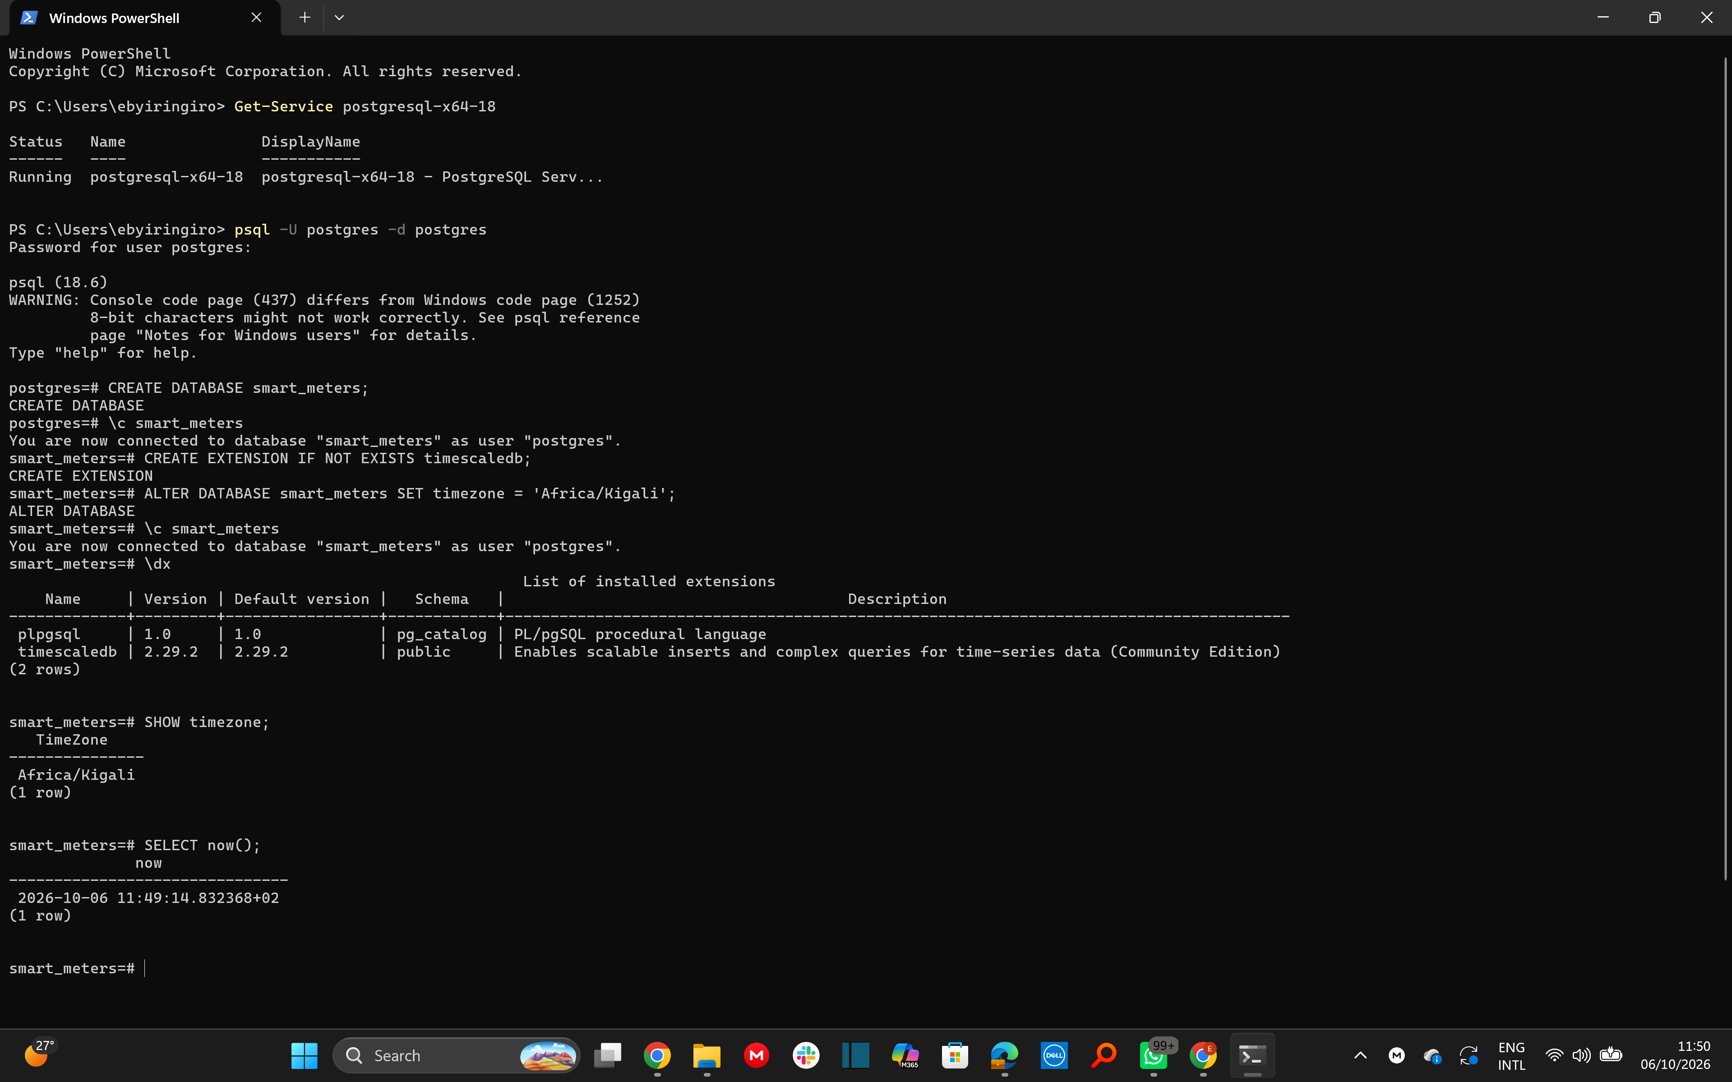
Screenshot 1.1-1 (1-1-1-postgres-db-extension-timezone.png)

Screenshot 1.1-2 (1-1-2-emqx-broker-status.png)
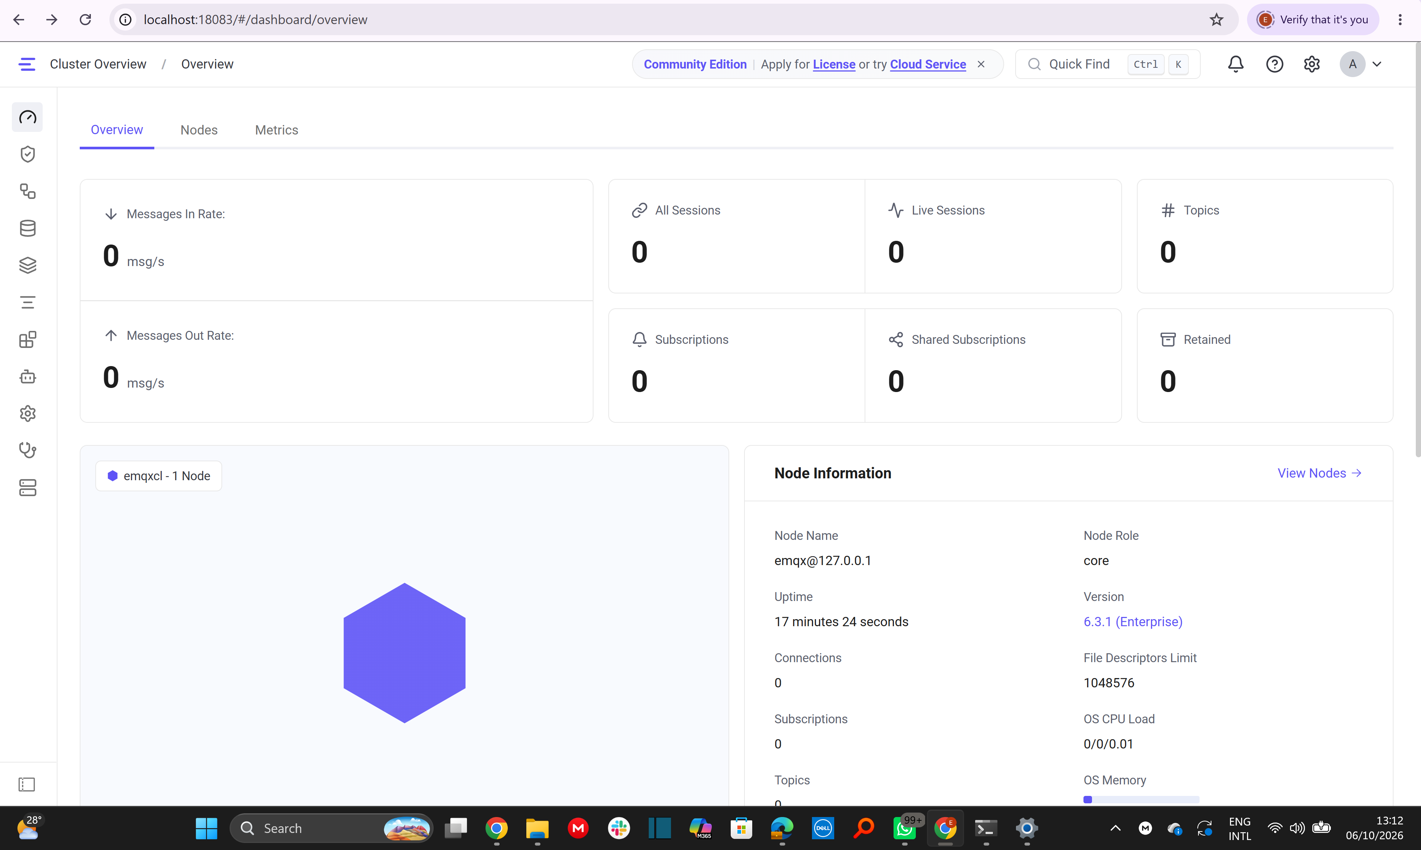
Screenshot 1.1-3 (1-1-3-emqx-dashboard.png)

Screenshot 1.1-4 (1-1-4-windows-clock-sync.png)
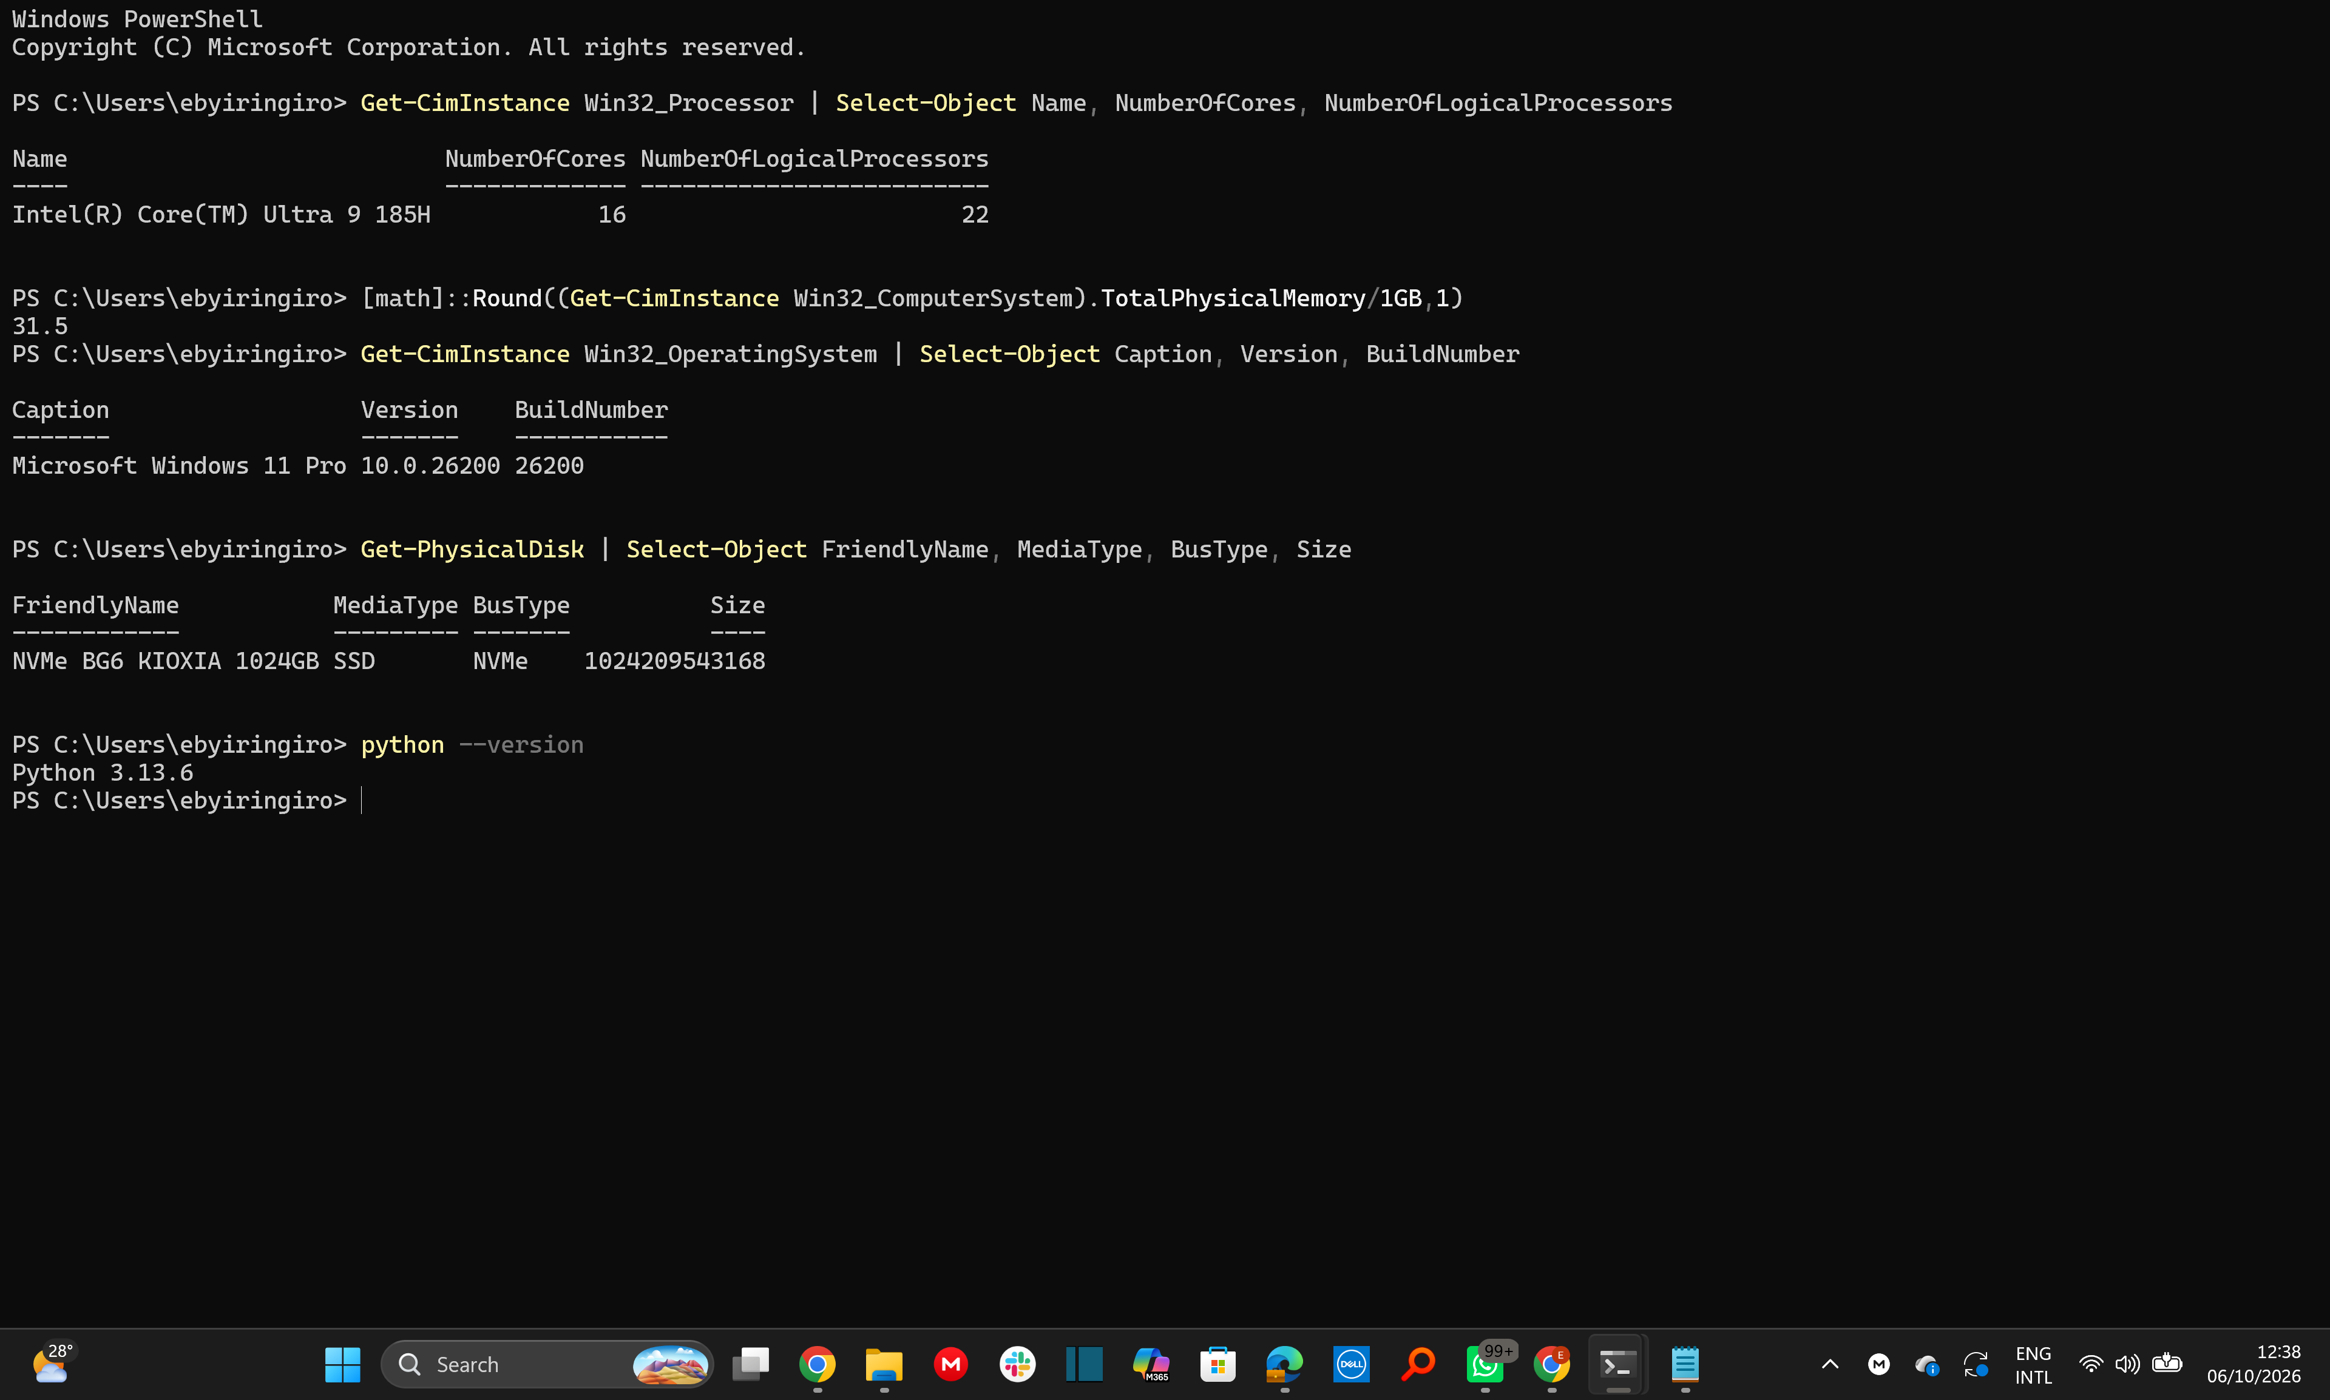
Screenshot 1.1-5 (1-1-4-hardware_os_python.png)
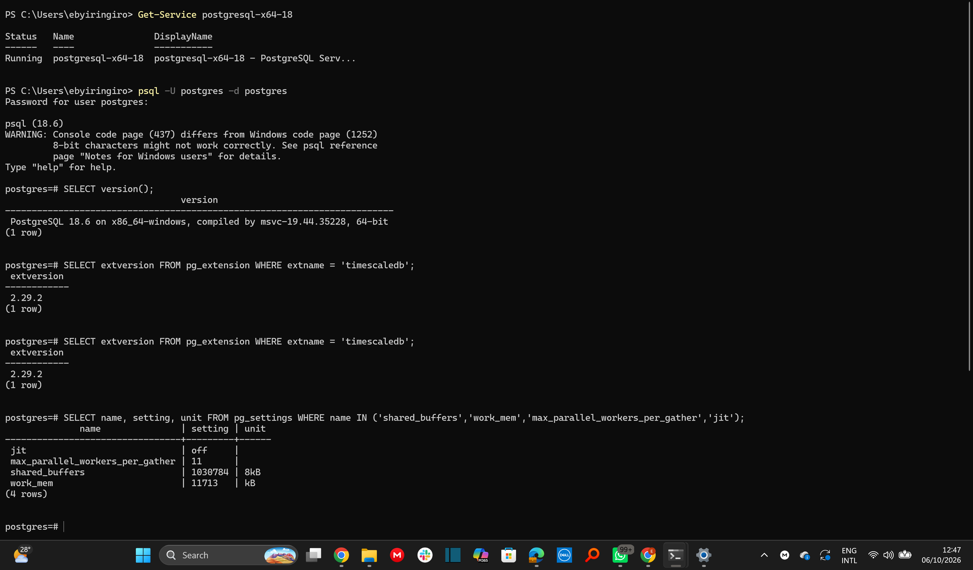
Screenshot 1.1-6 (1-1-5postgres-version-settings.png)

Screenshot 1.1-7 (1-1-6-wsl-version-limits.png)
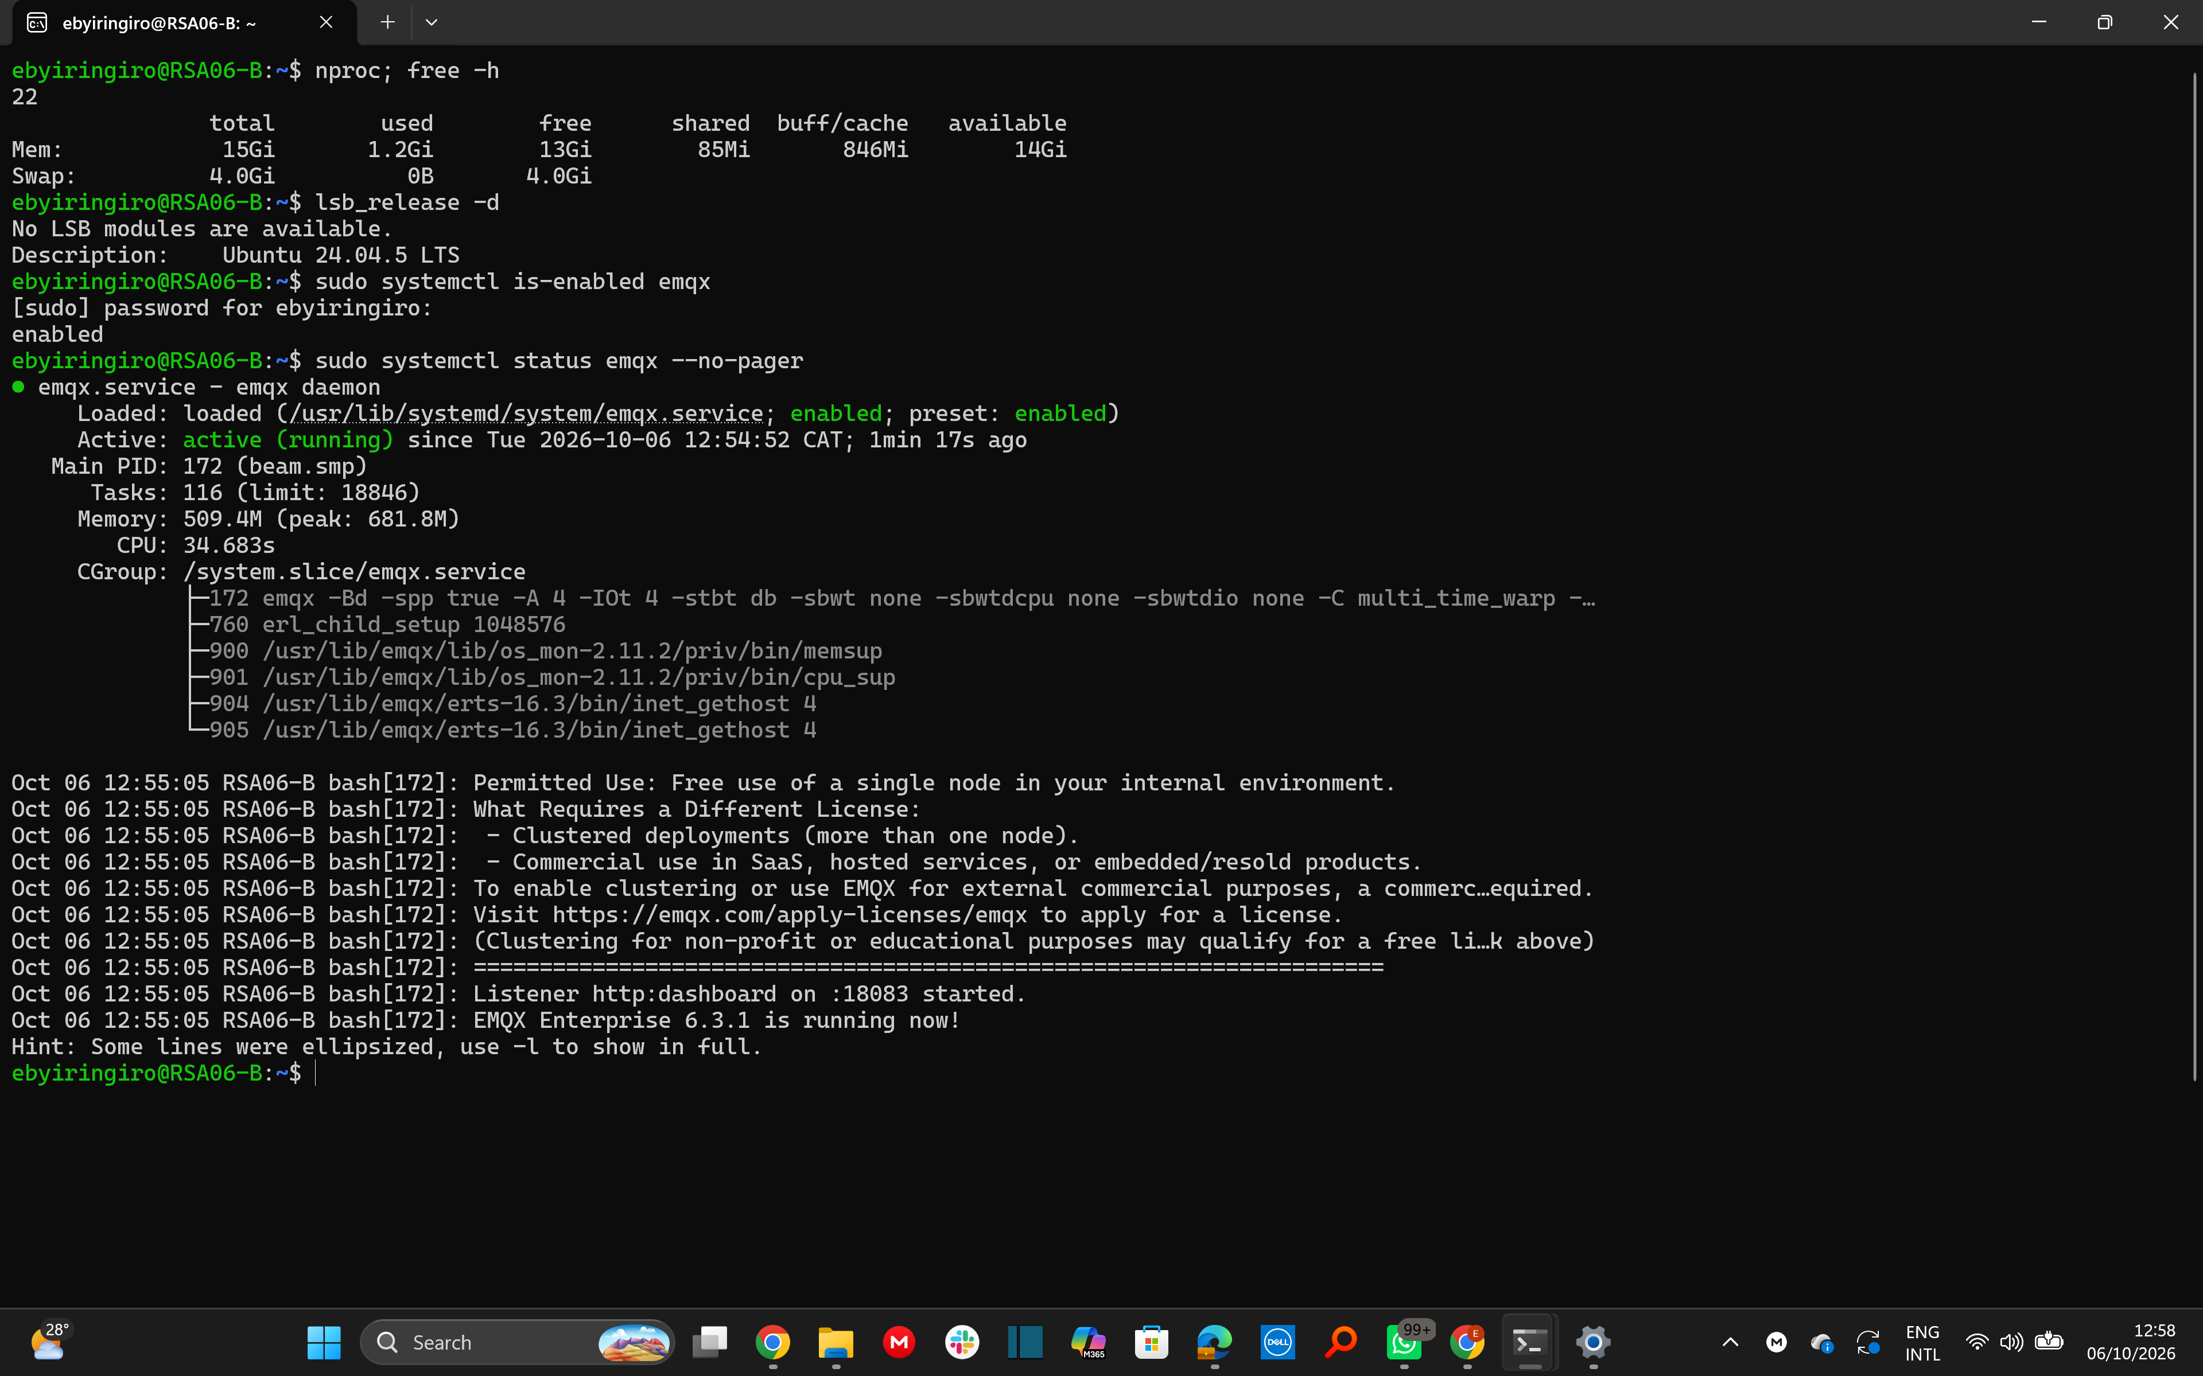
Screenshot 1.1-8 (1-1-7-wsl-resources-emqx-service.png)

Screenshot 1.1-9 (1-1-8-wsl-windows-clock-match.png)

1.2 Create the database structures
energy_live is a regular table. energy_readings is a TimescaleDB hypertable partitioned by event_time with one-day chunks (29 chunks, 2026-08-31 02:00 to 2026-09-29 02:00 CAT). Both reading tables have the same eight columns and allow duplicates at this stage. energy_readings has two indexes: (event_time DESC) and (meter_id, event_time). The meters table (meter_id primary key) was filled by load_meters.py, which imports smart_meter_simulator, calls meter_metadata() and inserts each dictionary; it holds 4,000 rows.
Data dictionary
Table | Column | PostgreSQL type | Meaning | Unit
energy_live, energy_readings | meter_id | BIGINT | Meter identifier (1000000000 to 1000003999) | -
energy_live, energy_readings | event_time | TIMESTAMPTZ | Start of the 15-minute reading interval | CAT, +02:00
energy_live, energy_readings | received_time | TIMESTAMPTZ | Simulated arrival time of the reading (not insertion time) | CAT, +02:00
energy_live, energy_readings | power_kw | DOUBLE PRECISION | Average power over the interval | kW
energy_live, energy_readings | voltage_v | DOUBLE PRECISION | Voltage | V
energy_live, energy_readings | current_a | DOUBLE PRECISION | Current | A
energy_live, energy_readings | frequency_hz | DOUBLE PRECISION | Grid frequency | Hz
energy_live, energy_readings | energy_kwh | DOUBLE PRECISION | Energy in the interval, about power_kw x 0.25 h | kWh
meters | meter_id | BIGINT (primary key) | Meter identifier | -
meters | region | TEXT | Region 1 to Region 10 (400 meters each) | -
meters | customer_type | TEXT | residential, commercial or industrial | -
meters | base_power_kw | DOUBLE PRECISION | Base power level of the meter | kW
meters | power_factor | DOUBLE PRECISION | Power factor (0.95) | none

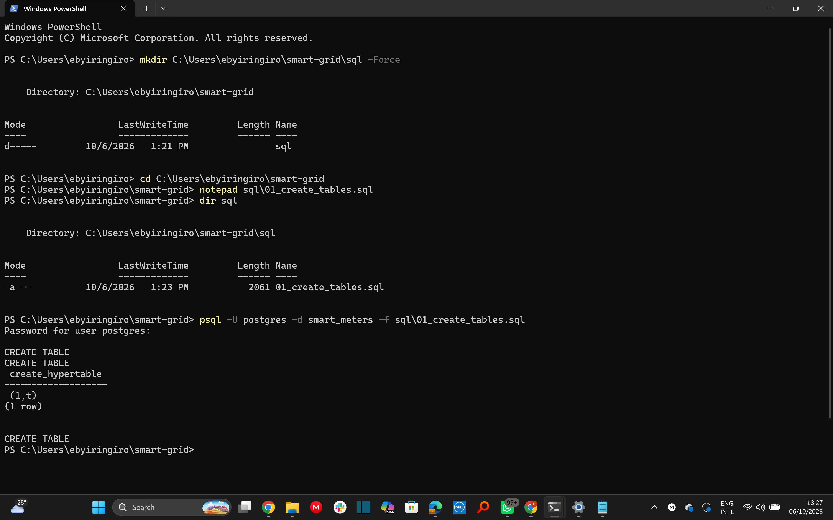
Screenshot 1.2-1 (1-1-2-1-run_create_tables_script.png)
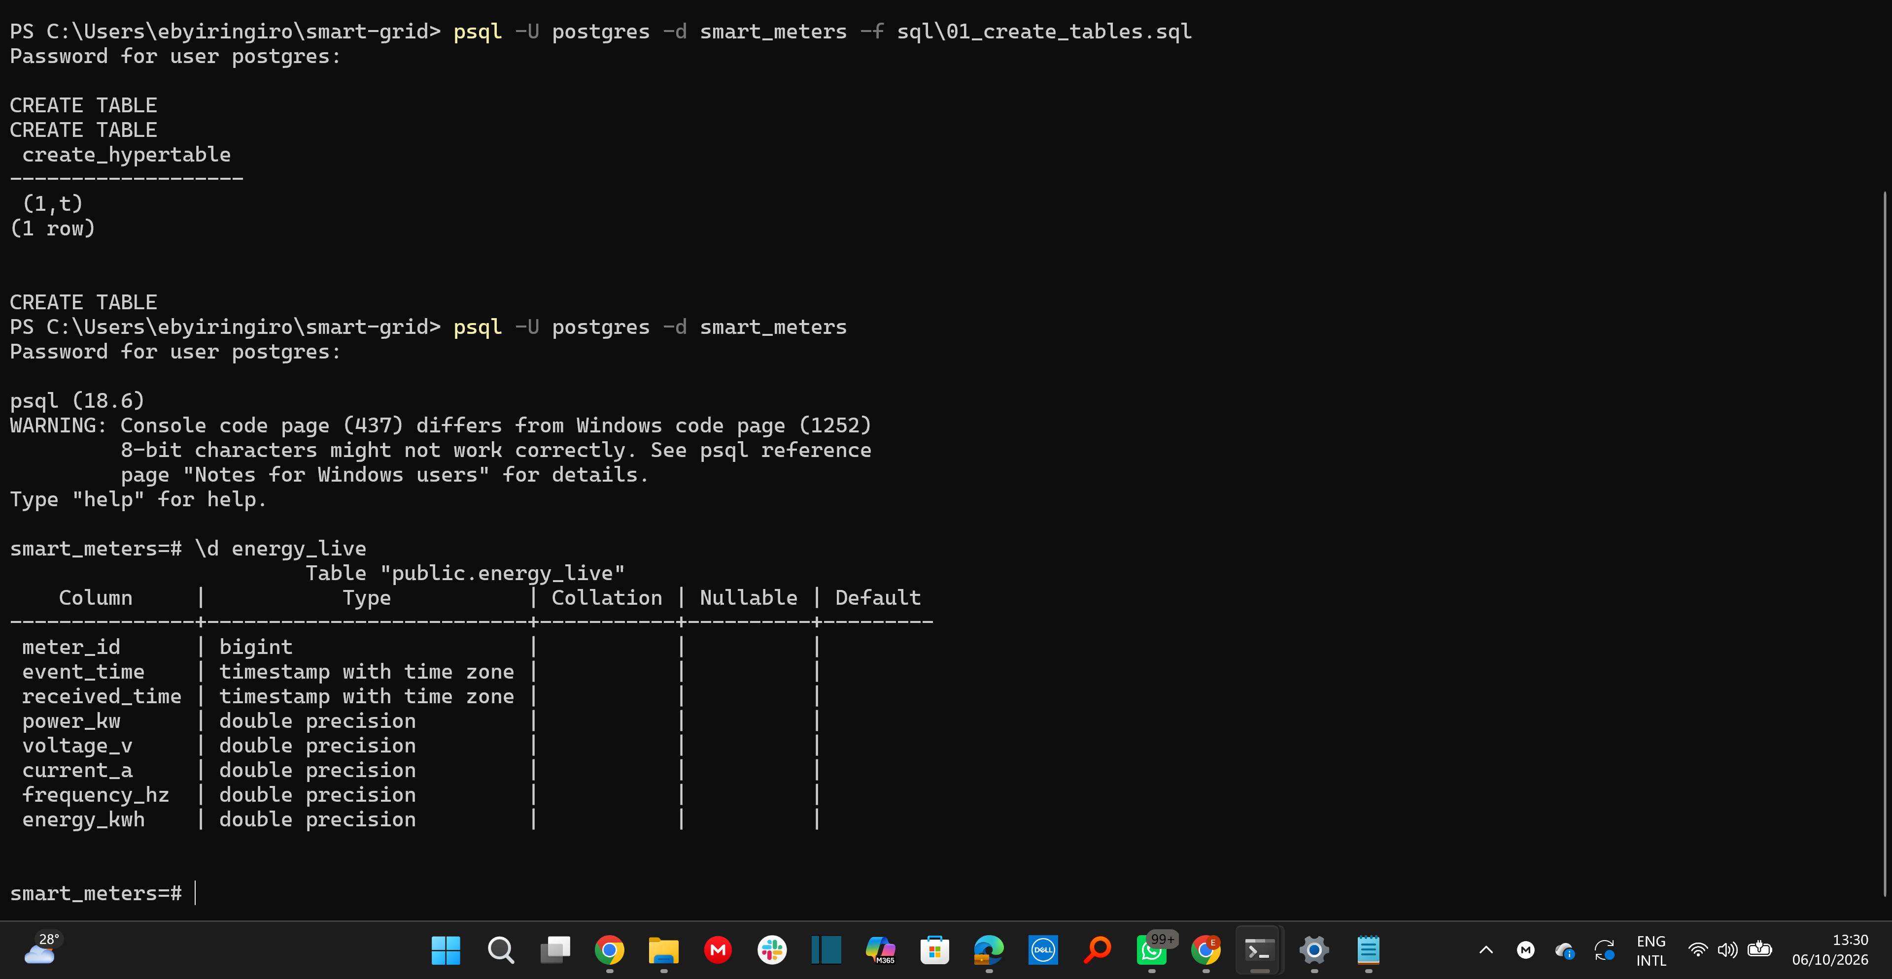
Screenshot 1.2-2 (1-1-2-2-describe_energy_live.png)
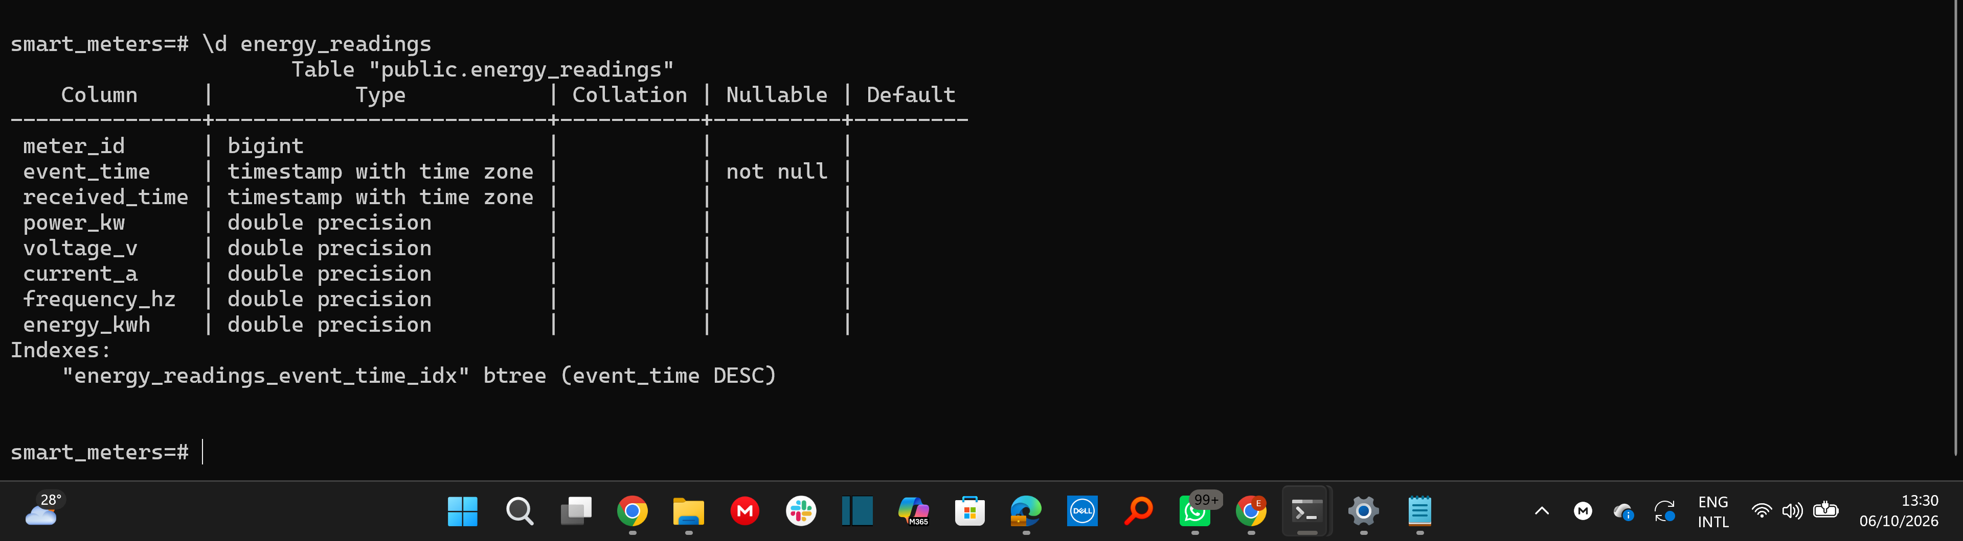
Screenshot 1.2-3 (1-1-2-2-describe_energy_readings.png)
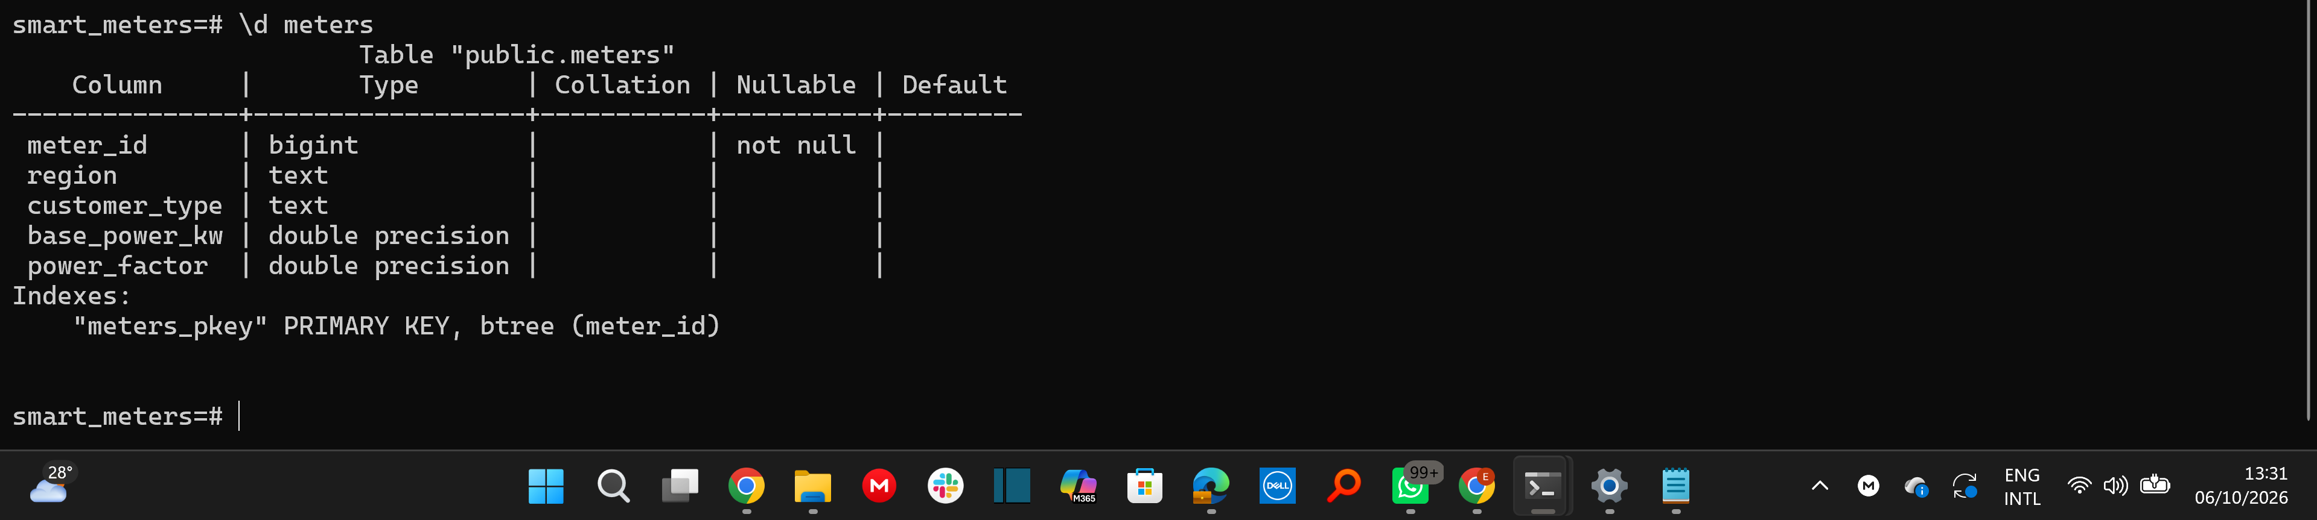
Screenshot 1.2-4 (1-1-2-3-describe_meters.png)
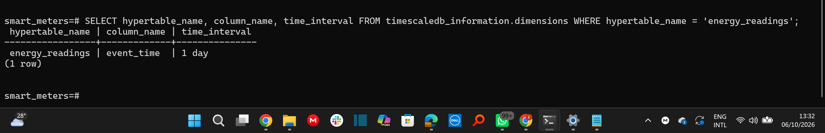
Screenshot 1.2-5 (1-2-5-chunk-interval.png)

Screenshot 1.2-6 (1-1-2-5-confirming 4,000 metadata rows.png)
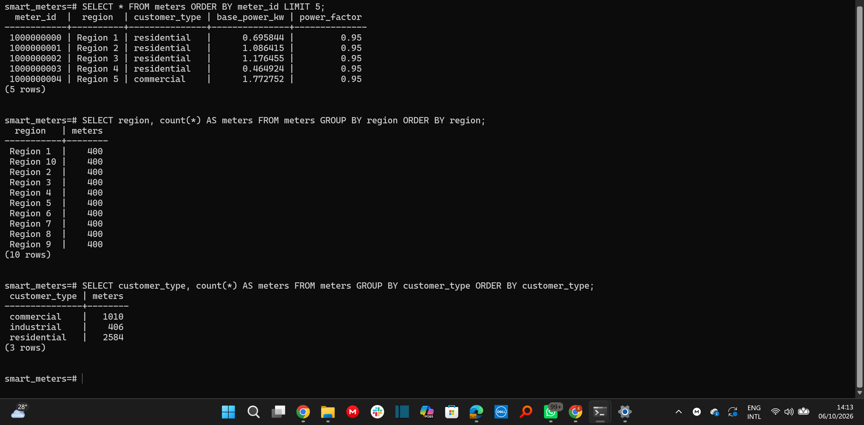
Screenshot 1.2-7 (1-1-2-6-Sample data.png)
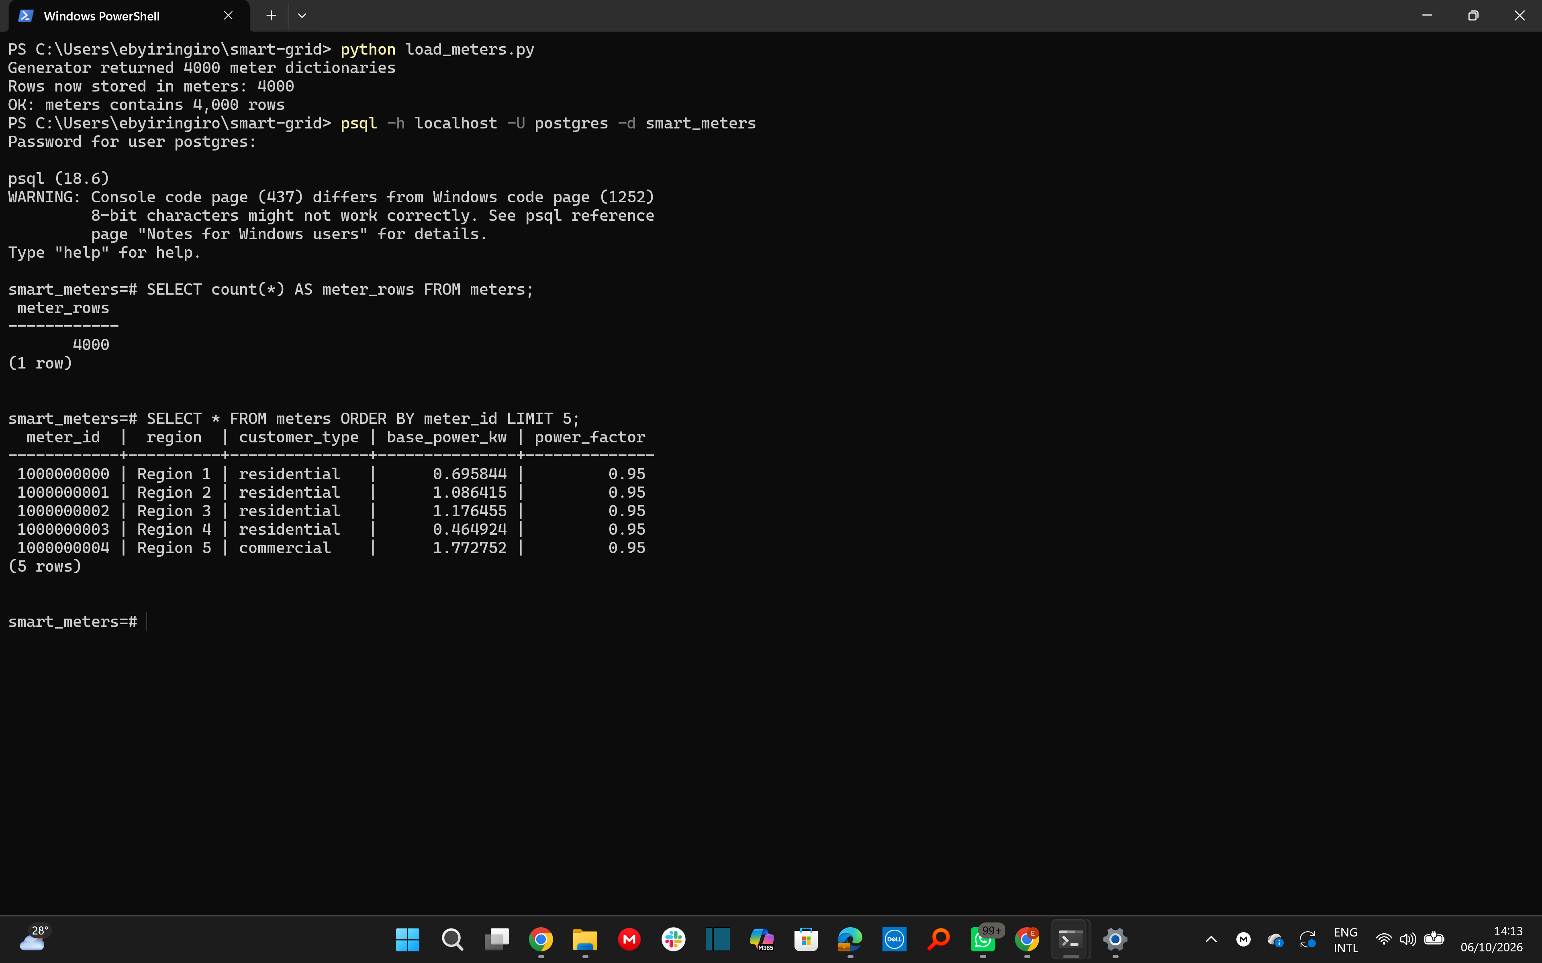
Screenshot 1.2-8 (1-1-2-7-Group by.png)

1.3 Capture and publish a pilot stream
pilot_publisher.py imports the unchanged generator, takes the first 2,000 dictionaries from iter_readings(), converts each to JSON and publishes one message to energy/meters/{meter_id} with MQTT QoS 1 and no retained messages. pilot_subscriber.py subscribes to energy/meters/# at QoS 1, parses each JSON message and inserts its eight fields into energy_live. energy_live was empty and the subscriber was started before the publisher.
Pilot counts (target: 2,000 at every stage)
Stage | Target | Run 1 | Final run
Dictionaries taken from the generator | 2,000 | 2,000 | 2000
Messages acknowledged by the broker | 2,000 | 1,876 | 2000
Messages received by the subscriber | 2,000 | 1,876 (124 missing) | 2000
Rows in energy_live | 2,000 | 1,753 | 2,000 (query on 12 Oct 2026)

Observation (run 1). On 12 Oct 2026 (publisher from 11:32:12, subscriber to 11:32:29 CAT) analyse_losses.py compared the publisher and subscriber logs. 124 of the 2,000 sent messages were missing at the subscriber, in 12 runs of consecutive send positions between 778 and 999 (for example 778-784, 833-844, 851-872 and 955-980). There were 0 arrivals without a matching send, so there was no redelivery or duplicate effect.
Cause and correction. State (a) what the logs showed was the cause of the 124 lost messages and (b) what you changed before the final run (the final run used 0.005 s pacing per message). Paste the log lines to Claude and ask for a paragraph if you want help wording it.
Do not write a cause you did not verify.
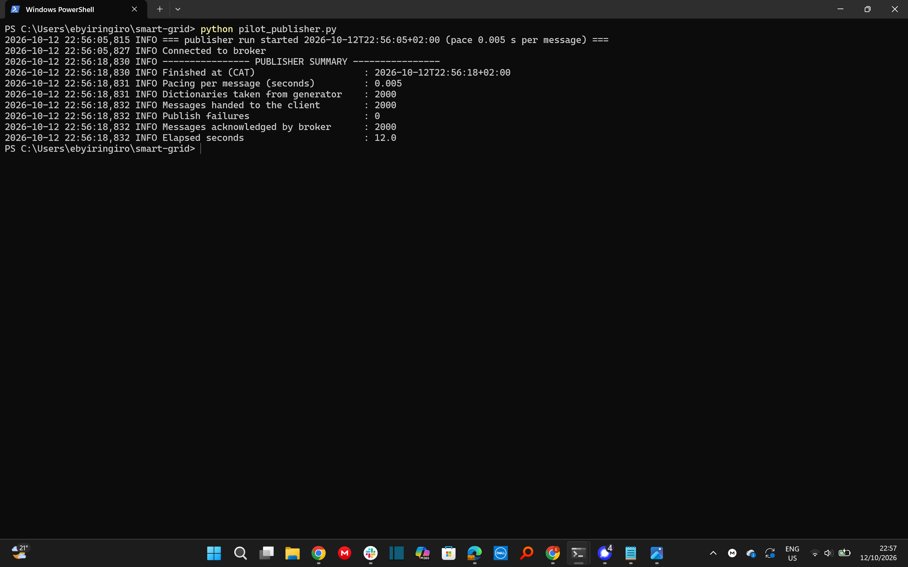
Screenshot 1.3-1 (Screenshot 2026-10-12 225743.png)
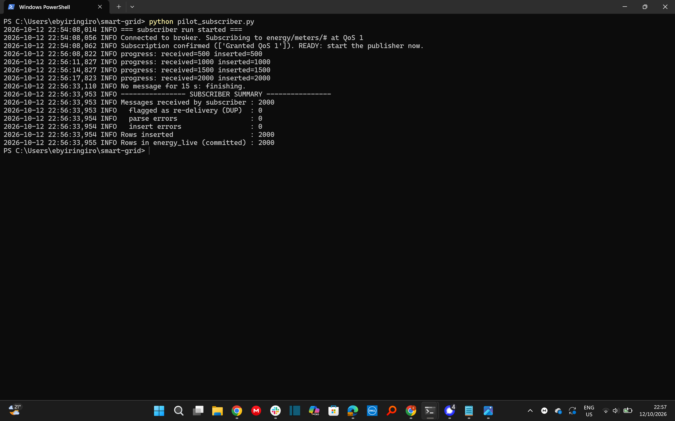
Screenshot 1.3-2 (Screenshot 2026-10-12 225731.png)
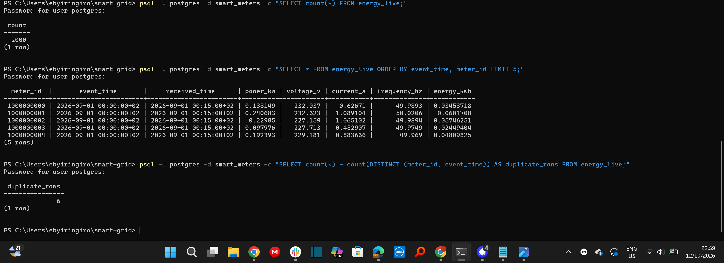
Screenshot 1.3-3 (Screenshot 2026-10-12 230006.png)
Screenshot 1.3-4 (Screenshot 2026-10-12 230108.png)

2 Capture and prepare the historical dataset

2.1 Capture and load the complete stream
Route: CSV + COPY. capture_to_csv.py iterates iter_readings() progressively and writes data\readings.csv; load_csv.py reads the file in 16 MB pieces and bulk-loads it into the empty energy_readings hypertable, including duplicates. The pilot rows remain in energy_live.
Check | Value
Planned readings (dataset_info) | 10,752,000
expected_counts.emitted_readings | 10,696,848
Dictionaries consumed from the generator | 10,696,848
Rows committed to energy_readings | 10,696,848
Data rows in the CSV file | 10,696,848 (plus 1 header row)
Generation (start 2026-10-12 20:18:03, end 20:19:38 CAT) | 95.4 s
Database load (start 2026-10-12 21:53:02, end 22:00:26 CAT) | 444.2 s
Active total (generation + load) | 539.6 s
Wall-clock span, first generation to final commit | 6,143 s (the two steps ran separately; about 93 minutes of this was idle time between them)

All three counts (consumed, committed and expected) agree at 10,696,848 before cleaning.
Database checks on energy_readings: 4,000 distinct meters; earliest event_time 2026-09-01 00:00:00+02; latest 2026-09-28 23:45:00+02 (these limits were re-checked after cleaning in 3.1).Size of energy_readings including all chunks, measured after cleaning (the pre-cleaning size was not captured): data 950.9 MB, indexes 405.8 MB, total 1,356.7 MB.
Screenshot 2.1-1 (Screenshot 2026-10-12 201956.png)
Screenshot 2.1-2 (Screenshot 2026-10-12 220117.png)

2.2 Investigate data quality
Entry | Reference | Measured | Percentage
planned_readings | 10,752,000 | 10,752,000 | -
emitted_readings | 10,696,848 | 10,696,848 | -
unique_readings | 10,643,735 | 10,643,735 | completeness 98.9931%
duplicate_readings (extra copies) | 53,113 | 53,113 | 0.4990% of unique pairs
delayed_unique_readings | 213,090 | 213,090 | 2.0020% of unique pairs
missing_readings | 108,265 | 108,265 | 1.0069% of planned

Consistency checks: unique + extra copies = 10,643,735 + 53,113 = 10,696,848 = emitted readings; planned - unique = 10,752,000 - 10,643,735 = 108,265 = missing readings.
The Measured column matches the 2.2 screenshots: every measured count equals its reference value.
Five meters with the most missing readings
missing 1.0069%, duplicates 0.4990%, delayed 2.0020%, completeness 98.9931%
Screenshot 2.2-1 (Screenshot 2026-10-12 222714.png)
Screenshot 2.2-2 (Screenshot 2026-10-12 222736.png)

2.3 Clean and preserve a consistent benchmark
Rows sharing meter_id and event_time were compared on received_time, power_kw, voltage_v, current_a, frequency_hz and energy_kwh. Exact copies were reduced to one row by sql\03_clean_duplicates.sql (repeatable). Missing intervals were kept as gaps.
Measure | Before cleaning | After cleaning
Row count | 10,696,848 | 10,643,735
Rows deleted | - | 53,113
Sum of energy_kwh | 3,872,863.89 kWh | 3,853,704.3468
Duplicate (meter_id, event_time) pairs | 53,113 extra copies (pairs affected not separately recorded) | 0

The final row count equals expected_counts.unique_readings (10,643,735). All 53,113 extra copies were exact duplicates (the conflict query returned 0 conflicting pairs), so one row per pair was kept and the rest deleted; no duplicate pair remains.
Why missing readings are not zero. A missing reading means no measurement arrived, not that the meter used no energy. Replacing gaps with zero would invent consumption of exactly 0 kWh, bias totals and averages downward and hide communication faults. Gaps are therefore reported as missing and counted in completeness.
Screenshot 2.3-1 (Screenshot 2026-10-12 224232.png)
Screenshot 2.3-2 (Screenshot 2026-10-12 224308.png)

3 Compare chunk intervals

3.1 Create and verify three configurations
Table | Chunk interval | Chunks | First chunk start | Last chunk end
energy_readings | 1 day | 29 | 2026-08-31 02:00 +02 | 2026-09-29 02:00 +02
energy_readings_3h | 3 hours | 225 | 2026-08-31 23:00 +02 | 2026-09-29 02:00 +02
energy_readings_week | 7 days | 5 | 2026-08-27 02:00 +02 | 2026-10-01 02:00 +02

Each table has two matching non-unique indexes: (event_time DESC) and (meter_id, event_time).
Table | Rows | Meters | Earliest | Latest | sum(power_kw) | sum(energy_kwh) | Diff kW / kWh vs daily
energy_readings | 10,643,735 | 4,000 | 2026-09-01 00:00 | 2026-09-28 23:45 | 15,414,817.3878 | 3,853,704.3468 | 0 / 0
energy_readings_3h | 10,643,735 | 4,000 | 2026-09-01 00:00 | 2026-09-28 23:45 | 15,414,817.3878 | 3,853,704.3468 | 1.9e-9 / 1.4e-9
energy_readings_week | 10,643,735 | 4,000 | 2026-09-01 00:00 | 2026-09-28 23:45 | 15,414,817.3878 | 3,853,704.3468 | 2.0e-8 / 3.3e-9

All three tables pass: 10,643,735 rows, 4,000 meters, identical dates and sums within the 0.001 tolerance.
Screenshot 3.1-1 (Screenshot 2026-10-13 112818.png)
Screenshot 3.1-2 (Screenshot 2026-10-13 112839.png)
Screenshot 3.1-3 (Screenshot 2026-10-13 113242.png)
Screenshot 3.1-4 (Screenshot 2026-10-13 113301.png)

3.2 Implement and time the five workloads
Query | Workload
Q1 | Average power_kw per CAT hour on 21 September across all meters (24 rows)
Q2 | Ten 15-minute intervals from 22 to 28 September with the highest summed power_kw, ties included
Q3 | Total energy per meter over the full period (4,000 rows)
Q4 | Energy total, average power and peak power for meter 1000000000, 22 to 28 September
Q5 | Full scan: row count, total energy, average, minimum and maximum power

Method: one machine (RSA06-B), one client (benchmark.py using Python 3.13.6 and psycopg 3.3.6), PostgreSQL never restarted and no cache cleared. Each query and table had one warm-up and five measured executions, timed from statement submission to the last result row received. All results are therefore warm-cache measurements. Results were checked against the one-day table (all matched within 0.001). Per-run CAT start and end times, durations and machine identifier are in results\benchmark_chunks_runs.csv.
Timing tool: time.perf_counter() around cursor.execute() and fetchall(), client Python 3.13.6 with psycopg 3.3.6. The session ran 38.1 s from the first warm-up submission to the last measured result.
Query | 1 day: median (min-max) ms | 3 hours: median (min-max) ms | 1 week: median (min-max) ms
Q1 | 71.1 (61.2-179.6) | 76.6 (74.1-80.7) | 77.5 (68.1-184.3)
Q2 | 147.0 (138.6-161.6) | 163.5 (143.4-201.0) | 202.6 (188.3-226.2)
Q3 | 583.7 (535.3-618.9) | 3,019.5 (2,957.4-3,065.3) | 537.8 (509.0-556.6)
Q4 | 2.7 (2.0-3.7) | 8.4 (7.1-9.4) | 2.2 (1.4-2.9)
Q5 | 401.6 (391.0-451.2) | 365.1 (330.6-394.5) | 411.7 (399.3-440.3)

Execution plans with actual timing and buffer statistics for each configuration are in the screenshots below (sql\06_explain_q1.sql).
Screenshot 3.2-1 (Screenshot 2026-10-13 114407.png)
Screenshot 3.2-2 (Screenshot 2026-10-13 114543.png)
Screenshot 3.2-3 (Screenshot 2026-10-13 114608.png)
Screenshot 3.2-4 (Screenshot 2026-10-13 114719.png)
Screenshot 3.2-5 (Screenshot 2026-10-13 114746.png)
Screenshot 3.2-6 (Screenshot 2026-10-13 114838.png)
Screenshot 3.2-7 (Screenshot 2026-10-13 114929.png)
Screenshot 3.2-8 (Screenshot 2026-10-13 120218.png)

3.3 Explain the chunk results
Observation = measured medians. Explanation = our reasoning about the cause; where no plan was captured the explanation is a hypothesis.
Q1 - fastest: 1 day (71.1 ms). 3 hours was 7.7% slower (76.6 ms) and 1 week 9.0% slower (77.5 ms); the differences are small and the 1-day and 1-week maxima (179.6 and 184.3 ms) show run-to-run noise. Explanation: Q1 filters a single day, which maps to one 1-day chunk, eight 3-hour chunks or one weekly chunk holding 7 days of data.
Q2 - fastest: 1 day (147.0 ms). 3 hours was 11.2% slower (163.5 ms) and 1 week 37.8% slower (202.6 ms). Explanation: the 22-28 September filter touches 7 daily chunks, 56 three-hour chunks, or 2 weekly chunks (weekly boundaries fall on 17 and 24 September, so those two chunks cover 14 days for 7 requested), so weekly chunks read and filter about twice the needed rows.
Q3 - fastest: 1 week (537.8 ms). 1 day was 8.5% slower (583.7 ms) and 3 hours 5.6 times slower (3,019.5 ms; 5.2 times the daily time). Explanation (hypothesis, no plan captured): a full scan touches all 225 three-hour chunks, so per-chunk overhead and merging of 225 partial aggregates over 4,000 meters dominates.
Q4 - fastest: 1 week (2.2 ms). 1 day was 22.7% slower (2.7 ms) and 3 hours 3.8 times slower (8.4 ms). Explanation: the (meter_id, event_time) index makes the query cheap, so planning and chunk-exclusion overhead, which grows with the number of chunks touched (56 for 3 hours, 7 daily, 2 weekly), is the main cost; absolute differences are at most 6.2 ms.
Q5 - fastest: 3 hours (365.1 ms). 1 day was 10.0% slower (401.6 ms) and 1 week 12.8% slower (411.7 ms). Explanation (hypothesis): with 11 parallel workers allowed, many small chunks share the scan more evenly than five large weekly chunks.
Overall: no single interval wins every workload. The one-day interval is the best compromise (fastest on Q1 and Q2, within 10% on Q3 and Q5, and 0.5 ms from the best on Q4) and was used as the baseline for Section 4.

4 Compare compression strategies

4.1 Create the two compressed configurations
Table | Chunk interval | Order by | Segment by
energy_time_compressed | 1 day | event_time DESC | none
energy_meter_compressed | 1 day | event_time DESC | meter_id

The one-day interval was chosen from Section 3. Both tables have the same eight columns and matching indexes. A compression policy for chunks whose end is more than 48 hours old was added to each table and paused until the 4.3 measurements were complete. Experiment start: 2026-10-13 20:55:26 CAT; cutoff (start - 48 h): 2026-10-11 20:55:26 CAT, the same for both tables. compress_load.py copied the cleaned data one chunk at a time; after each chunk was fully loaded it was compressed manually because its end preceded the cutoff, and load and compression were timed separately (results\compression_load_log.csv).
All 29 chunks of both tables were compressed (every chunk ends before the cutoff), covering the same time ranges. Load time was 209.9 s (time-ordered) and 204.3 s (meter-segmented), excluded from compression cost. Data checks on both new tables passed: 10,643,735 rows, 4,000 meters, earliest event_time 2026-09-01 00:00:00+02, latest 2026-09-28 23:45:00+02, power sum difference below 0.000001 kW and energy difference 0 kWh against the daily table (all_checks_pass = true). (First look at screenshot 211028 and confirm it shows both new tables.)
Screenshot 4.1-1 (Screenshot 2026-10-13 205227.png)
Screenshot 4.1-2 (Screenshot 2026-10-13 205249.png)
Screenshot 4.1-3 (Screenshot 2026-10-13 205304.png)
Screenshot 4.1-4 (Screenshot 2026-10-13 210420.png)
Screenshot 4.1-5 (Screenshot 2026-10-13 210938.png)
Screenshot 4.1-6 (Screenshot 2026-10-13 210954.png)
Screenshot 4.1-7 (Screenshot 2026-10-13 211028.png)

4.2 Measure storage and compression cost
Table | Data MB | Index MB | Total MB | Ratio | Saved % | Compress s | Compressed chunks | Rows in compressed %
energy_readings (baseline) | 950.9 | 405.8 | 1,356.7 | - | - | - | - | -
energy_time_compressed | 437.8 | 0.9 | 438.7 | 3.09 | 67.7 | 32.3 | 29 of 29 | 100.00
energy_meter_compressed | 496.1 | 5.5 | 501.6 | 2.70 | 63.0 | 58.3 | 29 of 29 | 100.00

Ratio = baseline total / compressed total; Saved % = 100 x (baseline - compressed) / baseline; compression cost is the sum of the measured chunk compression times, excluding loading.
Screenshot 4.2-1 (Screenshot 2026-10-13 210420.png)
Screenshot 4.2-2 (Screenshot 2026-10-13 210432.png)
Screenshot 4.2-3 (Screenshot 2026-10-13 211009.png)

4.3 Repeat the query comparison
Query | 1 day | 3 hours | 1 week | time-ordered | meter-segmented
Q1 | 114.4 (110.6-194.9) | 121.7 (117.8-214.0) | 131.4 (121.8-191.2) | 139.6 (91.9-203.0) | 639.4 (636.3-662.7)
Q2 | 275.1 (236.7-291.5) | 256.8 (239.7-295.8) | 312.8 (308.5-372.1) | 240.6 (204.0-270.5) | 190.9 (179.2-201.0)
Q3 | 1,085.9 (989.8-1,165.4) | 7,632.7 (7,507.2-7,861.3) | 825.4 (753.1-832.0) | 396.9 (363.4-401.9) | 285.6 (259.8-300.1)
Q4 | 3.9 (3.3-4.8) | 16.1 (13.5-19.2) | 4.3 (3.4-7.0) | 131.6 (126.4-185.1) | 8.0 (4.9-8.3)
Q5 | 566.6 (544.9-584.0) | 563.8 (550.1-566.7) | 623.1 (610.8-637.5) | 245.6 (236.8-260.0) | 359.9 (351.3-394.2)

Median (min-max) in ms, warm cache, results matched the reference for every query and table.
Query | Baseline (1 day) ms | time-ordered ms | Improvement % | meter-segmented ms | Improvement %
Q1 | 114.4 | 139.6 | -22.0 | 639.4 | -458.9
Q2 | 275.1 | 240.6 | +12.5 | 190.9 | +30.6
Q3 | 1,085.9 | 396.9 | +63.4 | 285.6 | +73.7
Q4 | 3.9 | 131.6 | -3,274.4 | 8.0 | -105.1
Q5 | 566.6 | 245.6 | +56.7 | 359.9 | +36.5

Improvement % = 100 x (baseline median - compressed median) / baseline median; positive means faster. The sum of the five medians is 2,045.9 ms (baseline), 1,154.3 ms (time-ordered) and 1,483.8 ms (meter-segmented).
Compression policies were resumed after the measurements; both show as enabled (jobs 1000 and 1001, next run 2026-10-14 21:20 CAT at the time of the pause/resume check).
Screenshot 4.3-1 (Screenshot 2026-10-13 211358.png)
Screenshot 4.3-2 (Screenshot 2026-10-13 211412.png)
Screenshot 4.3-3 (Screenshot 2026-10-14 100413.png)
Screenshot 4.3-4 (Screenshot 2026-10-13 211731.png)
Screenshot 4.3-5 (Screenshot 2026-10-13 211746.png)
Screenshot 4.3-6 (Screenshot 2026-10-13 211803.png)
Screenshot 4.3-7 (Screenshot 2026-10-13 211821.png)
Screenshot 4.3-8 (Screenshot 2026-10-13 211900.png)
Screenshot 4.3-9 (Screenshot 2026-10-13 211921.png)
Screenshot 4.3-10 (Screenshot 2026-10-13 212211.png)

4.4 Select a storage configuration
Effect of meter segmentation (meter-segmented versus time-ordered table)
Workload | meter-segmented ms | time-ordered ms | Effect
Q4 single meter | 8.0 | 131.6 | 93.9% faster
Q1 all meters, one day | 639.4 | 139.6 | 358.0% slower
Q2 all meters, 7 days | 190.9 | 240.6 | 20.7% faster
Q3 all meters, full period | 285.6 | 396.9 | 28.0% faster
Q5 full scan | 359.9 | 245.6 | 46.5% slower

The single-meter workload gains most from segmentation because the segment key lets the engine read one batch per chunk instead of decompressing about 94,000 rows per chunk and filtering (plans: 27.8 ms against 315.5 ms execution; those plan runs were not fully warm, so use them for structure and the medians for speed). Workloads across all meters gain or lose depending on whether they aggregate over time (Q2, Q3 faster) or must touch every segment of one day or the whole table (Q1, Q5 slower).
Recommendation. Use 1-day chunks with columnstore compression ordered by event_time DESC and segmented by meter_id.
Evidence. Total size 501.6 MB against 1,356.7 MB uncompressed (2.70 times, 63.0% saved); Q4 8.0 ms against 131.6 ms for the time-ordered table (3.9 ms uncompressed); Q3 285.6 ms against 1,085.9 ms uncompressed.
Tradeoff. Compression took 58.3 s against 32.3 s (1.80 times), the table is 14.3% larger than the time-ordered one (501.6 against 438.7 MB), Q1 is 5.6 times slower than uncompressed (639.4 against 114.4 ms) and the five medians sum to 1,483.8 ms against 1,154.3 ms for the time-ordered table. Stated assumption: per-meter drill-downs matter and the Section 6 aggregates serve network-wide queries; if network-wide scans dominated, the time-ordered table would be the better choice.

5 Investigate the utility data

5.1 Identify demand patterns
Total network energy per CAT day (kWh), sum of energy_kwh
Day |  | kWh | Day |  | kWh
01 Sep | Tue | 141,195.24 | 02 Sep | Wed | 141,533.90
03 Sep | Thu | 141,938.49 | 04 Sep | Fri | 142,301.48
05 Sep | Sat | 111,680.48 | 06 Sep | Sun | 111,950.74
07 Sep | Mon | 143,598.74 | 08 Sep | Tue | 144,127.00
09 Sep | Wed | 144,519.80 | 10 Sep | Thu | 144,818.08
11 Sep | Fri | 145,348.89 | 12 Sep | Sat | 114,025.49
13 Sep | Sun | 114,264.09 | 14 Sep | Mon | 146,611.63
15 Sep | Tue | 147,144.62 | 16 Sep | Wed | 147,508.12
17 Sep | Thu | 147,968.92 | 18 Sep | Fri | 148,320.20
19 Sep | Sat | 116,242.45 | 20 Sep | Sun | 116,493.00
21 Sep | Mon | 149,552.72 | 22 Sep | Tue | 150,056.53
23 Sep | Wed | 150,430.65 | 24 Sep | Thu | 150,800.61
25 Sep | Fri | 151,190.78 | 26 Sep | Sat | 118,623.96
27 Sep | Sun | 118,993.60 | 28 Sep | Mon | 152,464.16

Seven-day period | Energy (kWh)
01-07 Sep | 934,199.06
08-14 Sep | 953,714.97
15-21 Sep | 973,230.03
22-28 Sep | 992,560.29

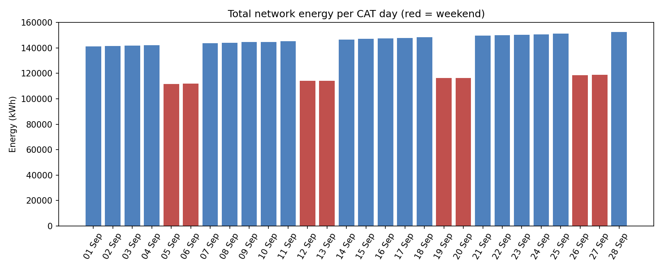
Total network energy per CAT day (red = weekend)
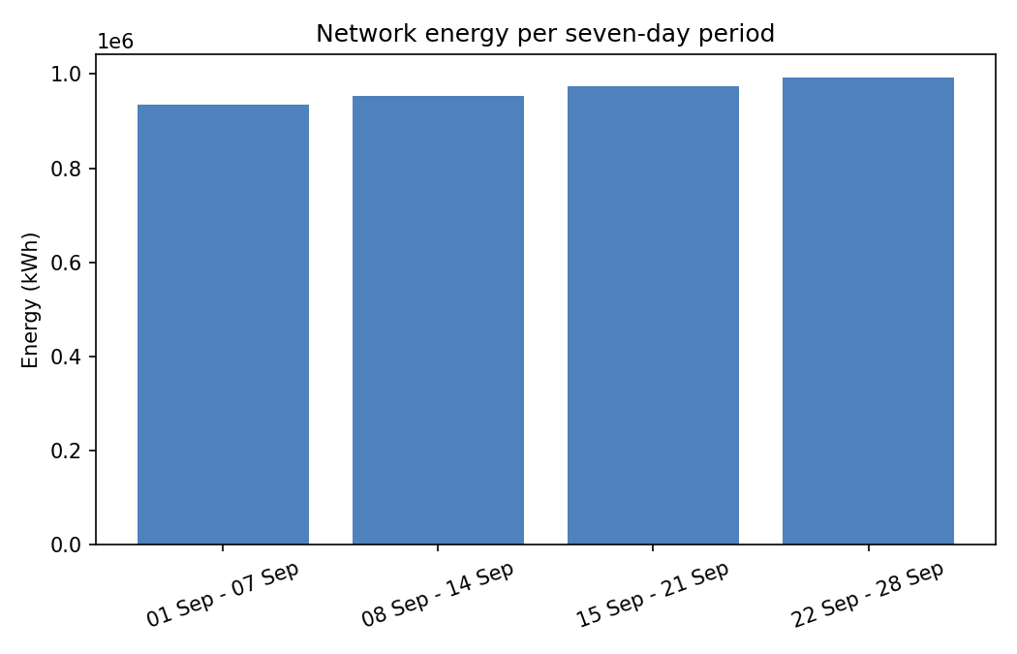
Network energy per seven-day period
Three highest 15-minute network demand intervals (sum of power_kw across meters)
Interval start (CAT) | Demand (kW) | Readings in interval
2026-09-28 13:00 | 7,993.69 | 3,965
2026-09-28 12:45 | 7,943.95 | 3,969
2026-09-28 13:15 | 7,943.64 | 3,952

Average network demand by CAT hour, weekday against weekend
Patterns. Weekday energy rises about 0.3% per day and the seven-day totals grow about 2% a week (934,199 to 992,560 kWh, +6.2% over four weeks). Weekend days are about 21% lower (for example 111,680 kWh on Saturday 5 September against 141,195 kWh on Tuesday 1 September). Weekday demand averages 7,618 kW at 13:00 and falls to about 4,400 kW overnight; weekends peak later and lower (5,963 kW at 18:00).
Operational implications. All three peaks fall on Monday 28 September between 12:45 and 13:15, consistent with the weekday midday profile and the growth trend. Capacity and storage should be sized against the weekday midday kW peak, whose headroom shrinks about 2% a week; overnight base load is about 58% of the peak. The peak intervals have 3,952-3,969 of 4,000 readings, so missing readings slightly understate them.
kW versus kWh. kW is power, the rate of use at an instant (here averaged over 15 minutes); kWh is energy, power multiplied by time. A 15-minute interval at 7,993.69 kW is about 1,998 kWh. Capacity is limited by kW, while consumption and billing use kWh.
Screenshot 5.1-1 (Screenshot 2026-10-14 110452.png)
Screenshot 5.1-2 (Screenshot 2026-10-14 110512.png)

5.2 Compare regions and customer types
Region | Meters | Total kWh | kWh per meter
Region 1 | 400 | 383,539.81 | 958.85
Region 2 | 400 | 378,448.89 | 946.12
Region 3 | 400 | 392,376.59 | 980.94
Region 4 | 400 | 324,404.48 | 811.01
Region 5 | 400 | 411,040.39 | 1,027.60
Region 6 | 400 | 346,512.84 | 866.28
Region 7 | 400 | 362,288.54 | 905.72
Region 8 | 400 | 503,475.83 | 1,258.69
Region 9 | 400 | 400,467.20 | 1,001.17
Region 10 | 400 | 351,149.78 | 877.87

Customer type | Meters | Total kWh | kWh per meter
commercial | 1,010 | 825,475.15 | 817.30
industrial | 406 | 2,220,672.04 | 5,469.64
residential | 2,584 | 807,557.16 | 312.52

Region x customer type: meters and kWh per meter
Region | comm. meters | ind. meters | res. meters | comm. kWh/m | ind. kWh/m | res. kWh/m
Region 1 | 116 | 37 | 247 | 821.3 | 5,726.3 | 309.3
Region 2 | 98 | 39 | 263 | 834.7 | 5,466.1 | 317.4
Region 3 | 94 | 46 | 260 | 807.7 | 5,141.0 | 307.6
Region 4 | 94 | 29 | 277 | 762.6 | 5,670.3 | 318.7
Region 5 | 94 | 48 | 258 | 826.6 | 5,315.7 | 303.1
Region 6 | 105 | 32 | 263 | 833.2 | 5,550.8 | 309.5
Region 7 | 103 | 35 | 262 | 794.4 | 5,641.9 | 316.8
Region 8 | 105 | 61 | 234 | 862.5 | 5,549.7 | 317.9
Region 9 | 96 | 45 | 259 | 826.4 | 5,380.9 | 305.0
Region 10 | 105 | 34 | 261 | 798.8 | 5,405.2 | 319.9

What remains after normalization. Customer type dominates: industrial meters are 10.2% of meters but use 57.6% of energy (5,470 kWh per meter against 313 for residential, about 17 times). Regions still differ per meter (Region 8 1,258.69 kWh, Region 4 811.01 kWh), but this is largely a customer-mix effect: Region 8 has 61 industrial meters (15.3%) against 29 (7.3%) in Region 4, and within each customer type the regions are much closer (residential 303-320, commercial 763-863, industrial 5,141-5,726 kWh per meter).
Implication. Do not read a regional gap as inherently higher demand; compare regions within a customer type and plan capacity around industrial customer counts.
Screenshot 5.2-1 (Screenshot 2026-10-14 110535.png)
Screenshot 5.2-2 (Screenshot 2026-10-14 110604.png)

5.3 Assess reporting quality
Region | Registered meters | Planned readings | Observed unique | Completeness %
Region 1 | 400 | 1,075,200 | 1,064,513 | 99.0060
Region 2 | 400 | 1,075,200 | 1,064,419 | 98.9973
Region 3 | 400 | 1,075,200 | 1,064,327 | 98.9887
Region 4 | 400 | 1,075,200 | 1,064,441 | 98.9993
Region 5 | 400 | 1,075,200 | 1,064,290 | 98.9853
Region 6 | 400 | 1,075,200 | 1,064,118 | 98.9693
Region 7 | 400 | 1,075,200 | 1,064,237 | 98.9804
Region 8 | 400 | 1,075,200 | 1,064,587 | 99.0129
Region 9 | 400 | 1,075,200 | 1,064,388 | 98.9944
Region 10 | 400 | 1,075,200 | 1,064,415 | 98.9969
NETWORK | 4,000 | 10,752,000 | 10,643,735 | 98.9931

21 September (events on that CAT day) | Energy (kWh) | Rows
Received by 00:00 on 22 September | 149,400.545 | 379,505
All arrivals | 149,552.723 | 380,036
Difference | 152.178 kWh (0.1018% of the final total) | 531

Effects. Completeness is about 99% everywhere (98.969% to 99.013%), so missing readings are spread evenly and no region is disproportionately affected. They are permanent gaps: the final total is a lower bound (21 September has 380,036 of 384,000 planned rows). Delayed readings are recoverable once they arrive, so a report issued at midnight understates the day by 0.10%.
Screenshot 5.3-1 (Screenshot 2026-10-14 110604.png)

5.4 Investigate abnormal consumption
Rule. For each customer type and event_time the reference is the mean power_kw of that group. Each meter reading is divided by that reference (removing the shared daily, weekly and growth pattern). For each meter the median ratio and the MAD (scaled by 1.4826) are computed over its own ratios; a reading is flagged when |ratio - median| / MAD > 6 (two-sided, so spikes and drops are both caught). K = 6 was fixed before the labels were loaded as a conservative cut-off; the labels were used only for evaluation.
Result (K = 6) | Value
Flagged readings | 474 (0.0045% of readings), on 40 meters
Detected events | 40 of 40
Missed events | 0 of 40
False flags (outside injected intervals) | 0 = 0.00000% of 10,643,261 observed readings
Meters with at least one false flag | 0 of 4,000 = 0.000% of meters affected by false flags
Readings inside injected intervals | 474 observed, all flagged (6 events had one missing reading: 40 x 12 = 480 planned)

Threshold K | Detected | Missed | False flags
4 | 40 | 0 | 0
5 | 40 | 0 | 0
6 (chosen) | 40 | 0 | 0
8 | 40 | 0 | 0
10 | 20 | 20 | 0

Explanation. Demand spikes scored 17.7-20.4 and unusual drops 8.5-9.2. A drop is bounded below at zero, so its deviation cannot grow like a spike's; at K = 10 exactly the 20 drop events are missed. There were no false alarms: normal readings stay below a deviation of 4 (K = 4 also gives 0 false flags), so there is a wide margin. This clean result reflects simulated data with well-behaved noise; on real data holidays, outages and new customers would cause false alarms, and an event whose readings were all missing could not be detected. The sensitivity table is for discussion only; K was not tuned on the labels.
Screenshot 5.4-1 (Screenshot 2026-10-14 111935.png)
Screenshot 5.4-2 (Screenshot 2026-10-14 111957.png)

5.5 Management recommendation
Operations. Weekday demand peaks around 13:00; the highest 15-minute interval was 7,993.69 kW on Monday 28 September, and weekly energy grew about 2% a week (934,199 to 992,560 kWh over four weeks). Plan capacity against the weekday midday peak and review headroom monthly. Weekend demand is about 21% lower, so schedule planned maintenance then. Industrial customers are 10.2% of meters but 57.6% of energy (5,470 kWh per meter against 313 for residential), so monitoring and demand-response effort should start there. Regional differences mostly reflect customer mix, so compare regions within a customer type.
Data quality. About 1.0% of planned readings never arrived and about 2.0% arrived late; network completeness was 98.99%. Report missing readings as gaps, never as zero. Figures issued at midnight understate the day slightly (21 September: 152.178 kWh, 0.10%), so label them provisional. The anomaly rule found all 40 injected events with no false flags, but this is simulated data, so run it alert-only on real data first.
Storage and reporting. Use one-day chunks with compression ordered by event_time and segmented by meter_id. It cut storage from 1,356.7 MB to 501.6 MB (2.70 times) and the single-meter query Q4 from 131.6 ms to 8.0 ms against the unsegmented compressed table. The cost is 58.3 s of compression time against 32.3 s, and network-wide Q1 ran 5.6 times slower than on the uncompressed table. For dashboards, keep the hourly and 15-minute regional aggregates: dashboard refresh fell from 1,065 ms to 108 ms (9.8 times) for 18.0 MB of storage. The daily per-meter aggregate used 70% of that storage and saved about 2 ms, so drop it unless per-meter history becomes a heavy workload.
Forecasting. Adopt the Ridge model for day-ahead hourly regional planning, keeping the previous-day baseline as a fallback. On the test week (1,680 hourly predictions) its MAE was 4.55 kWh against 42.71 kWh for the baseline (89% lower; RMSE 5.79 against 79.40 kWh). Most of the gain comes from Saturday and Monday, where the baseline copies a weekend day onto a weekday. Validate on more weeks, including holidays, before relying on it.
(346 words)

6 Create and investigate continuous aggregates

6.1 Create the three aggregate views
View | Bucket and key | Stored columns
cagg_15min_region | 15-minute bucket, region (inner join to meters) | sum_energy_kwh, sum_power_kw, reading_count
cagg_hourly_region | CAT hour (time_bucket with Africa/Kigali), region (inner join to meters) | same
cagg_daily_meter | CAT day (time_bucket with Africa/Kigali), meter_id | same

The views were created WITH NO DATA over energy_readings, and timescaledb.materialized_only is true on all three (real-time aggregation disabled), confirmed in timescaledb_information.continuous_aggregates.
View | Initial refresh (s) | Rows | Data size | Index size | Total size (bytes)
cagg_15min_region | 28.708 | 26,880 | 2,152 kB | 2,088 kB | 4,382,720
cagg_hourly_region | 46.787 | 6,720 | 640 kB | 608 kB | 1,318,912
cagg_daily_meter | 32.326 | 112,000 | 7,584 kB | 5,272 kB | 13,164,544
All three | 107.821 |  |  |  | 18,866,176 (about 18.0 MB)

Each refresh covered 2026-09-01 00:00 to 2026-09-29 00:00 CAT and ran before any policy was added (11:30:14 to 11:32:02 CAT on 14 Oct). Correctness: reading_count totals 10,643,735 in every view and the summed energy equals energy_readings (3,853,704.3468 kWh) to better than 1e-8.
Refresh policies (jobs 1002, 1003 and 1004): start offset 3 days, end offset 1 hour, schedule 15 minutes. Because the offsets are relative to the database clock, the policies only touch the last three days before the current time and never populate the older September data; each job ran successfully once with 0 failures.
Screenshot 6.1-1 (Screenshot 2026-10-14 112809.png)
Screenshot 6.1-2 (Screenshot 2026-10-14 112912.png)
Screenshot 6.1-3 (Screenshot 2026-10-14 112931.png)
Screenshot 6.1-4 (Screenshot 2026-10-14 114802.png)
Screenshot 6.1-5 (Screenshot 2026-10-14 114823.png)
Screenshot 6.1-6 (Screenshot 2026-10-14 114841.png)
Screenshot 6.1-7 (Screenshot 2026-10-14 114853.png)
Screenshot 6.1-8 (Screenshot 2026-10-14 114913.png)
Screenshot 6.1-9 (Screenshot 2026-10-14 115041.png)
Screenshot 6.1-10 (Screenshot 2026-10-14 115103.png)
Screenshot 6.1-11 (Screenshot 2026-10-14 115115.png)

6.2 Test freshness and delayed arrivals
Test on 14 Oct 2026 at 11:34:27 CAT: hour H (start of the most recent completed CAT hour) = 2026-10-14 10:00; older hour (H - 48 h) = 2026-10-12 10:00. Event times: 1 kWh at 2026-10-12 10:10, 0.5 kWh at 2026-10-12 10:25, 2 kWh at 2026-10-14 10:10. The test hypertable fresh_test and its hourly aggregate fresh_test_hourly have no refresh policy.
Stage | Older hour aggregate | Hour H aggregate
Initial refresh of the older hour only, real-time off | 1 kWh, 1 row | no bucket
After both new inserts, before refresh, real-time off | 1 kWh, 1 row | no bucket
Real-time on, still before refresh | 1 kWh, 1 row | 2 kWh, 1 row
After manual refresh of both hours | 1.5 kWh, 2 rows | 2 kWh, 1 row

The raw table showed 1.5 kWh in 2 rows (older hour) and 2 kWh in 1 row (hour H) after the inserts.
What became visible when. Materialized-only views show only what the last refresh stored: the late 0.5 kWh reading and the new hour were invisible until a refresh. Real-time aggregation added raw rows after the watermark, so hour H appeared (2 kWh) but the late reading inside the already-materialized older hour did not (still 1 kWh), because real-time results cover only data newer than the last materialized bucket. Only the manual refresh brought both hours to the raw totals. An absent bucket is not a zero reading.
Policy window. At the recorded test time the 6.1 policies would refresh [11 Oct 11:34, 14 Oct 10:34): this includes the older hour (12 Oct 10:00) but not hour H (14 Oct 10:00-11:00), whose bucket ends after the window end; hour H would be picked up by a policy run at or after 12:00 CAT.
Screenshot 6.2-1 (Screenshot 2026-10-14 114925.png)
Screenshot 6.2-2 (Screenshot 2026-10-14 114938.png)
Screenshot 6.2-3 (Screenshot 2026-10-14 114950.png)
Screenshot 6.2-4 (Screenshot 2026-10-14 115003.png)
Screenshot 6.2-5 (Screenshot 2026-10-14 115014.png)
Screenshot 6.2-6 (Screenshot 2026-10-14 115030.png)

7 Build and compare dashboards

7.1 Build the Raw dashboard
Tool: Grafana 13.2 with a PostgreSQL data source on smart_meters. The dashboard Raw reads energy_readings directly and joins meters where needed. Filters: Start day (CAT, inclusive), End day (CAT, exclusive) and Meter, converted to CAT midnights in SQL so only whole days are used; the time picker is set to the same range. Time zone: Africa/Kigali.
Panel | Content | Unit
1 | Hourly regional energy | kWh
2 | Daily network energy | kWh
3 | Network energy per seven-day period (periods from 1, 8, 15 and 22 September, clipped to the range) | kWh
4 | Daily energy for the selected meter | kWh
5 | Completeness by region (observed unique / planned) | %

Panel queries are listed in Appendix A and kept in dashboards\Raw.json and section7_dashboards.py.
Screenshot 7.1-1 (Screenshot 2026-10-14 123548.png)
Screenshot 7.1-2 (Screenshot 2026-10-14 154719.png)

7.2 Build the Aggregate dashboard
The dashboard Aggregate has the same five panels, layout, filters and date range. Hourly regional energy comes from cagg_hourly_region, daily and seven-day network energy and completeness counts from cagg_15min_region, and meter history from cagg_daily_meter. Stored energy sums and reading counts are summed when combining buckets, and planned readings are calculated from registered meter counts in meters (used only for labels and counts).
Screenshot 7.2-1 (Screenshot 2026-10-14 154704.png)

7.3 Verify matching results
Both dashboards were set to 22 Sep 00:00 to 29 Sep 00:00 CAT (exclusive), all regions, meter 1000000000. The numbers behind every panel were queried (python section7_dashboards.py verify, 14 Oct 2026 12:32:58 CAT) and matched by bucket, region or meter.
Panel | Compared rows | Keys identical | Reading counts identical | Max abs difference | Tolerance | Result
1 Hourly regional energy | 1,680 | yes | yes | 0.000000000 kWh | 0.001 | PASS
2 Daily network energy | 7 | yes | yes | 0.000000003 kWh | 0.001 | PASS
3 Seven-day period | 1 | yes | yes | 0.000000012 kWh | 0.001 | PASS
4 Selected meter daily | 7 | yes | yes | 0.000000000 kWh | 0.001 | PASS
5 Completeness by region | 10 | yes | yes | 0.000000000 pp | 0.000001 | PASS

The seven-day panel has one row because only the period starting 22 September lies inside the selected range. No unexplained differences remained. The per-panel data are in results\7_3_panel<N>_raw.csv and _agg.csv.
Screenshot 7.3-1 (Screenshot 2026-10-14 155336.png)

7.4 Measure performance and judge the tradeoff
Method: one warm-up refresh followed by ten measured refreshes per dashboard, same browser (Google Chrome 155, driven by Playwright 1600x1500 viewport), same machine and connection, browser cache disabled. Grafana OSS has no query-result cache to disable. The assignment background jobs were paused (15:55 CAT) and resumed after the measurement (16:06 CAT); no other sessions were active. Per-panel duration = browser request start to the last byte of that panel's query response; whole-dashboard time = click on Refresh until all five panel queries finished and two animation frames had been drawn, which approximates the time until all panels finished rendering. Measured 14 Oct 2026, 16:05:00 to 16:05:59 CAT; per-run values are in results\7_4_runs.csv.
Item | Raw median (min-max) ms | Aggregate median (min-max) ms | Improvement
1 Hourly regional | 1,003.1 (930.7-1,100.0) | 26.8 (24.4-41.0) | 97.3%
2 Daily network | 695.4 (620.2-845.0) | 21.5 (16.6-29.9) | 96.9%
3 Seven-day period | 951.8 (872.7-1,126.6) | 22.2 (16.6-34.7) | 97.7%
4 Selected meter | 20.3 (16.2-26.4) | 18.2 (14.3-31.1) | 10.3% (ranges overlap)
5 Completeness | 557.5 (412.2-709.5) | 19.2 (16.8-21.3) | 96.5%
Whole dashboard | 1,065.0 (999.1-1,190.6) | 108.2 (87.9-123.5) | 89.8% (about 9.8 times)

Observation. Panels 1, 2, 3 and 5 are 29 to 43 times faster from the aggregates; panel 4 shows no meaningful gain because the ranges overlap. The panels load in parallel, so the Raw total (1,065 ms) is close to the slowest panel (1,003 ms), not the sum of medians (3,228 ms). Aggregate mode still takes about 108 ms in total although no panel exceeds 27 ms, leaving about 80 ms of fixed browser and render overhead.
Cost. The three aggregates took 107.8 s to refresh once (6.1) and occupy 18,866,176 bytes (about 18.0 MB, about 1.3% of the 1,356.7 MB baseline table). The refresh policies were cheap when nothing needed refreshing (about 0.07 s per run in the first runs).
Judgment. Yes for the regional and network-wide panels: about 957 ms is saved per dashboard refresh for 18 MB and a one-time 108 s refresh (repaid after about 113 refreshes as an illustration, though server work and interactive latency are different units). The daily per-meter aggregate is hard to justify for this dashboard: it holds about 70% of the storage and 30% of the refresh time but saves about 2 ms on panel 4. Limits: Raw was timed before Aggregate, measurements are warm-cache with an 8 GB shared_buffers, and the dashboard covers 7 of 28 days; a longer range would probably widen the gap but was not tested.
Screenshot 7.4-1 (Screenshot 2026-10-14 155649.png)
Screenshot 7.4-2 (Screenshot 2026-10-14 155701.png)
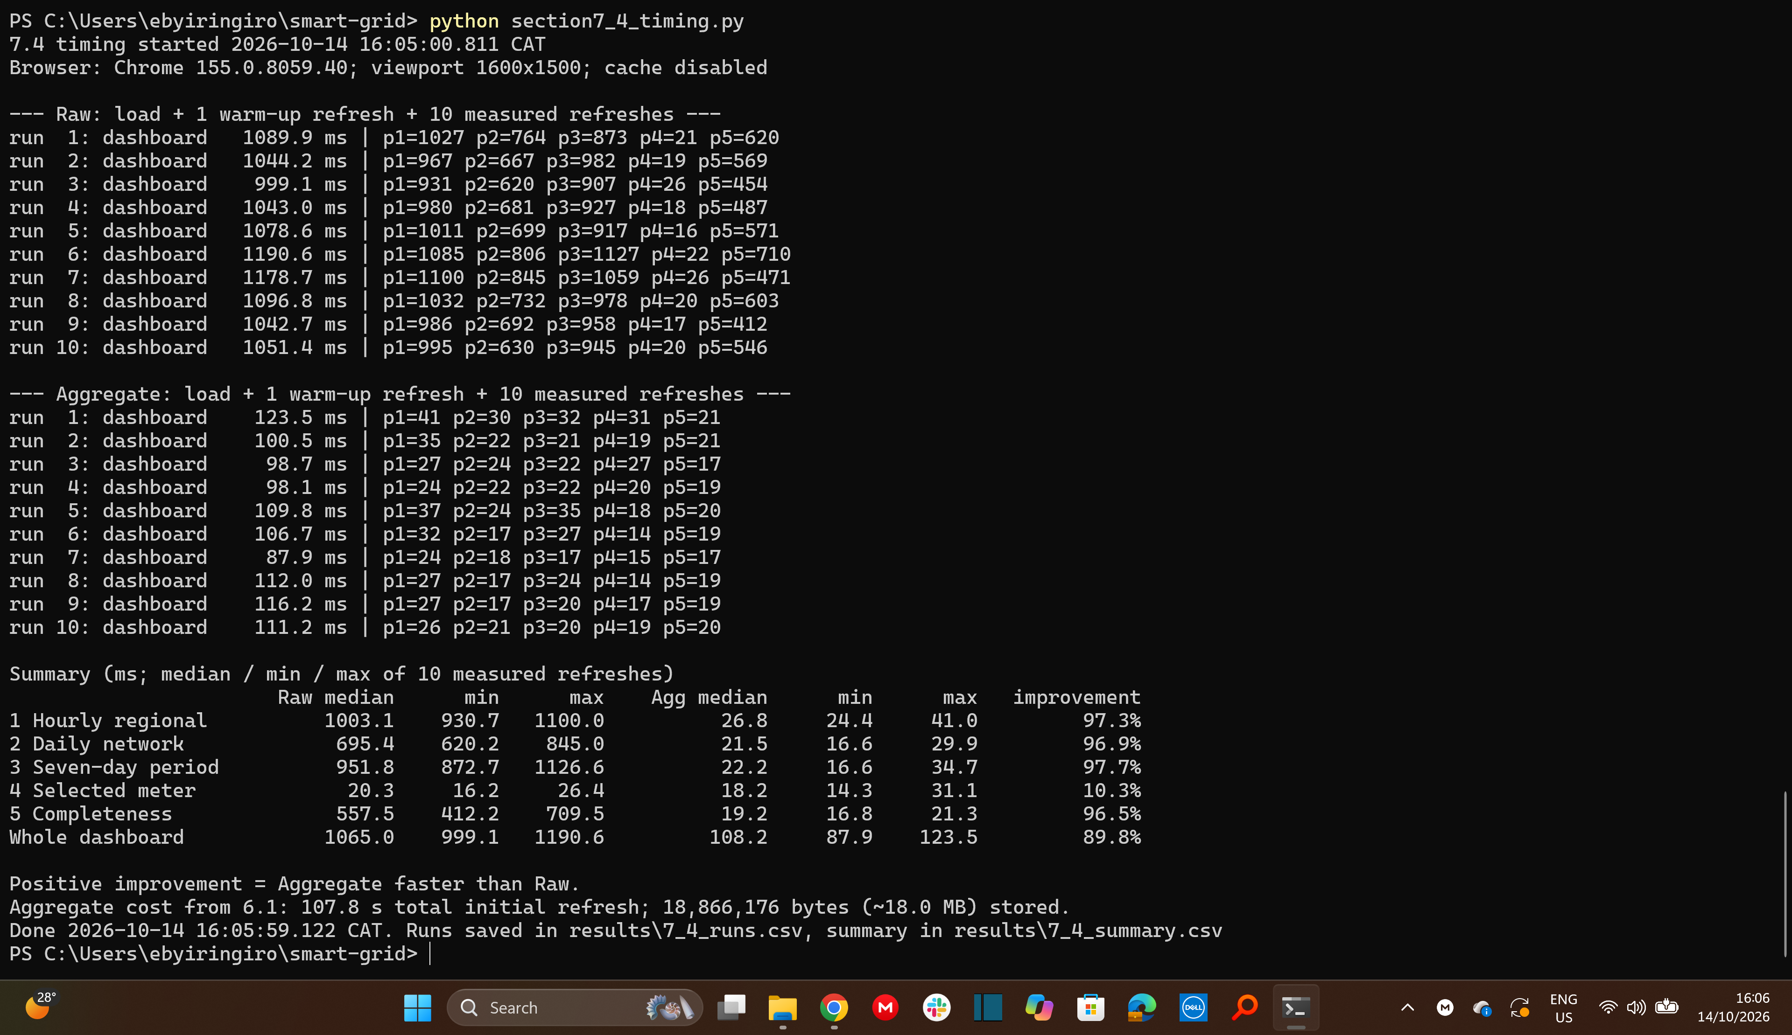
Screenshot 7.4-3 (Screenshot 2026-10-14 160606.png)
Screenshot 7.4-4 (Screenshot 2026-10-14 160630.png)

8 Forecast the next day

8.1 Prepare chronological data and features
Dataset: one row per region and CAT hour, summing energy_kwh from the cleaned readings (target, kWh). 6,720 of 6,720 region-hours are present (no absent hours); readings per region-hour range from 1,562 to 1,597 (mean 1,583.9; a full hour is 1,600) and total 10,643,735. Totals are observed sums; absent hours would stay absent and a missing predictor would be imputed with the training median (none occurred).
Split | Target dates | Rows | First target | Last target
train | 1-14 Sep | 3,360 | 2026-09-01 00:00 | 2026-09-14 23:00
validation | 15-21 Sep | 1,680 | 2026-09-15 00:00 | 2026-09-21 23:00
test | 22-28 Sep | 1,680 | 2026-09-22 00:00 | 2026-09-28 23:00

For each target hour the forecast origin is 00:00 at the start of its day. Preprocessing (median imputation, standardization of the numeric lags, one-hot encoding of region and hour) was fitted on training rows only.
Feature | Lag / window (h) | Earliest usable target
hour of day, weekend flag (calendar) | 0 | 2026-09-01 00:00
region | 0 | 2026-09-01 00:00
lag_24h (previous day, same hour) | 24 | 2026-09-02 00:00
lag_48h (two days earlier, same hour) | 48 | 2026-09-03 00:00
lag_168h (same hour one week earlier) | 168 | 2026-09-08 00:00
prev_day_mean_24h (mean of the previous day's 24 hours) | 24 | 2026-09-02 00:00

Initial lookback = 168 h (the longest lag), so the earliest usable training target is 2026-09-08 00:00. Training rows before exclusions: 3,360; excluded: 1,680; retained: 1,680. The same retained rows are used for every configuration. Missing predictor values: 0 in train, validation and test.
Lag check: for lag_24h, lag_48h and lag_168h the number of rows whose source timestamp is not earlier than the forecast origin is 0; prev_day_mean_24h uses only the previous day (latest source = origin - 1 h), 0 violations.
Screenshot 8.1-1 (Screenshot 2026-10-14 212920.png)
Screenshot 8.1-2 (Screenshot 2026-10-14 212937.png)

8.2 Evaluate the previous-day baseline
At 00:00 CAT of each test day the 24 hourly values were forecast with the previous day's corresponding hour, for all ten regions: 1,680 test predictions.
Method | Predictions | MAE (kWh) | RMSE (kWh)
Previous-day baseline | 1,680 | 42.708 | 79.403

Screenshot 8.2-1 (Screenshot 2026-10-14 212937.png)

8.3 Train and evaluate one regression model
Model: Ridge regression. Shared predictors: lag_24h, lag_48h, lag_168h, prev_day_mean_24h, region, hour of day and weekend flag. Four configurations differ only in the regularization strength alpha.
Config | Model settings | Training rows | Validation rows | Validation MAE (kWh) | Validation RMSE (kWh)
R1 | Ridge(alpha=0.1) | 1,680 | 1,680 | 4.453 | 5.659
R2 | Ridge(alpha=1.0) | 1,680 | 1,680 | 4.464 | 5.673
R3 | Ridge(alpha=10.0) | 1,680 | 1,680 | 4.778 | 6.113
R4 | Ridge(alpha=100.0) | 1,680 | 1,680 | 8.475 | 12.459

R1 has the lowest validation MAE and was frozen (model and preprocessing fitted on training rows only, not refitted on validation or test data). The same 1,680 test predictions as the baseline were generated using only information available before each daily origin; earlier completed test days supplied later lag values but were not used for fitting.
Screenshot 8.3-1 (Screenshot 2026-10-14 212937.png)
Screenshot 8.3-2 (Screenshot 2026-10-14 212954.png)

8.4 Judge forecast usefulness
Method | MAE (kWh) | RMSE (kWh)
Previous-day baseline | 42.708 | 79.403
Ridge model (R1) | 4.554 | 5.786
Model change vs baseline | -89.3% | -92.7%

Error = predicted - actual (kWh); MAE is the mean absolute error and RMSE the square root of the mean squared error, both in kWh, over all 1,680 test observations.
Region | n | Baseline MAE | Baseline RMSE | Model MAE | Model RMSE | MAE improvement %
Region 1 | 168 | 44.873 | 83.696 | 4.720 | 5.910 | 89.482
Region 2 | 168 | 41.629 | 76.811 | 4.538 | 5.675 | 89.099
Region 3 | 168 | 42.754 | 77.607 | 4.291 | 5.593 | 89.964
Region 4 | 168 | 34.856 | 64.233 | 4.070 | 5.149 | 88.325
Region 5 | 168 | 44.400 | 81.084 | 5.218 | 6.569 | 88.247
Region 6 | 168 | 39.426 | 74.766 | 3.679 | 4.691 | 90.668
Region 7 | 168 | 39.688 | 73.945 | 4.398 | 5.705 | 88.919
Region 8 | 168 | 55.967 | 102.057 | 5.706 | 7.080 | 89.806
Region 9 | 168 | 43.772 | 80.178 | 4.664 | 5.800 | 89.346
Region 10 | 168 | 39.717 | 74.282 | 4.257 | 5.324 | 89.282

Test day | Baseline MAE (kWh) | Model MAE (kWh)
2026-09-22 Tue | 4.991 | 4.548
2026-09-23 Wed | 4.652 | 4.650
2026-09-24 Thu | 5.311 | 5.181
2026-09-25 Fri | 5.008 | 4.962
2026-09-26 Sat | 135.695 | 3.645
2026-09-27 Sun | 3.840 | 4.003
2026-09-28 Mon | 139.461 | 4.889

Highest actual test-hour consumption per region (ties to the earliest hour)
Region | Peak hour | Actual kWh | Baseline pred. | Baseline abs err | Model pred. | Model abs err
Region 1 | 2026-09-28 13:00 | 835.61 | 565.27 | 270.34 | 826.29 | 9.32
Region 2 | 2026-09-28 13:00 | 780.13 | 546.91 | 233.21 | 773.78 | 6.34
Region 3 | 2026-09-28 13:00 | 783.00 | 554.69 | 228.32 | 790.33 | 7.33
Region 4 | 2026-09-28 18:00 | 659.90 | 561.41 | 98.50 | 655.56 | 4.34
Region 5 | 2026-09-28 13:00 | 828.23 | 577.36 | 250.87 | 826.02 | 2.21
Region 6 | 2026-09-28 13:00 | 749.11 | 504.41 | 244.70 | 730.97 | 18.14
Region 7 | 2026-09-25 13:00 | 751.05 | 736.64 | 14.41 | 743.29 | 7.76
Region 8 | 2026-09-25 13:00 | 1,016.55 | 1,010.53 | 6.02 | 1,011.78 | 4.77
Region 9 | 2026-09-23 13:00 | 808.96 | 796.89 | 12.07 | 803.95 | 5.01
Region 10 | 2026-09-28 13:00 | 743.03 | 502.33 | 240.71 | 734.61 | 8.42

Region 1: actual, baseline and model consumption, 22-28 Sep 2026
Does the model improve on the baseline? Yes. Test MAE is 4.554 kWh against 42.708 kWh (89.3% lower) and RMSE 5.786 against 79.403 kWh (92.7% lower); every region improves (MAE 88.2-90.7% lower) and the validation MAE (4.453 kWh) is close to the test MAE, so there is no sign of overfitting. The gain is concentrated on Saturday 26 and Monday 28 September (baseline MAE 135.7 and 139.5 kWh against 3.6 and 4.9 kWh), where the baseline copies a weekend day onto a weekday (explanation, not separately tested). On the other five days the methods are within about 0.5 kWh and on Sunday the baseline is slightly better (3.84 against 4.00 kWh). A same-weekday-last-week baseline was not tested and might narrow the gap.
Is it useful for planning? A 4.55 kWh MAE is about 0.8% of the mean test-hour regional consumption (about 591 kWh), accurate enough for day-ahead planning. At each region's peak hour the model's absolute error was 2.2 to 18.1 kWh (at most 2.4% of the peak) against up to 270.3 kWh for the baseline. Seven of the ten peaks fall on Monday 28 September. The model under-predicted nine of the ten peaks, so keep a small margin above the forecast (cause not tested).
Missing readings and delayed arrivals. About 1% of readings never arrive, so the totals are observed consumption, a lower bound on true use. In a live forecast at 00:00 the previous day's late-evening readings may still be in transit, because delays reach three hours (in 5.3, 531 rows or 0.10% of 21 September arrived after midnight), so the lag features would be slightly understated and live errors could exceed these offline results, which treat history as finalized.
Limits. One test week, 1,680 training rows after the lookback, simulated data and no holidays; confirm on more weeks before relying on the model.
Screenshot 8.4-1 (Screenshot 2026-10-14 212954.png)

9 Submit the report and code

9.1 Organize the report
This report follows the subsection order of the assignment. Required screenshots are embedded beside their subsections with the command or action, result, taskbar and clock visible; where a later subsection asks only for interpretation, earlier evidence is reused.

9.2 Make the work reproducible
Item | Value
GitHub repository | [[FILL: repository URL]]
ZIP file | [[FILL: ZIP file name]] (same files as the repository)
Generator | smart_meter_simulator.py submitted unchanged; [[FILL: SHA-256 hash matches the issued copy]]
README | README.md gives the execution order, commands, placeholders for secrets and the regeneration steps
Full dataset | kept local (data\readings.csv, about 10.7 million rows); regenerate with capture_to_csv.py and load_csv.py

Repository contents: unchanged generator; capture and ingestion programs (load_meters.py, pilot_publisher.py, pilot_subscriber.py, analyse_losses.py, capture_to_csv.py, load_csv.py); SQL files (sql\); benchmark and compression programs (benchmark.py, compress_load.py, improvement.py, section4_facts.py); analysis and model code (section5_analysis.py, section5_4_anomaly.py, section8_forecast.py); dashboard code and configuration (section7_dashboards.py, section7_4_timing.py, dashboards\Raw.json, dashboards\Aggregate.json); recorded benchmark timings and the validation comparison (results\); environment details (README.md, requirements.txt).
Pilot instructions from the README were run again and the four counts from 1.3 verified:

9.3 Document contributions
Name | Student ID | Individual contribution
ERIC BYIRINGIRO | 101389 | [[FILL: Eric's contribution]]
SANDRINE MFURANZIMA | 101411 | [[FILL: Sandrine's contribution]]
NDANYUZWE DUNCAN | 101413 | [[FILL: Duncan's contribution]]

All members are prepared to explain and present the group's work if called upon.

Appendix A: dashboard panel queries

Raw dashboard
Panel 1: Hourly regional energy (kWh)
SELECT time_bucket(INTERVAL '1 hour', r.event_time, 'Africa/Kigali') AS "time",
m.region AS metric,
sum(r.energy_kwh) AS "Energy (kWh)"
FROM energy_readings r
JOIN meters m ON m.meter_id = r.meter_id
WHERE r.event_time >= '$start_date'::date::timestamp AT TIME ZONE 'Africa/Kigali'
AND r.event_time < '$end_date'::date::timestamp AT TIME ZONE 'Africa/Kigali'
GROUP BY 1, 2
ORDER BY 1, 2

Panel 2: Daily network energy (kWh)
SELECT (r.event_time AT TIME ZONE 'Africa/Kigali')::date::text AS day,
sum(r.energy_kwh) AS "Energy (kWh)"
FROM energy_readings r
WHERE r.event_time >= '$start_date'::date::timestamp AT TIME ZONE 'Africa/Kigali'
AND r.event_time < '$end_date'::date::timestamp AT TIME ZONE 'Africa/Kigali'
GROUP BY 1
ORDER BY 1

Panel 3: Network energy per seven-day period (kWh)
SELECT to_char(DATE '2026-09-01' + 7 * (((r.event_time AT TIME ZONE 'Africa/Kigali')::date - DATE '2026-09-01') / 7), 'YYYY-MM-DD') AS period_start,
sum(r.energy_kwh) AS "Energy (kWh)"
FROM energy_readings r
WHERE r.event_time >= '$start_date'::date::timestamp AT TIME ZONE 'Africa/Kigali'
AND r.event_time < '$end_date'::date::timestamp AT TIME ZONE 'Africa/Kigali'
GROUP BY 1
ORDER BY 1

Panel 4: Daily energy for selected meter (kWh)
SELECT (r.event_time AT TIME ZONE 'Africa/Kigali')::date::text AS day,
sum(r.energy_kwh) AS "Energy (kWh)"
FROM energy_readings r
WHERE r.meter_id = $meter_id
AND r.event_time >= '$start_date'::date::timestamp AT TIME ZONE 'Africa/Kigali'
AND r.event_time < '$end_date'::date::timestamp AT TIME ZONE 'Africa/Kigali'
GROUP BY 1
ORDER BY 1

Panel 5: Completeness by region (%)
WITH reg AS (SELECT region, count(*) AS meters FROM meters GROUP BY region),
obs AS (
SELECT m.region, count(*) AS observed
FROM energy_readings r
JOIN meters m ON m.meter_id = r.meter_id
WHERE r.event_time >= '$start_date'::date::timestamp AT TIME ZONE 'Africa/Kigali'
AND r.event_time < '$end_date'::date::timestamp AT TIME ZONE 'Africa/Kigali'
GROUP BY m.region)
SELECT reg.region,
100.0 * obs.observed / (reg.meters * (('$end_date'::date - '$start_date'::date) * 96)) AS "Completeness (%)"
FROM reg
JOIN obs ON obs.region = reg.region
ORDER BY reg.region

Aggregate dashboard
Panel 1: Hourly regional energy (kWh)
SELECT c.bucket AS "time",
c.region AS metric,
sum(c.sum_energy_kwh) AS "Energy (kWh)"
FROM cagg_hourly_region c
WHERE c.bucket >= '$start_date'::date::timestamp AT TIME ZONE 'Africa/Kigali'
AND c.bucket < '$end_date'::date::timestamp AT TIME ZONE 'Africa/Kigali'
GROUP BY 1, 2
ORDER BY 1, 2

Panel 2: Daily network energy (kWh)
SELECT (c.bucket AT TIME ZONE 'Africa/Kigali')::date::text AS day,
sum(c.sum_energy_kwh) AS "Energy (kWh)"
FROM cagg_15min_region c
WHERE c.bucket >= '$start_date'::date::timestamp AT TIME ZONE 'Africa/Kigali'
AND c.bucket < '$end_date'::date::timestamp AT TIME ZONE 'Africa/Kigali'
GROUP BY 1
ORDER BY 1

Panel 3: Network energy per seven-day period (kWh)
SELECT to_char(DATE '2026-09-01' + 7 * (((c.bucket AT TIME ZONE 'Africa/Kigali')::date - DATE '2026-09-01') / 7), 'YYYY-MM-DD') AS period_start,
sum(c.sum_energy_kwh) AS "Energy (kWh)"
FROM cagg_15min_region c
WHERE c.bucket >= '$start_date'::date::timestamp AT TIME ZONE 'Africa/Kigali'
AND c.bucket < '$end_date'::date::timestamp AT TIME ZONE 'Africa/Kigali'
GROUP BY 1
ORDER BY 1

Panel 4: Daily energy for selected meter (kWh)
SELECT (c.bucket AT TIME ZONE 'Africa/Kigali')::date::text AS day,
sum(c.sum_energy_kwh) AS "Energy (kWh)"
FROM cagg_daily_meter c
WHERE c.meter_id = $meter_id
AND c.bucket >= '$start_date'::date::timestamp AT TIME ZONE 'Africa/Kigali'
AND c.bucket < '$end_date'::date::timestamp AT TIME ZONE 'Africa/Kigali'
GROUP BY 1
ORDER BY 1

Panel 5: Completeness by region (%)
WITH reg AS (SELECT region, count(*) AS meters FROM meters GROUP BY region),
obs AS (
SELECT c.region, sum(c.reading_count) AS observed
FROM cagg_15min_region c
WHERE c.bucket >= '$start_date'::date::timestamp AT TIME ZONE 'Africa/Kigali'
AND c.bucket < '$end_date'::date::timestamp AT TIME ZONE 'Africa/Kigali'
GROUP BY c.region)
SELECT reg.region,
100.0 * obs.observed / (reg.meters * (('$end_date'::date - '$start_date'::date) * 96)) AS "Completeness (%)"
FROM reg
JOIN obs ON obs.region = reg.region
ORDER BY reg.region

