Public GIT (Github/Bitbucket/Gitlab) url:
https://github.com/DuncoDough/Event_Management_db
Public API (Vercel or otherwise) url:

Task 1 Screenshot of your development environment setup:
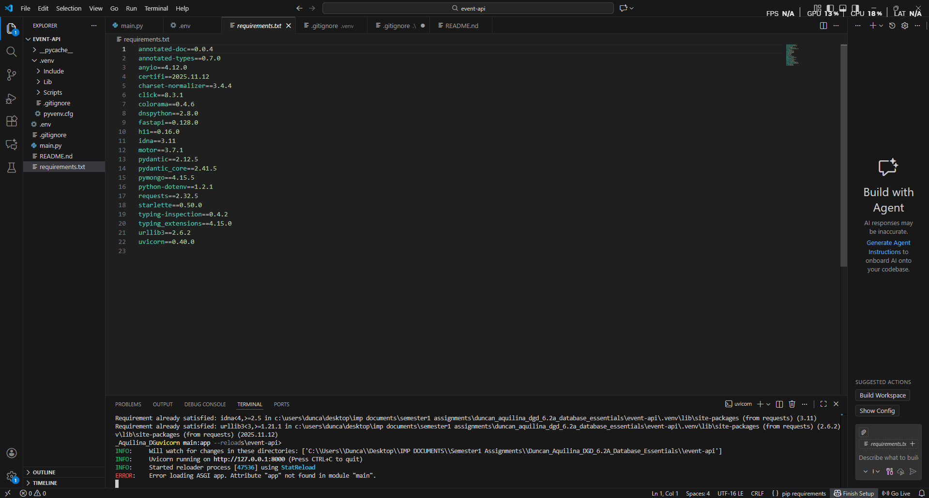
Task 2: Screenshot/s of your Mongo Database on MongoAtlas:

Task 3A: Screenshot of the API running on localhost in your browser:

Task 3B: Screenshot of the hosted API running on a public url such as Vercel:

Task 4A: Screenshot showing credential setup.

Task 4B: Screenshot showing IP whitelisting.

Task 4C: Screenshot showing how you are preventing SQL injection.

