Test Documentation

Unit Testing - Black Box Testing

|  |  |  |  |  |
| --- | --- | --- | --- | --- |
| Test case ID | Test case Description | Preconditions | Flow of events | Post conditions (Outputs) |
| 1.0 | This test case will test all login related sub test cases. | Valid user IDs and related passwords should be stored in the data base. | 1.1 Normal Case  1.2 Non registered User Name Entered  1.3 Valid User Name and Incorrect Password Entered  1.4 Entering a character other than 0-9 or V for user name.  1.5 Entering a username which exceeds 10 characters | Display the main interface  Or the relevant error message. |

1.0 Log-in

1.1) Normal Case

Explanation:- Existing user name and correct password will be entered

Input:-

User Name : 948190702V

Password : abc123

Output :- Displays main Interface of the user

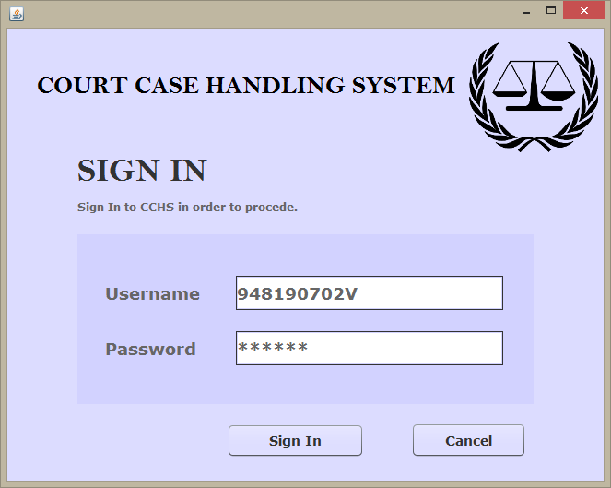

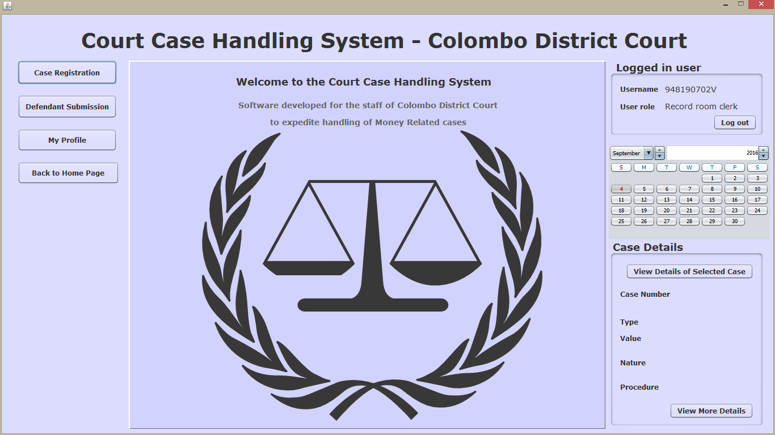

1.2) Non registered User Name Entered

Explanation:- User name accepts all the validation criterions but the user name hasn’t registered by the registrar yet .

Input:-

User Name : 948190703V

Password : abc123

Output :- Displays the “Invalid Username” Error Message

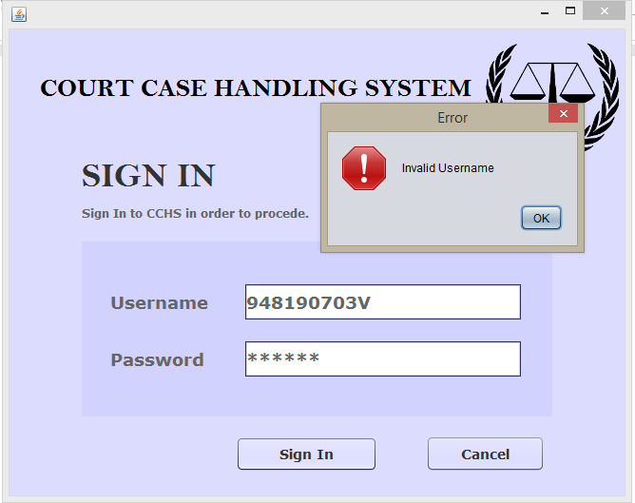

1.3) Valid User Name and Incorrect Password Entered

Explanation:- User name does exist in the database but the given password doesn’t match the given username.

Input:-

User Name : 948190702V

Password : abc

Output :- Displays the “Incorrect Password” Error Message

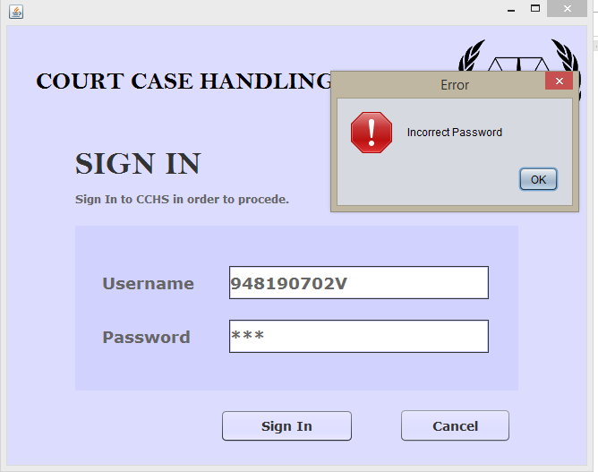

1.4) Entering a character other than 0-9 or V for user name.

Input:-

User Name : 948190a

Output :- Displays an Error Message

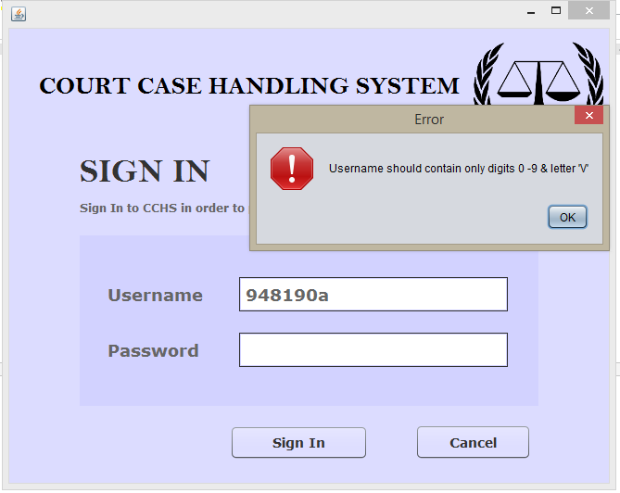

1.5) Entering a username which exceeds 10 characters

Input:-

User Name : 948190038v3

Output :- Displays an Error Message “NIC should contain only 10 characters”

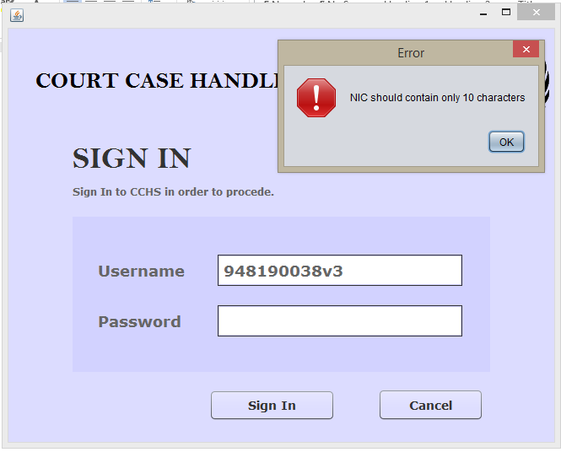

|  |  |  |  |  |
| --- | --- | --- | --- | --- |
| Test case ID | Test case Description | Preconditions | Flow of events | Post conditions |
| 2.0 | This test case will test all case registration related sub test cases. | User should have a valid user account and user should have logged in to the system. | 2.1 Normal Case  2.2 A character other than a numerical value character or full stop is Entered  2.3 A case value which is greater than 1 000 000.00 is entered.  2.4 Keeping certain fields empty and trying to proceed | Case transforms to the stage of stamp duty or relevant error message will be displayed. |

2.0 Case Registration

2.1) Normal Case

Explanation:- Registering a case with valid information

Input:-

Valid inputs without violating any validation rules.

Output :- Displays the summary of case details and **updates the database**

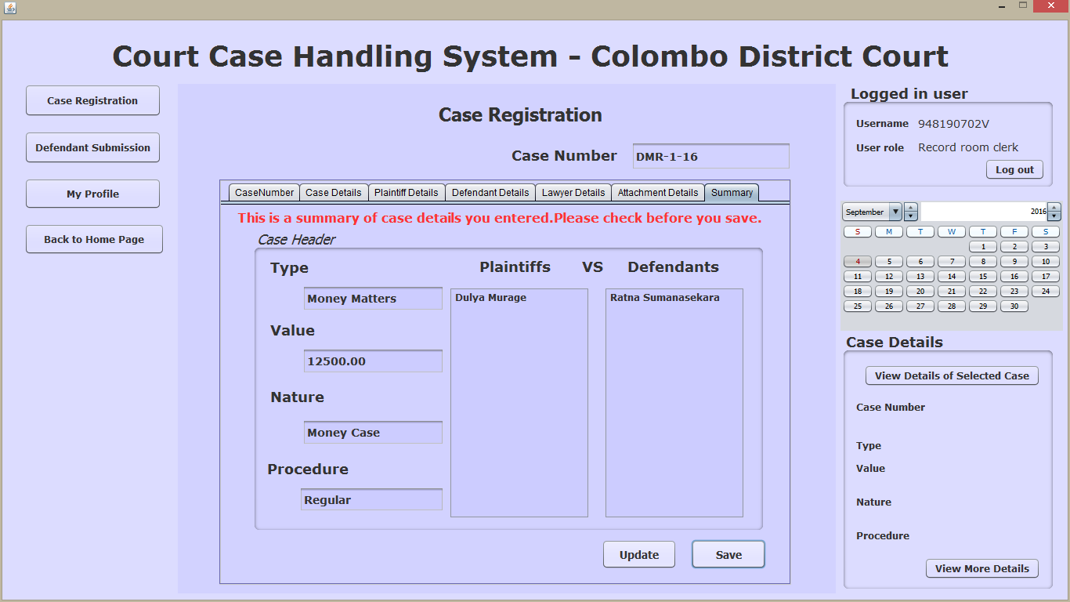

2.2) A character other than a numerical value character or full stop is entered

Explanation:- A character other than a numerical value character (0-9) or “.” Character(which is used to separate rupees and cents) is entered in the ‘value’ field.

Input:-

12A

Output: - Displays the error message “Please enter only numbers and “.” To separate cents”

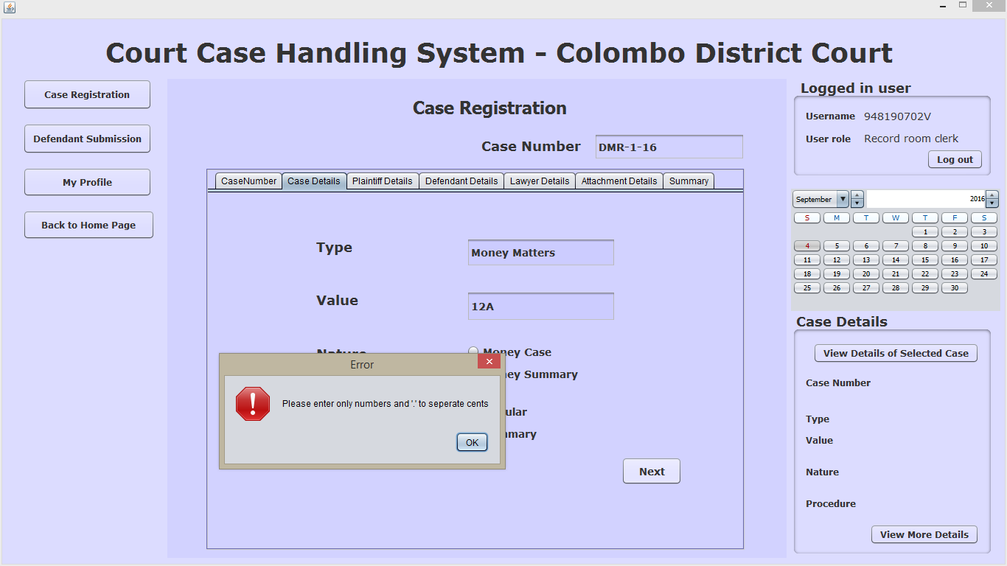

2.3) A case value which is greater than 1 000 000.00 is entered.

Explanation:- When filling the value field of case details, a value greater than one million is entered(because the stamp duty value of a case cannot exceed thousand.

I.e. stamp duty value = case value/1000)

Input:- 2000000.00

Output: - Displays the error message “Maximum value exceeded! Enter a value less than one million!”

2.4) Keeping certain fields empty and trying to proceed

Explanation:- When filling details of Plaintiffs ,Defendants and Lawyers ,keeping certain fields empty and trying to proceed(by clicking next button)

Input:- ___

Output :- Displays the error message “A required field is empty!”

Eg-“Please enter plaintiff details”

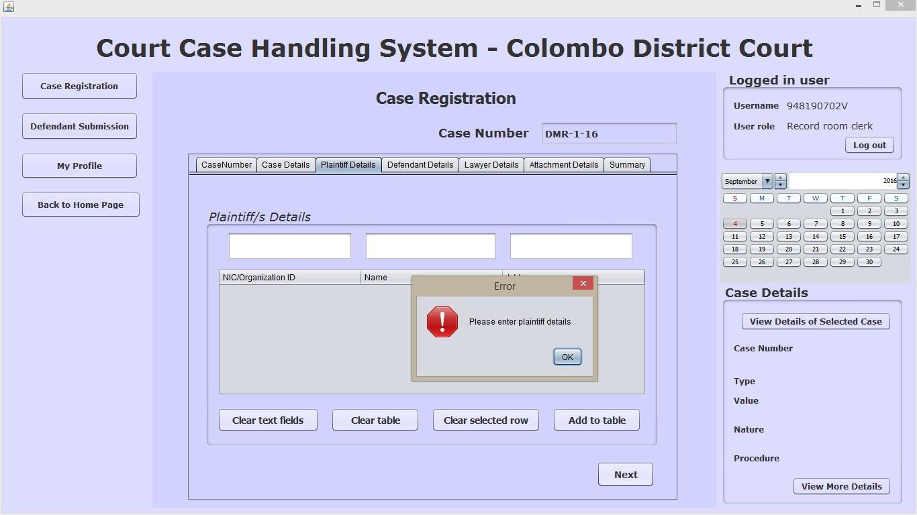

|  |  |  |  |  |
| --- | --- | --- | --- | --- |
| Test case ID | Test case Description | Preconditions | Flow of events | Post conditions |
| 3.0 | This test case will test all stamp duty process related sub test cases. | User should have a valid user account and user should have logged in to the system. There should be registered cases in the due list | 3.1 Normal Case  3.2 Clicking “print receipt” without viewing receipt details | Case transforms to the stage of summon1. |

3.1) Normal case.

Explanation:- There are no data to enter in the fields. Proceeding in the normal way

)

Input:-

Output: - Printed stamp duty receipt / The information message “Stamp Duty payment was successfully recorded” appears.

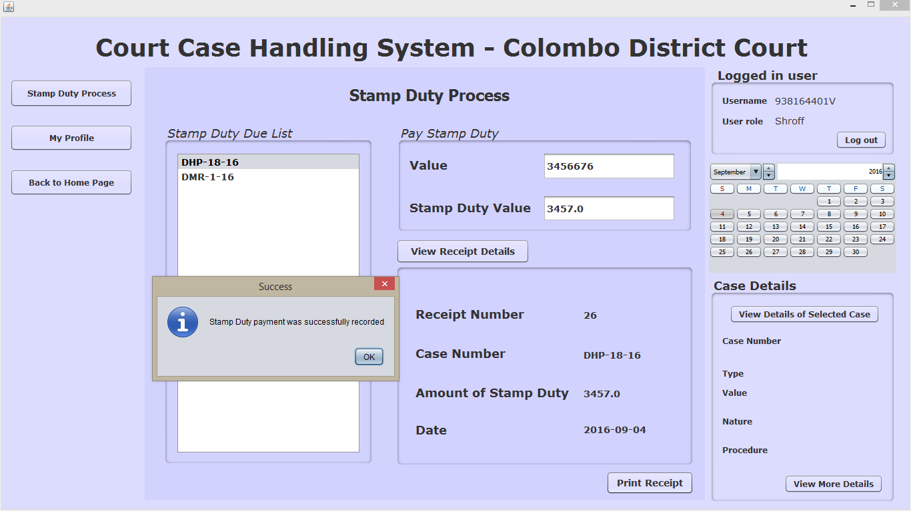

3.2) Trying to print the receipt without viewing receipt details

Explanation:- Clicking on the “print receipt ” button without clicking the”view receipt details” button

Input:-

Output: - An error message “Please View Receipt Data before printing receipt” appears

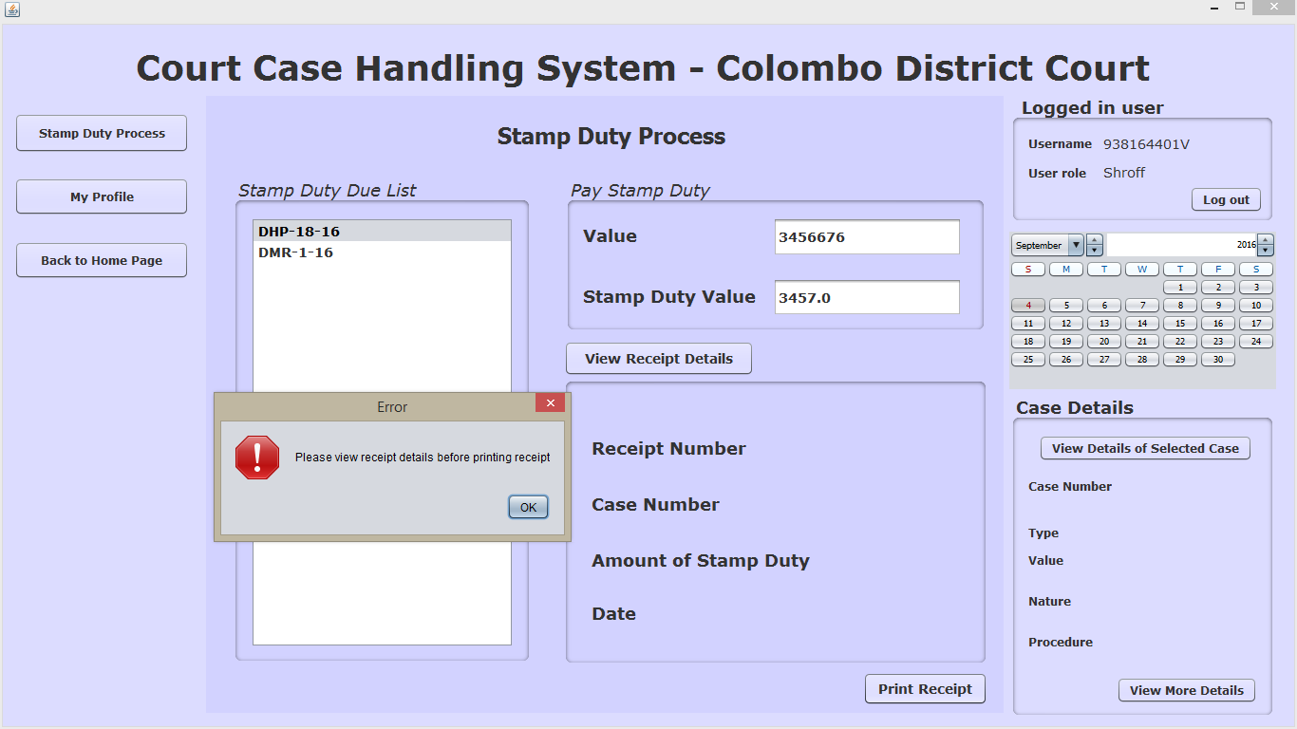

|  |  |  |  |  |
| --- | --- | --- | --- | --- |
| Test case ID | Test case Description | Preconditions | Flow of events | Post conditions |
| 4.0 | This test case will test all summon serving process related sub test cases. | User should have a valid user account and user should have logged in to the system. There should be stamp duty paid cases in the due list, for which the summons should be served. | 4.1 Normal Case  4.2 A past date is set as the first hearing date | Case transforms to the stage of fiscalreport and  The first hearing will be stored in the database or a particular error message will be displayed |

4.1) Normal Case

Explanation:- After selecting a particular case in the due list, fixing a future date as the first hearing date and clicking the “print” button to print the summon

Input:- select 2016-09-18 (a future date is selected)

Output :- Displays the information message “First Hearing Date was fixed successfully!” appears .After clicking the “print” button, an information message “2 copies will be sent to print”

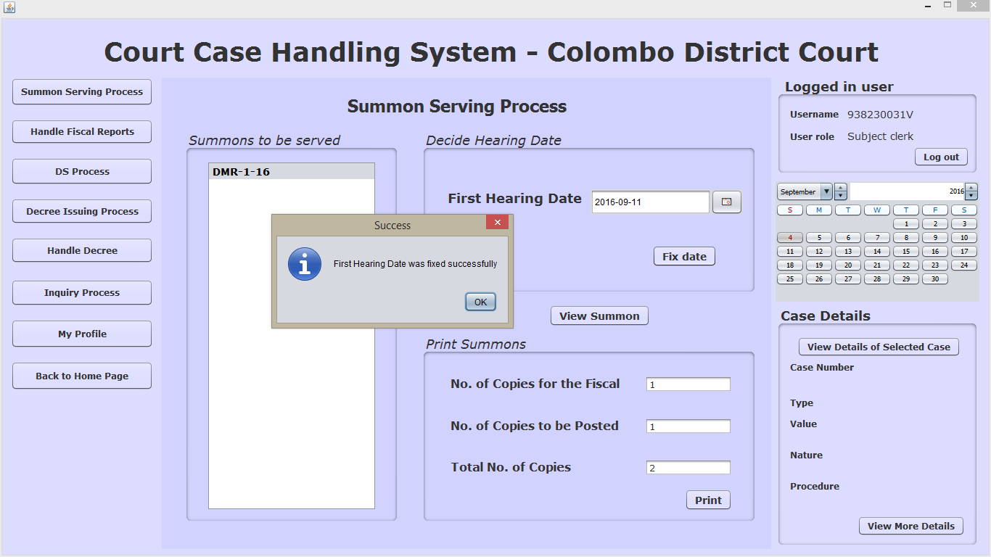

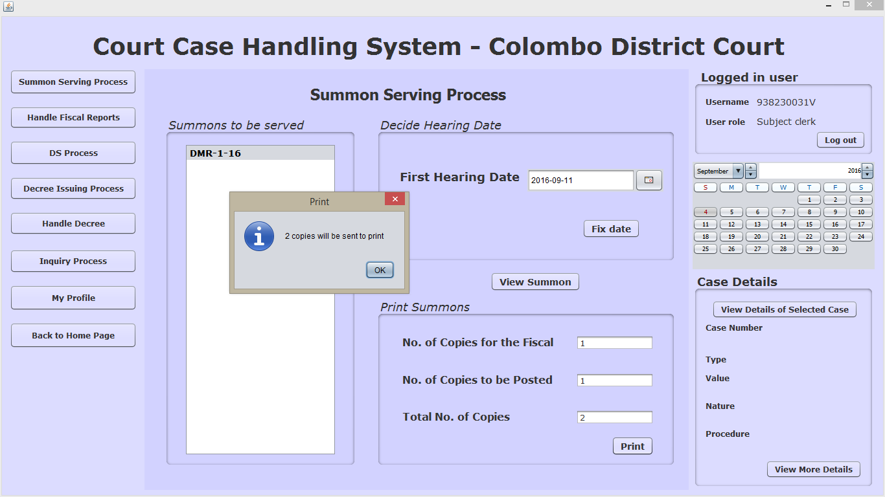

4.2) A past date is set as the first hearing date

Explanation:- After selecting a particular case in the due list, fixing a past date as the first hearing date.

Input:- select 2016-09-01 (a past date is selected)

Output: - Displays the error message “Select a hearing date in the future”

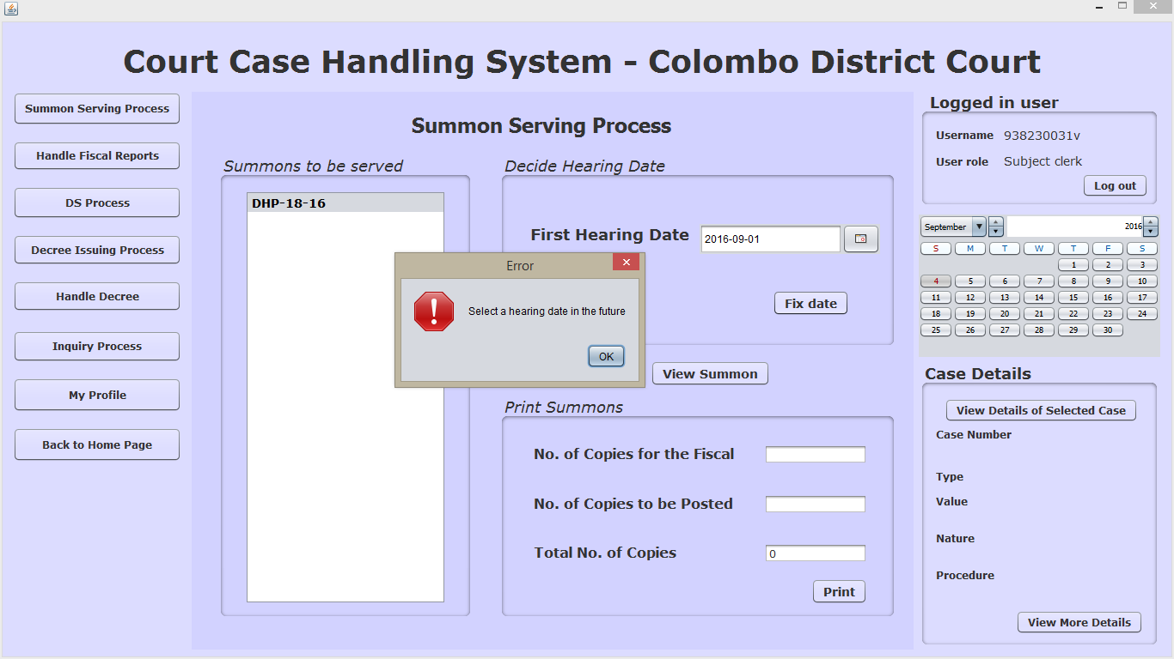

|  |  |  |  |  |
| --- | --- | --- | --- | --- |
| Test case ID | Test case Description | Preconditions | Flow of events | Post conditions |
| 5.0 | This test case will test all ‘Handle Fiscal Reports process ‘related sub test cases. | User should have a valid user account and user should have logged in to the system. There should be cases for which the summons are issued and handed over to the fiscal | 5.1 Normal Case  5.2 selecting the “fiscal couldn’t hand over summons” button and trying to save without entering a reason | Case transforms to the stage of ‘DefendantInformed’ or ‘dssummon’ and the reason will be stored in the database if the fiscal couldn’t hand over the summon |

5.1) Normal Case

Explanation:- After selecting a particular case in the due list selecting the relevant buttons accordingly.

Input 1:- select “fiscal handed over the summons” button

2:- select “fiscal couldn’t hand over the summons” button and entering the reason why the fiscal couldn’t hand it over

Output 1 :- display the information message” summon status successfully recorded”

2:- display the information message” summon status successfully recorded”

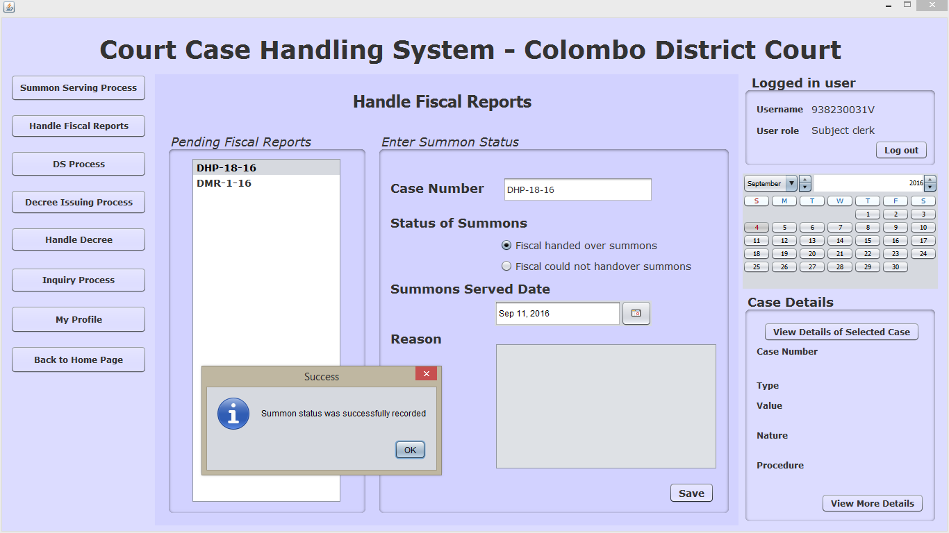

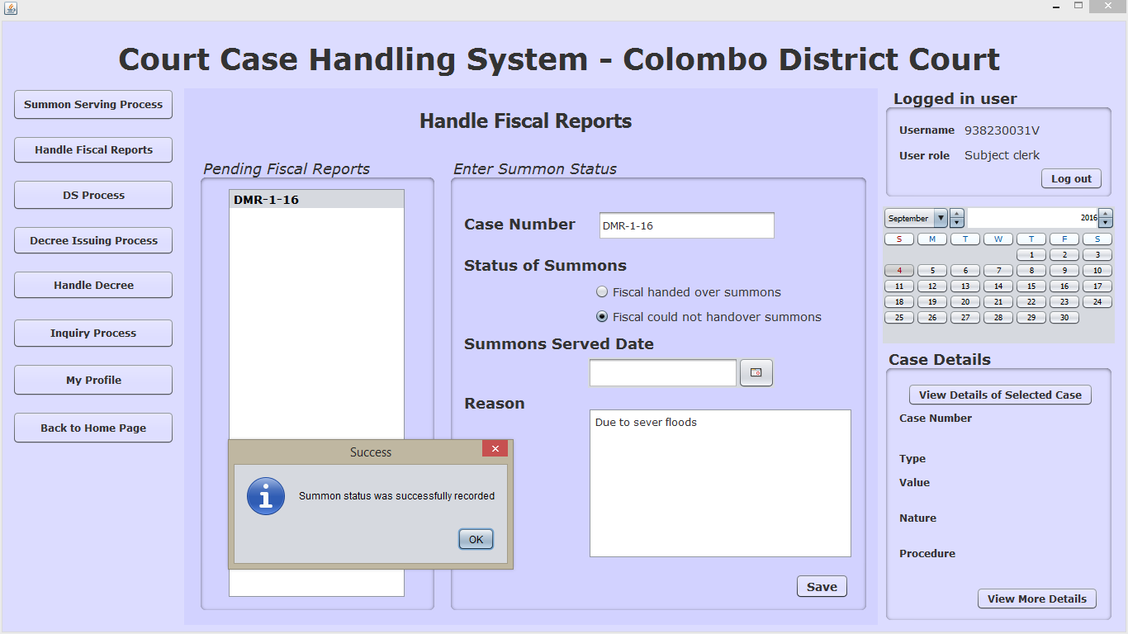

5.2) Selecting the “fiscal couldn’t hand over summons” button and trying to save without entering a reason

Explanation:- After selecting a particular case in the due list, selecting the “fiscal couldn’t hand over summons” button and trying to save without entering a reason in the text area for the reason.

Input: - select “fiscal couldn’t hand over the summons” button and not entering the reason why the fiscal couldn’t hand it over

Output: - display the error message “Please enter a reason indicating the inability to serve summons”

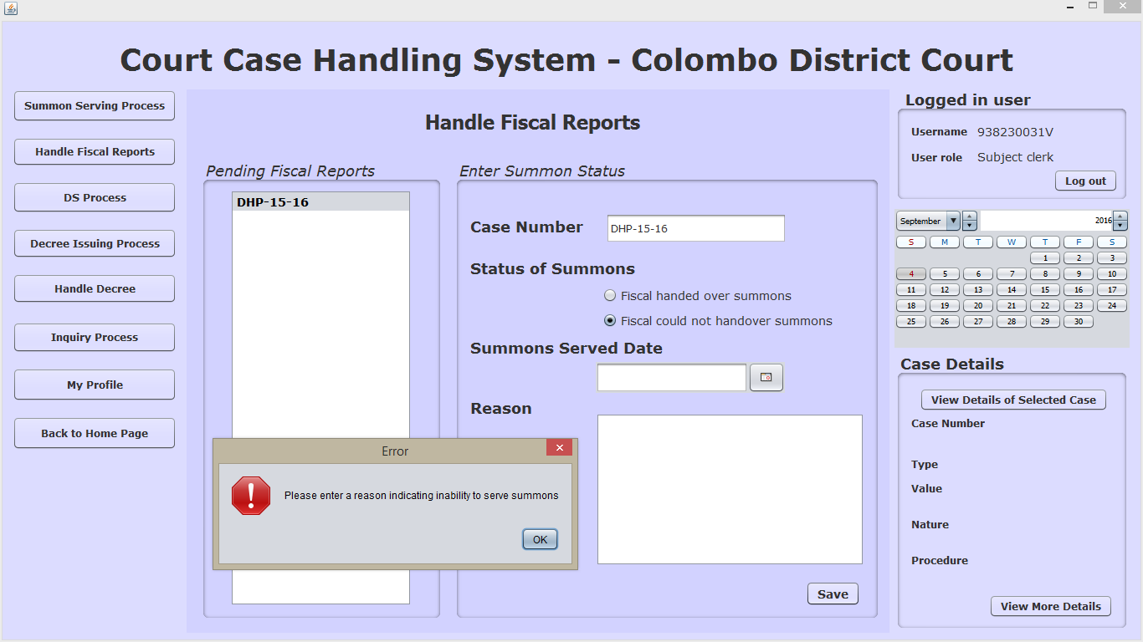

|  |  |  |  |  |
| --- | --- | --- | --- | --- |
| Test case ID | Test case Description | Preconditions | Flow of events | Post conditions |
| 6.0 | This test case will test all ‘User Registration process ‘related sub test cases. | Registrar should have logged in to the system. | 6.1 Normal Case  6.2 Entering a character other than 0-9 or V for the NIC  6.3 Entering a NIC which exceeds 10 characters  6.4 Entering characters other than the alphabetical characters in the name field.  6.5 Entering characters other than the numerical values in the contact number field | New user details will be stored in the database or an error message will be displayed. |

6.1 Normal Case

Explanation: - Entering valid inputs without violating any validation rules and proceeding

Input: - valid inputs without violating any validation rules

Output:-Information message “successfully registered new user”

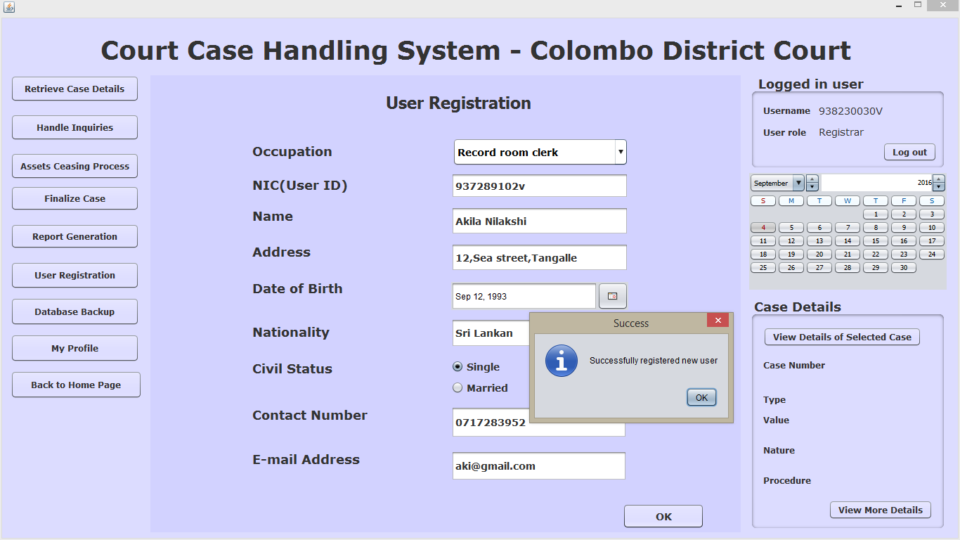

6.2) Entering a character other than 0-9 or V for the NIC

Explanation: - Entering a character other than 0-9 or V in the NIC field

Input: - 938230a

Output:-error message “NIC should contain only digits and letter V”

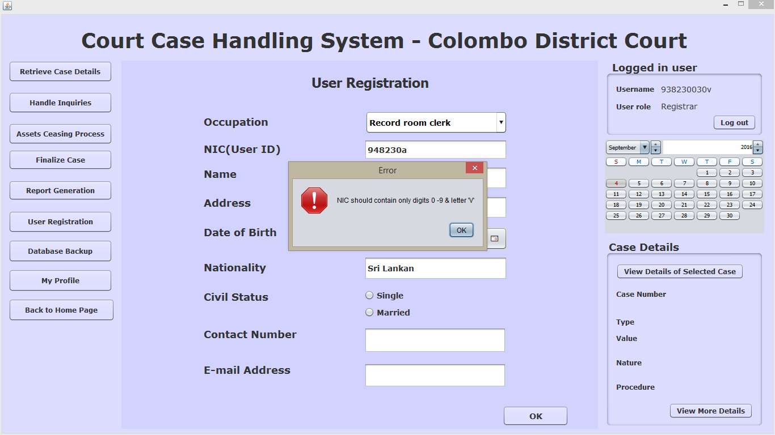

6.3) Entering an NIC which exceeds 10 characters

Explanation :- Entering an NIC which exceeds 10 characters in the NIC field.

Input :- 938230030V1

Output:-error message “NIC should contain only 10 characters”

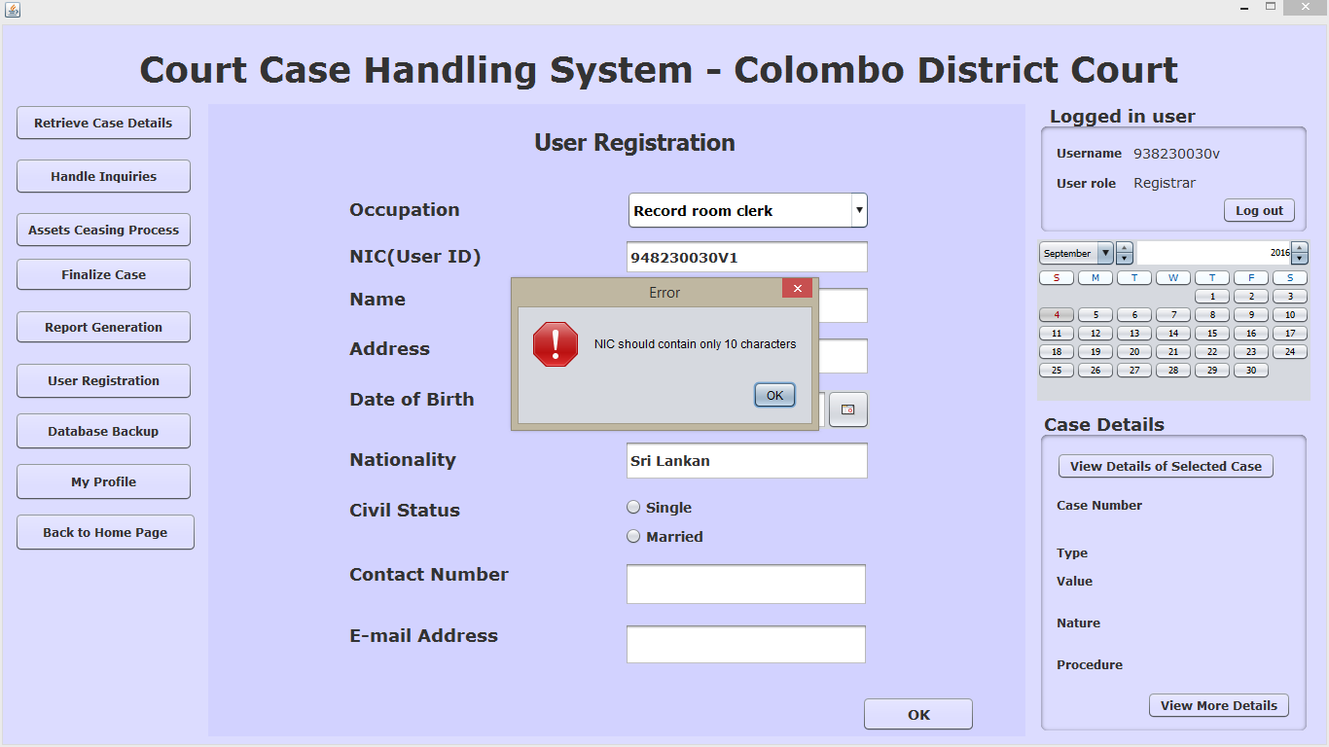

6.4) Entering characters other than the alphabetical characters in the name field.

Explanation :- Entering characters other than the alphabetical characters in the name field by the registrar.

Input :- Akila 1

Output :-error message “please enter only alphabetical characters”

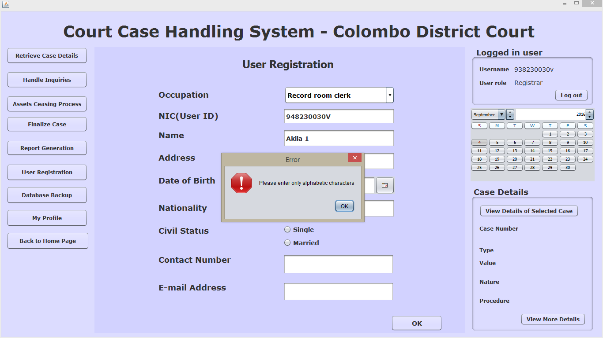

6.5) Entering characters other than the numerical values in the contact number field

Explanation: - Entering characters other than the numerical values in the contact number field by the registrar.

Input: - q

Output:-error message “please enter only numbers”

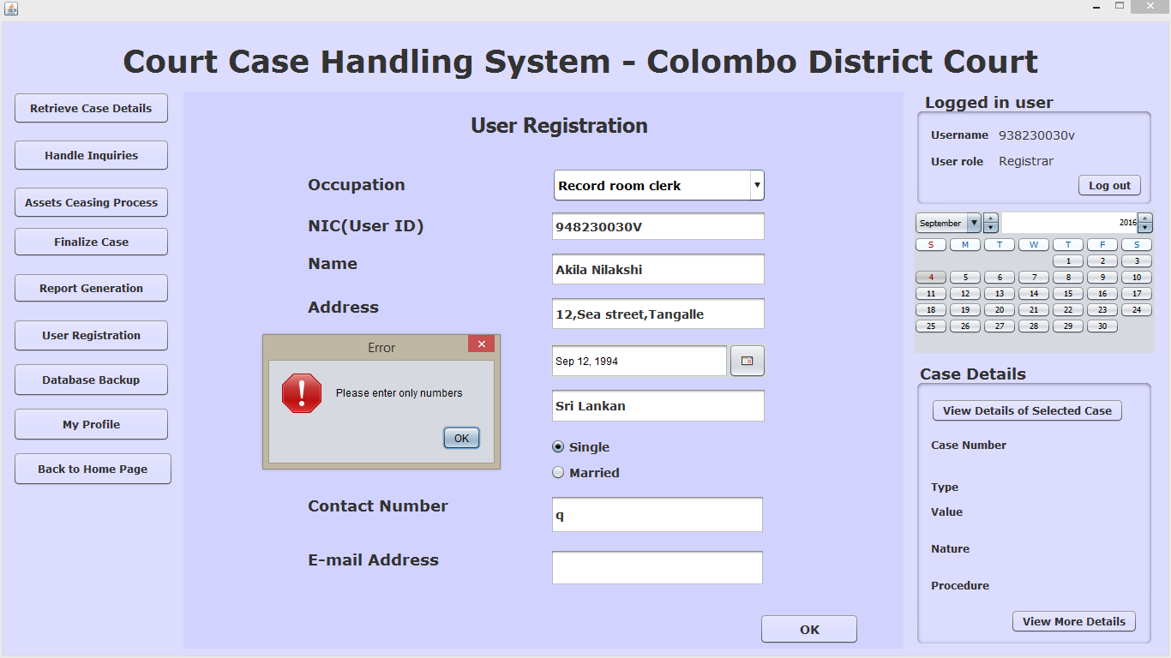

|  |  |  |  |  |
| --- | --- | --- | --- | --- |
| Test case ID | Test case Description | Preconditions | Flow of events | Post conditions |
| 7.0 | This test case will test all ‘Roll Court Normal Proceeding‘ process related sub test cases. | Both parties should have appeared in courts on the hearing date | 7.1 Normal Case  7.2 Confirming the final judgment without entering a final judgment  7.3 Confirming the next hearing date without fixing a next hearing date.  7.4 Confirming the next hearing date without entering judge comments. | Final judgment will be recorded or next hearing date will be assigned or corresponding error message will appear |

7.1) Normal Case

Explanation :- Proceeding normally without encountering an error message.

Input :- 1. Select “Final Judgment Given”, enter the final judgment and confirm it

2. Select “Next hearing date decided”, fix the next hearing date and confirm hearing date

Output :- 1. Display the information message “Final Judgment was successfully recorded”

2. Display the information message “Next Hearing Date was successfully recorded”

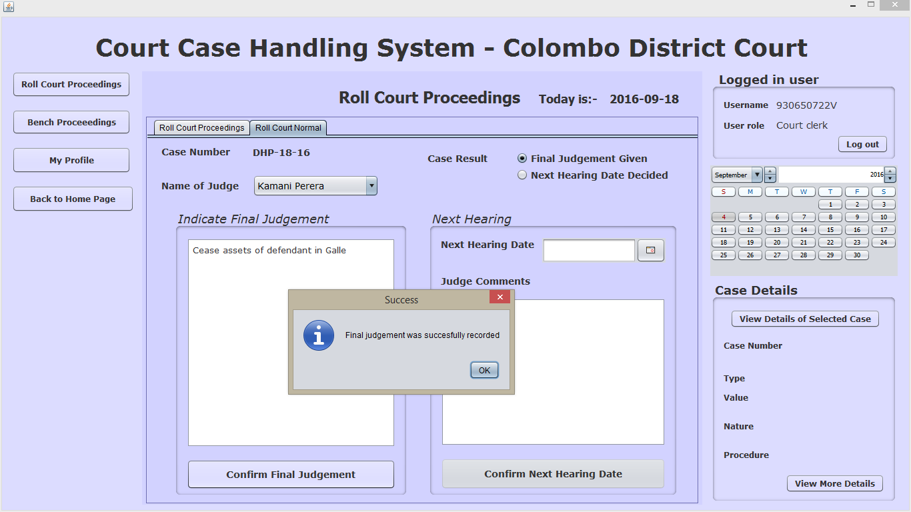

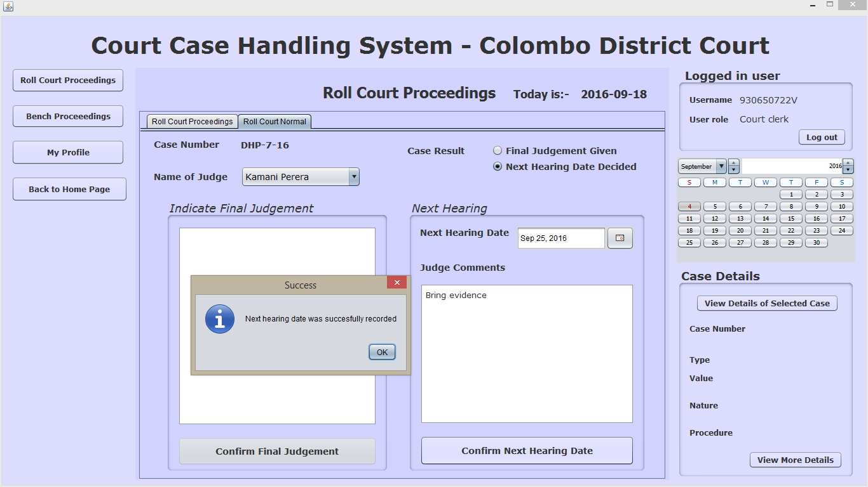

7.2) Confirming the final judgment without entering a final judgment

Explanation:- After selecting the “Final Judgment given” button, click on “Confirm Final Judgment” button while the “Indicate Final Judgment” field is kept empty.

Input:- __

Output:- display error message “Please enter the final judgment”

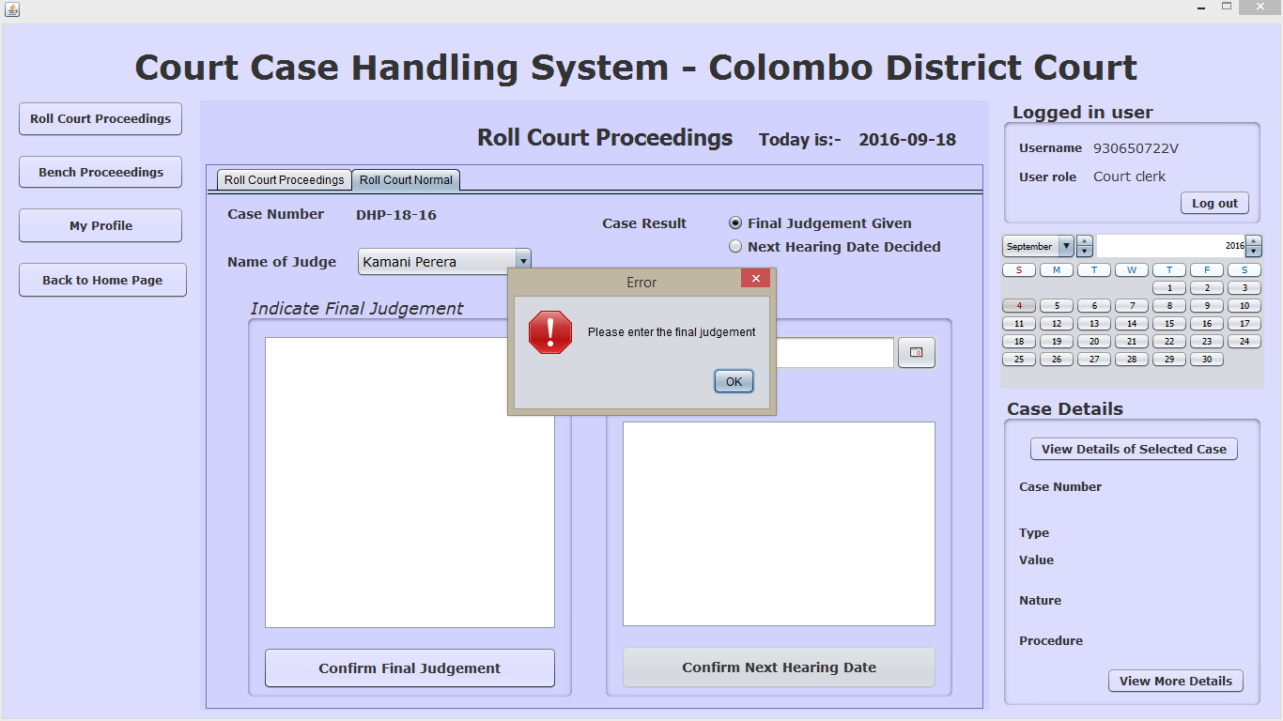

7.3) Confirming the next hearing date without fixing a next hearing date.

Explanation:- After selecting the “Next Hearing Date Decided” button, click on “Confirm Next Hearing Date” button without fixing a date.

Input:- __

Output:- display error message “Please Select a Hearing Date”

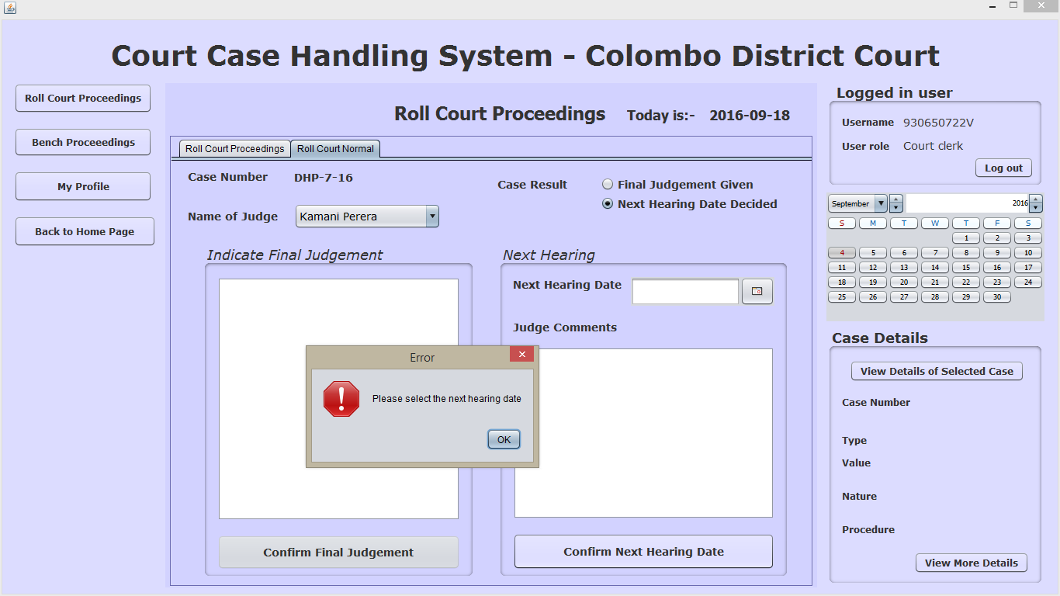

7.4) Confirming the next hearing date without entering judge comments.

Explanation:- After selecting the “Next Hearing Date Decided” button, click on “Confirm Next Hearing Date” button while leaving the judge comments field empty.

Input:- __

Output:- display error message “Please Enter the Judge Comments”

Waraddak wenna puluwan then :-

Default judge kenek wa select welaa thiyana eka

Hearing date eka past ekak fix karana welaawa

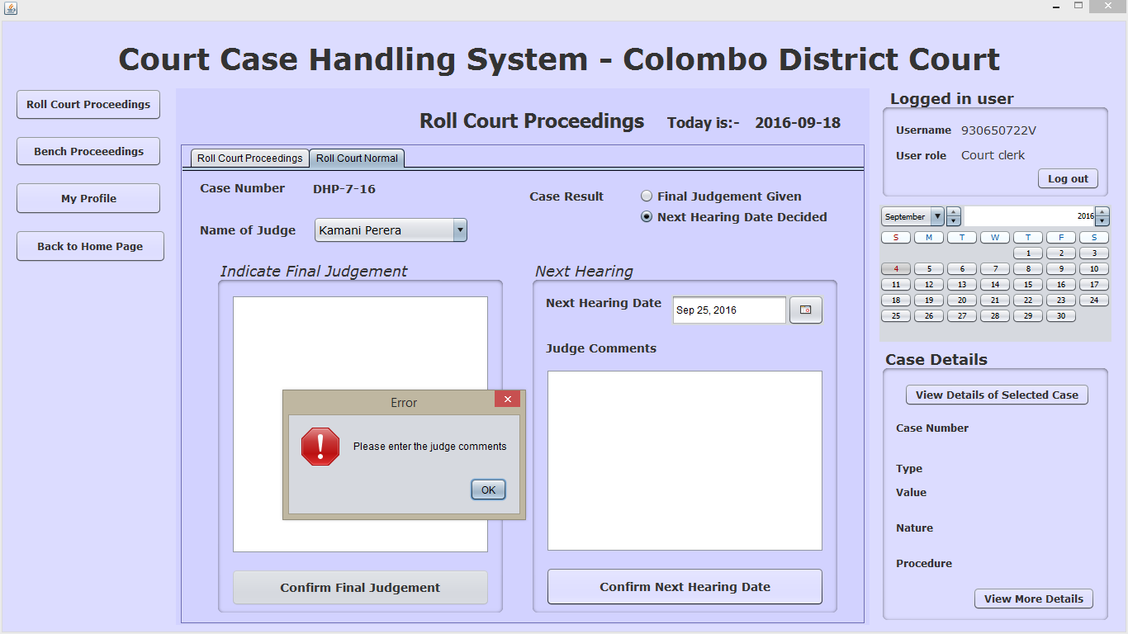

|  |  |  |  |  |
| --- | --- | --- | --- | --- |
| Test case ID | Test case Description | Preconditions | Flow of events | Post conditions |
| 8.0 | This test case will test all ‘Roll Court Proceeding- ex parte judgment‘ process related sub test cases. | Only the Plaintiff party should have appeared in courts on the hearing date | 8.1 Normal Case  8.2 Confirming ex parte judgment without entering an ex parte judgment | Ex Parte judgment will be recorded or corresponding error message will appear |

8.1) Normal Case

Explanation:- After selecting the “Convert to Ex Parte Fix” button, select a judge, enter the ex parte judgment and click on “Confirm Ex Parte Judgment ”button

Input:- __

Output:- display information message “Ex Parte Judgment was successfully recorded”

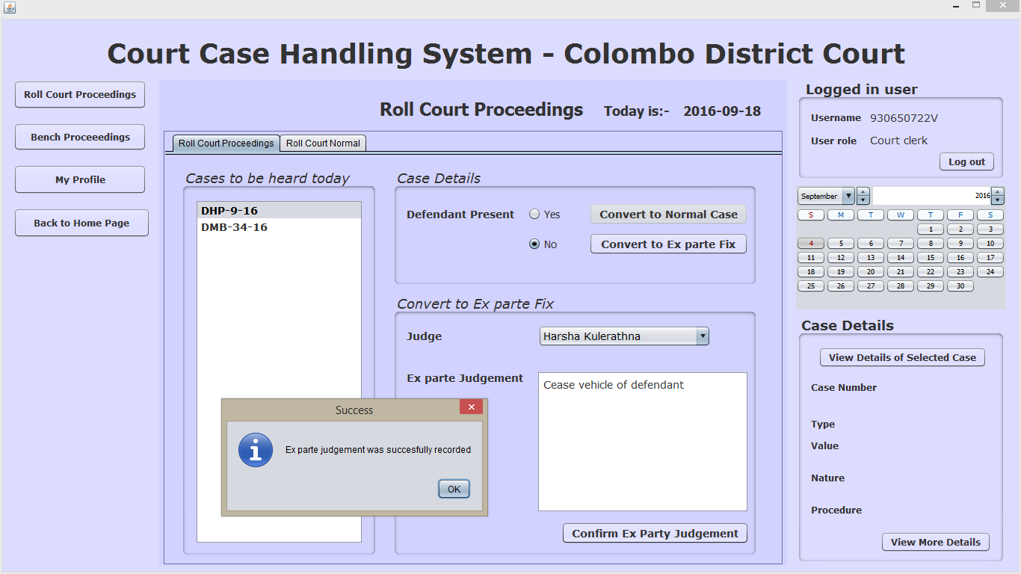

8.2) Confirming ex parte judgment without entering an ex parte judgment

Explanation:- Clicking on “Confirm ex parte judgment” button while leaving the “ex parte judgment” field empty

Input:- __

Output:- display information message “Please record Ex Parte Judgment below”

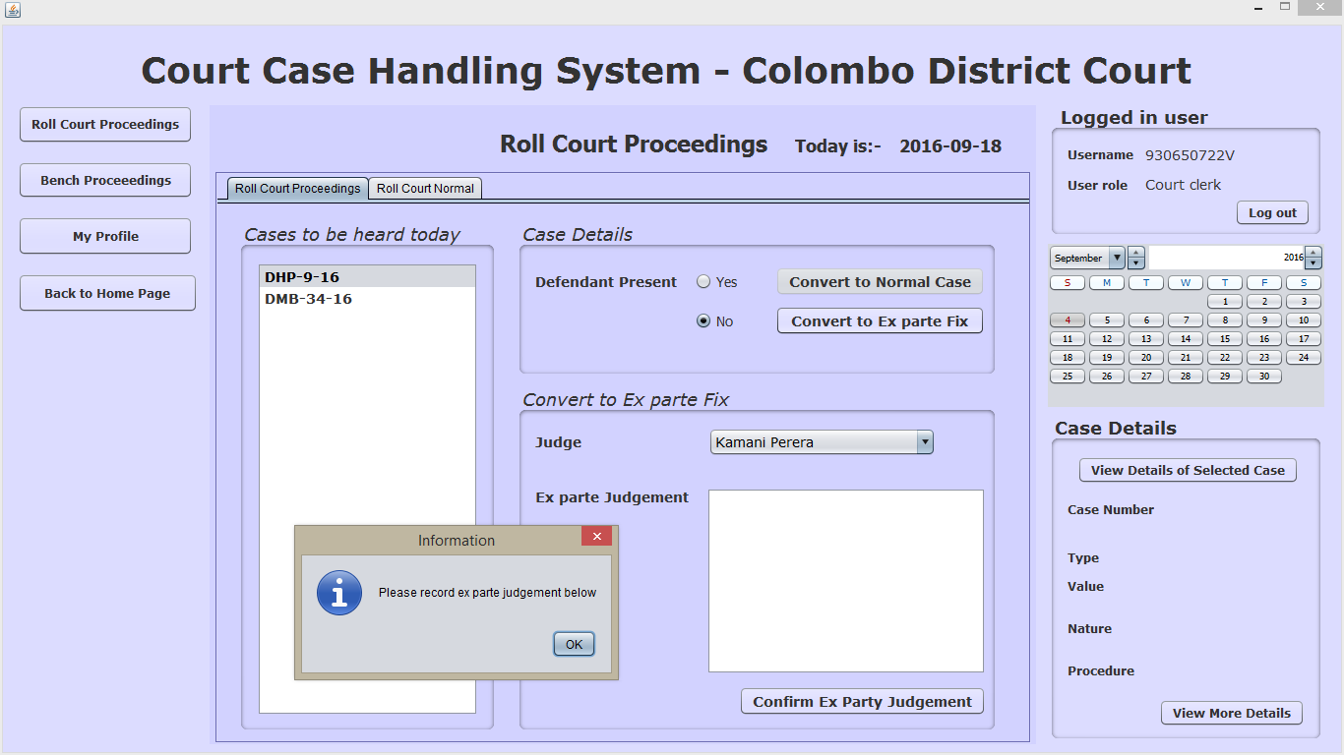

|  |  |  |  |  |
| --- | --- | --- | --- | --- |
| Test case ID | Test case Description | Preconditions | Flow of events | Post conditions |
| 9.0 | This test case will test all ‘Profile Editing process‘ related sub test cases. | User should have a user account and the user should have logged in | 9.1 Editing Personal Details of the user  9.2 Resetting the password |  |

9.1) Editing Personal Details of the user

Explanation:- Clicking on “Edit Details” tab and edit name, address,email and contact number fields(other fields are restricted to not to be updated)

Input:- valid data entries

Output:- display information message “Successfully updated user information”

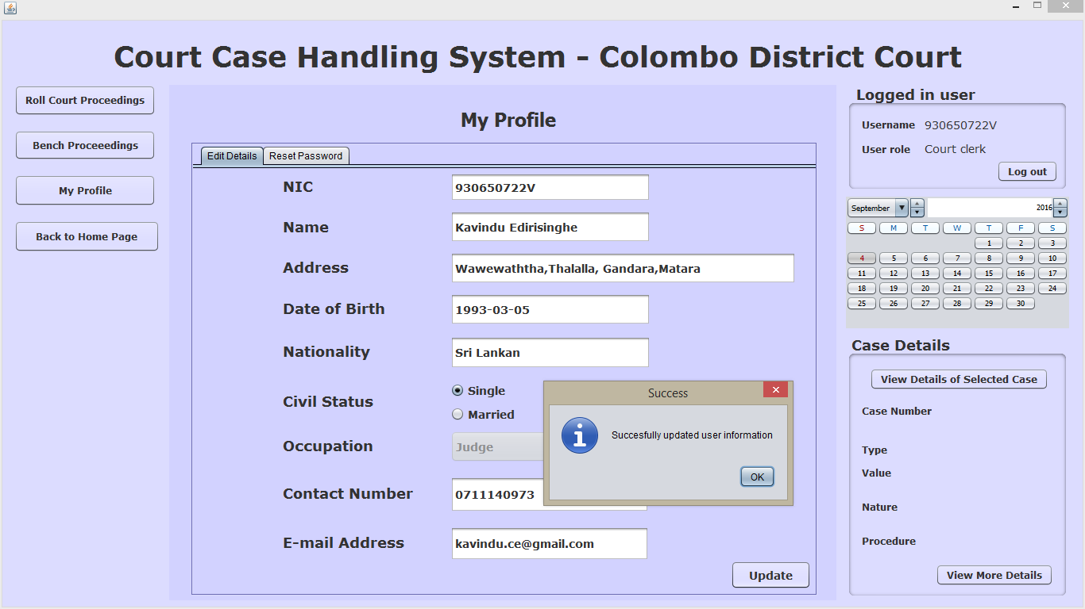

9.2) Resetting the password (Normal Case)

Explanation:- Clicking on “Reset Password” tab and trying to reset the password

Input:- valid data entries(valid ID, appropriate password, same new and confirmation password)

Output:- display information message “Successfully updated new password”

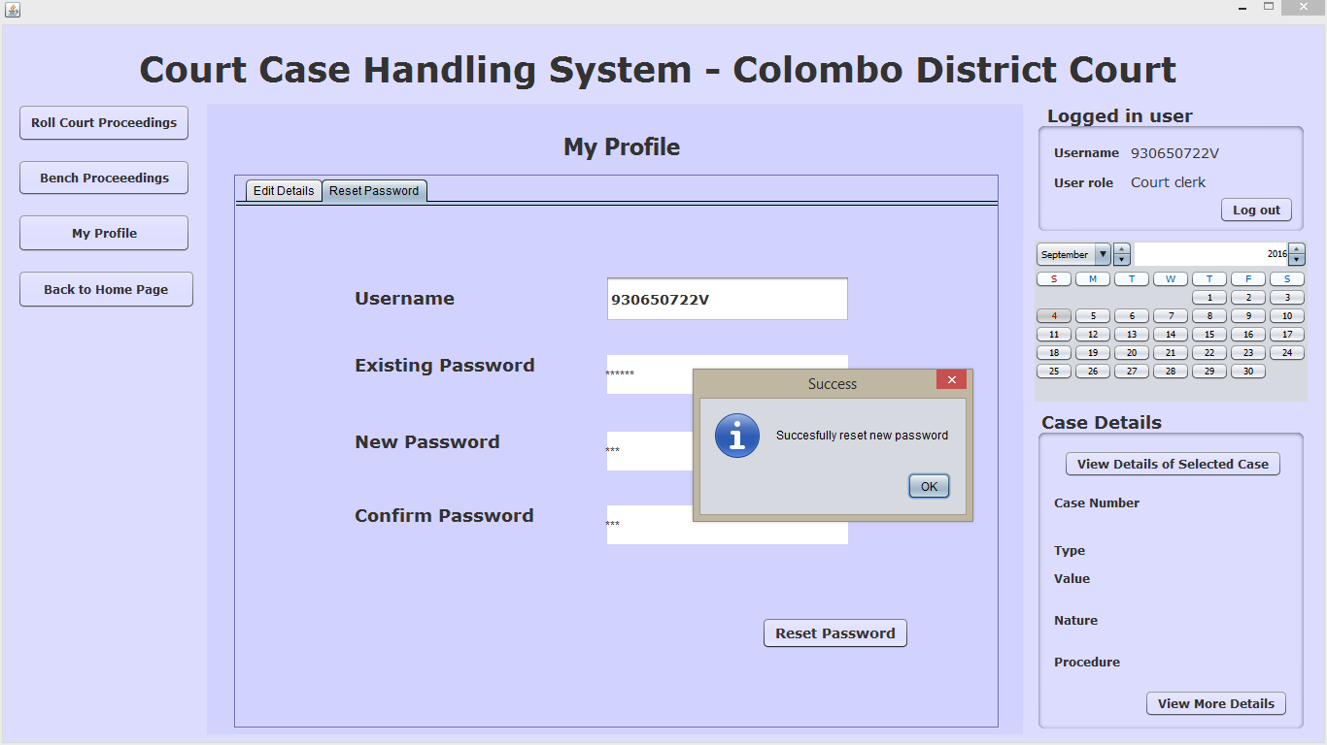

10.2) Entering an invalid user ID when Resetting the password

Explanation:- Clicking on “Reset Password” tab and entering an invalid user ID in the ‘Username’ field when trying to reset the password

Input :- 938230039V

Output:- display information message “”

Existing password wrong

New and confirmation do not match

Blank fields

Integration Testing-Bottom Up Approach

After the component wise unit testing of the completed units, that those components were integrated with related components and the outcomes were observed for the given inputs for the whole groups of components.

In order to do this, our group first started testing the bottom line components individually just in case. Then the components relying on bottom line components were tested with the bottom line components as a group.

The bottom line input we took for integration testing is:-

Case number- DMR-1-16 (automatically generated)

Type- Money Matters (automatically generated)

Value- 12000.00 (Rs)

Nature- money case

Procedure- regular

Plaintiff Details- fill ☺

Defendant Details- fill ☺

Lawyer D- fill ☺

Attachment D- fill ☺

1) test case 1-Within Case Registration and stamp duty process

|  |  |  |  |  |  |
| --- | --- | --- | --- | --- | --- |
| Purpose | Description | Input | Expected output | output | status |
| The integration between case registration component and stamp duty component is tested | After the case registration process was successfully completed, this test case checks whether the stamp duty process accurately proceeds by using the information of the case registration process | Bottom line input | The case registration number and the value of the case should be correctly displayed in appropriate fields | DMR-1-16  12000.00 | Successful ☺(akii u understand this, right? ) |
|  |  |  |  |  |  |