[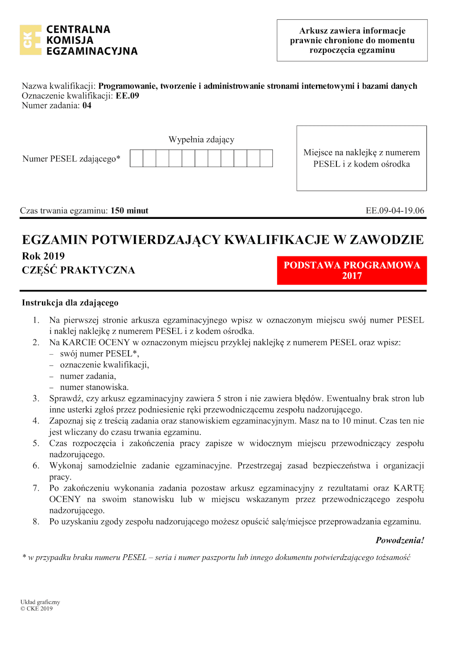](https://1.bp.blogspot.com/-3bfkDoga6Dc/XoASsrxIqMI/AAAAAAAAE1M/0nOoE4y0vM0qrOIydOao_mzxh-OE3ttzgCLcBGAsYHQ/s1600/ee_09_2019_06_04_kolor-1.png)

[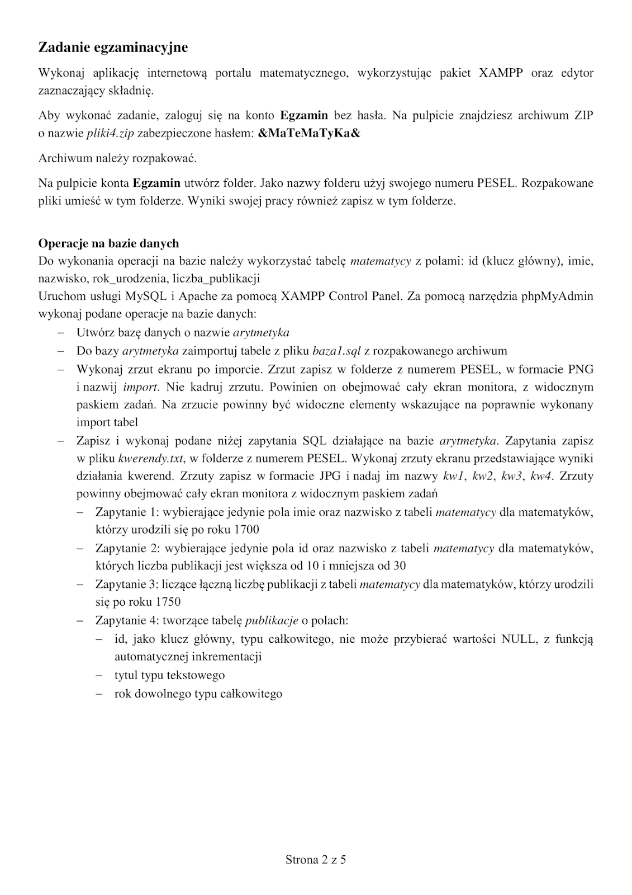](https://3.bp.blogspot.com/-i5fIECYKo4I/XoASskSsRUI/AAAAAAAAE1I/mUval20SGxML-kHGd_PWLIQ1JbVrHRqfwCLcBGAsYHQ/s1600/ee_09_2019_06_04_kolor-2.png)

[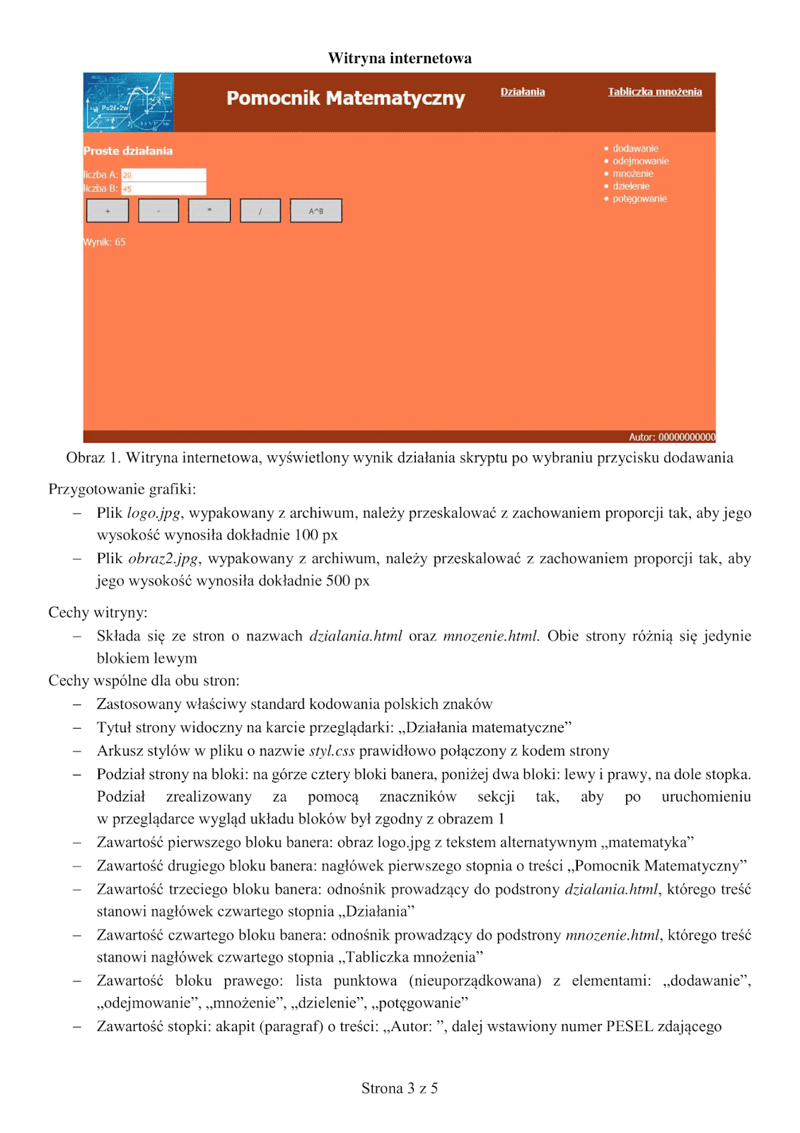](https://3.bp.blogspot.com/-WiUQwmpI4ks/XoASstd9pDI/AAAAAAAAE1Q/ydCYpIjqHxwUkyCLupq6VVzzrkmY6-vwACLcBGAsYHQ/s1600/ee_09_2019_06_04_kolor-3.png)

[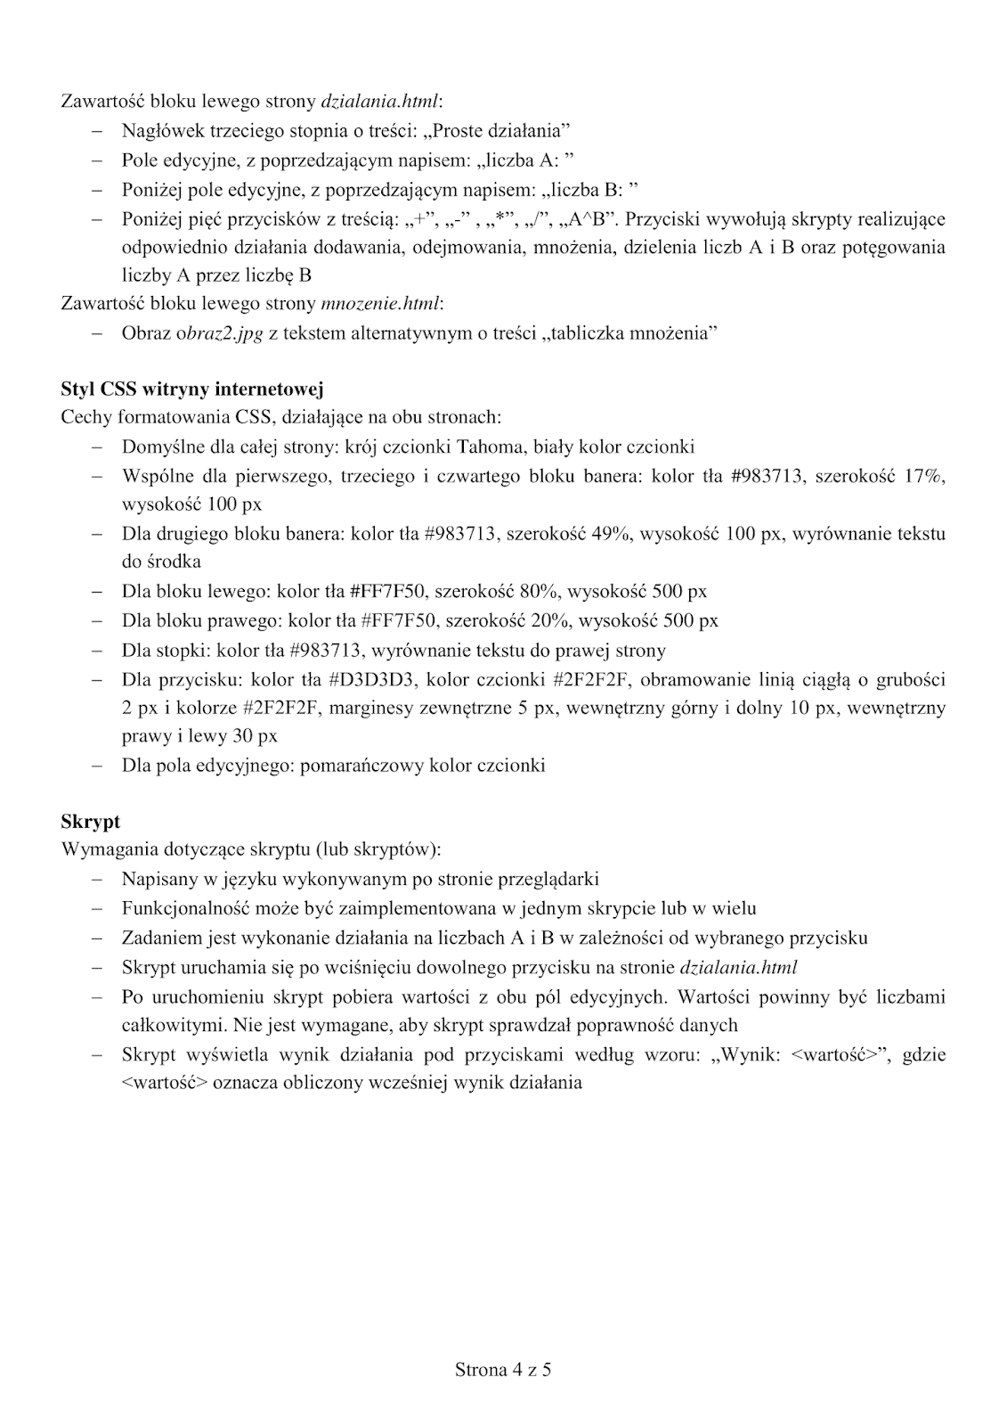](https://4.bp.blogspot.com/-dHrflMGg_GU/XoAStt7gwNI/AAAAAAAAE1U/iWq-oe7BKxg9SMx3z7suwdnD9lGoMJcQQCLcBGAsYHQ/s1600/ee_09_2019_06_04_kolor-4.png)

[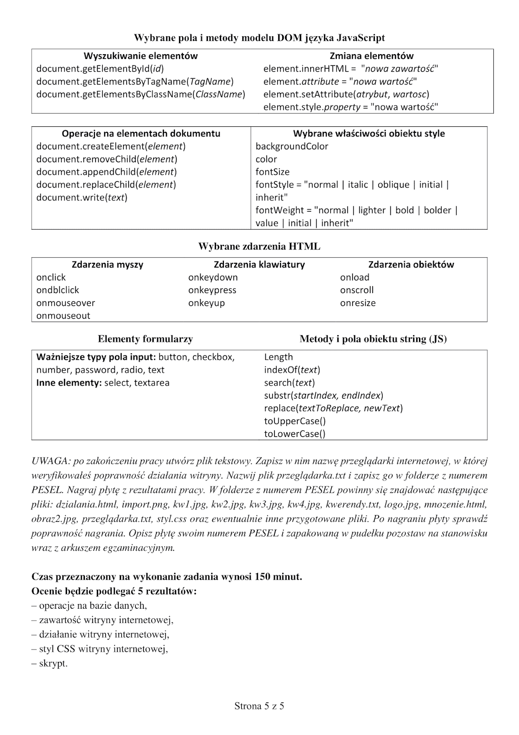](https://2.bp.blogspot.com/-HcyjuCRv3nI/XoAStx6zkVI/AAAAAAAAE1Y/Xiz0pwKORrclP9MpWf6e-OMeHz60PDvSQCLcBGAsYHQ/s1600/ee_09_2019_06_04_kolor-5.png)