Lab 2 changes to be made according to “AI critique”

- Improvement on actor model
  - Reason
“Registered User” is ambiguous
  - Why is this change necessary?
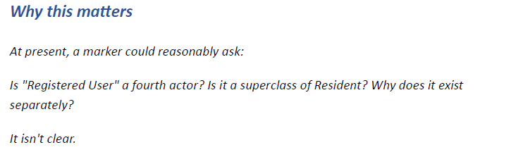
  - Where to change?
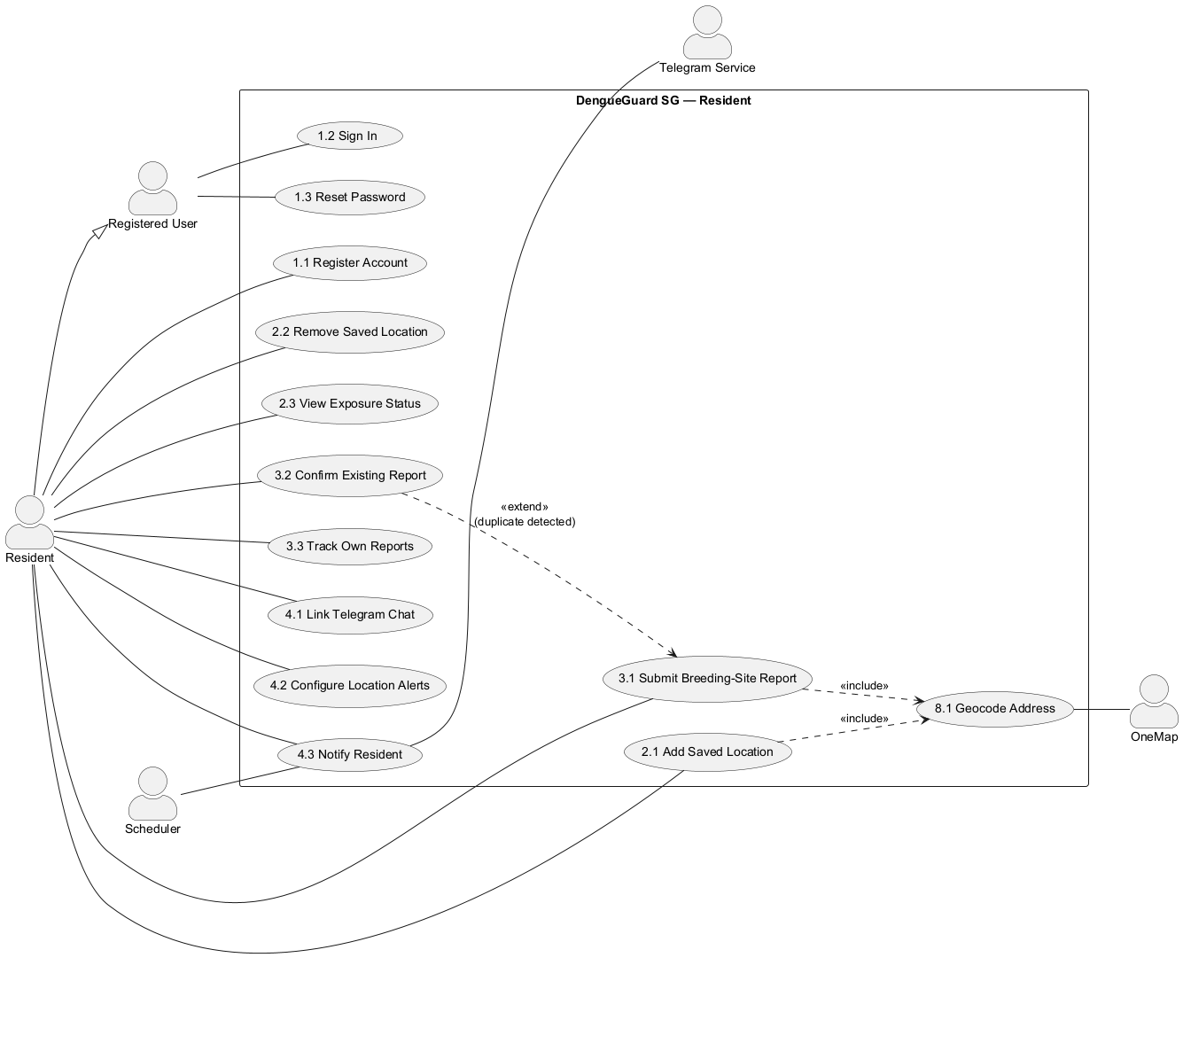
  - Recommended solution
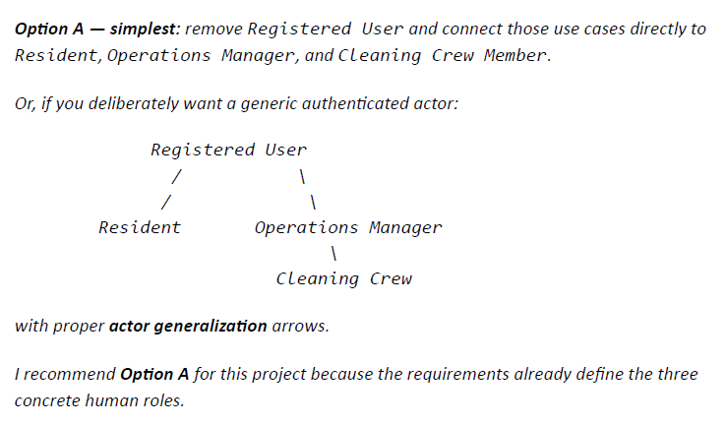\

- Missing extend relationship
  - Reason
There isn’t an equally clear second extend relationship from 6.7 to 6.5
  - Why is this change necessary?
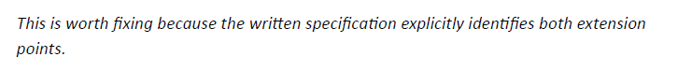
  - Where to change?
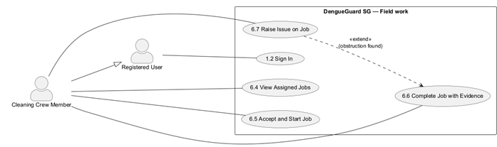
  - Recommended solution
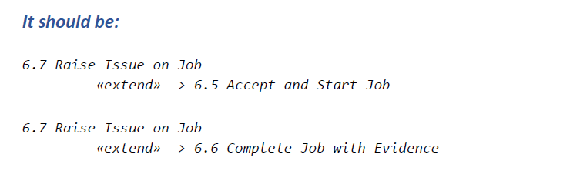

- Too many crossing association lines
  - Reason
The diagram has enormous curved lines running.
  - Why is this change necessary?
This makes it difficult to answer simple questions. A use-case diagram should communicate relationships at a glance.
  - Where to change?
[On use case diagrams]
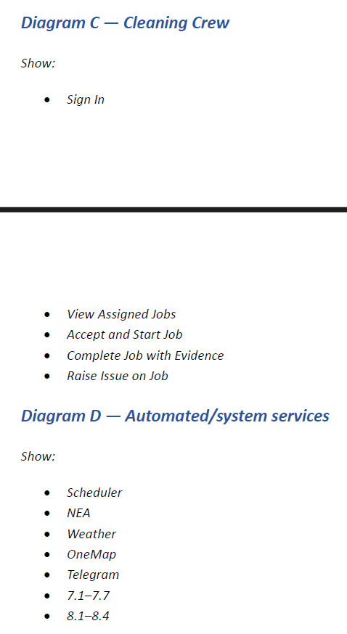
  - Recommended solution
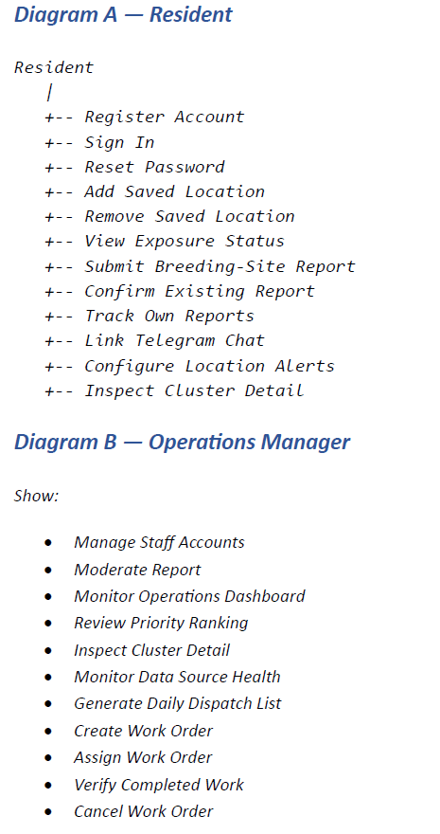

- Use cases 8.1-8.4 look like “technical” use cases
  - Reason
These functions are largely reusable sub-functions
  - Why is this change necessary?
To improve readability
  - Where to change?
[Use case diagram with 8.1 – 8.4]
  - Recommended solutions
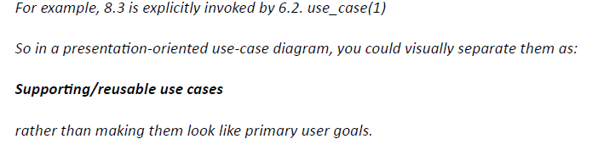

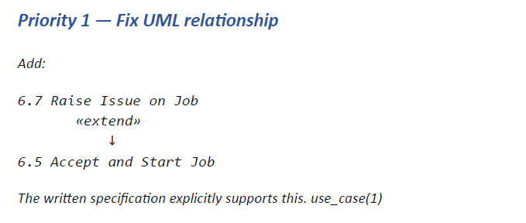
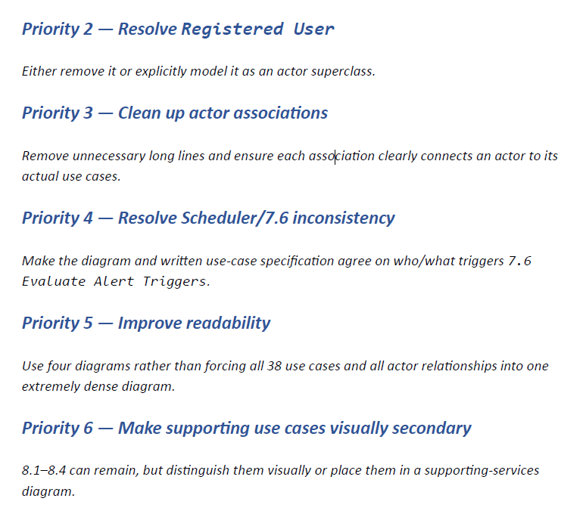

- –
  - Reason
  - Why is this change necessary?
  - Where to change?
  - Recommended solution

