ĐẠI HỌC QUỐC GIA TP. HỒ CHÍ MINH

TRƯỜNG ĐẠI HỌC CÔNG NGHỆ THÔNG TIN

KHOA HỆ THỐNG THÔNG TIN

**Assignment in class** **MSIS207.O11.CTTT**

**Web Application Development**

**Lecture: Trần Vĩnh Khiêm**

**Authors: Nguyễn Thị Dung**

**ID: 20521211**

**CONTENTS**

**Basic Javacript: Exercise 1** 4

**1.** **Display the current day and time** 4

**Figure 1: Day and Time** 4

**2.** **Copy a string to the clipboard.** 4

**Figure 2: Copy Text** 4

**3.** **Parse HTTP Cookie Header.** 4

**Figure 3: Parse HTTP Cookie Header** 4

**4.** **JSON object** 5

**Figure 4: JSON object** 5

**Basic Javacript: Exercise 2 (DOM)** 6

**1.** **Submit button** 6

**Figure 5: Submit Botton** 6

**2.** **Create a form** 6

**Figure 6: Create a Form** 6

**3.** **Create a form to calculate age** 6

**Figure 7: Create a Form to calculate age** 6

**4.** **Highlights the bold word** 6

**Figure 8: This is we do nothing** 6

**Figure 9: This is when you touch mouse in the first line** 7

**Figure 10: This is when you click in first line** 7

**5.** **Get the windown’s Width and Height** 7

**Figure 11: The windown’s Width and Height** 7

**Basic Javacript: Exercise 3 (DOM and CANVAS)** 8

**1.** **DOM** 8

**Figure 12: Interval, button and counter** 8

**Figure 13: Load array to list** 8

**Figure 14: Load img to div** 8

**Figure 15: Load array to list** 9

**Figure 16: Add and Reset Internal JS 1** 9

**2.** **CANVAS** 10

**Figure 17: Start Game** 10

**Figure 18: Start Game level 2** 11

**Javacript - Homework** 12

**1.** **Homework 2** 12

**Figure 19: Update the CV** 12

**2.** **Homework 2.1** 12

**Figure 20: Drum Kit** 12

**3.** **Homework 2.2** 13

**Figure 21: Make Multi Filter** 13

**Figure 22: Template Process** 14

**4.** **Homework 2.3** 14

**Figure 23: Login** 14

**5.** **Google Skill** 15

**a)** **Kim Clock** 15

**Figure 24: Kim Clock** 15

**b)** **Calculator** 16

**Figure 25: Calculator** 16

**Link Github:** 16

# **Basic Javacript: Exercise 1**

1. **Display the current day and time**

### **Figure 1: Day and Time**

1. **Copy a string to the clipboard.**

### **Figure 2: Copy Text**

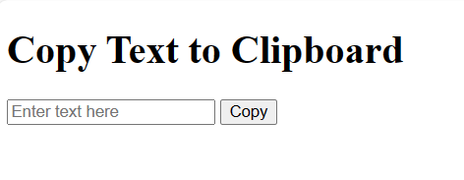

1. **Parse HTTP Cookie Header.**

### **Figure 3: Parse HTTP Cookie Header**

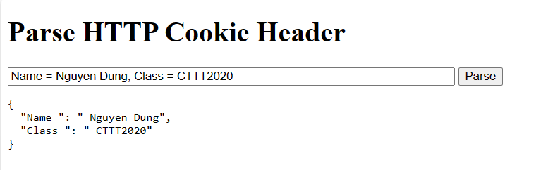

1. **JSON object**

### **Figure 4: JSON object**

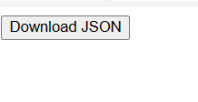 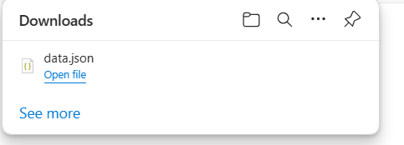

# **Basic Javacript: Exercise 2 (DOM)**

1. **Submit button**

### **Figure 5: Submit Botton**

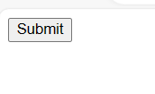

1. **Create a form**

### **Figure 6: Create a Form**

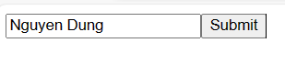

1. **Create a form to calculate age**

### **Figure 7: Create a Form to calculate age**

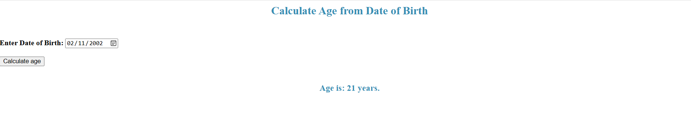

1. **Highlights the bold word**

### **Figure 8: This is we do nothing**



### **Figure 9: This is when you touch mouse in the first line**



### **Figure 10: This is when you click in first line**



1. **Get the windown’s Width and Height**

### **Figure 11: The windown’s Width and Height**

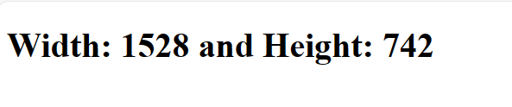

# **Basic Javacript: Exercise 3 (DOM and CANVAS)**

1. **DOM**

### **Figure 12: Interval, button and counter**



### **Figure 13: Load array to list**

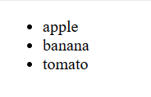

### **Figure 14: Load img to div**

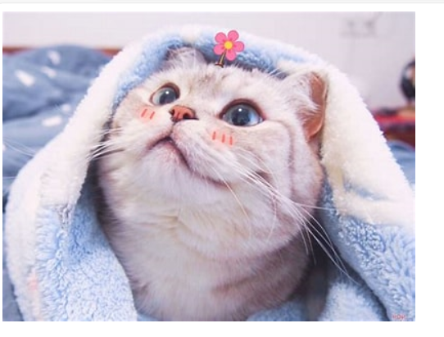

### **Figure 15: Load array to list**

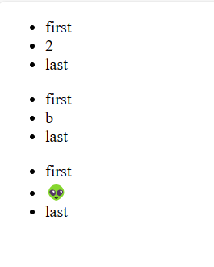

### **Figure 16: Add and Reset Internal JS 1**

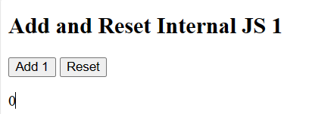

1. **CANVAS**

### **Figure 17: Start Game**

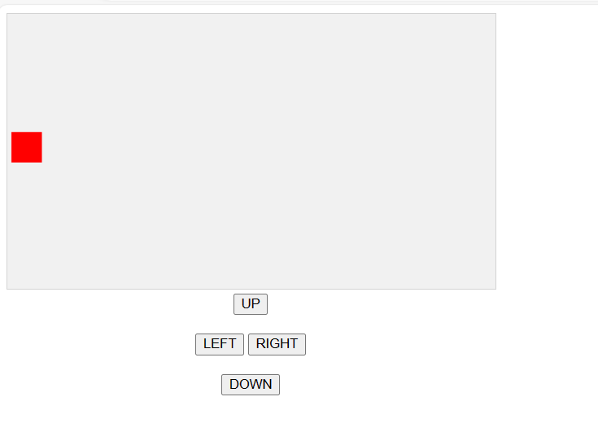

### **Figure 18: Start Game level 2**

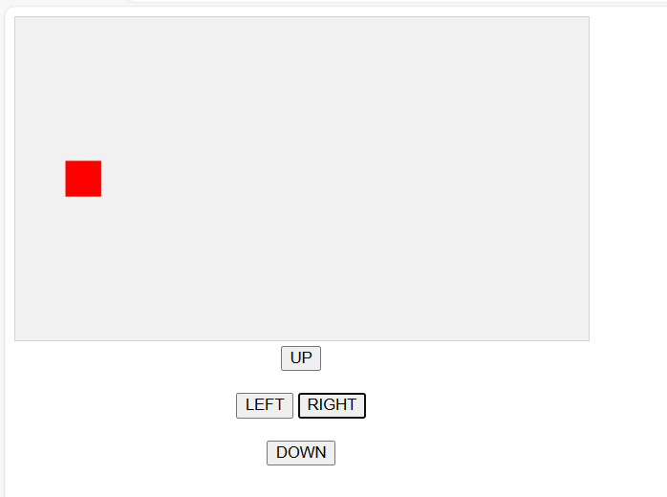

# **Javacript - Homework**

1. **Homework 2**

### **Figure 19: Update the CV**



1. **Homework 2.1**

### **Figure 20: Drum Kit**

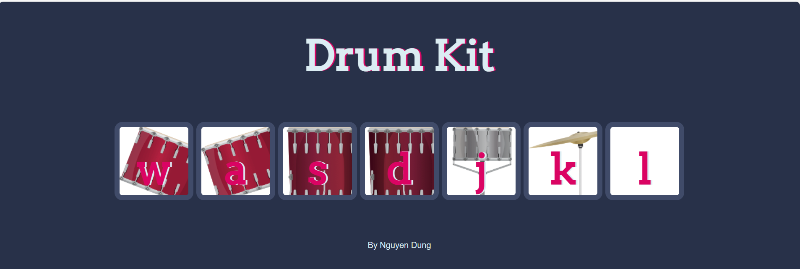

1. **Homework 2.2**

Make Multi Filter

### **Figure 21: Make Multi Filter**

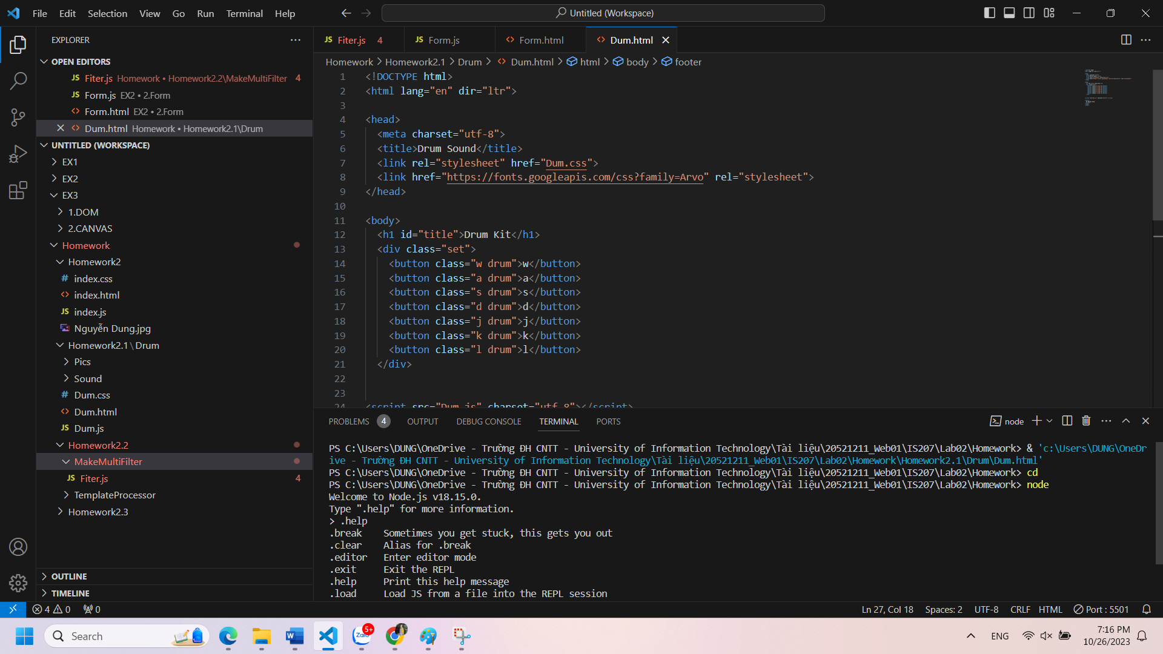

### **Figure 22: Template Process**

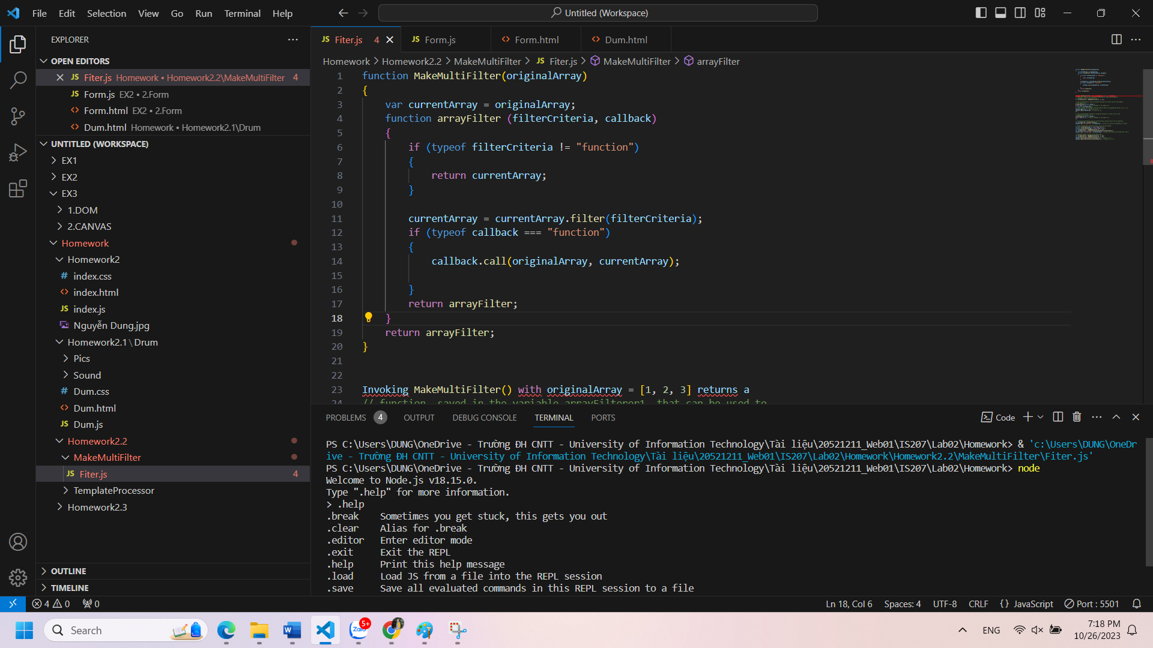

1. **Homework 2.3**

### **Figure 23: Login**

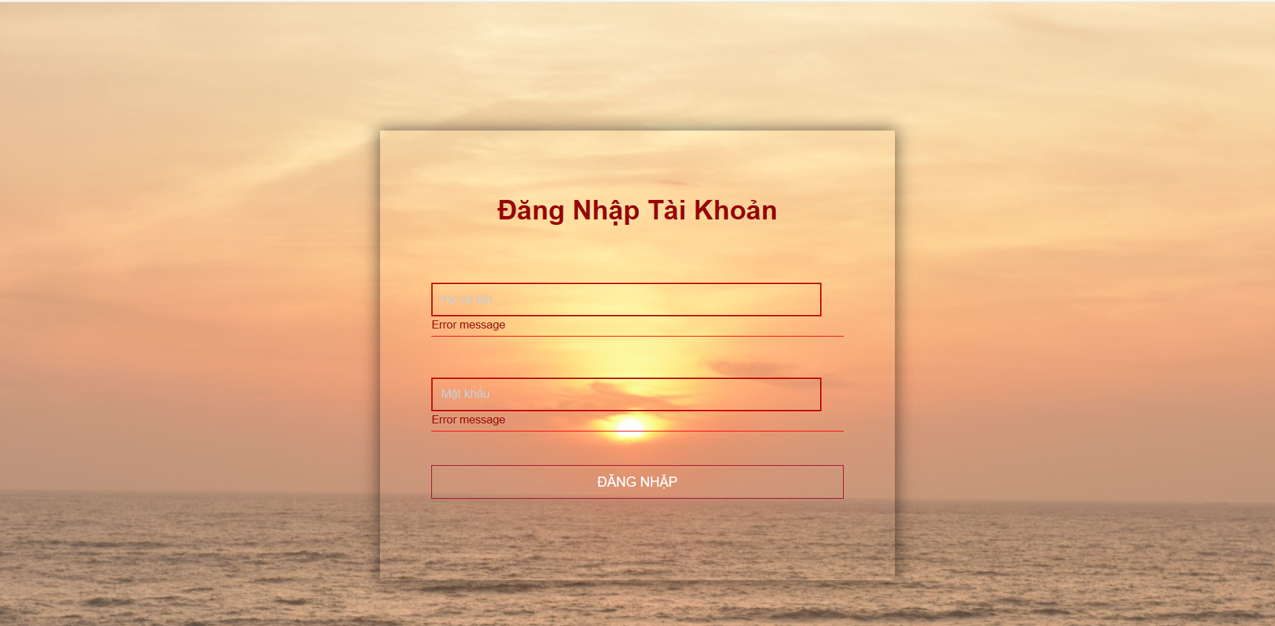

1. **Google Skill**
2. **Kim Clock**

### **Figure 24: Kim Clock**

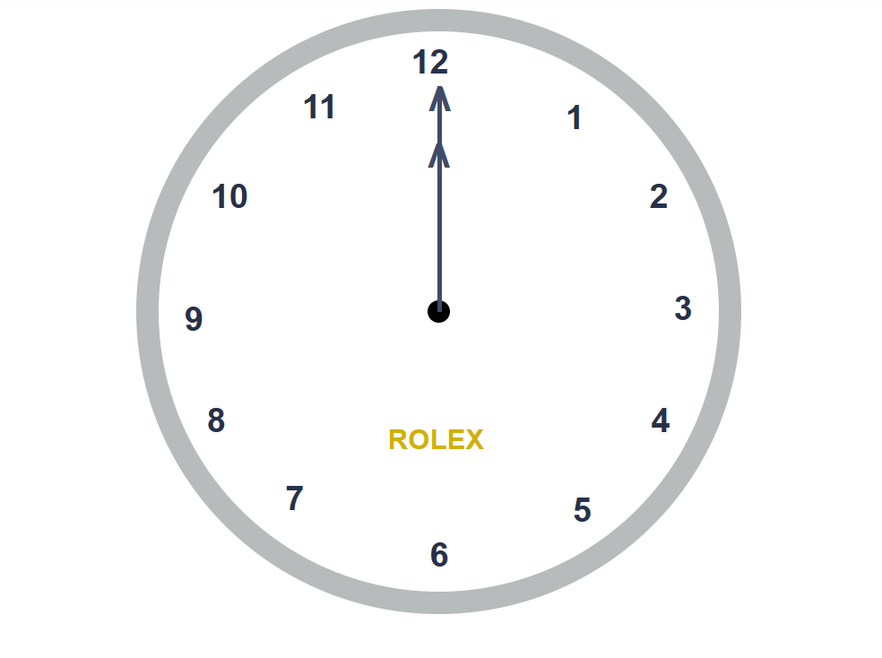

1. **Calculator**

### **Figure 25: Calculator**

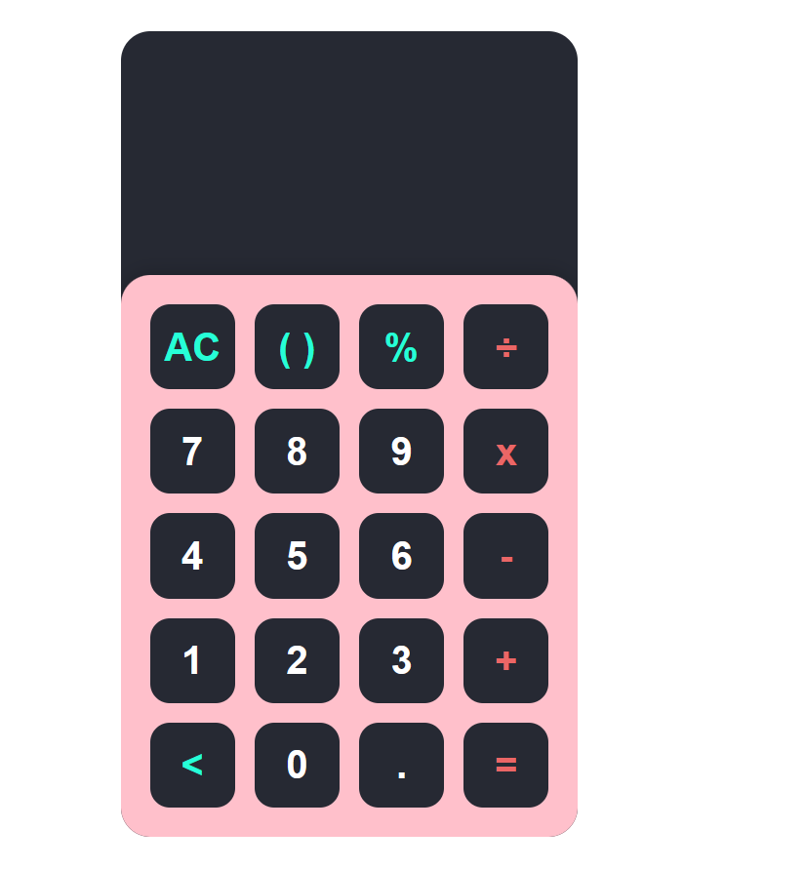

# **Link Github:**

https://github.com/Dung261102/IS207.git