**Technical document**

1. **Introduction**

The application stimulates a toy robot moving on a square tabletop, of dimensions 5 units x 5 units. The application will read in commands of the following form:

* Place X,Y,Z
* MOVE
* LEFT
* RIGHT
* REPORT

The application is built as a console application (.NET Framework), which accepts user’ inputs from keyboard. The application is created and run in Visual Studio 2019 (<https://visualstudio.microsoft.com/vs/>) .

1. **Application Structure**

The application is divided into two parts including console application and unit tests.

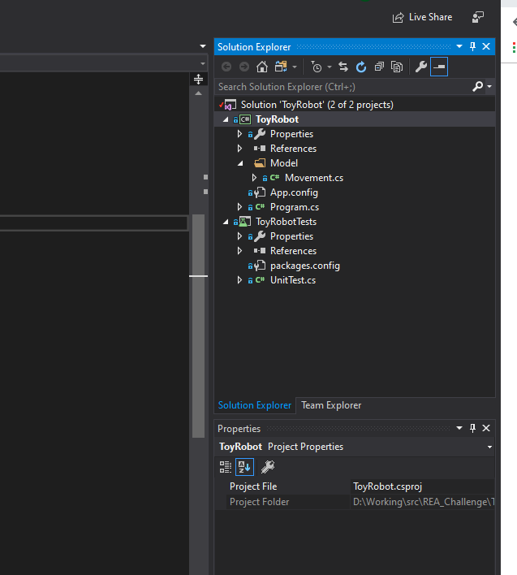

Figure 1: Project Structure

1. **Console application**

The console application contains main method in “Program.cs” file and controlling methods in “Movement.cs” file.

The application can be run by clicking the “Start” button on the top of visual studio.

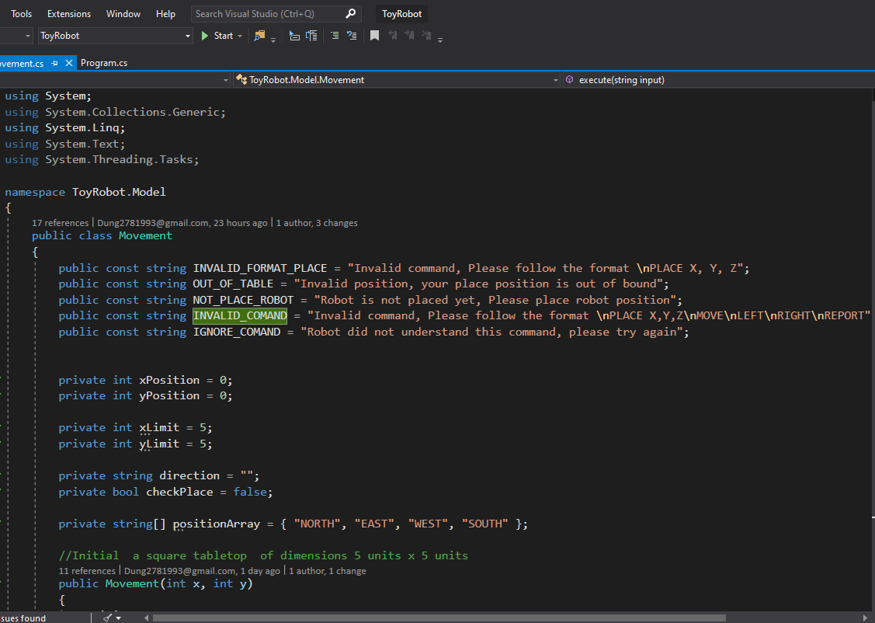

Figure 2: Running Procedure (Start)

It will display a console window for interaction.

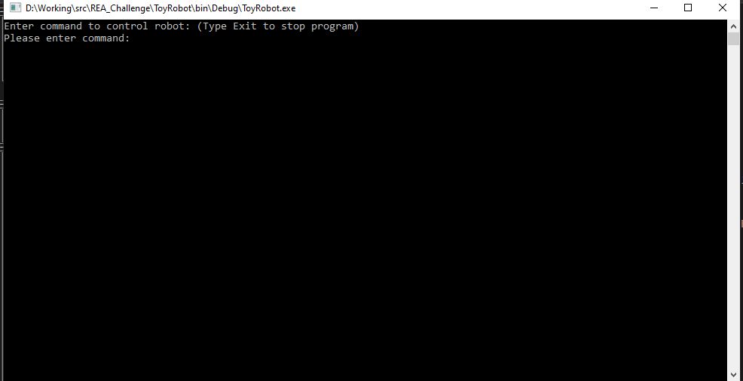

Figure 3: User Input

From the console window, users can start providing input commands such as **PLACE, MOVE, LEFT, RIGHT,** and **REPORT.**

2. **Unit Tests**

The unit tests are created to examine all the scenarios while running the application. The documentation for unit testing can be found in (<https://docs.microsoft.com/en-us/visualstudio/test/getting-started-with-unit-testing?view=vs-2019>)

In this case, the application provides 10 test cases, which tackle all failure situations that may happen. All the test cases can be found in the UnitTests.cs file. To run test case, you can select Run All Tests in Test Option or enable Live Unit Testing.

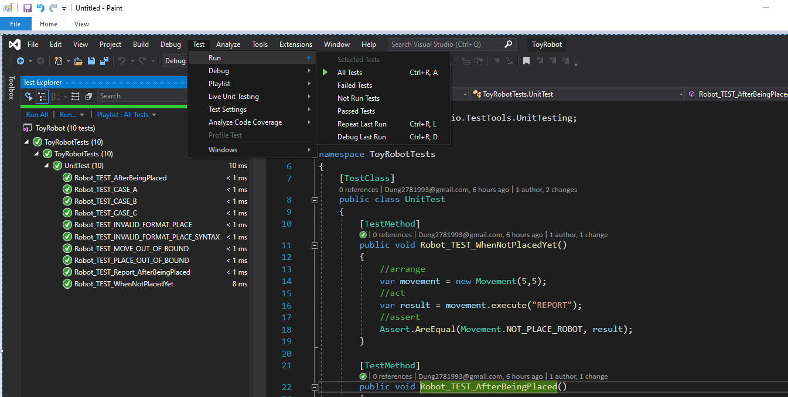

Figure : Unit Tests

The more details about failed or passed test cases can be found in Microsoft documentation.

1. **Code Structure**

In terms of code structure, the main method can be found in Program.cs file and the controlling method can be found in Movement.cs file.

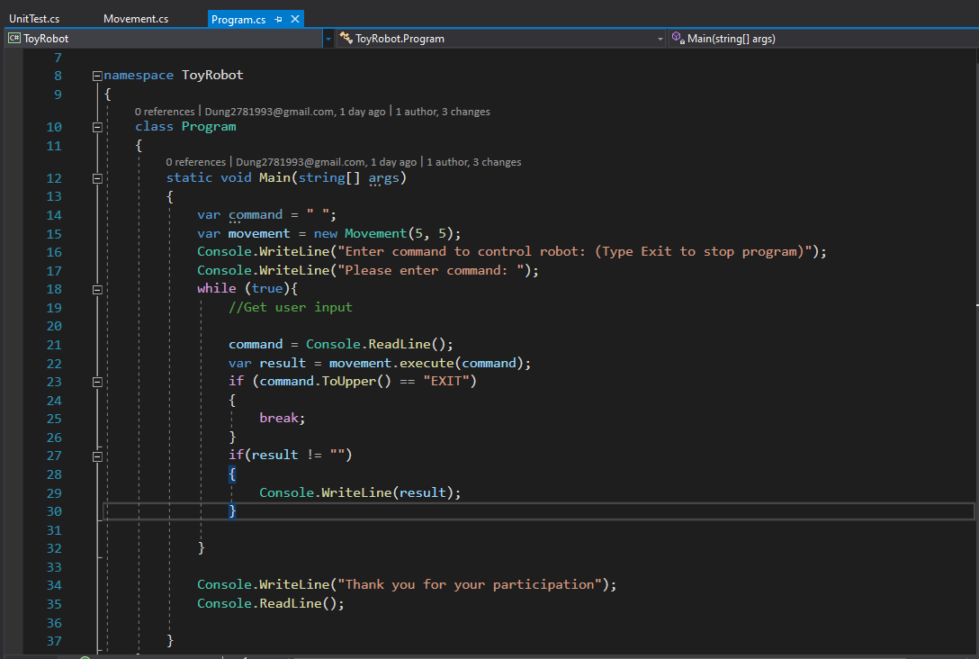

Figure : Main Function

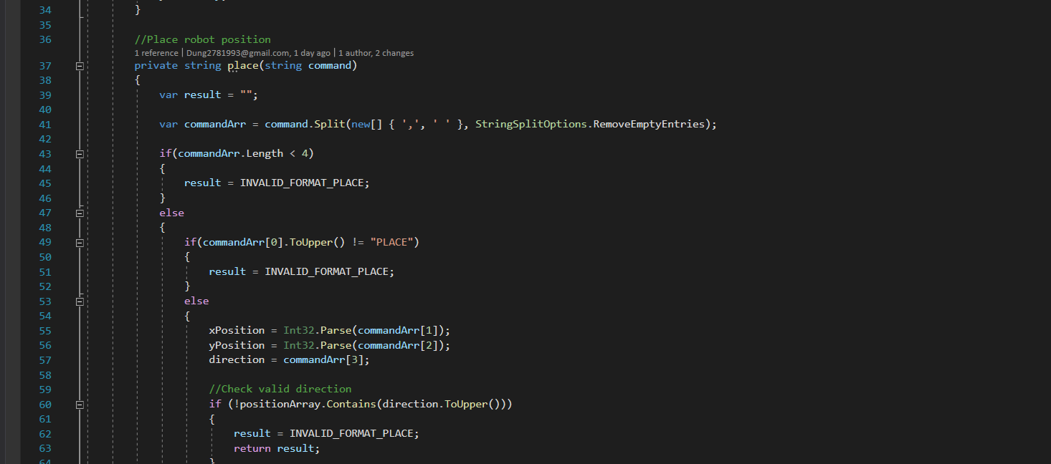

Figure : Place Method

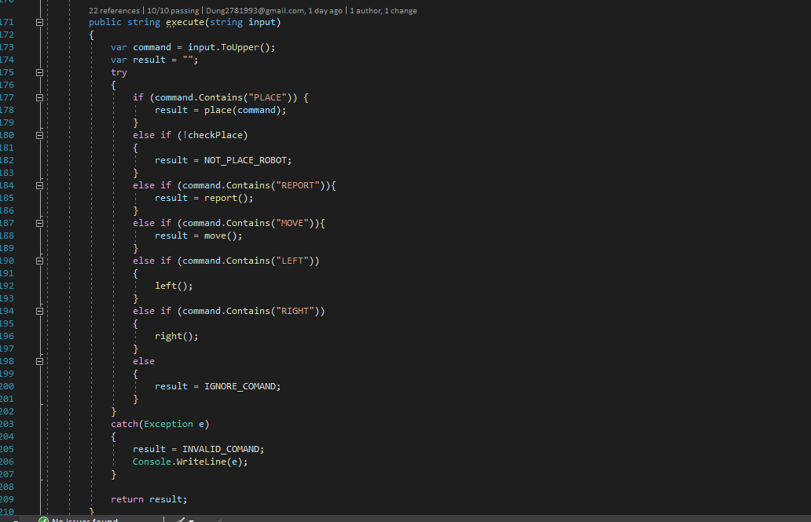

Figure : Execute method

1. **Repository**

The source code for robot project can be downloaded from (<https://github.com/Dung2781993/robot>)